Lake Lanier as a System Case Study

Figure 1. World map showing the location of Lake Sidney Lanier
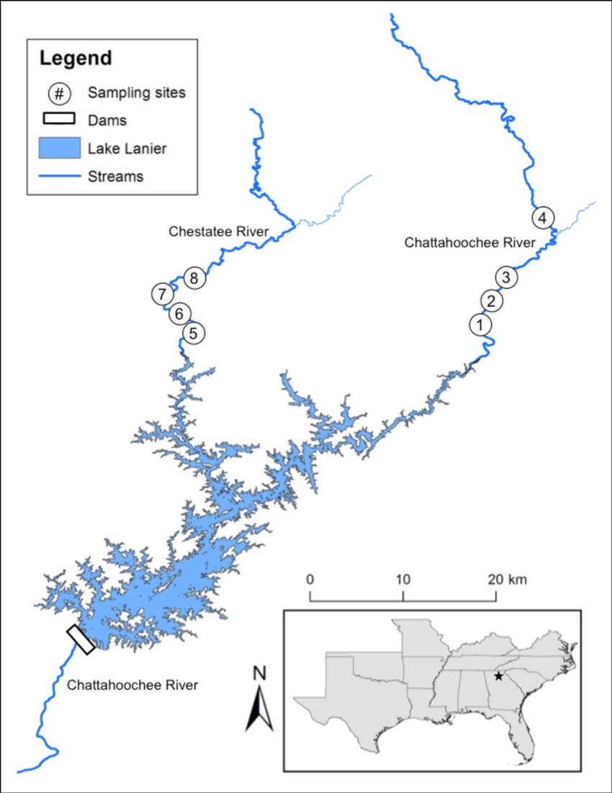

Influences of fragmentation on fluvial-specialist black bass species

Figure 2: Background information on Lake Sidney Lanier

Lake Lanier came to be in 1956, when the Corps of Engineers completed Buford Dam on the Chattahoochee River. The Corps built the lake to manage navigation and flood control of the Chattahoochee River, provide hydroelectricity, and supply water for the city of Atlanta
http://thatlakestore.com/lake-lanier-map/

Located in the foothills of the Georgia Blue Ridge Mountains
- Headwaters of the Apalachicola/Chattahoochee/Flint (ACF) watershed
- Impounded by the Buford Dam and extends up the Chattahoochee and Chestatee Rivers.
- 692 miles of shoreline | 38,542-acre Reservoir Area
- Holds approx. 637 billion gallons of water | approx. 354 billion in the conservation storage
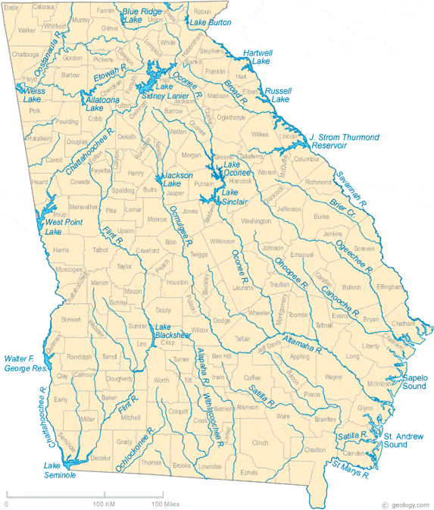
- Holds 63% of the total managed reservoir conservation water storage in the ACF watershed; drainage basin is approx. 6% of ACF watershed drainage area
- Touches seven Georgia counties: Dawson, Forsyth, Habersham, Hall, Gwinnett, Lumpkin, and Whit

- Area: 57.92 mi²
- Max depth: 156′ 0″
- Length: 44 mi

https://geology.com/lakes-rivers-water/georgia.shtml

Figure 3. Photographs of Lake Sidney Lanier

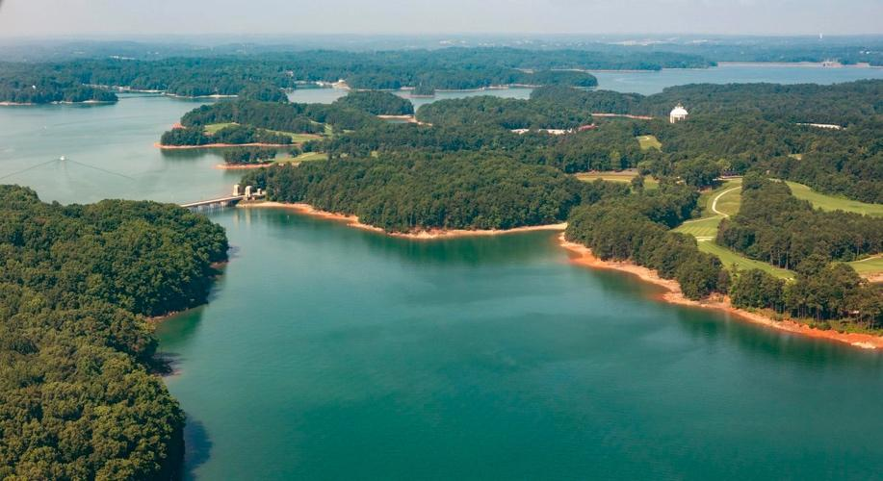

https://www.dawsonnews.com/sports/emphasis-water-safety-lake-lanier-enters-recreation-season/

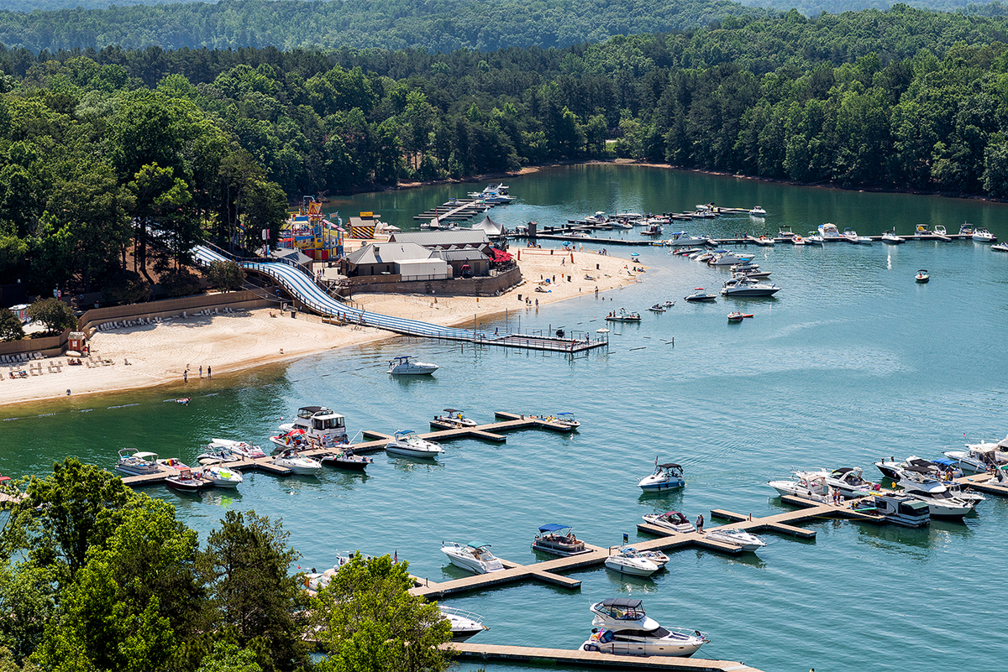
https://www.careersmargaritavilleatlanierislands.com/

Figure 4 Monthly rainfall and inflows to Lake Lanier

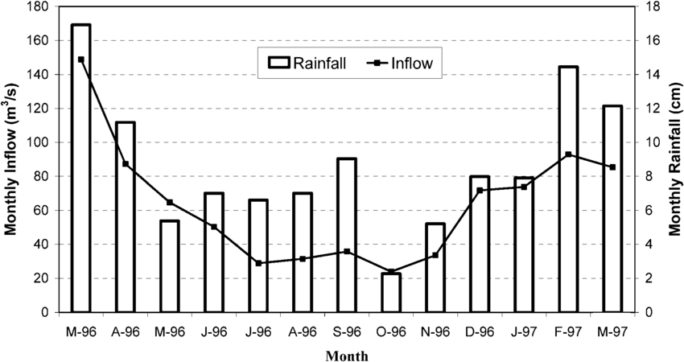
https://www.researchgate.net/publication/7544088_Multivariate_Statistical_Characterization_of_Water_Quality_in_Lake_Lanier_Georgia_USA

Figure 5: Water Distribution

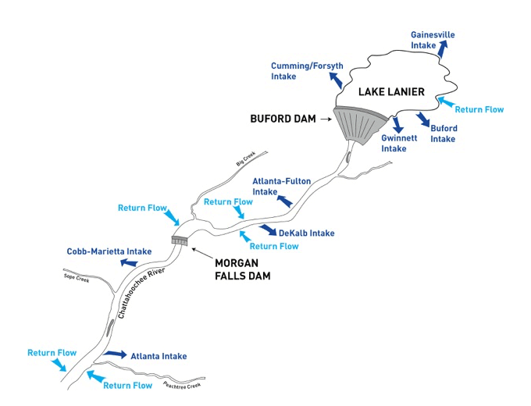

https://atlantaregional.org/natural-resources/water-wars/tri-state-water-wars-background-and-history/

Figure 6: Pollution Issues around Lake Lanier

As the population grows around Lake Lanier and the creeks and rivers that feed it, these bodies of water are absorbing more runoff and treated wastewater — enough that regulators are starting the process of tightening restrictions for municipalities and water utilities
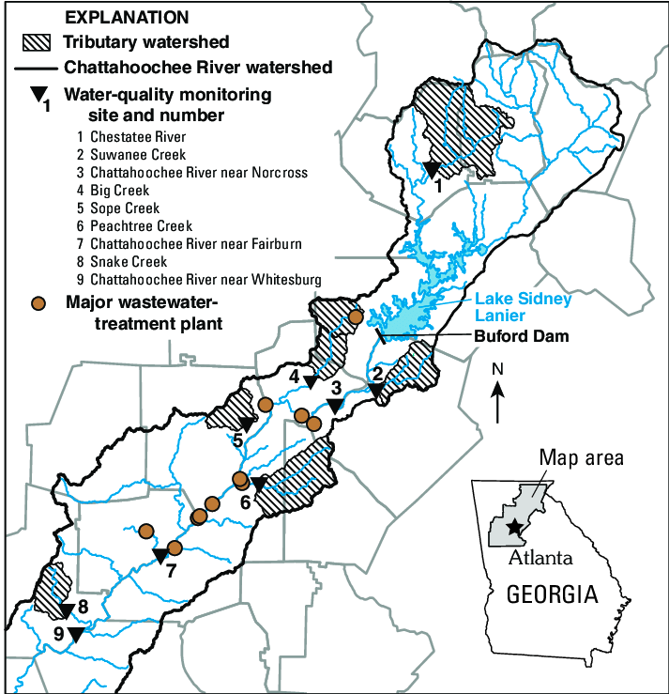
That growth is causing more runoff into state waterways with more roads, parking lots and gutters, more subdivisions, lawns and vehicles.

The issue is the amount of nutrients flowing into the upper portion of the Chattahoochee River watershed, a corridor of streams, rivers and lakes stretching from North Carolina through Georgia and through the Florida Panhandle. The upper watershed includes Lake Lanier, the Chattahoochee River and its feeder streams in the north part of Georgia.

As communities expand around the lake, the watershed and particularly Lake Lanier are seeing higher concentrations of phosphorus and nitrogen — two nutrients that promote growth of algae that in large enough quantities can foul water supplies for both humans and wildlife

https://www.researchgate.net/figure/Lake-Lanier-location-and-water-quality-sampling stations_fig1_7544088

Figure 5: Lake Lanier Watershed Land Coverage
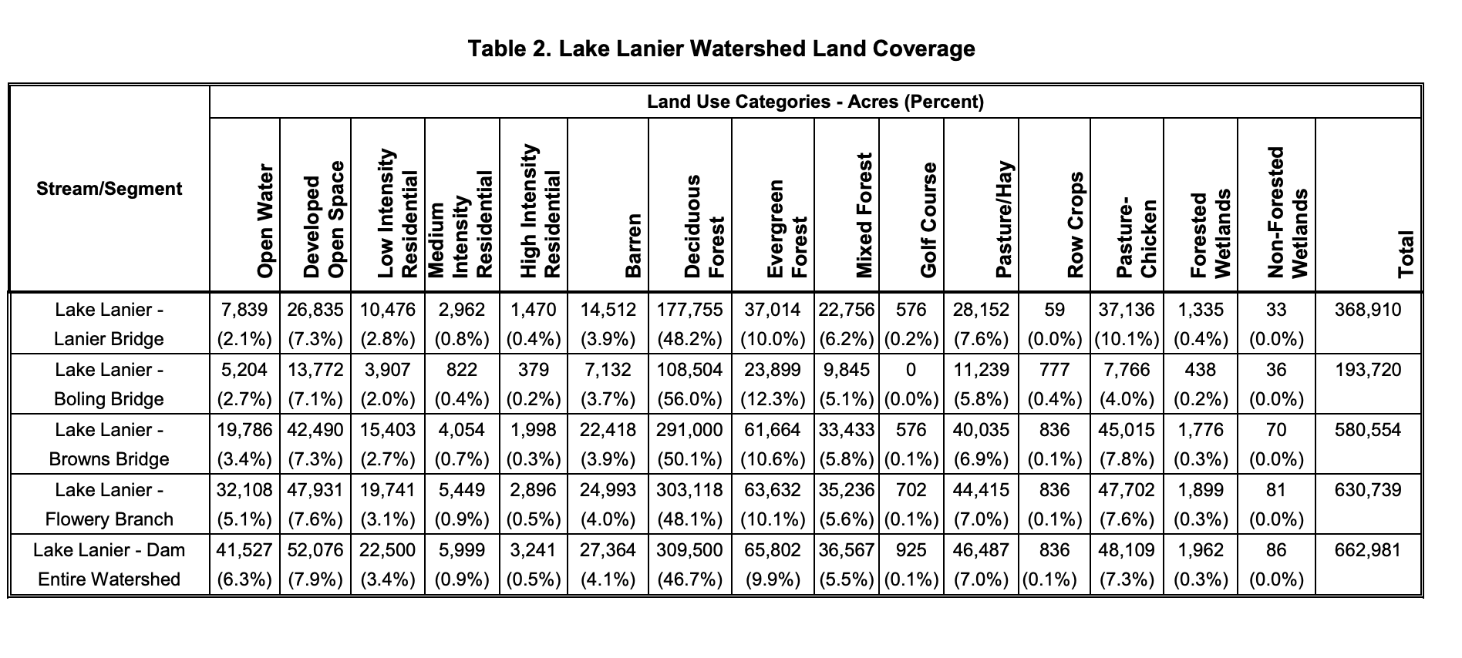
https://epd.georgia.gov/sites/epd.georgia.gov/files/related_files/site_page/EPD_Final_Lake_Lanier_ChlorophyllA_Phosphorous_TMDL_2017.pdf

Lake Lanier is surrounded by hills and these hills provide the catchment area for the lake; rain falling on these hills will naturally drain into the lake. Alongside the rainfall are various other inputs. As we look at the lake we will discuss what these inputs are and how they result in outputs from the Lanier Lake System.

Figure 6 : Atlanta Population Forecast 2015-2050

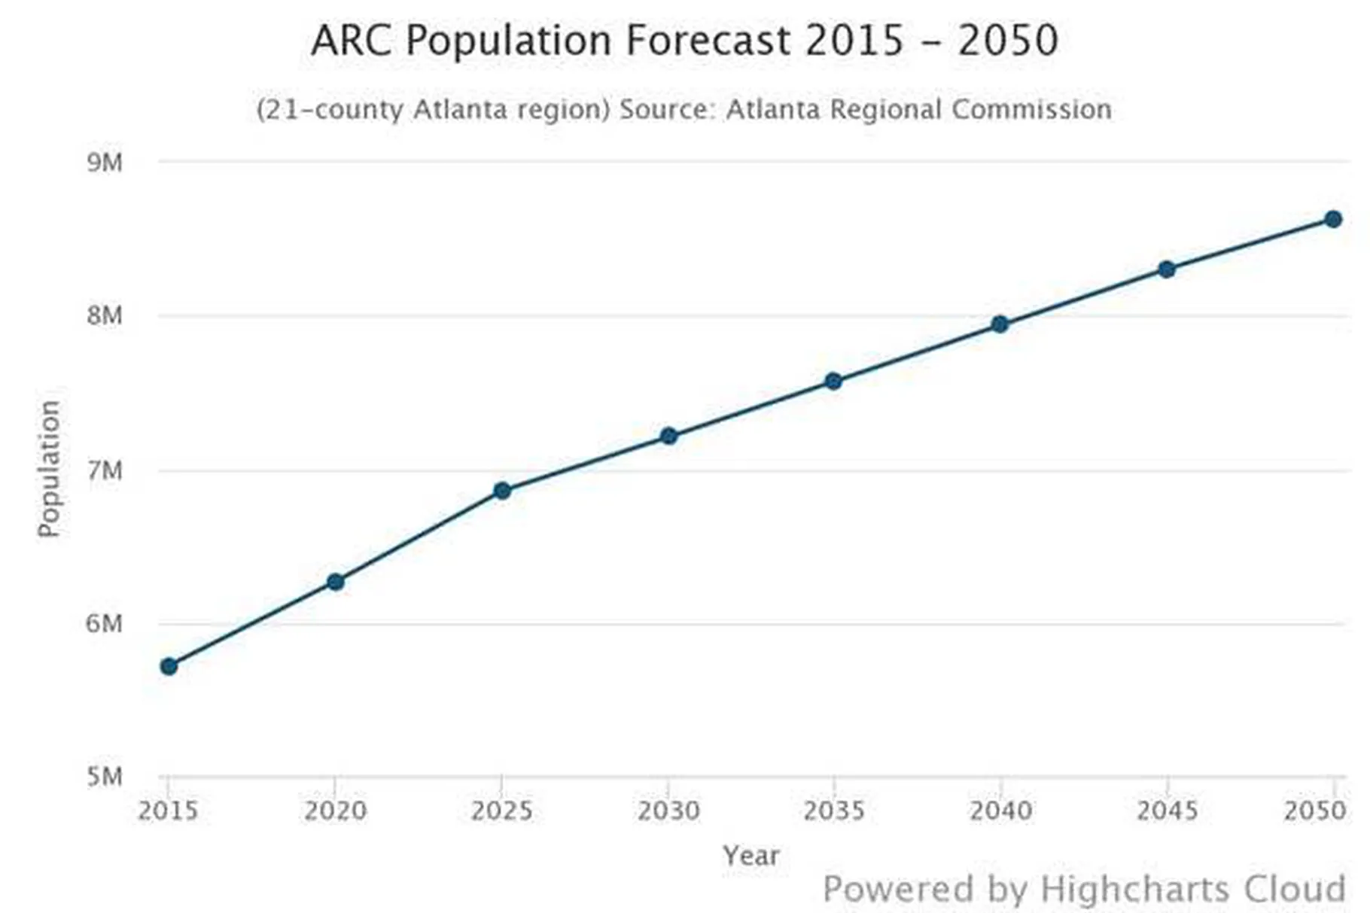
Figure 7. Plant and animal species in and around Lake Lanier

Trees & Shrubs
Southern red oak, Hickory, sweetgum, Tuliptree, Loblolly pine and Virginia pine.
During spring and summer the shorelines are a profusion of color provided by flowering Dogwood, Azalea, Mountain Laurel, Rhododendron.

Vascular Plants
Elodia, Water Weed, Pond Weed, Gout Weed, Hemlock, Honewort, English Ivy, Holly, Wild Garlic, Sunflowers, Golden Aster, Dandelion, Woodland Lettuce, Ragwort, Goldenrod,
Amphibians
American Toad, Fowler’s Toad, Northern Cricket Frog, Spotted Salamander, Marbled Salamander

Birds
Tufted Titmouse, Northern Cardinal, Carolina Wren, Carolina Chickadee, Red-Eyed Vireo, American Crow, Blue Jay, Red-Bellied Woodpecker, Blue-Gray Gnatcatcher, Downy Woodpecker.
Canada geese, great blue herons, green-backed herons, kingfishers and ospreys are common during the summer.
Bald Eagles can also be found in some areas.

Mammals
Squirrels, Rabbits, White-tailed deer, and Wild Turkeys.

Fish
Striped bass, Largemouth Bass, Smallmouth Bass, Crappie, Blacktail shiner, Green Sunfish, Yellow Bullhead, Bluegill, yellow perch and Trout.

Reptiles
Glass Lizard, Worm Snake, Racer, Corn Snake, Rat Snake, King Snake, Milk Snake, Water Snakes, Garter Snake, Ground Skink, CopperHead, Snapping Turtle, Box Turtle,and Musk Turtle
(information from Chattahoochee River National Recreation Area)

Directions:
- In this case study you will learn how to draw a system diagram for a local system.
- There are some system conventions that you should follow. These are simplified for the ESS course.
  - Start with a box on your page which should fill two thirds of the space.
  - Identify as many inputs into the system. Which of these are energy and which are matter?
  - Draw an arrow from outside the box to touch the edge of the box. Use different colors for energy and matter. The size of the arrow should represent the size of the input (this can be an estimate).
  - Identify as many outputs from the system.
  - Draw arrows from the box outwards. Use different colors for energy and matter. Again, the size of the arrow should represent the size of the output (an estimate).
  - Think about what are the stores that are always present inside your system. Draw different sized boxes inside the large box to represent these stores. Make sure you label your stores.
  - As an extension, draw arrows between these stores and label them as flows?

Make sure to include these words?
  - System
  - Flow
  - Transfer
  - Transformation
  - Store
  - Input
  - output

Assignment:
You are required to provide two pieces of work for this lab:
- Create a table to identify the inputs, outputs, transfers, transformations, stores and flows.
- Draw a labeled system diagram of Lanier Lake with arrows showing the various sizes of inputs and outputs into and out of the system. You will also be expected to note the stores, flows and transformations
- Answer the questions based on the Lake Sidney Lanier Case Study

Table

Inputs | Outputs | Transfers | Transformations | Stores | Flows

Systems Diagram of Lake Sidney Lanier (10 marks)

Questions
- Define the terms systems and models. (2 marks)

- Outline why Lake Lanier is considered an open system (2 mark)

- Suggest why most ecosystems are negative feedback systems. (2 mark)

- As you develop your model, state what is meant by transfer within a system? How does this differ from transformation processes? (2 marks)

- Outline how urbanization might impact two of the storages in your model. (2 marks)

- Runoff from agricultural land can result in excess nutrients entering water bodies. State one management strategy that could control the release of agricultural runoff. (2 mark)

- Evaluate the strengths and limitations of the Lake Lanier model you drew for describing an aquatic system. (Not your drawing ability, but the strengths and limitations of your model as it represents an aquatic system) (4 marks)

- Figure 6 shows the estimated population growth within the Atlanta area for 2050. To meet these demands water will be a critical commodity. There is a plan to dam the Flint River that could be the answer to Atlanta's ongoing population growth and water crisis. Outline the arguments that might be given for building the dam by a deep ecologist and a cornucopian. (4 marks)

