Carrying Capacity and Limiting Factors
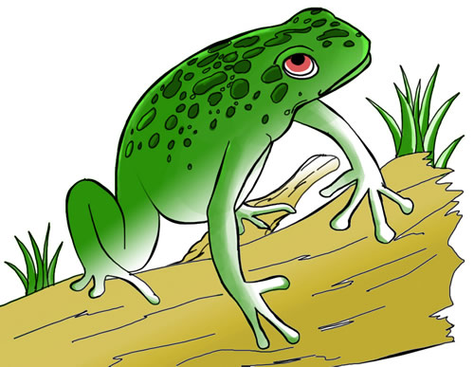
What Factors Limit Population Growth?
When the living conditions in an area are good, a population will generally grow. But eventually some environmental factors will cause the population to stop growing. A limiting factor is an environmental factor that causes a population to stop growing or decrease in size. Some limiting factors for population are, weather, space, food, water, and predation.
Climate – Changes in climate conditions, such as temperature and the amount of rainfall, can limit population growth. A cold spring season can kill the young and many species of organisms, including birds and mammals. Unusual events like floods, hurricanes, and tornadoes can also have long-lasting effects on population size.

Space – Space is another limiting factor for populations. Gannets are seabirds that are usually seen flying over the ocean. They come to land only to next on rocky shores. But the nesting shores get very crowded. If a pair does not find room to next, they will not be ale to add any offspring to the gannet population. So nesting space on the shore is a limiting factor for gannets. If there was more nesting space, more gannets would be able to next. The population could increase.
The amount of space in which a plant grows determines where the plant can obtain the sunlight, water and soil nutrients it needs. For example, many pine seedlings sprout each year in forests. But as the seedlings grow, the roots of those that are too close together run out of space. Branches from other trees many block the sunlight the seedlings need. Some of the seedlings then die, limiting the size of the pine population.

Food and Water – Organisms require food and water to survive. When food and water are in limited supply, they can be limiting factors. Suppose a giraffe must eat 10 kg of leaves each day to survive. The trees in an area can provide 100 kg of leaves a day while remaining healthy. Five giraffes could live easily in the area, because they would need just 50 kg of food per day. But 15 giraffes could not all survive-there would not be enough food. No matter how much shelter, water and other resources there were, the population would not grow much larger than 10 giraffes. The largest population that an area can support is called its carrying capacity. The carrying capacity of this giraffe habitat would be 10 giraffes. The size of a population can vary, but usually stays near its carrying capacity because of the limiting factors in its habitat.

Go to the link below and select the narrated version of Using Amphibians as Indicators Walk.
http://nationalzoo.si.edu/education/conservationcentral/walk/
After completing the Walk in the Forest, Click on the When Frogs Croak (http://www.newsreview.com/issues/sacto/2002-01-10/enviro.asp) article, and answer the following questions.
- When the yellow-legged frogs were very numerous, how were they described?

- One of the largest known populations, consisting of 2000 adults in 1996, was found to contain only contain how many frogs in 1999?

- Complete the statement: “These particular amphibians are an indicator of the overall _______ of the environment,” said Mike Sherwood, an attorney for Earthjustice.

- What feature of the frogs skin makes them exceptionally sensitive to environmental changes?

- What benefit would an endangered species listing have for the frogs?

- Where are adult AND tadpoles usually found? What are they not the same?

- How long does it take for the yellow-legged frogs to mature from tadpoles?

- What TWO requirements do the lakes and ponds the frogs live in require? WHY?

- What must the frogs due during the brief warm season?

- Name at least two predators of the frogs.

- What TWO factors make the frogs at risk of extinction?

- What TWO factors attribute to the frog’s decline?

- Complete the statement: “Creating a more natural system would not only help the frog, but also create better _________.” Introduced fish also impact _______. Since “fish eat all the insects, some of the bird species prey on the frogs. You have to look at the whole system with regard to stocking fish.”

- Chemical pollution comes from what?

- Name a negative affect on the frogs caused by pesticide residue in water.

- Another toad called the Yosemite toad also has experienced recent precipitous declines. How long does it take this frog to become sexually mature?

- Summarize why we should be concerned about declining frog populations.

- (Put it together, refer to reading on the first page and the article) Explain how the frogs can be considered a limiting factor for both insects and snakes.

