Name:___________________________________ Pd: _________ Date:___________________

Demographic Transition and Age Structures Lab

AIM: How do age structure diagrams represent various stages in the demographic transition?

OBJECTIVES:
• Discuss the relationship between age structure diagrams and stages of demographic transition

Directions. Use the images on the following page to successfully identify the demographic transition stage represented by various age structure diagrams and provide a detailed description of each stage.

Demographic Transition | 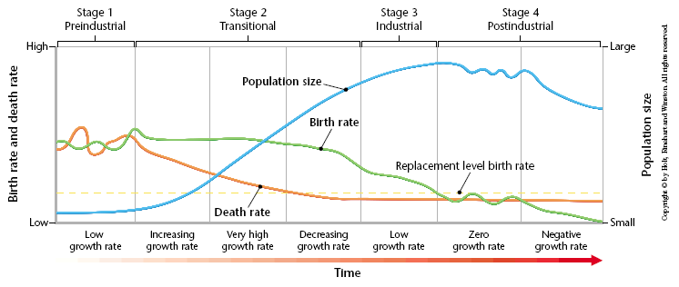
Age Structure Diagram

Description

Analysis Questions.

1. Discuss how immigration and emigration would impact an age structure diagram.

2. One concern about the Hawaiian Monk Seal, which is a highly endangered species, is that there are few “teenage” (8-15 year olds) females. Monk Seals have a life expectancy of 25-30 years, and the females reach reproduce age about 6 years old.

(a) Sketch the age structure diagram for the Hawaiian Monk Seal (focus on drawing the shape of the
diagram, rather than specific ages)

(b) Explain why this is a concern to biologists.

3. Some cultures have traditionally favored male children over female children (such as Indian and Chinese cultures). Why might it be advantageous to have male children rather than female children in these countries? What are the implications for future generations if this trend continues?

4. According to the theory of demographic transition, why do birth rates start to decline?

Images

