Topic 1.2 Systems and Models
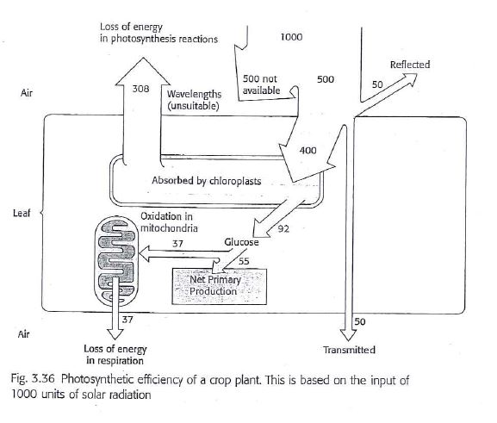
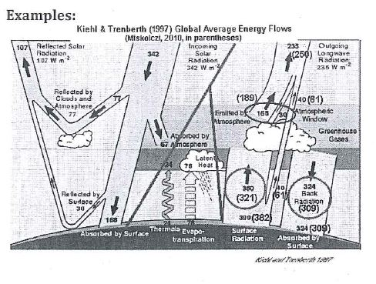
Energy Flow Diagrams Homework

The classical energy flow example

Silver Springs in central Florida is famous among ecologists as the place where Howard T. Odum researched energy flow in the ecosystem in the 1950s. Odum *1924-2002) was a pioneer ecologist working on ecological energetic. This was the first time an energy budget measurement was attempted when Odum measured primary productivity and losses by respiration. (Later, near the end of a long and illustrious career, he and David Scienceman developed the concept of emergy (embodied energy) which is a measure of the quality and type of energy and matter that go into making and organism). The figure below shows the energy flows and biomass stores measured by Odum at Silver Springs. Many different versions of this diagram have been produced. This simple community consists of algae and duckweed (producers); tadpoles, shrimps and insects larvae (herbivores); water beetles and frogs (first carnivores); small fish (top consumers); and bacteria, bivalves and snails (decomposers and detritivores). Dead leaves also fall into the water and spring water flows out, exporting some detritus.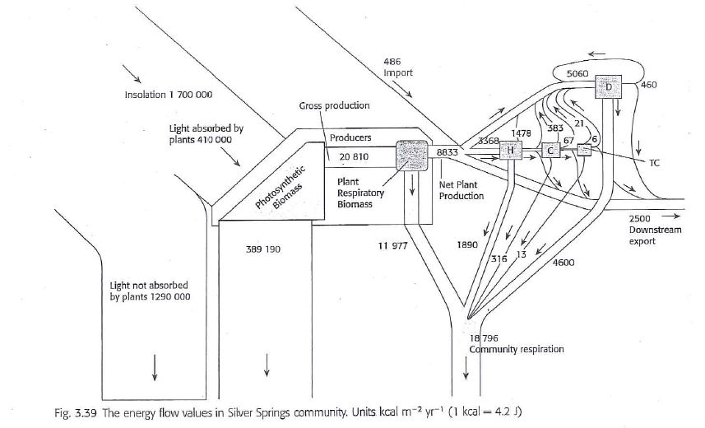

Questions
- Why does the width of the energy flow bands become progressively narrower as energy flows through the ecosystem?

- Suggest an explanation for the limit on the number of trophic levels to four or five at most in a community.

- How is the energy transferred between each trophic level?

- Insolation (light) striking leaves is 1 7000,000 units but only 410.000 are absorbed. What happens to the unabsorbed light energy?

- A further 389, 190 units escape from producers as heat. What is this?

- Account (mathematically for the difference between gross and net primary productivity.

- Draw a productivity pyramid from the data given.

- Would it be possible to draw a biomass pyramid from the data given?

- Does the model support the first law of thermodynamics? Show your calculations

