IB Biology Lab Potato Tissue

Analysis

Aim: Measure and graph changes in potato cores placed in salt solutions of different concentrations

INTRODUCTION
Since all life takes place in water—either external waters or internal waters—we must also address the special case of the movement of water across cell membranes in our study of diffusion. The diffusion of water through a selectively permeable membrane is referred to as osmosis. As with the diffusion of solutes, water moves from a region of higher concentration of water to a region of lower concentration of water. This is often also stated as movement from a region of higher water potential to a region of lower water potential. Distilled water (pure water) has the highest concentration of water or the highest water potential. The concentration of water decreases as solutes—like sugars and salts— are dissolved in the water.

Cells lose or gain water due to the difference in solute concentrations between the cytoplasm (the intracellular fluid) and the solution surrounding the cell (the extracellular fluid). The laws of diffusion govern the movement of water in and out of a cell: water flows from a region of higher water concentration to a region of lower concentration.

When a cell is in a hypertonic solution, it will experience a net loss of water. A hypertonic solution contains a higher concentration of solutes than the cell and therefore a lower concentration of water. Consequently, water will flow out of the cell from the region of higher water concentration to the region of lower concentration.

When a cell is in a hypotonic solution, it will experience a net gain of water. A hypotonic solution contains a lower concentration of solutes than the cell and therefore a higher concentration of water. Consequently, water will flow into the cell from the region of higher water concentration to the region of lower concentration.
When a cell is in an isotonic solution, it will experience either a net gain or loss of water. An isotonic solution contains an equal concentration of solutes as the cell and therefore an equal concentration of water. Consequently, water will flow equally into and out of the cell.

Plasmolysis is the shrinking of the cytoplasm of a plant cell in response to diffusion of water out of the cell and into a hypertonic solution surrounding the cell. During plasmolysis the cell membrane pulls away from the cell wall. In this lab exercise, you will examine this process by observing the effects of a highly concentrated salt solution on plant cells.

Skills: making sample cores
Preparing solution concentrations
Collecting data
Analyzing data to look for water potential.

PROCEDURE:
The date table for this lab has been designed for you. Copy it onto your document.

DAY ONE:
- Record all measurements under “Day 1” on the data table.
- Obtain 6 potato cores from your instructor.
- Using the knife, trim the skin from the ends of the cores so that each are approximately the same length, 30-40 mm. Identify the cores.
- Make and record observations of the cores.
- Measure the length, width, and height of each potato core to the nearest 0.1 mm (0.01cm) and record this on your data table.
- Calculate the volume of each core to the nearest 0.01 ml and record this on the table.
- Blot the cores dry and measure the mass of each using the balance. Record each core’s mass to the nearest 0.01 gram on the data table.
- Label the beakers 0.0M, 0.2M, 0.4M, 0.6M, 0.8M and 1.0M (include your group name) and place the correct core in each tube.
- To each beaker add enough solution to cover the core by at least 1 cm. Record the % solution in your data table.
- Cover the beakers and place the tubes aside as directed by your instructor.

PREDICTION: Make a prediction about what you think will happen to each of the cores.

DAY TWO:
- Record all measurements under “Day 2” on the data table.
- Retrieve your beakers. Remove the cores and gently blot them dry.
- Measure the length, width and height of each core. Record these measurements on the data table.
- Calculate the volume of each core and record on the data table.
- Measure the mass of each core and record this on the data table.
- Dispose of the cores in the trash, not the sink. Clean out the beakers and put them away as directed by the instructor.
- Calculate the “Change” in volume and mass for each core by subtracting “Day 1” from “Day 2”.
- Calculate the “% Change” by dividing the “Change” by “Day 1” (NOTE: Keep any calculations which are negative do not use the absolute value).
- Graph the % change in mass on one graph and the % change in the volume on a separate graph.
- Correctly label the Y (vertical) axis and the X (horizontal) axis of each graph.

Computer Tasks:
1) Hypothesis: which potato do you think will have higher water potential?

- Define your variables

- Prepare a suitable table for your results

- Plot the data using a scatter graph in excel (include a error bars for uncertainty and a trend line, and R2 value)

- Identify where the trend line crosses the x-axis (this will be the approximate molarity of the potato tissue.

- Using the table provided in the appendix, estimate the osmotic potential of the potato tissue

- Make a conclusion, and an evaluation based on your results.

Potato Core Lab Sample Data Collection
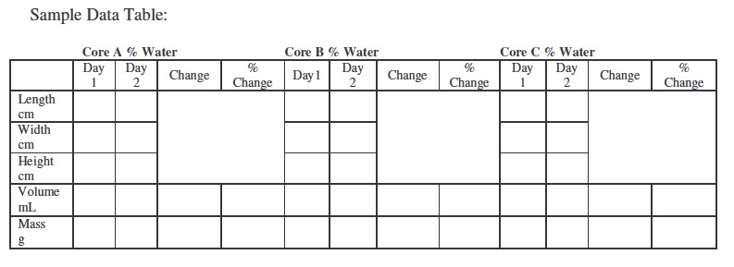

Molarity (mol dm) | Osmotic potential kPa
0.05 | -130
0.10 | -260
0.15 | -410
0.20 | -540
0.25 | -680
0.30 | -860
0.35 | -970
0.40 | -1120
0.45 | -1280
0.50 | -1450
0.55 | -1620
0.60 | -1800
0.65 | -1980
0.70 | -2180
0.75 | -2370
0.80 | -2580
0.85 | -2790
0.90 | -3000
0.95 | -3250
1.00 | -3500

Table4.1 Relationship between molarity and osmotic potential of sucrose solution

How to draw a scatter graph in excel (brief notes)
- Prepare your table, according to the IA student guide
- Select the data that you wish to plot (you can select discrete columns using the control and command keys together)
- Go to insert scatter graph, with markers
- If excel has plotted your x axis as a series, you will need to adjust this by clicking on your graph using control click (on the graph), and then select data.
- You can remove the unwanted series (it will usually be series one), and then select it as an x-axis label.
- You should use the chart layout tab to edit the title, axes labels, gridlines (choose major and minor), and error bars.
- You should also add trend line, choose linear, and in option find R2 value (display it). The closer that is to 1, the better is your line of fit and the more meaningful is the relationship shown.
- For error bars we may use uncertainty (for individual data readings), or standard deviation (if we are plotting means which represent sets of data)
- Prepare an error bar column, insert error bars, custom, specify value, and then highlight your error bar column in your table twice (for positive and negative)
- If x-axis bars are produced, delete them.
Analysis Rubric

This criterion assesses the extent to which the student’s report provides evidence that the student has selected, recorded, processed and interpreted the data in ways that are relevant to the research question and can support a conclusion.

- If your error bars are too small, they may not show up (ie if you have a small uncertainty relative to your data)

