Impacts of Pollution on Biota
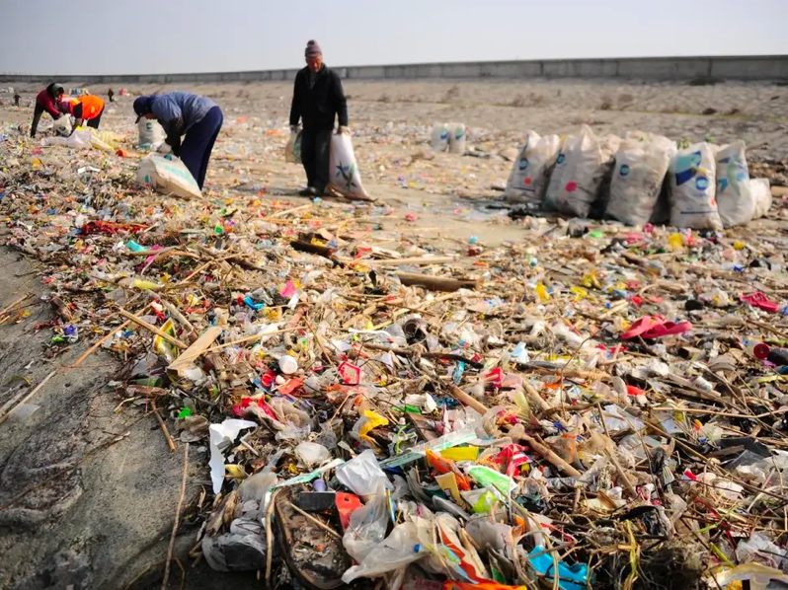
Pollution is an ever-present factor in our lives. Pollution is all around us and takes many forms. One of the questions that environmental scientists are commonly facing is exactly to what extent does pollution impact living things. In this activity you are to design an investigation that looks at the effects of one type of pollution on living things.
https://www.independent.co.uk/environment/plastic-pollution-china-sea-waste-rivers-yangtze-pearl-environment-a9176286.html
You will be assessed on the CONTEXT and PLANNING aspects of the IB ESS IA rubric. Please feel free to use all resources available to you in the lab and the science department.

IDENTIFYING THE CONTEXT

Achievement level | Descriptor
0 | The student does not reach the standard of any of the descriptors given below
1 - 2 | states a research question, but there is a lack of focus
 | outlines an environmental issue (either local or global) that is linked to the research question
 | lists connections between the environmental issue (either local or global) and the research question but there are significant omissions.
3 - 4 | states a relevant research question
 | outlines an environmental issue (either local or global) that provides the context to the research question
 | describes connections between the environmental issue (either local or global) and the research question, but there are omissions
5 - 6 | states a relevant, coherent and focused research question
 | discusses a relevant environmental issue (either local or global) that provides the context for the research question
 | explains the connections between the environmental issue (either local or global) and the research question

Checklist

Think of a problem you have encountered in your daily life which impacts the environment in some way
- something you have seen?
- something you have read about?
- something you feel strongly about>
Carry out some research on this issue
- you should have at least 4-5 different sources
- one of the sources should contain statistics that help quantify the issue
- did you expain everything your reader would need to know before ding the lab?
- Did you expain the science behind the lab? The Why and HOW of it working?
- Did you cite your sources (in-text and work cited)?
- Did you expain how the science is connected to your lab/research idea?
Now you have a clear background to your issue it is time to consider how you will investigate the problem
- experiment in the lab?
- survey?
- analysis of data from a database?
- sampling?
Time to state your research question
- is it clear and concise?
- Is it testable
- Does it contain both independend and dependt variables
- Is it focused and coear (do people know exactly what yu are trying to do withut questions)?
- Are the variables quantifiable?
- is it obvious how it links back to your environmental issue?
Environmental Issue
- Did you identify an environmental issue in relation to your RQ? (Should be done first)
- Did you discuss the environmental issue in the context of your Research Question? (A range of arguments within the focus of the issue)
- Did you explain how the issue is connected to your research question?
- Does your background information provide sufficeient information about the environmental context?
Local and/or Global Connections
- Did you provide the reader with an understanding of how the RQ and issue are connected to a local and or global environmental issue?
- Did you clearly explain how these connections are relevant to your RQ?
- Did you provide enough background information for the reader to understand these connections?

Time to start writing
- introduce your topic by explaining why you chose it
- describe your issue citing your sources to help explain why it is important (worthy of investigation!)
- use statistics to illustrate why your problem is relevant
- link the issue back to your research question – how are the two connected?
- Briefly describe how you will answer your research question and how the answers will help towards a solution for your issue

PLANNING

Achievement level | Descriptor
0 | The student does not reach the standard of any of the descriptors given below
1 -2 | designs a method that is inappropriate because it will not allow for the collection of relevant data
 | outlines the choice of sampling strategy but with some errors and omissions
 | lists some risks and ethical considerations where applicable
3-4 | designs a repeatable* method appropriate to the research question that allows for the collection of sufficient relevant data
 | describes the choice of sampling strategy
 | outlines the risk assessment and ethical considerations where applicable
5 - 6 | designs a repeatable* method appropriate to the research question that allows for the collection of sufficient relevant data
 | justifies the choice of sampling strategy used
 | describes the risk assessment and ethical considerations where applicable

Checklist

Independent variable
- clearly state the independent variable (IV)
- state the units and range of your IV
- a minimum of 5 increments if it is a continuous variable
- explain how you will change the IV
- How many repeats will you do (if an experiment)?
Dependent variable
- dependent variable (DV) is stated
- units of DV are clear
- Any calculations you will carry out are described (and why they are necessary for your analysis)
Controlled and uncontrolled variable
- List all relevant control variables that would affect the outcome of your data and used in your experiment.
- presented these in three seperate tables
- explain how you will control your variables (what method/equipment you will use to keep it the same)?
- explain how you will monitor your uncontrolled variables (state the equipment you will use to monitor them)?
Hypothesis (if applicable)
- Does your hypothesis contain reserached scientific reasoning (not simply prior knowledge)
- Does your hypothesis clearly state what you expect to happen to your dependent variable when the independent is changed? What do you expect your graph to look like (if possible)
- Is your hypothesis testable? Meaning can you acgtually determine if it is true
Materials and methods
- List (bulleted) all the materials you will use (incuding sizes/concentrations/quantities/uncertainties etc)
- All equipment useds the proper scientific names (if you don’t know look it up)
- Contains pictures if necessary
- method written in third person passive (not I did/we will/he said etc.)
- enough detail in the method for the reader to replicate the data collection anywhere in the world
- describe why you chose this method – what makes it ideal for answering the research question?
- If needed, sectioned to make it easier to read
- If needed, pictures to make it more understandable
- Is it clear and logical
- Uses command terms (oi.e. pour), not
“then“ statements
- Did you take repetitions intou account
- Did you make sure to mention and keep track of control variables
- Did you mention how and when to change your independent variables
- Did you mention when and how to collec data
- Did you write how to process your data
- Did you justify your method
- Did you indicagte why you choose to collct data the way you did
- How did you verify that the data is radom and unbiased (specifically in survey data)
- Did you indicate how you made sure th collect sufficient and relevant data
Risk assessment and ethical considerations
- Safety concerns listed with precautions that will be taken including procedure for working safely with hazardous materials
- Specific instructions for disposing of hazardous waste given if relevant
- Refers to the animal experimentation policy if an experiment or data privacy if a survey
- Environmental issues explained with methods for overcoming them
- Did you state how to remove or what to do about minimizing those concerns.

