**Precision**

**PURPOSE:**

To learn how to measure according to the IB standards.

**HOW MANY DIGITS DO I INCLUDE?**

* **Unless there is a digital display, always measure to one spot beyond the smallest unit of CERTAIN measurement of the tool.**
* For example, if you use a ruler that can accurately measure to the tenth of a centimeter, your measurement would be to the hundredth of a centimeter.

This line would be measured as 4.50 cm

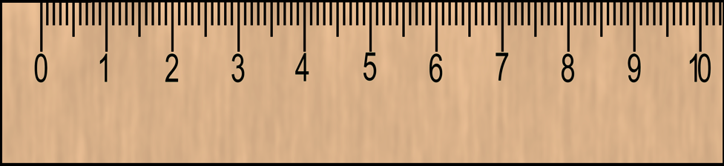

**WHAT’S THE UNCERTAINTY?**

* **Every measurement has an uncertainty** associated with it, unless it is an exact, counted integer, such as the number of trials performed.
* The lower the accuracy and precision of a measurement instrument are, the larger the measurement uncertainty is.
* The numerical value of a **± uncertainty value tells you the range of the result**. For example a result reported as 1.23 ± 0.05 means that the experimenter has some degree of confidence that the true value falls in between 1.18 and 1.28
* **To determine uncertainty:**
  + **Find the smallest increment of measurement on your measurement device**
  + **Divide it by two**

This line would be measured as 4.50 cm

+/- 0.05cm

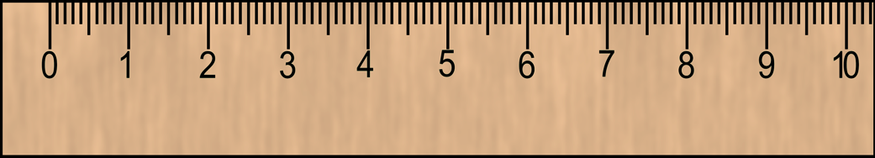

**CONVERSIONS**

We’ll always and only use metric measurements in class. You should be familiar with the following metric prefixes and be able to convert between them:

|  |  |  |  |  |  |  |  |
| --- | --- | --- | --- | --- | --- | --- | --- |
| **Kilo-** | **Hecto-** | **Deka-** | **BASE UNIT** | **Deci-** | **Centi-** | **Milli-** | **Micro-** |
| k | h | da | -- | d | c | m | µ (mu) |
| 103 | 102 | 10 | -- | 10-1 | 10-2 | 10-3 | 10-6 |
| 1000 | 100 | 10 | -- | 0.1 | 0.01 | 0.001 | 0.000001 |