Size Matters
Calculating Surface Area to Volume Rations
Name
Key Concept Questions:
- Fill out the table below by calculating surface area, volume, and surface area to volume ratio (SVR) for each of the cubes.

Cube | Surface Area | Volume | SVR
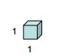
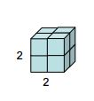
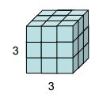
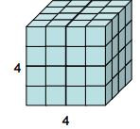

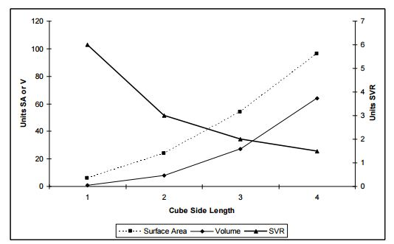
- Describe the relationships between surface area, volume, and SVR (y-axis) to increasing cube size (x-axis) in a graph and in a few sentences

- a. Animals can be thought of as simple three-dimensional shapes. Suppose a black-tailed prairie dog is represented as a rectangular prism with units 2x1x1 (length x width x height) and an American bison is represented as a rectangular prism with units 24x6x14. Fill out the table below by calculating surface area, volume, and SVR for the bison and prairie dog.
Cube | Surface Area | Volume | SVR
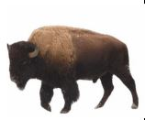

3b. Mammals maintain a relatively constant body temperature. This is an energy intensive task especially in the winter, when animals lose heat to the cold air. Because animals lose heat proportional to their surface areas…. [etc. do problem here; determine heat loss per unit volume (size, assuming volume is proportional to mass) – total heat loss (joules) is larger in the bison but heat loss/gram is much higher in the prairie dog]
- Why are mittens warmer than gloves?

- Why do muffins cook faster than bread, made from the same batter?

- Small animals lose heat faster, for their size, than large animals. Partly because of this, small animals have to eat more for their size than large animals. This shows how much a vole and a rhino have to eat in a week compared to their body size:
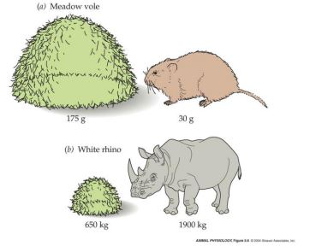

How much animals have to eat depends on how fast they are using up energy— their metabolic rate. Here is the equation for figuring out an animal’s total metabolic rate (not the metabolic rate per gram):
M=Wb
where M= total metabolic rate, W= mass of the animal in grams, and b= 0.75 for all groups of animals.
A mouse weighs 20g and a small elephant weighs 2,000,000g

a) If b were 1, then M=W. Plot the mouse and the elephant on a graph with size on the x axis and total metabolic rate on the y axis. Based on this value for b, an elephant’s metabolic rate would be _________ times higher than a mouse’s.
b) Actually, from looking at data from real animals, scientists have noticed that the points don’t fall on that ―b=1‖ line. Instead they seem to follow M=Wb where b isn’t 1, but instead is 0.75. Using this new value for b, calculate the metabolic rate for the real mouse and elephant and plot them on your graph. Based on your calculations: an elephant’s metabolic rate is _________ times higher than a mouse’s.

4. Mammals have extraordinarily high metabolic rates, so they need a lot of surface area to provide oxygen and void carbon dioxide (reactants and products of aerobic respiration). To provide this surface area, lungs branch many times, like a tree, and end in little sacs called alveoli, where oxygen and carbon dioxide are exchanged between the air and blood. If the lungs did not branch at all, there would be one alveolus. If they branched once, there would be two alveoli.
a) How many alveoli would there be if the lungs branches twice?
b) What if the lungs branched 8 times? 2
c) What if—as is actually the case— the lungs branched 29 times? [Please don’t expand your answer—leave it as an exponent.]

5. Amphibians are able to breathe across their skin as well as in their lungs. During the mating season, male Hairy Frogs grow filamentous projections on their legs and sides. What could be the purpose of these projections? Why would a male need these projections during the breeding season and not throughout the year (keep in mind the throat pouches of frogs are some of the most energy demanding tissues of the animal world)?

