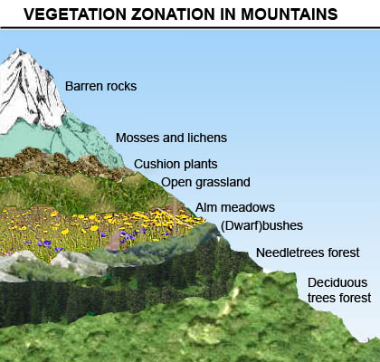 | 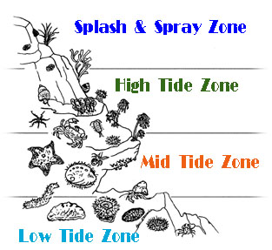 |  |  | 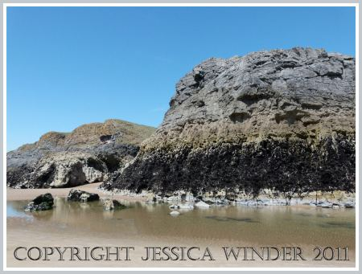 |  | 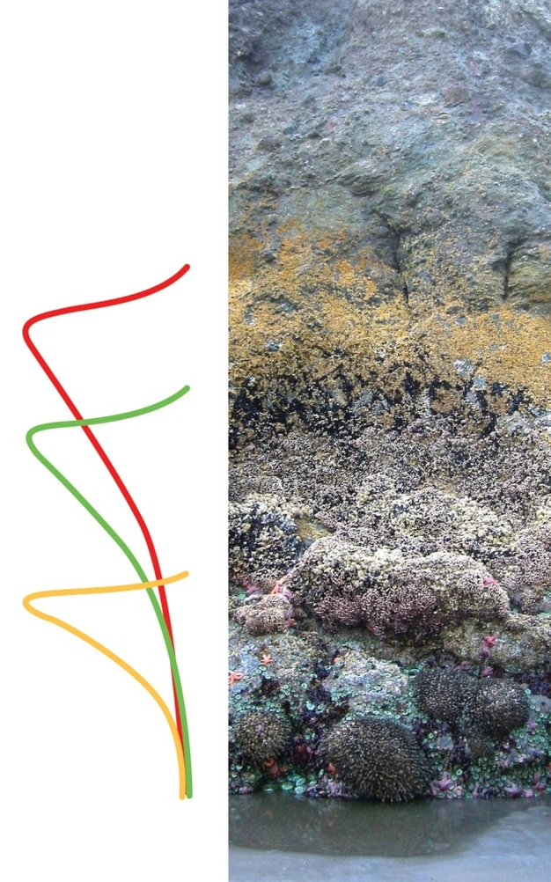
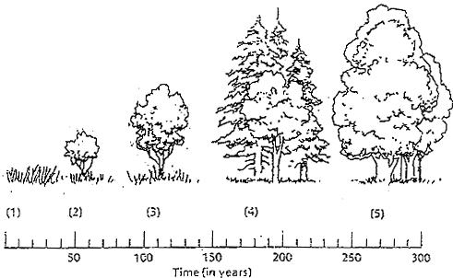 |  |  | 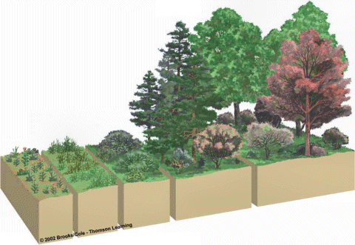 | 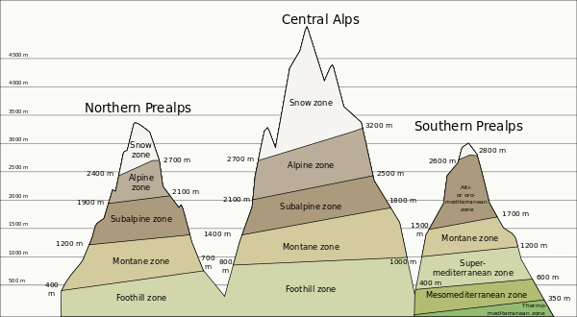
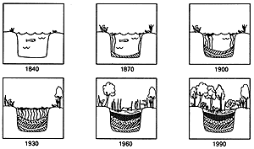 |  | 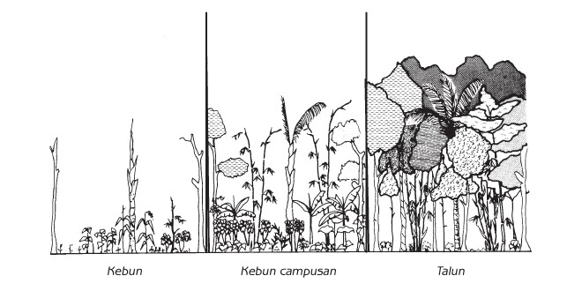 |  |  | 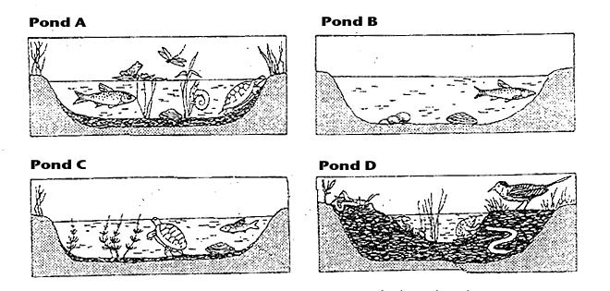 | Zonation
 |  |  |  |  |  | Succession

Pioneer Community | Intermediate Community | Climax Community
Organisms are quite small  (lichens, grasses, etc) | Medium sized organisms  (tall grasses, bushes, small trees) | Large organisms  (big trees)
Simple food chains & food webs | More complex food chains & food webs | Complex food chains & food webs
Very little top soil | Some top soil | Lots of top soil
Very little water holding capacity | Some water holding capacity | High water holding capacity
Very little minerals deposited | Little minerals deposited | Lots of minerals deposited
Very little nutrient cycling | Some nutrient cycling | Lots of nutrient cycling
Few niches & habitats so low biodiversity | Diverse niches & habitats so high biodiversity | Stable habitats so fewer niches so decrease in biodiversity  Biodiversity stabilizes
Few producers so low GPP  Low respiration  High NPP | More producers, consumers, etc. so higher GPP  Higher Respiration  Low NPP | High GPP (but mature trees, produce less)  High respiration (esp. decomposers)  Low NPP

