Tropical Rainforest Case Study: Papua New Guinea
Vocabulary
Conservation: to manage the environment in such a way that it will be protected from change.
Exploitation: when the environment is used in such a way that it is destroyed and will be of no use to future generations.
Sustainable development: the development of an area using techniques and approaches that will help to protect the environment for the future.
Location of the case study

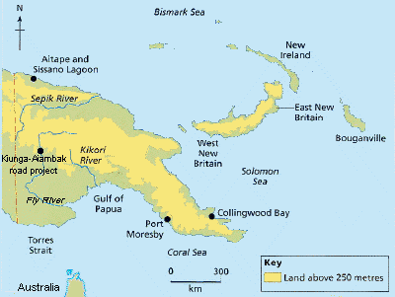
Source: 'Tomorrow's Geography', Harcourt and Warren, Ed. Warn, Hodder & Stoughton
Rainforest Exploitation
Papua New Guinea (PNG) possesses one of the planet's largest remaining tropical rainforest. At least seventy-five percent of its original forest cover is still standing, occupying vast, biologically rich tracts over 100,000 square miles in all. Its forests provide the habitat for about 200 species of mammals, 20,000 species of plants, 1,500 species of trees and 750 species of birds, half of which are endemic to the island. It has been estimated that between 5 and 7% of the known species in the world live in PNG. Rare plants and animals like the largest orchid, the largest butterfly, the longest lizard, the largest pigeon and the smallest parrot ever registered live in these forests.

The forests also constitute the home of the indigenous peoples, the Maisin. For the Maisin, forests provide everything from food and medicinal plants, to materials for houses, canoes and tools. Under the Papua New Guinea constitution, the Maisin are the legal owners of their traditional lands. But these forests and forest peoples are under threat due to large-scale logging activities and oil palm plantations. Oil palm plantations are not aimed at the production of edible oil for the local population and almost the entire production is export-oriented.

Resource Exploited
- Timber extraction e.g. Kiunga-Aiambak road project located in previously intact rainforests in Papua New Guinea’s remote Western Province.
- Oil palm plantation at Aitape
- Prawn and sea fishing industry destroyed in Sissano Lagoon through use of fertilisers and pesticides
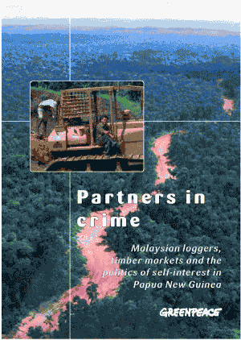
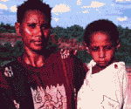
"Our bush was really green and healthy [before the company came] – nowadays it is black. The company came and spoilt our environment here. The animals are now far away – before the company came in those animals were close."
Baida Bamesa, women’s representative from Middle Fly region, Kiunga-Aiambak area
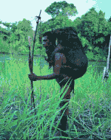

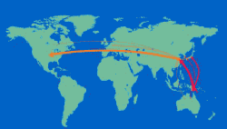
"The people were tricked … the road has brought no real and good changes. Life has worsened. In the past animals and food were plentiful. Now they have decreased dramatically, and the water is very dirty."

The main markets for Papua New Guinea logs are China and Hong Kong, followed by Japan and Korea. China has a rapidly growing export market for cheap furniture to the USA, Hong Kong, Japan and the EU.

Problems Created
- Soil erosion
- Loss of biodiversity
- Diseases spread amongst indigenous Maisin population through contact with the timber cutters
- Increase in viral diseases and malaria, because of the ecological changes deforestation causes
- Loss of game animals
- Loss of clean water supply through sedimentation
- Sedimentation and Eutrophication caused through soil erosion (after forest clearance) and use of fertilisers would kill the nearby coral reef in Sissano Lagoon
Groups For
- PNG Government: who sold logging rights and helped finance the project
- Transnationals and their shareholders: Malaysian company bought logging rights
- Consumers in MEDCs who want cheap plywood and furniture
- Indigenous population who obtain work with the logging company
- PNG Government: offers tax incentives in the oil palm sector designed to encourage growth and boost production
- Transnational oil palm companies and their shareholders
- Plantation workers have jobs
- Fertiliser and pesticide company have more sales

Groups Against
- Landowners: not consulted and paid very little in compensation for the loss of their cocoa smallholdings.
- Environmental groups: e.g. Greenpeace
- Australian Government: Australia lies too close to Papua New Guinea to be isolated from its social problems
- Indigenous population who object to the logging companies illegally taking over their land and the cultural, social and financial problems that followed
- Indigenous people who claim legal rights to the land seized from them
- Local fishermen who would lose their livelihoods
- Tour companies and workers: the coral reef attracts tourists and divers
- Tourists who prefer to see unspoilt coral reefs

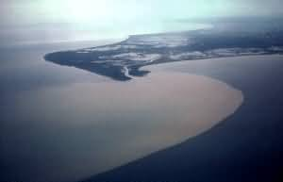
Sissano Lagoon: coral reef and fishing industry threatened by sedimentation after forest clearance
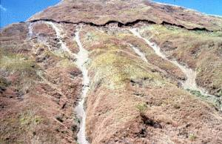
Ease of access resulting from the incursion of a logging road has resulted in the complete loss of forest cover and subsequent soil erosion
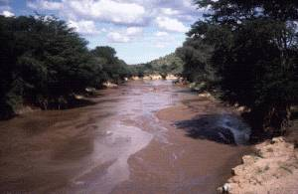
The effects of forest clearance on water quality

Sustainable Development and Forest Conservation

Funded by the Chevron Oil company and Greenpeace and agreed by the PNG government after being taken to court by the Maisin people. The PNG government has been under pressure from the World Bank and International Monetary Fund (IMF), and the Australian Government to enforce environmentally-friendly changes in their development programme. Awareness patrols to remote areas by local environmental charity groups have been spreading the message of what exploitative logging will do to rural communities. The recent screening on PNG television station EMTV of the Rainforest Information Centre's documentary Mama Bilong Olgeta on the PNG logging industry was a great success.

"The Papua New Guinea government has decided to exclude Maisin customary lands, located in Collingwood Bay from plans for timber or large scale agricultural development. Greenpeace and others have been active in the area in developing small scale alternative community development schemes. Despite numerous community attempts to have their land removed from large scale industrial development consideration, a number of schemes were proposed. This action should give the community the room they need to regulate their own development potential in a sustainable, community owned manner."
PNG Government Press Conference statement following the Maisin court case

Sustainable Development Techniques Employed
- Community-based sustainable forestry
- Training in sustainable forestry
- Fish farming
- Butterfly farming
- Eco-tourism
- Managed conserved areas
- Cottage industries: nut harvesting, tourist souvenir and tapa cloth production
- Greenpeace active in developing Maisin cloth and art markets in the USA
- Local log-processing industries are being established. Processed timber is worth much more on the world market
- Small logging operations are encouraged, owned by many different companies, who all have certified sustainable management certificates
Problems Encountered
- High levels of illiteracy and lack of skills create difficulties in dealing with tourists
- Rivalries between different tribal clans makes team work difficult
- Government difficulties in controlling the activities of the multinational logging companies
- Coconut oil powers island's cars
- For years, the people of the island of Bougainville in Papua New Guinea have been dependent on expensive fuel imported onto the island. Shortages have often caused many businesses in this part of Papua New Guinea to grind to a halt. High energy costs have not helped either.
- Increasingly, locals are turning to a cheaper and far more sustainable alternative to diesel. Coconut oil is being produced at a growing number of backyard refineries.
More information for this case study can be found in 'Tomorrow's Geography', Harcourt and Warren, Ed. Warn, Hodder & Stoughton www.hodderheadline.co.uk

Attitudes of the people affected:
When the company came in they sort of disturbed village activities, so many youths went to Aiambak to seek employment with the company and some even became spectators on the project because there was no space for employment. We became spectators on our own land.
Robert Polus, PNG
(Previously public relations officer with Paiso landowner company subsidiary)

After the bush was destroyed, landowners raised their complaints but 6 policemen came with guns. Villagers fled into the bush in fear of losing their lives. Police threatened to shoot both men and women to protect company’s operation on their land.
Kitai
Woman from Aewa village, PNG

They were doing logging where so much destruction was done with trucks making feeder roads. There was destruction like trees cut down unnecessarily, small trees and vegetation cleaned up, eventually leaving the land barren and then having grasses growing instead of trees. In places the water sources became dry and people had to go so far away to look for water.
Arnold Kombo
Community leader
Nangumarum, East Sepik Province, PNG

Conditions for workers were very hard. Some were blinded, the sawdust went into their eyes, some were hit by fallen branches because there were no helmets issued. There was no compensation paid, even some were killed during that time, but there was no compensation paid. We told the company but they gave some kind of excuses. They made some kind of form, before we went in we signed it. It was a promise that if something happened to me this week, I shouldn’t be paid.
Charles Dambara
Clan Chief of Aewa village, PNG
(Former employee of Concord Pacific 1997-1998)

Nobody cares about this place, we are forgotten people here and government has not given us any services. Before people said they could see fish in the water, they comb their hair by seeing themselves in the water. Now you can see the water is really muddy and when people go to the sago place there is no clean water, so they drink water there and get sick, they get gastric pain, blood, these people are very, very sick.
Sister Yatamara
Sister in charge of Baboa Health Centre, PNG

No to logging …
Greenpeace works with members of Melanesian communities that have said no to logging and instead embraced eco-forestry and other small scale local enterprises, like paper making.
“Generations of my people have said no to logging. We rely on many different bush materials and don’t want the logging to damage them. But we have now agreed to cut ecotimber.”
Simon Okai
Zongo clan chief

How I see it from our perspective is that eco-forestry is much better than logging. I prefer eco-forestry because it does not spoil our sea, land, rivers and water catchment.
Reedle Gebe
Lobi Village Eco-forestry Project
Solomon Islands

The sawmill project we have here is not for the sake of making business alone. We use this project as a vehicle to bring in revenue and we direct those funds into the community and building our villages. We’ve got to have good schools built up. We’ve got to have an improved housing system, health services and all the most basic services we need.
Arnold Kombo
Community leader
Nangumarum, East Sepik Province, PNG

We would not like to see the natural environment pass away. The future generations will never see it again. We would like to see the natural beauty to remain as it is today.
Arnold Kombo
Community leader
Nangumarum, East Sepik Province, PNG

The good thing about papermaking is that women, children and older people can work on it and equally benefit. The money we have earned is divided among the families. They have used it to buy basic needs like soap and exercise books for school.
Jerry Tekopo
A Tenggomo Chief
Solomon Islands

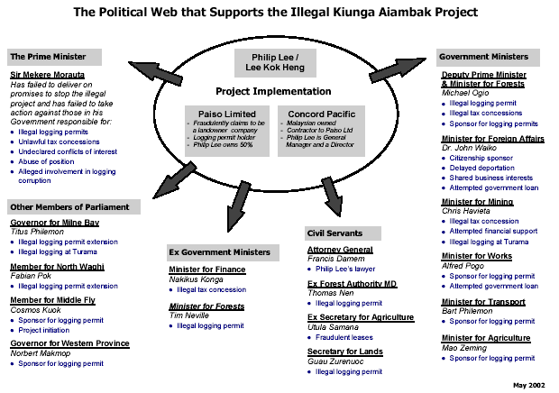
The map shows some of the key people who have been allegedly involved in advocating, facilitating and protecting the illegal Kiunga Aiambak timber project. The map also shows how these key individuals are allegedly linked to the project and it graphically illustrates both the breadth and the depth of the political network that supports the project.

Perhaps the central figure to the whole illegal project is Philip Lee, a Malaysian born businessman who has built an extensive political support network that protects him and his illegal operations from any semblance of outside control.

Prominent Ministers, Members of Parliament and senior civil servants of the Papua New Guinea government are all implicated in the network that ensures that the illegal Kiunga Aiambak project continues to deliver misery for local people and millions of dollars into the bank accounts of the fortunate few.

Further reading on the role of China in the destruction of the tropical forests of Southeast Asia including Papua New Guinea: Forests in Southeast Asia Fall to China

The Australian Orangutan Project is also maintaining updates to PNG Palm Oil Plantation Issues.

