Water (Hydrological) cycle diagram
Using the words on the worksheet label the water (hydrological) cycle diagram.
Highlight the storages and flows in different colours

Ocean Transport Evapotranspiration
Human management Infiltration Ice and Snow
Groundwater (aquifer) Lake Condensation
Surface run-off Percolation River Discharge
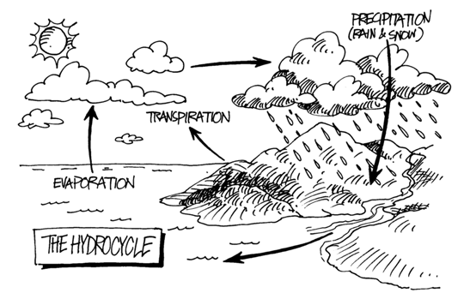
Evaporation Stream flow Precipitation

