Understandings, Applications and Skills (This is what you maybe assessed on)

Significant ideas
- The laws of thermodynamics govern the flow of energy in a system and the ability to do work
- Systems can exist in alternative stable states or as equilibria between which there are tipping points
- Destabilizing position feedback mechanisms will drive systems toward these tipping points, whereas stabilizing negative feedback mechanisms will resist such changes
Big questions
- What strengths and weaknesses of the systems approach and the use of models have been revealed through this topic
- How are the issues addressed in this topic of relevance to sustainability or sustainable development?
- The principle of conservation of energy can be modeled by the energy transformations along food chains and energy production systems: what are the strengths and limitations for such models?
- How do the delays involved in feedback loops make it difficult to predict tipping points and add to the complexity of modeling systems?
- Do the benefits of the models used to predict tipping points outweigh their limitations?
- How does sustainability reduce the change that tipping points will be reached?
 | Statement | Guidance
1.3.U1 | The first law of thermodynamics is the principle of conservation of energy, which states that energy in an isolated system can be transformed but cannot be created or destroyed | The use of examples in this sub-topic is particularly important so that the abstract concepts have a context in which to be understood
1.3.U2 | The principle of conservation of energy can be modelled by the energy transformations along food chains and energy production systems.
1.3.U3 | The second law of thermodynamics states that the entropy of a system increases over time. Entropy is a measure of the amount of disorder in a system. An increase in entropy arising from energy transformations reduces the energy available to do work.
1.3.U4 | The second law of thermodynamics explains the inefficiency and decrease in available energy along a food chain and energy generation systems.
1.3.U5 | As an open system, an ecosystem will normally exist in a stable equilibrium, either in a steady-state equilibrium or in one developing over time (for example, succession), and maintained by stabilizing negative feedback loops. | 1. A stable equilibrium is the condition of a system in which there is a tendency for it to return to the previous equilibrium following disturbance  ​2. A steady-state equilibrium is the condition of an open system in which there are not changes over the longer term, but in which there may be oscillations in the very short term
1.3.U6 | Negative feedback loops (stabilizing) occur when the output of a process inhibits or reverses the operation of the same process in such a way as to reduce change—it counteracts deviation.
1.3.U7 | Positive feedback loops (destabilizing) will tend to amplify changes and drive the system towards a tipping point where a new equilibrium is adopted.
1.3.U8 | The resilience of a system, ecological or social, refers to its tendency to avoid such tipping points and maintain stability | Emphasis should be placed on the relationships between resilience, stability, equilibria and diversity
1.3.U9 | Diversity and the size of storages within systems can contribute to their resilience and affect their speed of response to change (time lags). | Examples of human impacts and possible tipping points should be explored
1.3.U10 | Humans can affect the resilience of systems through reducing these storages and diversity | A tipping point is the minimum amount of change within a system that will destabilize it, causing it to reach a new equilibrium or stable state
1.2.U11 | The delays involved in feedback loops make it difficult to predict tipping points and add to the complexity of modelling systems. | A tipping point is the minimum amount of change within a system that will destabilize it, causing it to reach a new equilibrium or stable state
1.3.A1 | Explain the implications of the laws of thermodynamics to ecological systems.
1.3.A2 | Discuss the resilience in a variety of systems
1.3.A3 | Evaluate the possible consequences of tipping points

1.3.U1 The first law of thermodynamics is the principle of conservation of energy, which states that energy in an isolated system can be transformed but cannot be created or destroyed.
1.3.U2 The principle of conservation of energy can be modelled by the energy transformations along food chains and energy production systems.
1.3.A1 Explain the implications of the laws of thermodynamics to ecological systems.

  - Watch the video on Biological processes depend on energy flow through the Earth system. https://youtu.be/k6mX5uInCds

  - Define and explain the first law of thermodynamics by referring to the diagrams below
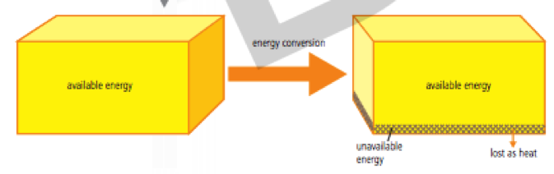

  - Using named examples explain the first law of thermodynamics in an ecosystem

- Identify the implications of the first law

- Identify how the 1st Law of Thermodynamics can be modelled by energy transfers
  - Along food chains

  - Along energy production systems

1.3.U3 The second law of thermodynamics explains the inefficiency and decrease in available energy along a food chain and energy generation systems.
1.3.U4 The second law of thermodynamics explains the inefficiency and decrease in available energy along a food chain and energy generation systems.
1.3.A1 Explain the implications of the laws of thermodynamics to ecological systems.

Watch https://www.youtube.com/watch?v=gS_C7dM25pc

- Using named examples explain the second law of thermodynamics

- With reference to entropy, state what happens to energy as it flows through a food chain.

- Describe the relationship between entropy and the Second Law of Thermodynamics. How is this energy lost? State the rule of thumb for energy loss through an ecosystem

- Identify the implications of the second law

- Deduce why it is more efficient to eat plants than animals

- Suggest why food chains usually only have four or five links.

1.3.U5 As an open system, an ecosystem will normally exist in a stable equilibrium, either in a steady-state equilibrium or in one developing over time (for example, succession), and maintained by stabilizing negative feedback loops.
1.3.U6 Negative feedback loops (stabilizing) occur when the output of a process inhibits or reverses the operation of the same process in such a way as to reduce change—it counteracts deviation.
1.3.U7 Positive feedback loops (destabilizing) will tend to amplify changes and drive the system towards a tipping point where a new equilibrium is adopted.

- Using a named example explain the two different types of equilibrium

- Annotate the graphs below to show the different types of equilibria

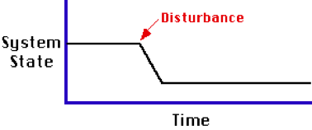
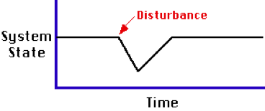

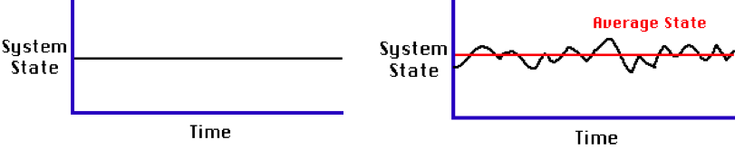

Negative feedback can be defined as feedback that counteracts any change away from equilibrium, contributing to stability. Negative feedback is a method of control that regulates itself. An ecosystem, for example, normally exists in a stable equilibrium, either a steady-state equilibrium or one developing over time (e.g. succession) because it is maintained by stabilizing negative feedback loops. Negative feedback mechanisms are stabilizing forces within ecosystems as they can counteract deviation

Before you begin this section watch the Ted Video on Feedback Loops https://www.youtube.com/watch?v=inVZoI1AkC8

- Using a named example explain negative feedback loop. Draw an example of a negative feedback loop

Positive feedback occurs when a change in the state of a system leads to additional and increased change. Thus, an increase in the size of one or more of the system’s outputs feeds back into the system and results in self-sustained change that alters the state of a system away from its original equilibrium towards instability

- Using a named example explain positive feedback loop. Draw an example of a positive feedback loop

- Here are a number of examples of how both positive and negative feedback mechanisms might operate in the physical environment. No one can be sure which of these effects is likely to be most influential, and consequently we cannot know whether or not the Earth will manage to regulate its temperature, despite human interference with many natural process

  - Label each example as either positive or negative feedback

As carbon dioxide levels in the atmosphere rise the temperature of the Earth rises. | As the Earth warms the rate of photosynthesis in plants increases, more carbon dioxide is therefore removed from the atmosphere by plants, reducing the greenhouse effect and reducing global temperatures.
As the Earth warms: | Ice cover melts, exposing soil or water. Albedo decreases (albedo is fraction of light that is reflected by a body or surface). More energy is absorbed by Earth’s surface. Global Temperature rises. More ice melts.
As the Earth warms, upper layers of permafrost melt, producing waterlogged soil above frozen ground. | Methane gas is released in an anoxic environment. The greenhouse effect is enhanced. Earth warms, melting more permafrost.
As Earth warms, increased evaporation produces more clouds. | Clouds increase albedo, reflecting more light away from Earth. Temperature falls. Rates of evaporation fall.
As Earth warms, organic matter in soil is decomposed faster: | More carbon dioxide is released. Enhanced greenhouse effect occurs. Earth warms further. Rates of decomposition increase.
As Earth warms, evaporation increases: Snowfall at high latitudes increases. | Icecaps enlarge. More energy is reflected by increased albedo of ice cover. Earth cools. Rates of evaporation fall.
As Earth warms, polar icecaps melt releasing large numbers of icebergs into oceans. | Warm ocean currents such as Gulf Stream are disrupted by additional freshwater input into ocean. Reduced transfer of energy to poles reduces temperature at high latitudes. Ice sheets reform and icebergs retreat. Warm currents are re-established.

Predator-prey interactions and negative feedback
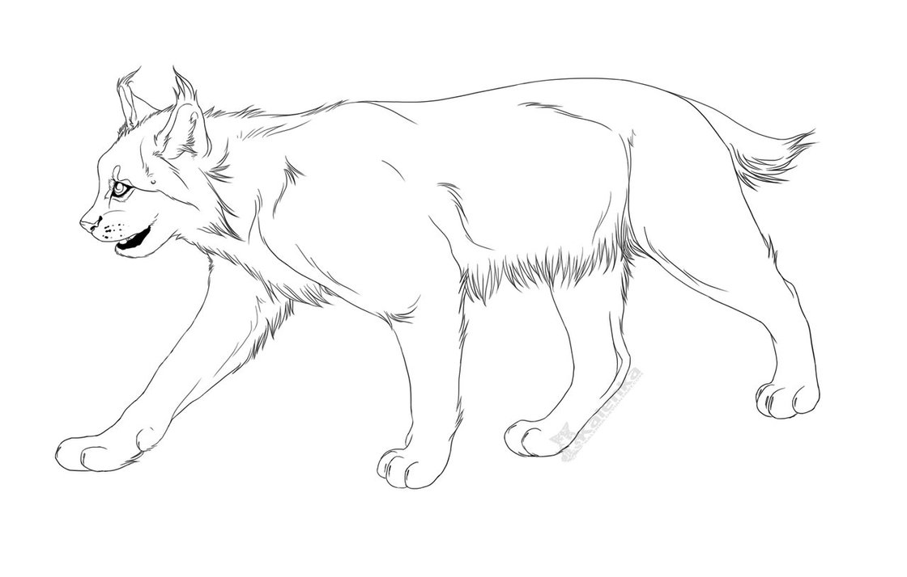
The Hudson Bay Trading Company in Northern Canada kept very careful records of pelts (skins) brought in and sold by hunters over almost a century. This is a classic set of data and shows this relationship because the hare is the only prey of the lynx and the lynx its only predator. Usually things are more complicated. We have to assume that the numbers of animals trapped were small compared to the total populations and that the numbers trapped were roughly proportional to total population numbers. Also assumed is the prey always has enough food so it does not starve. Given that, the cycles are remarkably constant with the lynx populations always smaller than and lagging behind the hare ones.

Use the graph to answer the following questions

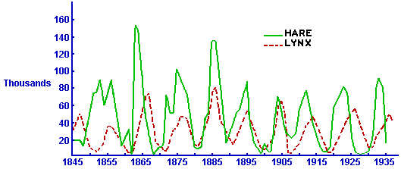
  - On average, what was the cycle length of the lynx population?

  - On average, what was the cycle length of the hare population?

  - Why do lynx numbers lag behind hare numbers?

  - Why are lynx numbers smaller than hare numbers?

  - Things are never as straightforward in ecology as we expect though. In regions where lynx died out, hare populations still continued to fluctuate. Why do you think this was?

1.3.U8 The resilience of a system, ecological or social, refers to its tendency to avoid such tipping points and maintain stability
1.3.U9 Diversity and the size of storages within systems can contribute to their resilience and affect their speed of response to change (time lags).
1.3.U10 Humans can affect the resilience of systems through reducing these storages and diversity
1.3.U11 The delays involved in feedback loops make it difficult to predict tipping points and add to the complexity of modelling system
1.3.A2 Discuss the resilience in a variety of systems
1.3. A3 Evaluate the possible consequences of tipping points

The use of energy in one part of the globe may lead to a tipping point or time lag that influences the entire planet’s ecological equilibrium.
- Using two named ecological disturbances explain resilience

The costs of tipping points, both from environmental and economic perspectives, could be severe, so accurate predictions are critical. Models that predict tipping points are, therefore, essential and have alerted scientists to potential large events. Continued monitoring, research, and modelling is required to improve predictions.
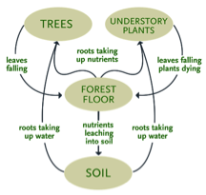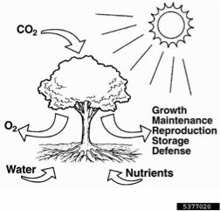
- Discuss the relative size of storages in these two system diagrams

- Describe how named storage contributes to resilience of the system shown above

- Using a named example explain how humans affect resilience

- Using two named examples explain “Tipping Element”.

- After watching the video on the Apo Island Marine Sanctuary https://www.youtube.com/watch?v=v8oNhckPjFM&feature=youtu.be, complete the flow chart

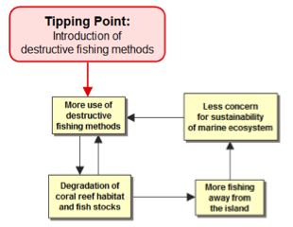

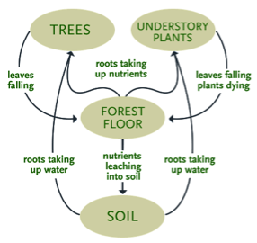
- Other than eating maple syrup, outline how humans may have a negative impact on the resilience of the forest system shown

- Outline ways people may have a positive impact on the diversity of the forest ecosystem

- With reference to one of the 6 positive climate feedback loops shown, identify two delays in the feedback loop

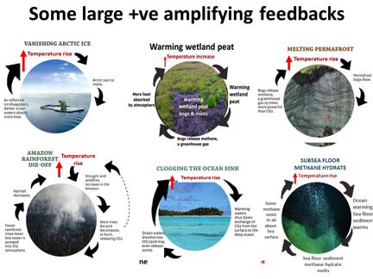

- Complete the reading on tipping points and resilience
The resilience of a system, ecological or social, refers to its tendency to avoid tipping points, and maintain stability through steady-state equilibrium. Diversity and the size of storages within systems can contribute to their resilience and affect the speed of response to change. Large storages, or high diversity, will mean that a system is less likely to reach a tipping point and move to a new equilibrium.

Humans can affect the resilience of systems through reducing these storages and diversity. Tropical rainforests, for example, have high diversity (i.e. a large number and proportions of species present) but catastrophic disturbance through logging (i.e. rapid removal of tree biomass storages) or fires can lower its resilience and can mean it takes a long time to recover. Natural grasslands, in contrast, have low diversity but are very resilient, because a lot of nutrients are stored below ground in root systems, so after fire they can recover quickly

Complex ecosystems such as rainforests have complex food webs which allow animals and plants many ways to respond to disturbance of the ecosystem and thus maintain stability. They also contain long-lived species and dormant seeds and seedlings that promote steady-state equilibrium. Rainforests have thin, low-nutrient soils, however, and although storage of biomass in trees is high, nutrient storage in soils is low. Nutrients are locked-up in decomposing plant matter on the surface and in rapidly growing plants within the forest, so when the forest is disturbed, nutrients are quickly lost (e.g. leaf layer and topsoil can be washed away). Ecosystems with higher resilience have nutrient-rich soils which can promote new growth.

A tipping point is a critical threshold when even a small change can have dramatic effects and cause a disproportionately large response in the overall system. Positive feedback loops are destabilizing and tend to amplify changes and drive the system towards a tipping point where a new equilibrium is adopted Most projected tipping points are linked to climate change, and represent points beyond which irreversible change or damage occurs. Increases in CO₂ levels above a certain value (450 ppm) would lead to increased global mean temperature, causing melting of the ice sheets and permafrost. Reaching such a tipping would, for example, cause long-term damage to societies, the melting of Himalayan mountain glaciers, and a lack of freshwater in many Asian societies.

If external conditions in the environment, such as nutrient input or temperature, change gradually, then ecosystem state may respond gradually, in which case there are no tipping points involved (shown in graph a). In other cases, there may be little response below a certain threshold, but fast changes in the system can occur once the threshold is reached even though a small change in environmental conditions has occurred – in such cases, a tipping point has been reached (shown in graph b).

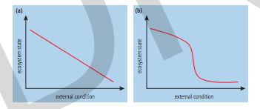

The resilience of a system, ecological or social, refers to its tendency to avoid tipping points, and maintain stability through steady-state equilibrium. Diversity and the size of storages within systems can contribute to their resilience and affect the speed of response to change. Large storages, or high diversity, will mean that a system is less likely to reach a tipping point and move to a new equilibrium.

Humans can affect the resilience of systems through reducing these storages and diversity. Tropical rainforests, for example, have high diversity (i.e. a large number and proportions of species present) but catastrophic disturbance through logging (i.e. rapid removal of tree biomass storages) or fires can lower its resilience and can mean it takes a long time to recover. Natural grasslands, in contrast, have low diversity but are very resilient, because a lot of nutrients are stored below ground in root systems, so after fi re they can recover quickly (case study

Models are used to predict tipping points and, as you have already seen, such models have strengths and limitations. The delays involved in feedback loops make it difficult to predict tipping points and add to the difficulty of modelling systems. Other problems with predicting tipping points include:
- There is no globally-accepted definition of what is meant by the term tipping point i.e. how different do two system states need to be to say that a tipping point has been reached?
- Not all properties of a system will change abruptly at one time, and so it may be difficult to say when a tipping point has been reached.
- The exact size of the impacts resulting from tipping points have not been fully identified for all systems.
- It may be difficult to determine the causes of a tipping point – whether it has been reached because of the inherent nature of the system or external factors such as human activity, for example.
- It is difficult to determine the conditions under which ecosystems experience tipping points, because of their complexity.
- Not all systems that could be affected by tipping points have been examined or possibly even identified.
- No one may know the exact tipping point until long after it has happened.

- Describe the permanent change from equilibrium resulting from a tipping point being passed in one of the feedback loops

- Go to http://www.ecotippingpoints.org/education/feedback-diagrams-for-teachers/index.html
  - Scroll down and read the background
  - Select one of the links for teaching materials for the most instructive cases listed
  - Click on ‘View full Story’ and read the article
  - Use the information in the article to complete the graphic organizer below to help you organize the main ideas in the article (use bullet points – no more than 3-4 per box)

Who was involved?
What happened?
When did it happen?
Where did it happen?
Why did it happen?
How did it happen?
How was the problem solved?
What does the future hold?

  - Download the teaching materials for that case

- Summarize the negative and positive tipping points for your case into the table below:

Negative Tipping Points | Summative tipping points

- Copy, paste and complete the feedback loop diagram to show how the ‘vicious’ circle was transformed into a ‘virtuous’ circle for your case study

Theory of Knowledge
- The laws of thermodynamics are examples of scientific laws—in which ways do scientific laws differ from the laws of human science subjects, such as economics?

ESS can be like learning a new language. So many words are not commonly used in everyday English. This can be challenging. To help you keep up with ESS Terms, you will need to create your own ESS DICTIONARY. You should add to this over the year and keep it in your notebook or on a page file THAT YOU CAN UPDATE AND ADD TO EASILY. Most of the vocabulary words can be found either on your STUDY GUIDE or at mrgscience.com.
You will be responsible for leaning the words and their meaning. Periodic quizzes will be given on the words. So, make your dictionary creative and you will remember the words more easily.

KEY TERMS

positive feedback

tipping-point

resilient

stability

diversity

stability

monoculture

Laws of Thermodynamics

negative feedback

entropy

destabilizing

stabilizing

work

global warming

albedo

​Principle of the Conservation of Energy

sustainability

thermodynamics

energy transfer

equilibria

transformation

transfer

predator/prey

entropy

​albedo

ecosystem

equilibrium

storage

energy

static equilibrium

unstable equilibria

transformations

​homeostasis

​keystone species

energy efficiency

flows

steady-state equilibrium

energy transformation

stable equilibria

complexity

​precautionary principle

​eutrophication

