Understandings, Applications and Skills (This is what you maybe assessed on)

 | Statement | Guidance
1.3.U1 | Phospholipids form bilayers in water due to the amphipathic properties of phospholipid molecules. | Amphipathic phospholipids have hydrophilic and hydrophobic properties.
1.3.U2 | Membrane proteins are diverse in terms of structure, position in the membrane and function.
1.3.U3 | Cholesterol is a component of animal cell membranes.
1.3.A1 | Cholesterol in mammalian membranes reduces membrane fluidity and permeability to some solutes.
1.3.S1 | Drawing of the fluid mosaic model. | Drawings of the fluid mosaic model of membrane structure can be two dimensional rather than three dimensional. Individual phospholipid molecules should be shown using the symbol of a circle with two parallel lines attached. A range of membrane proteins should be shown including glycoproteins.
1.3.S2 | Analysis of evidence from electron microscopy that led to the proposal of the Davson-Danielli model.
1.3.S3 | Analysis of the falsification of the Davson-Danielli model that led to the Singer-Nicolson model.

Recommended resources:
http://bioknowledgy.weebly.com/13-membrane-structure.html
Allott, Andrew. Biology: Course Companion. S.l.: Oxford UP, 2014. Print.

- Define the term plasma membrane.

1.3.U1 Phospholipids form bilayers in water due to the amphipathic properties of phospholipid molecules.

- If a molecule is attracted to water it is said to be hydrophilic.
- If a molecule is repelled by water it is said to be hydrophobic.
- Phospholipids are unusual because part of a phospholipid molecule is hydrophilic and part is hydrophobic. Molecules with this property are described as amphipathic.

- Draw a diagram of a single phospholipid molecule. Label the hydrophobic and hydrophilic sections.

- Explain how hydrophobic and hydrophilic properties of the phospholipid bilayer allow a membrane to maintain its structure.

1.3.S1 Drawing of the fluid mosaic model.

- Draw and label a simplified (2D) diagram of the plasma membrane.
Include: phospholipid bilayer, integral and peripheral proteins, glycoproteins and cholesterol.

1.3.S2 Analysis of evidence from electron microscopy that led to the proposal of the Davson-Danielli model.

- Outline the structure of the Davson-Danielli model of the cell membrane.

- Why was the model proposed, what did it help explain?

- Describe the evidence from electron microscopy, such as the image to the right, that supported this model.
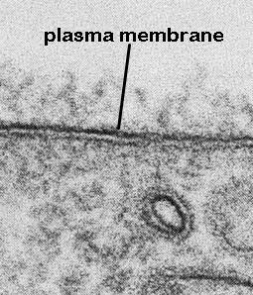

1.3.S3 Analysis of the falsification of the Davson-Danielli model that led to the Singer-Nicolson model.

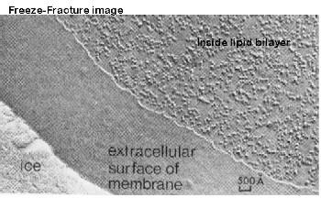
http://www.cytochemistry.net/cell-biology/ffimage.jpg
- Outline how the electron micrograph image above was obtained and why it undermines the Davson-Danielli model of the cell membrane.

- Improvements in biochemical techniques allowed proteins to be extracted from membranes. How did insights gained from these techniques undermine the Davson-Danielli model?

- Fluorescent antibody tagging used red or green fluorescent markers attached to antibodies which would bind to membrane proteins on the surface of the cell membrane. What did experiments with the markers find out and what conclusions could be drawn from them?

- Outline the Singer-Nicholson fluid mosaic model of the cell membrane.

n.b. a widely accepted model was falsified when new evidence came to light. It would be wise to assume that the current fluid mosaic model will at least be modified or even possibly rejected in favour of a new model in time.

1.3.U2 Membrane proteins are diverse in terms of structure, position in the membrane and function.

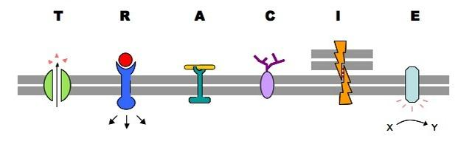
http://www.ib.bioninja.com.au/_Media/tracie_med.jpeg

- List the six main functions of the membrane proteins.

T :
R :
A :
C :
I :
E :

- State the functions of glycoproteins found in the plasma membrane

1.3.U3 Cholesterol is a component of animal cell membranes.

- Cholesterol is a type of lipid, but it is not a fat or oil. What group does it belong to?

- Cholesterol makes up around about 20% of the mass of cell membranes. This percentage varies greatly and some membranes, e.g. bacteria, do not contain it at all.

  - Where in the plasma membrane can cholesterol be found?

  - What properties cause it to be located in this position?

1.3.A1 Cholesterol in mammalian membranes reduces membrane fluidity and permeability to some solutes.

The hydrophobic hydrocarbon tails usually behave as a liquid. Hydrophilic phosphate heads act more like a solid. Though it is difficult to determine whether the membrane is truly either a solid or liquid it can definitely be said to be fluid. It is important to regulate the degree of fluidity in order that:
- It needs to be fluid enough that the cell can move
- It needs to be fluid enough that the required substances can move across the membrane
- If too fluid however the membrane could not effectively restrict the movement of substances across itself.

- The presence of cholesterol in the membrane restricts the movement of phosolipids and other molecules. How does this affect the physical properties of the membrane?

- The presence of cholesterol disrupts the regular packing of the of the hydrocarbon tails of phospholipid molecules. What impact does this have on the physical properties of the membrane?

- What chemical properties of the membrane are affected by cholesterol?

- Cholestrol also encourages the membrane to take on a concave shape. What structures and processes does this aid?

Citations:
Allott, Andrew. Biology: Course Companion. S.l.: Oxford UP, 2014. Print.

Cornell, Brent. 2.4 Membranes. Web. 24 Aug. 2014. <http://www.ib.bioninja.com.au/standard-level/topic-2-cells/24-membranes.html>.

Taylor, Stephen. "Essential Biology 02.4 Membranes.docx." Web. 24 Aug. 2014. <https://app.box.com/shared/1nhjmfssdq>.

