Topic 1.3 Sustainability

Guiding Questions
- What is sustainability and how can it be measured?
- To what extent are challenges of sustainable development also ones of environmental justice?

Understandings | Class | Home | Got it
1.3.1 Sustainability is a measure of the extent to which practices allow for the long-term viability of a system. It is generally used to refer to the responsible maintenance of socio-ecological systems such that there is no diminishment of conditions for future generations.
1.3.2 Sustainability is comprised of environmental, social and economic pillars.
1.3.3 Environmental sustainability is the use and management of natural resources that allows replacement of the resources, and recovery and regeneration of ecosystems.
1.3.4 Social sustainability focuses on creating the structures and systems, such as health, education, equity, community, that support human well-being.
1.3.5 Economic sustainability focuses on creating the economic structures and systems to support production and consumption of goods and services that will support human needs into the future.
1.3.6 Sustainable development meets the needs of the present without compromising the ability of future generations to meet their own needs. Sustainable development applies the concept of sustainability to our social and economic development.
1.3.7 Unsustainable use of natural resources can lead to ecosystem collapse.
1.3.8 Common indicators of economic development, such as gross domestic product (GDP), neglect the value of natural systems and may lead to unsustainable development.
1.3.9 Environmental justice refers to the right of all people to live in a pollution-free environment, and to have equitable access to natural resources, regardless of issues such as race, gender, socio- economic status, nationality.
1.3.10 Inequalities in income, race, gender and cultural identity within and between different societies lead to disparities in access to water, food and energy.
1.3.11 Sustainability and environmental justice can be applied at the individual to the global operating scale.
1.3.12 Sustainability indicators include quantitative measures of biodiversity, pollution, human population, climate change, material and carbon footprints, and others. These indicators can be applied on a range of scales, from local to global.
1.3.13 The concept of ecological footprints can be used to measure sustainability. If these footprints are greater than the area or resources available to the population, this indicates unsustainability.
1.3.14 The carbon footprint measures the amount of greenhouse gases (GHGs) produced, measured in carbon dioxide equivalents (in tonnes). The water footprint measures water use (in cubic metres per year).
1.3.15 Biocapacity is the capacity of a given biologically productive area to generate an ongoing supply of renewable resources and to absorb its resulting wastes.
1.3.16 Citizen science plays a role in monitoring Earth systems and whether resources are being used sustainably.
1.3.17 There are a range of frameworks and models that support our understanding of sustainability, each with uses and limitations.
1.3.18 The UN Sustainable Development Goals (SDGs) are a set of social and environmental goals and targets to guide action on sustainability and environmental justice.
1.3.19 The planetary boundaries model describes the nine processes and systems that have regulated the stability and resilience of the Earth system in the Holocene epoch. The model also identifies the limits of human disturbance to those systems, and proposes that crossing those limits increases the risk of abrupt and irreversible changes to Earth systems.
1.3.20 The doughnut economics model is a framework for creating a regenerative and distributive economy in order to meet the needs of all people within the means of the planet.
1.3.21 The circular economy is a model that promotes decoupling economic activity from the consumption of finite resources. It has three principles: eliminating waste and pollution, circulating products and materials, and regenerating nature.

Introduction to Sustainability
- Define sustainability

- Watch the video "Episode 5: Sustainable and Unsustainable Practices from around the Globe | SDG 2030," https://www.youtube.com/watch?v=9u0NrMuORgk. Answer the following questions,
  - Identify one specific example of sustainable practices featured in the video. (Identify: Provide an answer from a number of possibilities. Recognize and state briefly a distinguishing fact or feature)

  - Outline how it contributes to achieving the Sustainable Development Goals (SDGs) (Outline: Give a brief account or summary.)

  - Based on the video, identify the challenges communities face in transitioning from unsustainable to sustainable practices (Identify: Provide an answer from a number of possibilities. Recognize and state briefly a distinguishing fact or feature)

- List key milestones in the development of sustainability as a global concern, including important conferences and reports. (List: Give a sequence of brief answers with no explanation.)

- Watch the video The Tragedy Of Deforestation | Climate Change: The Facts https://youtu.be/B5Fwl4P4EW8
Identify another resources that could be sustainable or unsustainable (Identify: Provide an answer from a number of possibilities. Recognize and state briefly a distinguishing fact or feature)

- Suggest one example of a global perspective for managing resources sustainably and one example of a local perspective for managing resources sustainably. Which one is more sustainable? (Suggest: Propose a solution, hypothesis or other possible answer)

- Complete the table below on the 3 pillars of sustainable

Pillar | Description | Example
Environmental

Social

Economic

- Identify a local ecosystem that could benefit from regeneration efforts. What actions could help restore it?" (Identify: Provide an answer from a number of possibilities. Recognize and state briefly a distinguishing fact or feature)

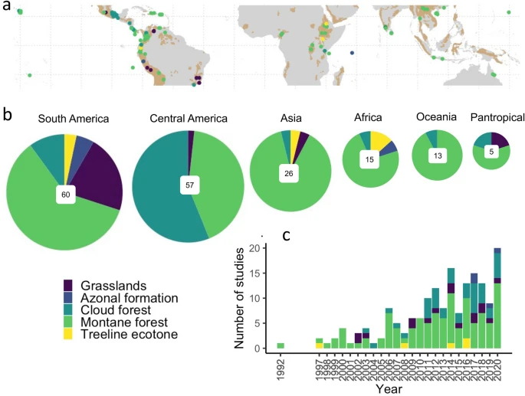
- Many tropical mountain ecosystems (TME) are severely disturbed, requiring ecological restoration to recover biodiversity and ecosystem functions. Review the graph and identify the benefits of active ecosystem regeneration and environmental sustainability efforts of TMEs (Identify: Provide an answer from a number of possibilities. Recognize and state briefly a distinguishing fact or feature)

  - active ecosystem regeneration

  - enviornmental sustainability

https://www.nature.com/articles/s41598-021-03205-y

- The Biomimicry Institute (biomimicry.org) defines biomimicry as “the practice of looking to nature for inspiration to solve design problems in a regenerative way. By comparing Nature's Unifying Patterns to human behaviour, we understand our mistake. Identify the various ways in which we can use nature to help understand our mistakes. (Identify: Provide an answer from a number of possibilities. Recognize and state briefly a distinguishing fact or feature)

- Consider a social sustainability issue in Georgia. Identify the stakeholders and the tensions between these stakeholders. Select one of the examples and below and Suggest one step you or your community could take to address it. (Suggest: Propose a solution, hypothesis or other possible answer)
  - Urban Heat Islands and Tree Canopy Loss in Atlanta affects low-income and minority communities disproportionately. Real estate developers seek to maximize land use and community groups advocate for green spaces and environmental justice.
  - Water Quality and Accessibility in Rural Georgia such as those near industrial agriculture operations, face water quality issues due to pesticide runoff and inadequate wastewater treatment facilities. Industrial agricultural use for food insecurities while local communities demand clean water, and environmental groups push for stricter pollution controls
  - Renewable Energy Transition and Economic Development such as solar farms in rural areas, offers opportunities for economic development but also raises concerns about land use and community concerns about land and visual impacts, as well as workers from traditional energy sectors facing job transitions.

Issue

Stakeholders

Tensions between stakeholders

Solution

- Reference the graph below.
  - Describe the general trend on the relationship between the country's economic activity (GDP per capita) and its environmental impact (carbon emissions per capita) (Describe: Give detailed account or picture of a situation, event, pattern or process.)

  - Based on the observed trend, suggest the implications about the balance between economic development and environmental sustainability. (Suggest: Propose a solution, hypothesis or other possible answer)

  - Choose one country from the graph. Identify specific factors that might contribute to its position on the graph (Identify: Provide an answer from a number of possibilities. Recognize and state briefly a
distinguishing fact or feature.)

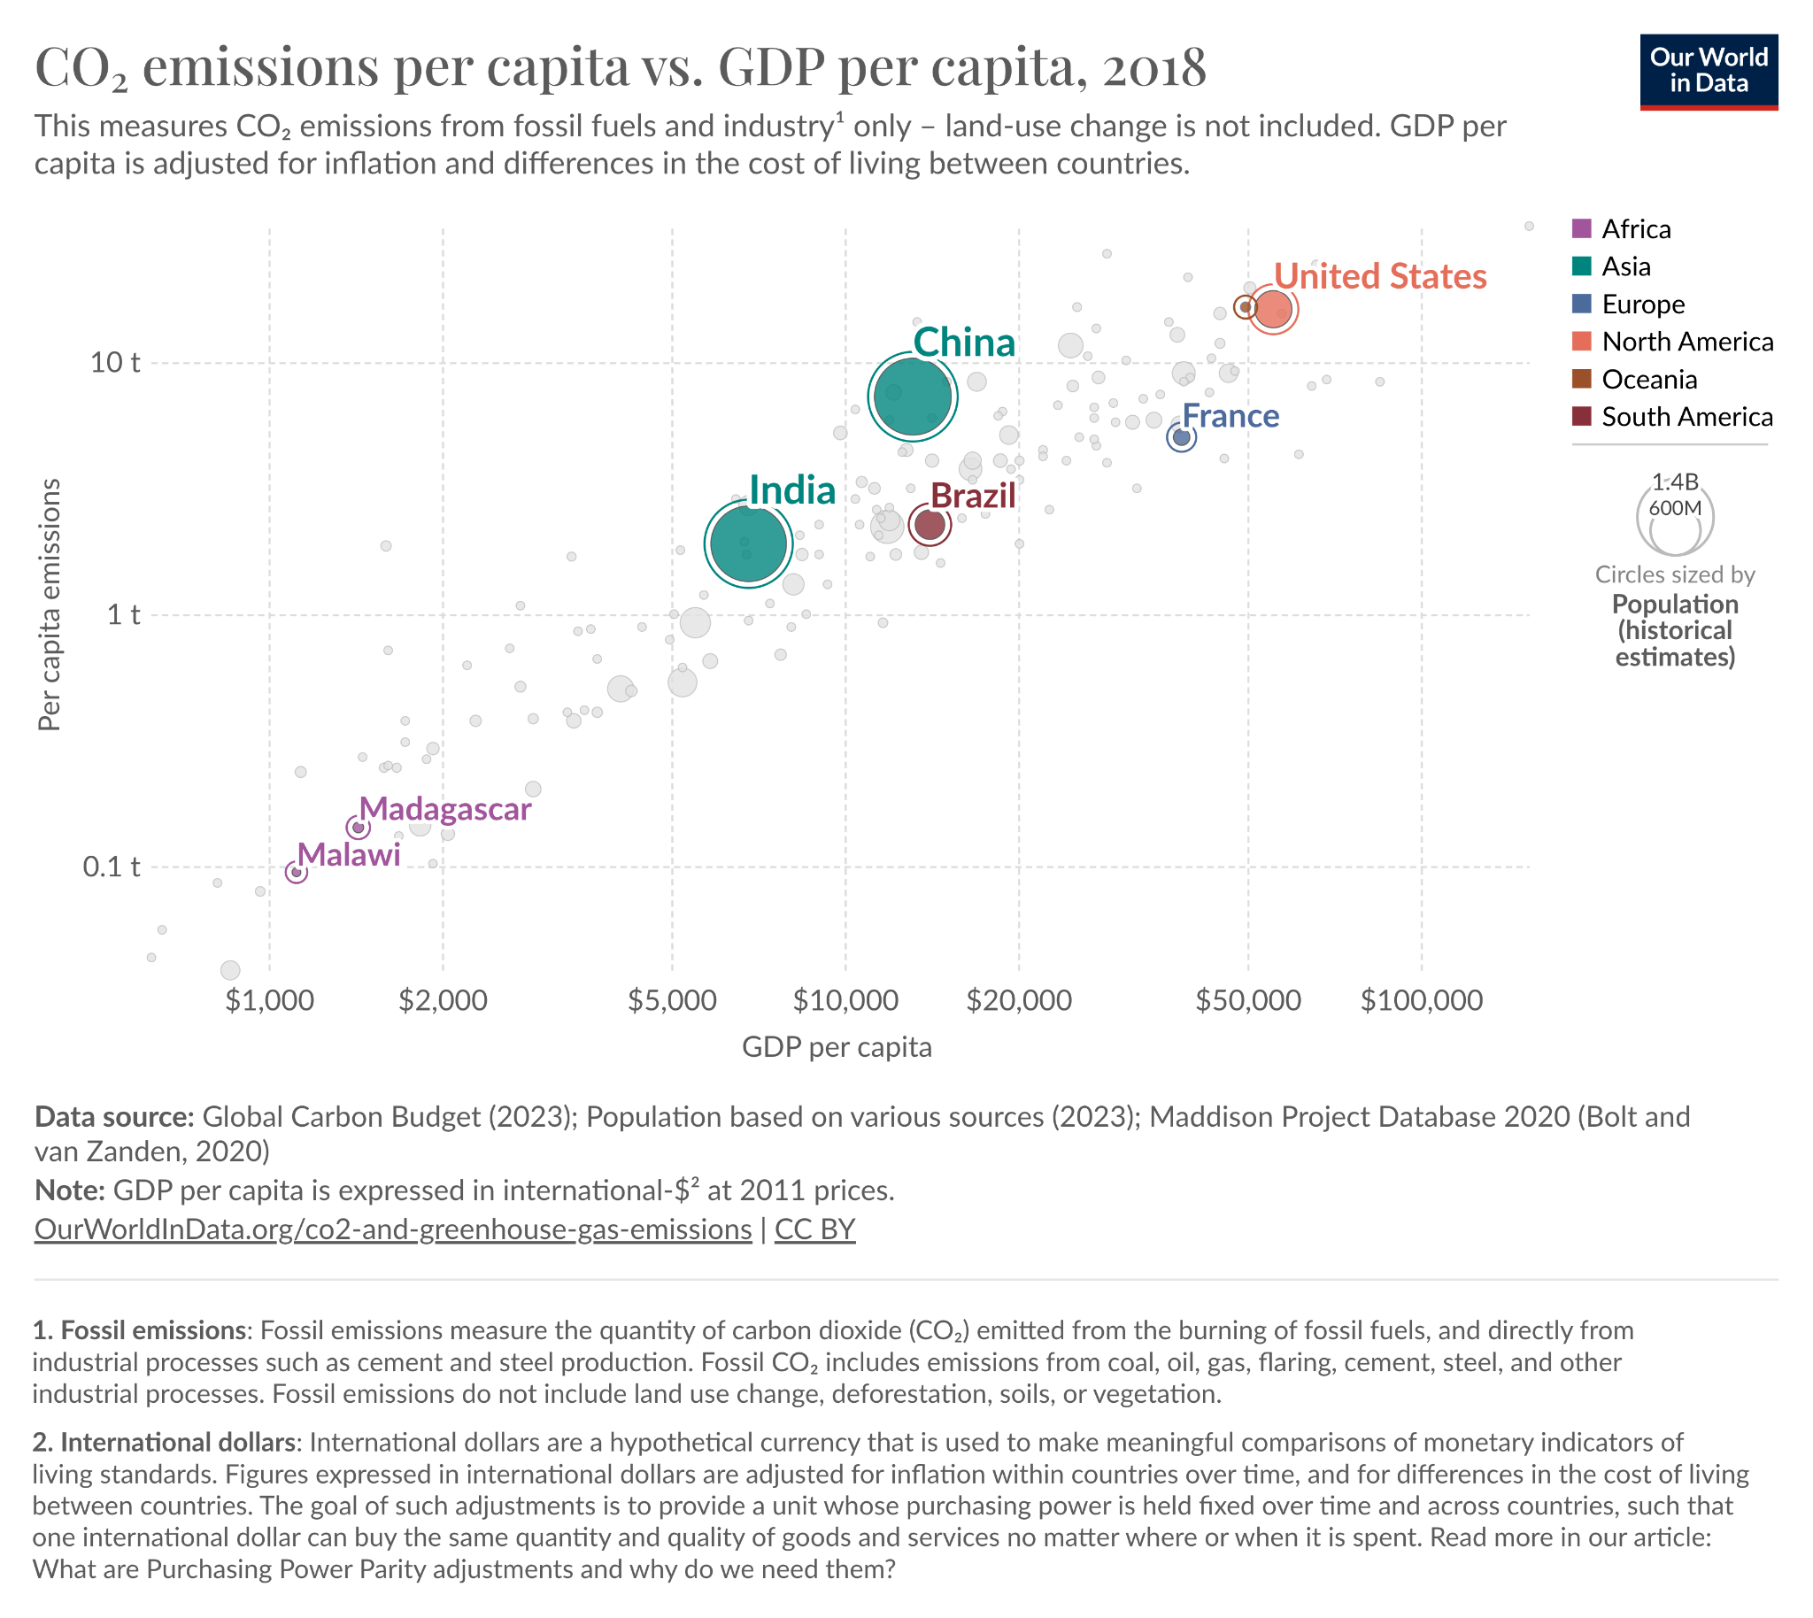

- Discuss the concept of sustainable development (Discuss: Offer a considered and balanced review that includes a range of arguments, factors or hypotheses. Opinions or conclusions should be presented clearly and supported by appropriate evidence.)

- State at least one advantage of measuring sustainability… (State: give a specific name, value or other brief answer without explanation ore calculation)
  - ...on a local scale:
  - ...on a global scale:

Unsustainable Practices

- Watch the video on the overfishing of Newfoundland Cod. https://youtu.be/3fCX6XKzbUY
  - Identify the immediate and long-term environmental, economic, and social consequences of this overfishing, (Identify: Provide an answer from a number of possibilities. Recognize and state briefly a distinguishing fact or feature.)

  - State how such a situation be prevented in the future (State: give a specific name, value or other brief answer without explanation ore calculation)

- Complete the table below. Then go to the Biomimicry Institute website https://biomimicry.org/ . Identify three more of Nature's Principles. Add these to the table. For each one, consider whether human beings behave sustainably or not. (Identify: Provide an answer from a number of possibilities. Recognize and state briefly a distinguishing fact or feature.)

Nature's Unifying Principles | Human Behaviour
 | Human beings have created a take-make-waste linear economy. Very few materials are recycled.
Nature uses chemistry and materials that are safe for living beings.

Nature builds using abundant resources, incorporating rare resources only sparingly. | Human beings produce and build using many materials, some abundant, some not. Even resources that were once abundant, like sand used in concrete, are increasingly scarce. We use many non-renewable resources..

- Find an example of ecosystem collapse caused by the unsustainable use of natural resources.
  - State the ecosystem collapse (State: Give a specific name, value or other brief answer without explanation or calculation.)

  - Outline the causes of the collapse (Outline: Give a brief account or summary.)

  - Identify the solutions were used to reverse the decline? (Identify: Provide an answer from a number of possibilities. Recognize and state briefly a distinguishing fact or feature.)

  - Evaluate the solution (Evaluate: Make an appraisal by weighing up the strengths and limitations.)

- Outline the difference between sustainability and sustainable development (Outline: Give a brief account or summary.)

- Define GDP (Define: Give the precise meaning of a word, phrase, concept or physical quantity)

- Access Gapminder https://www.gapminder.org/data/. . Create a graph showing the correlation between GDP and life expectancy for 10 MEDC and 10 LEDC countries in 2023. Copy and paste your graph here. Explain the pattern of your graph (Explain: Give a detailed account including reasons or causes.)

- Outline the concept of Green GDP (Outline: Give a brief account or summary.)

Environmental Justice

- Outline the role of environmental justice in sustainable development (Outline: Give a brief account or summary.)

- Look at the infographic. Describe the patterns you notice in the types of communities affected by environmental injustices (Describe: Give detailed account or picture of a situation, event, pattern or process.)
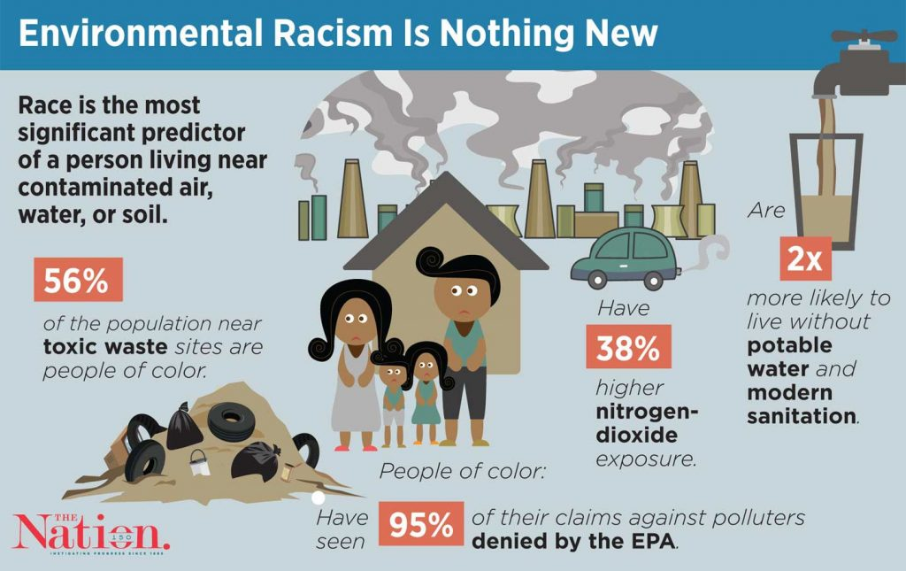

- Investigate one local and one global example of environmental injustice. State how your example illustrate the concept of environmental racism. Identify the role governments, communities, and individuals play in addressing the environmental injustice. (Q22) (State: Give a specific name, value or other brief answer without explanation or calculation.)
Examples: Deepwater Horizon oil spill; Flint Michigan; Landfills located in low-income areas; Oil and Gas on Indigenous lands; Union Carbide gas release in Bhopal, India; Pesticide exposure to farm workers; Maasai land rights in Kenya and Tanzania; Plastic waste disposal by developed to developing countries; Proctor Creek Watershed; TAV Waste site

- Explore the inequalities in access to food, water, and energy of a two named countries. Identify at least two regions with differing levels of access to these resources. Identify the main factors contributing to these disparities, and what sustainable practices could be implemented to improve equity in access (Identify: Provide an answer from a number of possibilities. Recognize and state briefly a distinguishing fact or feature.)

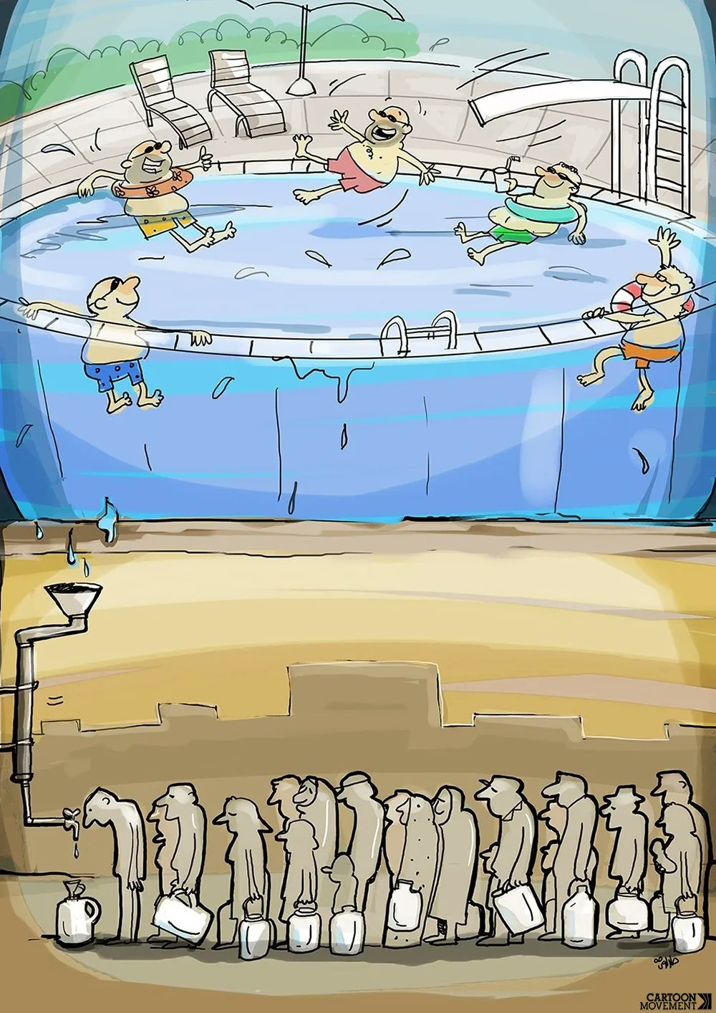
- Reference the cartoon.
  - Identify the message of the cartoon (Identify: Provide an answer from a number of possibilities. Recognize and state briefly a distinguishing fact or feature.)

  - Suggest what the cartoon say about the issue of water inequality (Suggest: Propose a solution, hypothesis or other possible answer.)

  - State how inequalities lead to disparities in access to water(State: Give a specific name, value or other brief answer without explanation or calculation.)

- Outline the role of environmental justice in sustainable development. (Outline: Give a brief account or summary)

- Create a chart showing how sustainability and environmental justice can be applied at an individual, community, city, country and global scale.
- Identify the similarities that apply to each level (Identify: Provide an answer from a number of possibilities. Recognize and state briefly a distinguishing fact or feature.)
- Suggest ways these issues are addressed vary between levels (Suggest: Propose a solution, hypothesis or other possible answer.)
- State the distinctions between each level (State: Give a specific name, value or other brief answer without explanation or calculation.)
- Explain how the implementation of sustainability and environmental justice at the global scale depend on individuals and societies at the local scale (Explain: Consider an argument or concept in way that uncovers the assumptions and interrelationships of the issue.)

Sustainability

- Define sustainability indicators. (Define: Give the precise meaning of a word, phrase, concept or physical quantity)

- Select and analyse one environmental sustainability indicator, detailing what it measures, its units, and whether higher or lower values are preferable for both social and environmental sustainability. (Analyse: Break down in order to bring out the essential elements or structure. To identify parts and relationships, and to interpret information to reach conclusion.)

- Energy Consumption:
- Air Quality Index (AQI):
- Gross Domestic Product (GDP) per Capita
- Human Development Index (HDI):
- Natural increase rate (NIR) of population
- Access to Clean Water and Sanitation:
- Gender Inequality Index (GII):
- Poverty Index:
- Economic Inequality (Gini Coefficient):

- Watch the video clip on Ecological Footprints https://www.youtube.com/watch?v=g_aguo7V0Q4 Outline what is meant by the term “ecological footprint”. (Outline: give a brief account or summary)

- Distinguish between ecological footprint and biocapacity. (Distinguish: Make clear the difference between two or more concepts items)

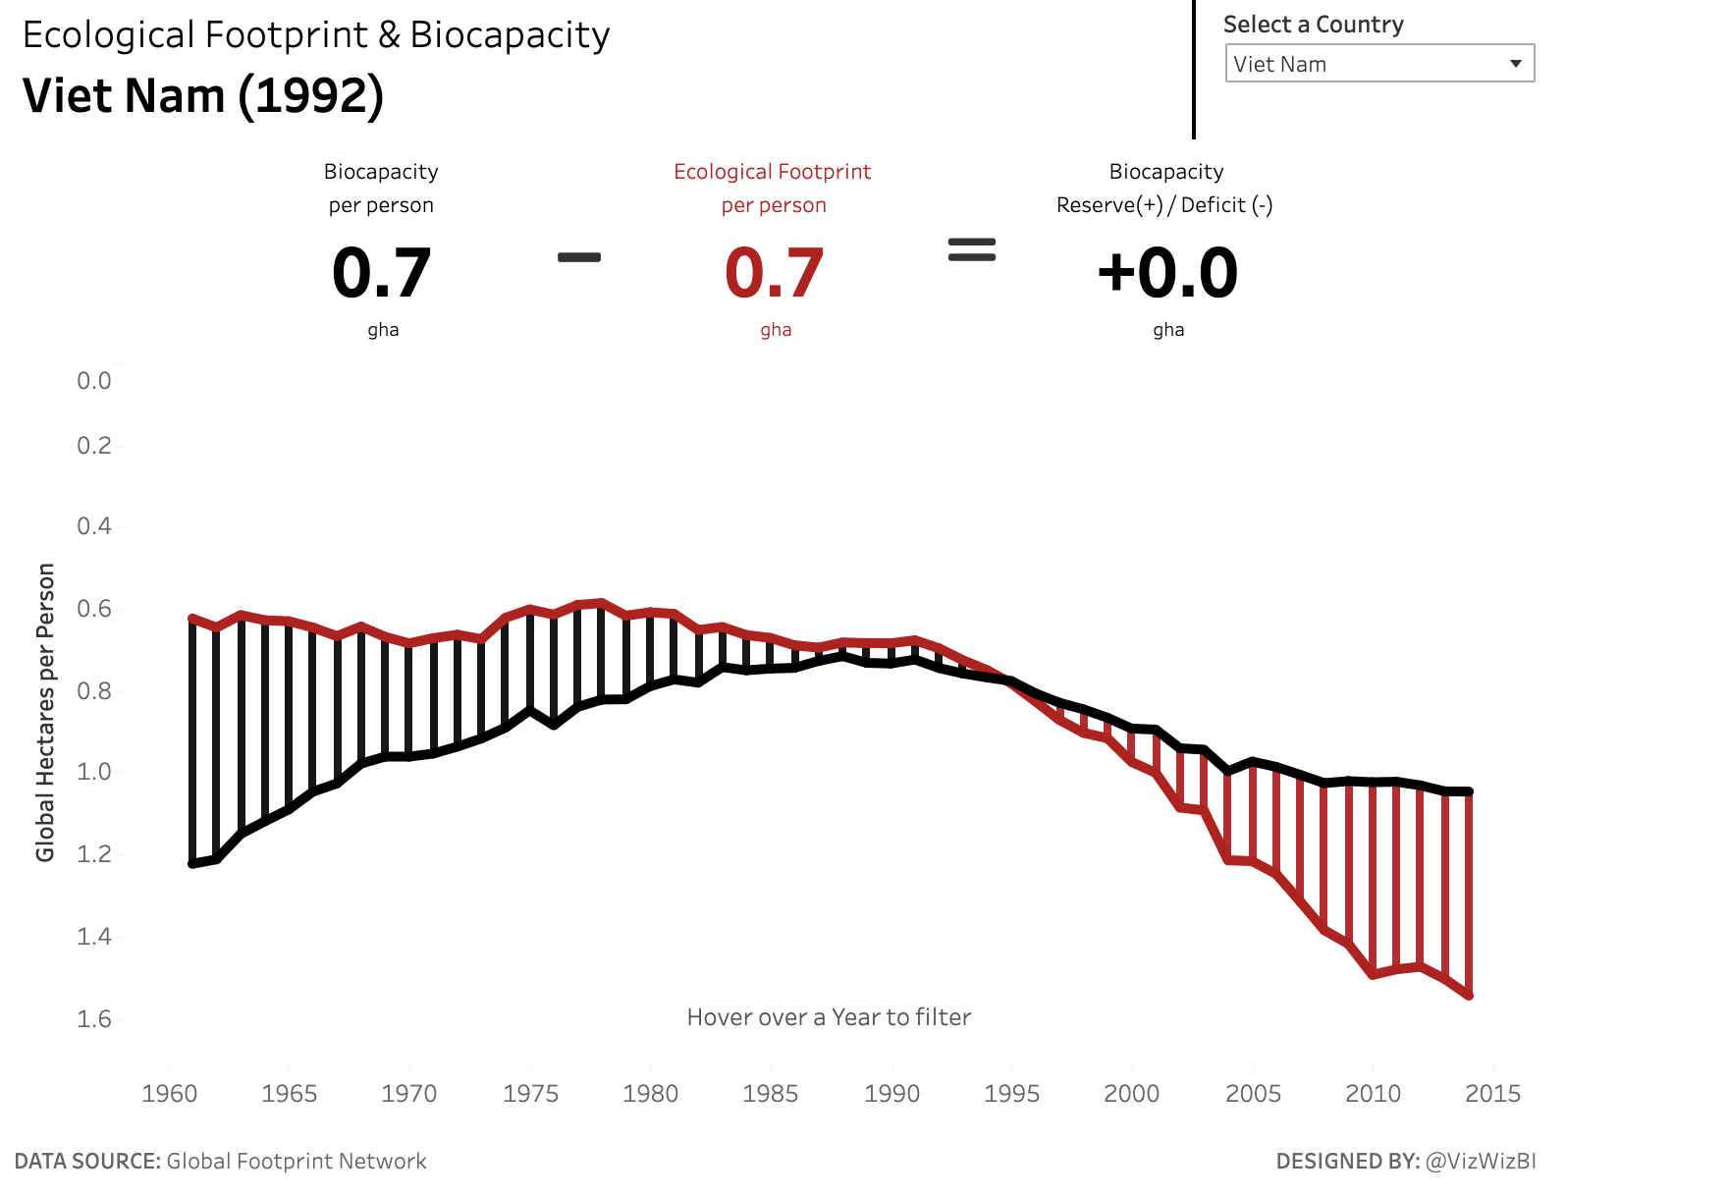
- Reference the graph. Evaluate the sustainability of VietNam (Evaluate: Make an appraisal by weighing up the strengths and limitations.)

- Access the Global Footprint Network ecological footprint calculator to calculate your ecological footprint. https://www.footprintcalculator.org/home/en
- Answer the questions honestly and accurately to calculate your ecological footprint.
- List your results, including your overall footprint and the specific areas contributing to it (e.g., carbon footprint, food, housing). (List: Give a sequence of brief answers with no explanation.)
- List the issues that are considered when calculating EF. (List: Give a sequence of brief answers with no explanation.)
- Suggest how you could reduce your EF, or that of your school, based on the information you are given. (Suggest: Propose a solution, hypothesis or other possible answer.)

- List the factors that affect a countries ecological footprint (List: Give a sequence of brief answers with no explanation.)

- Access the Footprint Data Foundation website. https://data.footprintnetwork.org/#/. Select Total Ecological Footprint. Select a country of your choice on the interactive map.
- Copy and paste the selected country's biocapacity and ecological footprint data in your workbook.
- Identify where your country ranks (Identify: Provide an answer from a number of possibilities. Recognize and state briefly a distinguishing fact or feature.)
- Based on this information, discuss the implications of the country's ecological footprint relative to its biocapacity. (Discuss: Offer a considered and balanced review that includes a range of arguments, factors or hypotheses. Opinions or conclusions should be presented clearly and supported by
- appropriate evidence.)
- Suggest strategies that the country could implement to achieve ecological balance. (Suggest: Propose a solution, hypothesis or other possible answer)

- Access the Footprint Data Foundation website https://data.footprintnetwork.org/#/
- Select the Explore Data tab from the top of the page
- Select 10 MEDC and 10 LEDC countries
- Collect data for the past 5 years
- Graph your data
- Describe how the trends differ between MEDCs and LEDCs. Identify the factors might explain these differences. (Describe: Give detailed account or picture of a situation, event, pattern or process.)
- Suggest the implications these trends have for the sustainability of natural resources and overall environmental health in MEDCs and LEDCs (Suggest: Propose a solution, hypothesis or other possible answer)

- Access the Global Footprint Network. https://overshoot.footprintnetwork.org/
- Identify the most recent Overshoot Day (Identify: Provide an answer from a number of possibilities. Recognize and state briefly a distinguishing fact or feature.)
- Suggest how Earth Overshoot Day illustrate the concept of ecological deficit? (Suggest: Propose a solution, hypothesis or other possible answer)
- Suggest actions individuals and communities can take to move the date towards a more sustainable future (Suggest: Propose a solution, hypothesis or other possible answer)

- Complete the table below on the strengths and limitations of using ecological footprint as a sustainability indicator

Strengths | Limitations
It is a useful snapshot of the sustainability of a population’s lifestyle

 | It uses approximations of actual figures that cannot be accurately calculated
 | It is negative in approach, so could be perceived as demotivating

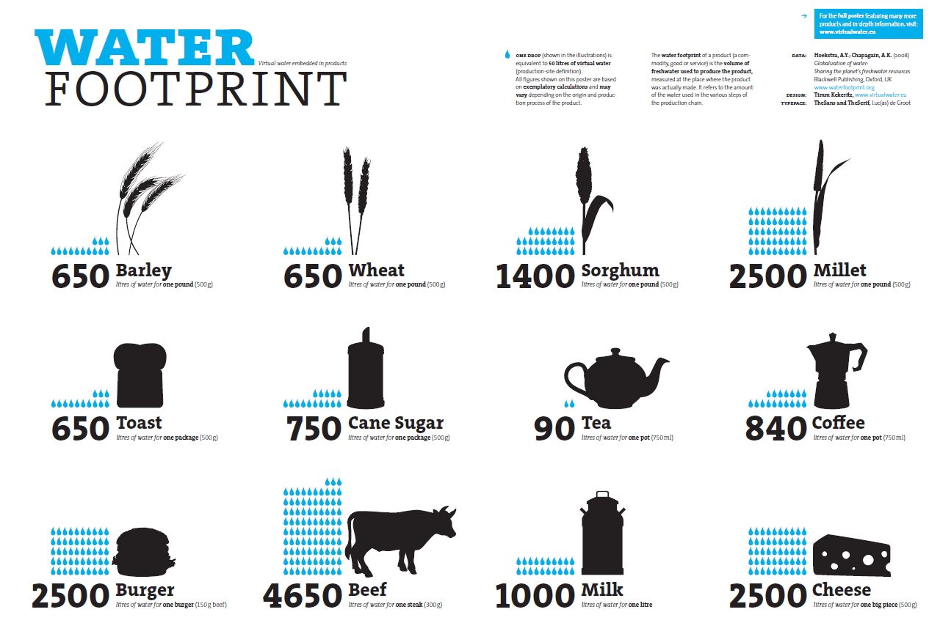
- The figure below shows the volume of water needed to produce various food products. Analyse the data carefully, then answer the questions.
  - Identify the products that have the highest levels of water usage. Identify: Provide an answer from a number of possibilities. Recognize and state briefly a distinguishing fact or feature.)

  - Suggest why some products require a much larger volume of water than others? (Suggest: Propose a solution, hypothesis or other possible answer.)

  - Suggest how this knowledge be used to reduce the water footprint of an individual or society? (Suggest: Propose a solution, hypothesis or other possible answer.)

  - Suggest how realistic is it to expect an individual or society to reduce their water footprint by changing food and drink consumption? Suggest the strengths and limitations of this approach?(Suggest: Propose a solution, hypothesis or other possible answer.)

UN Sustainable Development Goals

- For each SDG, there are sets of targets and indicators. A target is a narrower goal and an indicator is how the target is measured. Select two UN Sustainability Goals. Identify the targets and indicators for each goal
https://www.undp.org/content/undp/en/home/sustainable-development-goals.html#:~:text=The%20Sustainable%20Development%20Goals%20(SDGs,peace%20and%20prosperity%20by%202030.

Sustainability Goal | Target | Indicator

- Go to Sustability Development Report https://dashboards.sdgindex.org/map. Select two countries. Outline their Sustainability progress (Outline: Give a brief account or summary.)

- Identify some of the challenges associated with the SDGs. (Identify: Provide an answer from a number of possibilities. Recognize and state briefly a distinguishing fact or feature.)

- Complete the table on the uses and weaknesses of the SDGs

Uses | Limitations
Common ground: the common set of goals, targets and indicators makes it easier for governments, businesses and other organisations to use the same language for policies.

 | Lack of context: because the same set of goals, targets, and indicators are used for all countries, there may not be enough attention to contextual challenges faced by some countries
Ambition: the SDGs are the first time that countries have outlined socio-ecological goals for the planet; the fact that they are hard to achieve shows ambition
 | Data: Some targets do not have adequate indicators so there are SDGs that are not measured adequately

Planetary Boundary Model

- Outline the planetary boundaries model. (Outline: Give a brief account or summary.)

- Draw a visual diagram that represents the current status of Earth’s planetary boundaries. (Draw: Represent by means of a labelled, accurate diagram or graph, using a pencil.)

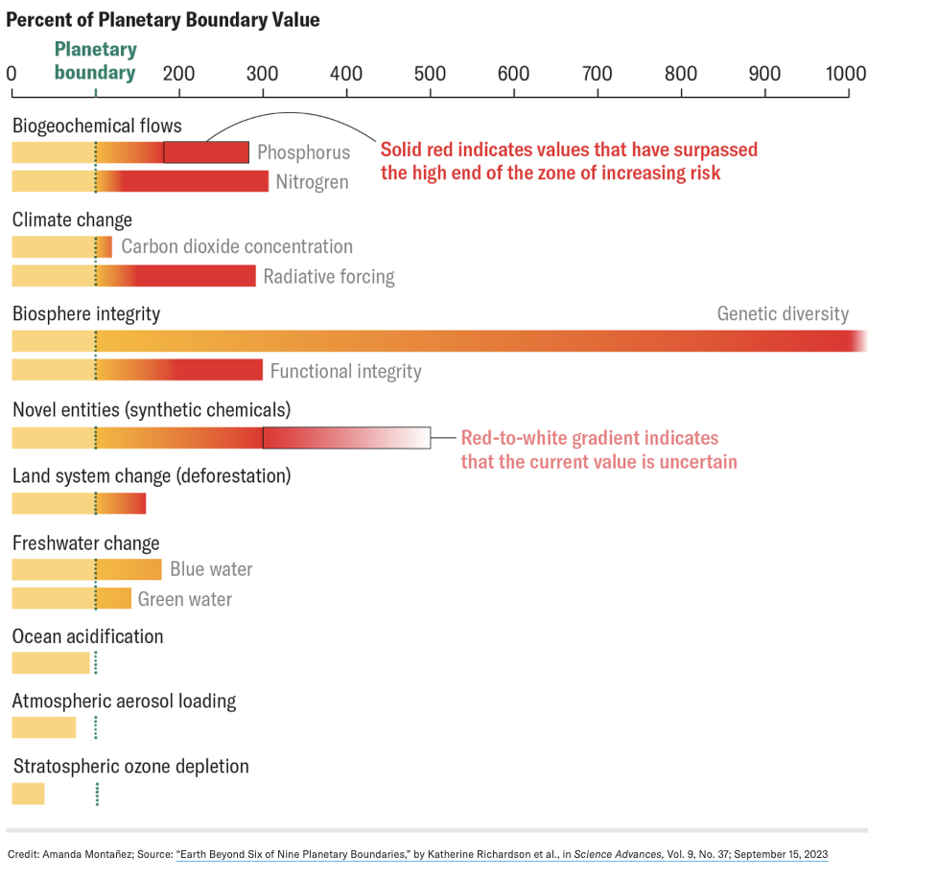
- Reference the image.
  - Identify the specific boundaries that have been crossed and by how much (Identify: Provide an answer from a number of possibilities. Recognize and state briefly a distinguishing fact or feature.)

  - Suggest measures that can be taken to reverse or halt the progression beyond these boundaries (Suggest: Propose a solution, hypothesis or other possible answer)

- Choose one planetary boundary that is currently at high risk.
  - Discuss the potential global impacts if this boundary is not managed effectively. (Discuss:Offer a considered and balanced review that includes a range of arguments, factors or hypotheses. Opinions or conclusions should be presented clearly and supported by appropriate evidence.)

  - Suggest strategies that could be implemented at global and local levels to address this issue." (Suggest: Propose a solution, hypothesis or other possible answer)

- Complete the table on the use and limitations of the planetary boundaries model

Uses | Limitations
 | Data incomplete: focuses only on ecological systems and does not consider the human dimension necessary to take action for environmental justice;
Focus on complex systems: highlights the need to focus on more than climate change (which dominates discussion);

 | Local usefulness: the focus on global boundaries may not be a useful guide for local and country-level action.

- The graph plots Global atmospheric CO₂ concentration. Go to the One World In Data Site https://ourworldindata.org/grapher/global-co2-concentration and complete the questoins
  - The planetary boundary for global carbon dioxide concentration was identified as 350 ppm. According to the data, when was this planetary boundary crossed?

  - Is the increase in global carbon dioxide concentration accelerating or decelerating? You can identify 5 or 10 year periods of data and calculate percentage change to find out.

  - Only based on past data, what prediction would you make about the future for global atmospheric carbon dioxide concentrations?

  - Consider other information you may know about carbon dioxide emissions (flows). How might that change your prediction, if at all? Be sure to consider the delays associated with storages

Doughnut Economics

- Outline the doughnut economics model (Outline: Give a brief account or summary.)

- Complete the table on the use and limitations of the doughnut economics model

Uses | Limitations
 | Difficult paradigm shift: rejects the goal of economic growth that most governments and businesses still aim for; shifting worldviews has been difficult
Developing: being used at different scales (for example, countries, cities, neighbourhoods, businesses) to support action on sustainability.

- Discuss the concepts of regenerative and distributive design within the context of sustainable development (Discuss: Offer a considered and balanced review that includes a range of arguments, factors or hypotheses. Opinions or conclusions should be presented clearly and supported by appropriate evidence)

Circular economy

- Distinguish between a linear and circular economy. (Distinguish: Make clear the difference between two or more concepts items.)

- The butterfly diagram from the Ellen MacArthur Foundation is a useful illustration of the circular economy.
  - Summarize the main points made in the video. (Summarize: Abstract a general theme or major point(s).)

  - Why is it called the ‘butterfly diagram

  - What do the wings of the butterfly represent?

  - How does the diagram demonstrate the circular economy?

- Complete the table on the use and limitations of the circular economy model

Uses | Limitations
 | Eco-ignorance: lack of environmental awareness by consumers and companies;
Localvore: improvement of local food networks and support of local communities
Reconsumption changed consumer habits.

- Outline a named example of how the circular economy has been applied to the production of one commodity. (Outline: Give a brief account or summary.)
- Example:
- Take-back Schemes in Germany:
- Adidas Infinite Play: In Germany, Adidas runs a program called Infinite Play, where customers can return their used Adidas gear in exchange for a voucher. The returned products are then cleaned, repaired if necessary, and resold. This not only keeps the materials in use for longer but also encourages sustainable consumer behavior.

Citizen Scientists

- Explain the role of a citizen scientist in contributing to environmental research and conservation. Beyond the examples discussed in class, provide at least one additional named example of a citizen science project and describe its objectives and impact (Explain: Give a detailed account including reasons or causes; Describe: Give detailed account or picture of a situation, event, pattern or process.)

Reflection

Reflect on the various sustainability models discussed in this unit, including the nested dependencies model, ecological footprints vs. biocapacity, UN Sustainable Development Goals (SDGs), Planetary boundaries model, Doughnut Economics model, and the Circular Economy model. How do these models help in understanding and addressing global sustainability challenges? Which model do you find most effective for conceptualizing sustainability, and why?

ESS can be like learning a new language. So many words are not commonly used in everyday English. This can be challenging. To help you keep up with ESS Terms, you will need to create your own ESS DICTIONARY. You should add to this over the year and keep it in your notebook or on a page file THAT YOU CAN UPDATE AND ADD TO EASILY. Most of the vocabulary words can be found either on your STUDY GUIDE or at mrgscience.com.
You will be responsible for learning the words and their meaning. Periodic quizzes will be given on the words. So, make your dictionary creative and you will remember the words more easily.

KEY TERMS

planetary boundries

ecological footprint

tipping point

diversity

justice

indicators

sustainability

doughnut economics

circular economy

renewable resources

non-renewable resources

biocapacity

regeneration

