Understandings, Applications and Skills (This is what you maybe assessed on)

Significant ideas
- Pollution is a highly diverse phenomenon of human disturbance in ecosystems.
- Pollution management strategies can be applied at different level

Big questions
- What strengths and weaknesses of the systems approach and the use of models have been revealed through this topic?
- What value systems can you identify at play in the causes and approaches to resolving the issues addressed in this topic?
- How can systems diagrams be used to show the impact of pollution on environmental and social systems?
- How do EVSs influence the choice and implementation of pollution management strategy?

 | Statement | Guidance
1.5.U1 | Pollution is the addition of a substance or an agent to an environment through human activity, at a rate greater than that at which it can be rendered harmless by the environment, and which has an appreciable effect on the organisms in the environment.. | The term pollutant and contaminant in environmental chemistry are considered more or less synonymous
1.5.U2 | Pollutants may be in the form of organic or inorganic substances, light, sound or thermal energy, biological agents or invasive species, and may derive from a wide range of human activities including the combustion of fossil fuels. | You are expected to be able to construct system diagrams to show the impact of pollutants
1.5.U3 | Pollution may be non-point or point source, persistent or biodegradable, acute or chronic | Pollution which arises from numerous widely dispersed origins is described as non-point source. Point source pollution arises from a single clearly identifiable site.  Biodegradable means capable of being broken down by natural biological processes
1.5.U4 | Pollutants may be primary (active on emission) or secondary (arising from primary pollutants undergoing physical or chemical change)
1.5.U5 | Dichlorodiphenyltrichloroethane (DDT) exemplifies a conflict between the utility of a “pollutant” and its effect on the environment.
1.5.A1 | Evaluate the effectiveness of each of the three different levels of intervention, with reference to Figure 3. | With reference to figure 3, students should appreciate the advantages of employing the earlier strategies of pollution management over the later ones, and the importance of collaboration
1.5.A2 | Evaluate the uses of DDT | Students might demonstrate knowledge of both the anti-malarial and agricultural use of DDT
1.5.S1 | Construct systems diagrams to show the impact of pollutants.

1.5.U1 Pollution is the addition of a substance or an agent to an environment through human activity, at a rate greater than that at which it can be rendered harmless by the environment, and which has an appreciable effect on the organisms in the environment

Pollution cannot be contained by national boundaries and therefore can act either locally, regionally or globally.

- Define pollution

- State how pollutants are classified

1.5.U2 Pollutants may be in the form of organic or inorganic substances, light, sound or thermal energy, biological agents or invasive species, and may derive from a wide range of human activities including the combustion of fossil fuels

- Compare organic and inorganic substances.

- Give examples of light, sound, thermal energy bio agents and invasive species. State how each can affect the environment.

- Light

- Sound

- thermal energy

- bio agents

- invasive species

1.5.U3 Pollution may be nonpoint or point source persistent or biodegradable, acute or chronic

- Identify the different sources of pollution

- Compare and contrast point and non-point pollutant. Give an example for each

- Identify the following as either point or non point source pollution.

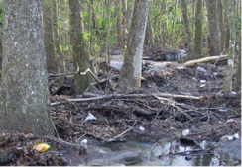
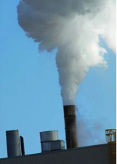

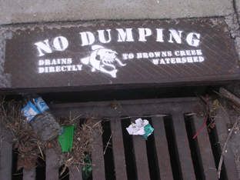

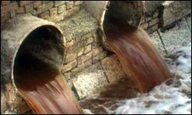

6. Complete the following table

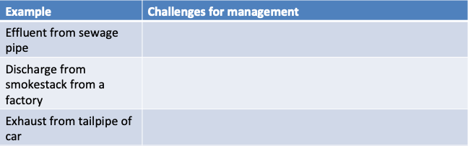
- Outline the problems associated with POPs. Give two examples of a POP

- Define biomagnification. Give an example

- Define biodegradable. Give an example

- Identify the strengths and weaknesses of biodegradable pollution

- Compare and contrast acute and chronic pollution Give an example for each

1.5.U4 Pollutants may be primary (active on emission) or secondary (arising from primary pollutants undergoing physical or chemical change)

- State the differences between primary and secondary pollutants. Give an example for each

- How might a “time lag” between the moment when the pollution enters a system and its detection by scientists impact the effects on organisms?

1.5.S1 Construct system diagrams to show the impact of pollutants

- Your diagram should include and label all aspects of the system:
- Storages
- Sinks
- Flows (inputs and outputs

  - Diagram 1: Plastic microbeads in a marine food web (at least 5 organisms and 3 feeding (tropic) levels)

  - Diagram 2: Thermal pollution’s effect on dissolved oxygen levels in a stream ecosystem

Pollution management strategies can be applied at different levels

- Methods for testing pollutants

Direct

Indirect

- Describe direct methods of monitoring pollution.

- air pollution

- soil pollution

- water pollution

- The 3-tiered approach to pollution management is based on:

- Essentially, we can manage pollution by doing any combination of 3 things:

- Change the human activity that generates the pollutant in the first place.

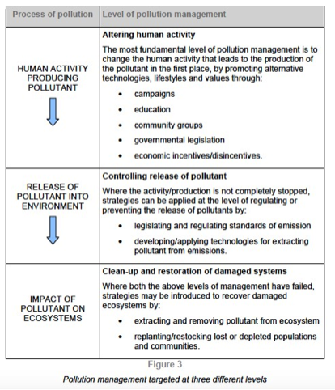

- Preventing or regulating the production/release of pollutants

- Clean up the pollutant and the affected areas after the pollutant has been released.

Refer to the case studies on pp. 282-283 of the IB ESS Course Companion. Some things to consider when discussing pollution management...

- Human factors affect pollution management
  - cultural values

  - political systems

  - economic systems

1.5.A1 Evaluate the effectiveness of each of the three different levels of intervention, with reference to fi
- Evaluate – weight the pros and cons, then reach conclusions about which are more significant
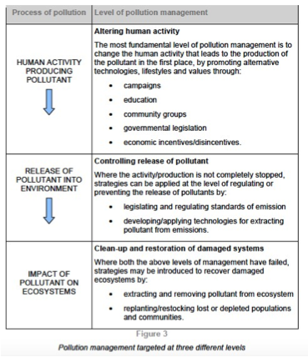
- Think of it as a cost benefit analysis
- How is each intervention level successful?
- What hinders the success of each intervention level?
- Which level is likely to be the most effective and feasible to implement?
- Justify your conclusion with reasons and evidence

1.5.U5 Dichlorodiphenyltrichlorethane (DDT) exemplifies a conflict between the utility of a “pollutant” and its effect on the environment.
1.5.A2 Evaluate the use of DDT

- Why was DDT invented?

- What was the discovered effect of DDT on the environment and who was responsible for rining this to the public’s attention?

- Identify the strengths and weakness of the use of DDT

Strengths Weaknesses

- Discuss the health impacts of DDT

- Discuss the environmental impacts of DDT

- Apply the precautionary principle to the use of DDT

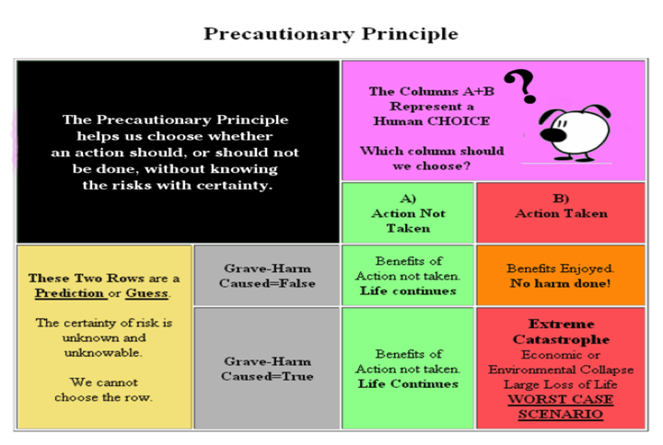

- Task Evaluate the use of DDT
  - What are the pros and cons?

  - What are the successes?

  - What are the problems?

  - Which are more important

  - Be careful in looking at sources. Are they biased? Can they substantiate their claims?

Theory of knowledge:
- Experts sometimes disagree about pollution management strategies—on what basis might we decide between the judgments of the experts if they disagree?

Questions

- . Outline two advantages and two disadvantages of coal.

- . What locations on the earth have the largest coal reserves? What locations have the largest oil reserves?

- . Outline the global implications of increasing worldwide fossil fuel use on the planet. (Provide at least 4 major effects and explain them)

- . State and explain which type of pollution, point source or non-point source, is easier to identify, control and eliminate.

- Compare the changes in fertilizer use in developing countries with those in Western Europe, as shown by this data.

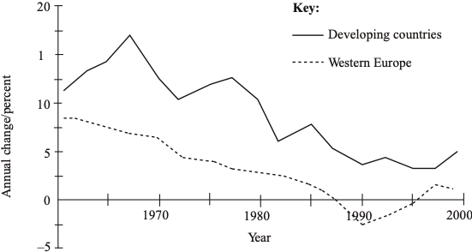

b. Explain how the use of inorganic fertilizers might be described as “pollution”.

ESS can be like learning a new language. So many words are not commonly used in everyday English. This can be challenging. To help you keep up with ESS Terms, you will need to create your own ESS DICTIONARY. You should add to this over the year and keep it in your notebook or on a page file THAT YOU CAN UPDATE AND ADD TO EASILY. Most of the vocabulary words can be found either on your STUDY GUIDE or at mrgscience.com.
You will be responsible for leaning the words and their meaning. Periodic quizzes will be given on the words. So, make your dictionary creative and you will remember the words more easily.

KEY TERMS

positive feedback

tipping-point

resilient

stability

diversity

stability

monoculture

Laws of Thermodynamics

negative feedback

entropy

destabilizing

stabilizing

work

global warming

albedo

​Principle of the Conservation of Energy

sustainability

thermodynamics

energy transfer

equilibria

transformation

transfer

predator/prey

entropy

​albedo

ecosystem

equilibrium

storage

energy

static equilibrium

unstable equilibria

transformations

​homeostasis

​keystone species

energy efficiency

flows

steady-state equilibrium

energy transformation

stable equilibria

complexity

​precautionary principle

​eutrophication

