11. Animal Physiology (AHL) 11.3 The Kidney
Name
Essential Idea: All animals excrete nitrogenous waste products and some animals also balance water and solute concentrations.
Understandings, Applications and Skills (This is what you maybe assessed on)
 | Statement | Guidance
11.3.U1 | ​Animals are either osmoregulators or osmoconformers.
11.3.U2 | The Malpighian tubule system in insects and the kidney carry out osmoregulation and removal of nitrogenous wastes.
11.3.U3 | The composition of blood in the renal artery is different from that in the renal vein.  .
11.3.U4 | The ultrastructure of the glomerulus and Bowman’s capsule facilitate ultrafiltration.
11.3.U5 | The proximal convoluted tubule selectively reabsorbs useful substances by active transport
11.3.U6 | The loop of Henle maintains hypertonic conditions in the medulla.
11.3.U7 | ADH controls reabsorption of water in the collecting duct. | ADH will be used in preference to vasopressin.
11.3.U8 | The length of the loop of Henle is positively correlated with the need for water conservation in animals.
11.3.U9 | The type of nitrogenous waste in animals is correlated with evolutionary history and habitat.
11.3.A1 | Consequences of dehydration and overhydration.
11.3.A2 | Treatment of kidney failure by hemodialysis or kidney transplant.
11.3.A3 | Blood cells, glucose, proteins and drugs are detected in urinary tests.
11.3.S1 | Drawing and labelling a diagram of the human kidney.
11.3.S2 | 11.3.S2 Annotation of diagrams of the nephron. | The diagram of the nephron should include glomerulus, Bowman’s capsule, proximal convoluted tubule, loop of Henle, distal convoluted tubule; the relationship between the nephron and the collecting duct should be included

1.3.U9 The type of nitrogenous waste in animals is correlated with evolutionary history and habitat
Define excretion
- ________________________ is the removal from the body of the waste products of metabolic activities
- Much of the metabolic waste is in the form of
- Fish and amphibian waste is primarily
- Mammals waste is primarily
- Terrestrial animals repackage their toxic ammonia as which can be
- Reptiles and birds package their nitrogenous waste as

11.3.U1 Animals are either osmoregulators or osmoconformers

Define osmoconformers

What is the advantage and disadvantage of minimizing the osmotic gradient.

Define osmoregulators

Give an example of a osmoconformer and osmoregulator

11.3.U2 The Malpighian tubule system in insects and the kidney carry out osmoregulation and removal of nitrogenous wastes.

The fluid inside found inside the insect that is analogous to blood is referred to as

List the steps of the removal of nitrogenous waste and osmoregulation in insects by the Malpighian tube
1.

2.

3.

11.3.S1 Draw and label a diagram of the human kidney

11.3.U3 The composition of blood in the renal artery is different from that in the renal vein
The kidney causes changes in the composition of blood

- Renal vein (filtered blood)

- Renal artery (unfiltered blood)

- Ureter (urine)

\

11.3.S2 Annotate a diagram of a glomerulus and associated nephron to show the function of each part

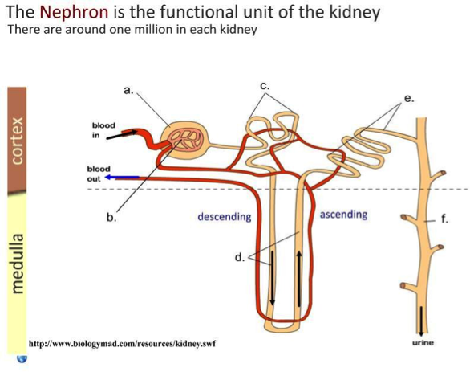

- The nephron is the functional unit of the kidney and includes:
  - ________________________________________: Brings blood to the nephron to be filtered
  - ________________________________________: Removes blood from nephron (minus filtered components)
  - __________________________________: Capillary tuft where filtration occurs
  - __________________________________________: First part of nephron where filtrate is collected
  - ___________________________________________________________: Where selective reabsorption occurs
  - ____________________________________: Important for establishing a salt gradient in the medulla
  - ________________________________________________________: Final site of selective reabsorption
  - ____________________________________________: Feeds into ureter and is where osmoregulation occurs
  - _____________________________________: Blood network that reabsorbs components from the filtrate

11.3.U4 The ultrastructure of the glomerulus and Bowman’s capsule facilitate ultrafiltration
Define ultrafiltration

The (it contains pores) allowing fluid to move through it. The only allows smaller molecules to be filtered
filtration slits between foot projections of cells act as a filter allowing only smaller molecules to be filtered

- Glomerulus and associated nephron
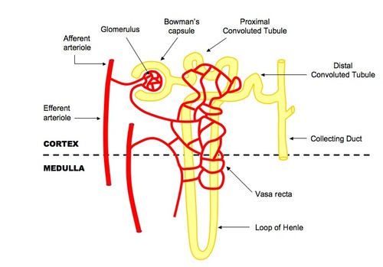
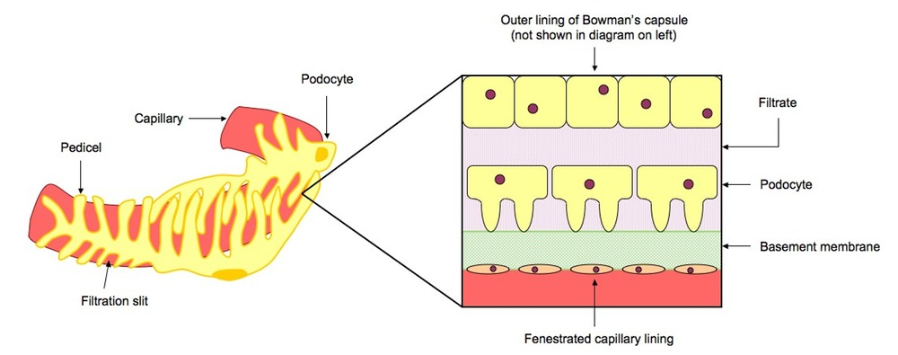

11.3.U5 The proximal convoluted tubule selectively reabsorbs useful substances by active transport
Identify those substances that are selectively reabsorbed in the proximal convoluted tubule (PTC)

State how the surface area of the tubule increases reabsorption

Due to of recovered substances in PCT cells the substances can into the (along the concentration gradient)

11.3.U6 The loop of Henle maintains hypertonic conditions in the medulla. AND 11.3.U7 ADH controls reabsorption of water in the collecting duct.
Define osmoregulation

- Creating a Salt Gradient in the Medulla
  - The function of the ____________________________ is to create a ___________________________ concentration in the fluid surrounding the tubule
  - The descending limb of the loop of Henle is ______________________________________________________
  - The ascending limb of the loop of Henle is _______________________________________________________
  - This means that as the __________________________________________________, the interstitial fluid becomes more salty (and less salty as it ascends into the cortex)
  - As the _____________________________________________________ that surrounds the loop flows in the ________________________________________ (counter-current exchange), this further multiplies the effect

The hormone ADH balances the water concentration of the blood by changing the permeability of the collecting duct.

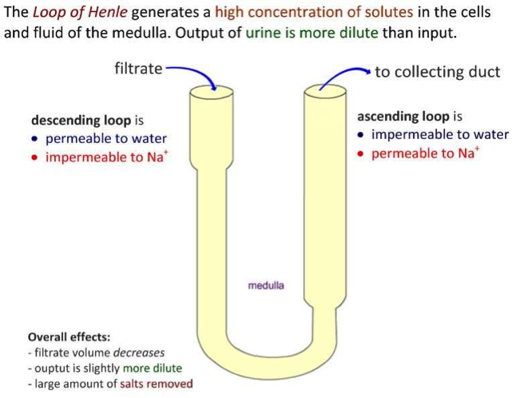
- Osmoregulation
  - As the collecting duct passes through the medulla as it drains into the _______________, the ______________ solution of the deep medulla will _______________________________
  - Antidiuretic hormone (________________________________) is a hormone released from the posterior pituitary in response to ____________________ (detected by hypothalamus)
  - ADH increases the ____________________________ of the collecting duct to water, allowing more water to be _______________________________________________________________________________________
  - This means ________________________________________________________________________________
  - When the individual is suitably rehydrated, ______________________________________ and less water will be _________________________________________________
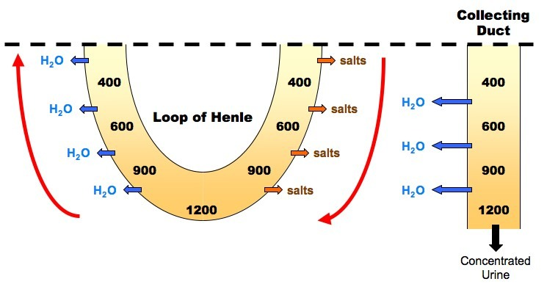
11.3.U8 The length of the loop of Henle is positively correlated with the need for water conservation in animals
The kangaroo rat’s (Dipodomys nitratoides) loop of Henle is much longer than that of other rodents. This in part explains the kangaroo rat’s amazing ability to survive in deserts.
Identify the relationship between the length of the medulla area and the urine concentration that can be produced
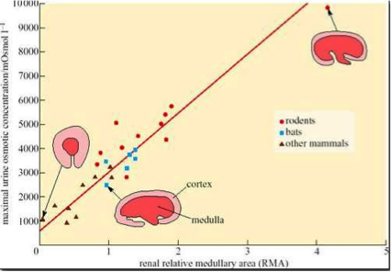

Exam Question: Explain osmoregulation in the kidney

11.3.A1 Consequences of dehydration and overhydration
Define and explain the effects of dehydration

Define and explain the effects of overhydration

1.3.A2 Treatment of kidney failure by hemodialysis or kidney transplant
Explain the treatment of kidney failure

What are the advantages and disadvantages of kidney transplant

11.3.A3 Blood cells, glucose, proteins and drugs are detected in urinary tests

What is the importance of urinalysis testing

