Understandings, Applications and Skills (This is what you may be assessed on)

Significant ideas
- A species interacts with its abiotic and biotic environments; its niche is described by these interactions.
- Populations change and respond to interactions with the environment.
- A system has a carrying capacity for a given species. ​
Big questions
- What strengths and weaknesses of the systems approach and the use of models have been revealed through this topic?

 | Statement | Guidance
2.1.U1 | A species is a group of organisms that share common characteristics and that interbreed to produce fertile offspring | Students should address this topic in the context of valid named species, for example use Atlantic salmon rather than fish
2.1.U2 | A habitat is the environment in which a species normally lives | It is useful to be aware that for some organisms, habitats can change over time as a result of migration.
2.1.U3 | A niche describes the particular set of abiotic and biotic conditions and resources to which an organism or population responds
2.1.U4 | The fundamental niche describes the full range of conditions and resources in which a species could survive and reproduce. The realized niche describes the actual conditions and resources in which a species exists due to biotic interactions.
2.1.U5 | The non-living, physical factors that influence the organisms and ecosystem - such as temperature, sunlight, pH, salinity and precipitation - are termed abiotic factors
1.2.U6 | The interactions between the organisms - such as predation, herbivory, parasitism, mutualism, disease and competition - are termed biotic factors.
2.1.U7 | Interactions should be understood in terms of the influences each species has on the population dynamics of others, and upon the carrying capacity of the others environment.
2.1.U8 | A population is a group of organisms of the same species living in the same area at the same time, and which are capable of interbreeding.
2.1.U9 | S and J population curves describe a generalized response of populations to a particular set of conditions (abiotic and biotic factors).
2.1.U10 | Limiting factors will slow population growth as it approaches the carrying capacity of the system
2.1.A1 | Explain population growth curves in terms of numbers and rates
2.1.S1 | Interpret graphical representations or models of factors that affect an organism's niche. Examples include predator prey relationships, competition, and organism abundance over time

Access the video clip on the Serengeti (https://www.youtube.com/watch?v=nwbSvC6pO28). Watch the video and take notes throughout the video on key points that you believe will be important to understand throughout Topic 2.

IB often asks for named examples, be sure to use specific examples and use specific names (scientific names are not required).

For example, if you just say tiger this refers to 1 of 10 species versus Bengal tiger is specific to one region and one species!

For a named example of a habitat or ecosystem
Be specific; The Giant Kelp Forest off the coast of Monterrey Bay California is much better than the beach gives as much detail as possible; The Sundarbans is the largest mangrove forest in Southern Bangladesh and South-eastern India

Components of an Ecosystem
2.1 U1 A species is a group of organisms that share common characteristics and that interbreed to produce fertile offspring
1.2.U2 A habitat is the environment in which a species normally lives
2.1.3U A niche describes the particular set of abiotic and biotic conditions and resources to which an organism or population responds
2.1.U4 The fundamental niche describes the full range of conditions and resources in which a species could survive and reproduce. The realized niche describes the actual conditions and resources in which a species exists due to biotic interactions.
2.1.U5 The non-living, physical factors that influence the organisms and ecosystem - such as temperature, sunlight, pH, salinity and precipitation - are termed abiotic factors.
2.1.U8 A population is a group of organisms of the same species living in the same area at the same time, and which are capable of interbreeding.

- Define the following terms and give a specific example (Use Topic 2.1 & 2.2 Vocabulary to complete this section. Watch the video https://youtu.be/GlnFylwdYH4
Term | Definition | Example
Species

Habitat

Niche

Abiotic

Biotic

Carrying capacity

- Watch the video https://www.youtube.com/watch?v=MdlwPtKg-VI&feature=emb_logo. Define the following terms and give a specific example

Term | Definition | Example
Individual

Species

- Watch the video https://youtu.be/Z7Zd0smPeAg
  - keystone species - Describe why they are classified as a keystone species

- Watch the video https://youtu.be/JGcIp4YEKrc. Define the following terms and give a specific example
Term | Definition | Example
Population

Population dynamics

Community

Ecosystem

Biome

Habitat

Use Topic 2.1 presentation to complete this section. There will be some overlap

- Identify the following as biotic or abiotic

 | Biotic/Abiotic |  | Biotic/Abiotic
River Dolphin |  | Bacteria
Algae |  | Mushroom
Daylight hours |  | Rocks
Precipitation |  | Minerals
Moss |  | Swamp grass
Soil composition |  | Fossil fuels

- Using the diagram to help you list the biotic and abiotic factors within a specific ecosystem.
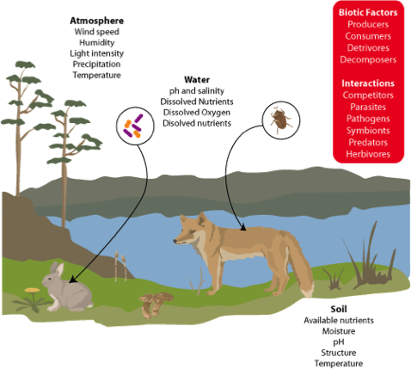
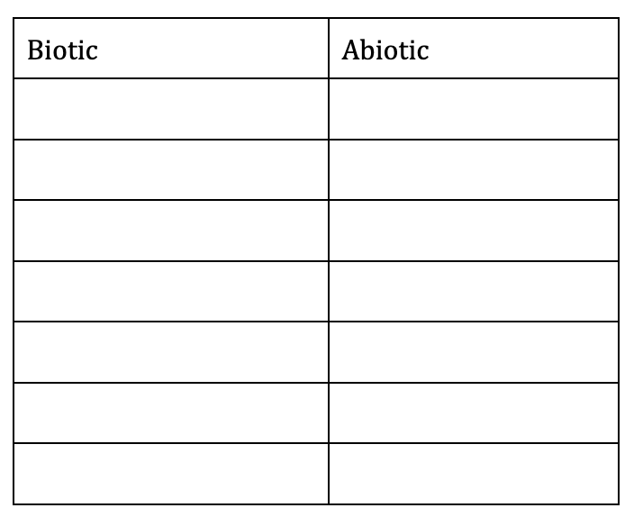

- State why it is important for us to use Latin binomials.

- State how populations size can be determined

- Explain how populations can change and respond to interactions within the environment.

- Explain how to habitat of the Pacific golden plover changes throughout the year. https://www.allaboutbirds.org/guide/Pacific_Golden-Plover/overview

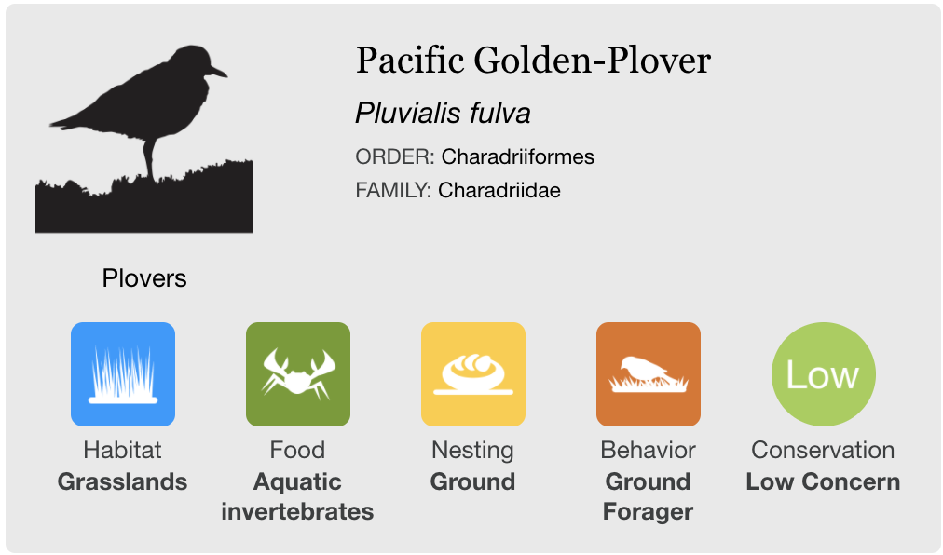
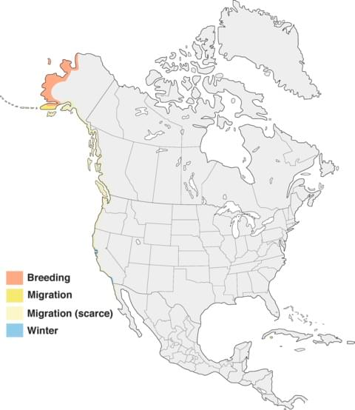

- . Distinguish between fundamental niche and realized niche

- Case study: American ecologist Joseph Connell investigated the realized and fundamental niches of two species of barnacles – a common animal on rocky shores in the UK. Connell had observed that one of the species, Semibalanus (Balanus) baladoides, was most abundant on the middle and lower intertidal area and that the other species, Chthamalus stellatus, was most common on the upper intertidal area of the shore. When he removed Chthamalus from the upper area of shore, he found that no Semibalanus replaced it, his explanation was the Sembalanus could not survive in an area that regularly dried out due to low tides. He concluded that Semibalanus realized niche was the same as its fundamental niche.

In another experiment he removed Semibalanus from the upper and middle area. He found that over time Chthamalys replaced it in the middle intertidal zone; his explanation was that Semibalanus was a more successful competitor in the middle intertidal zone and usually excluded Chthamalus. He concluded that the fundamental niche and realized niche of Chthamals were not the same and that its realized niche was smaller due to interspecific competition leading to competitive exclusion
  - Read through the case study then answer the following questions
    - What is the habitat of the two species?

    - Why did Connell need to do both experiments to make an accurate conclusion? What information would be missing without the second experiment?

    - Use this example to explain the differences between fundamental niche and realised niche

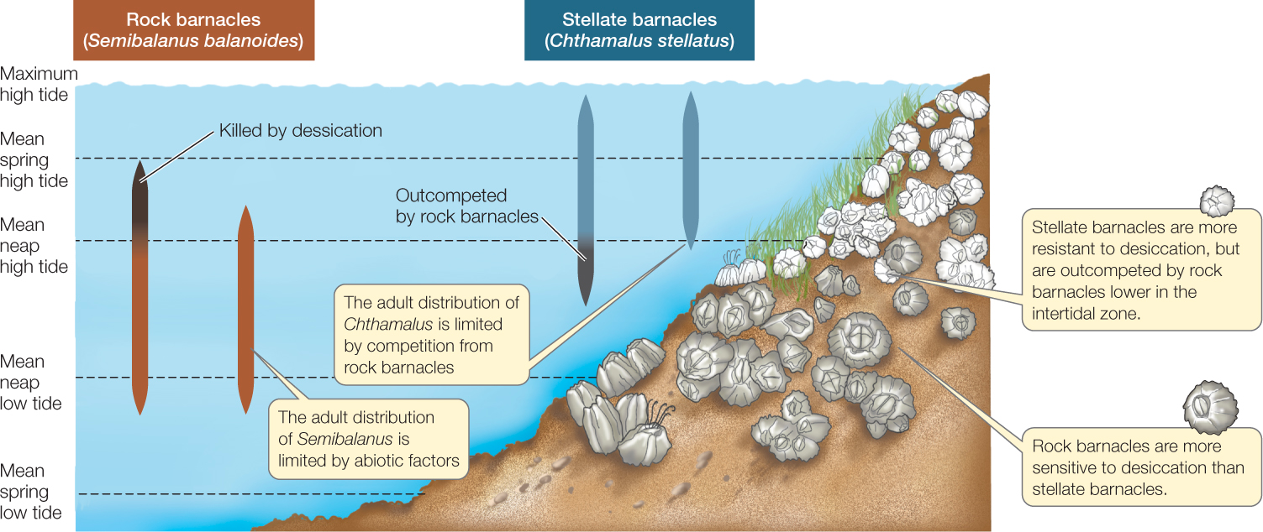

- In the space below draw
  - a bunch of little organisms. Some of the same type and some of different types.
  - Label 1 individual as an organism.
  - Label a group of the same type of organisms (species)
  - Circle: individuals of the same species (Population)
  - Draw interactions between the populations (Community)

- Suggest why population growth slows when a population approaches its carrying capacity.

2.1.U6 The interactions between the organisms - such as predation, herbivory, parasitism, mutualism, disease and competition - are termed biotic factors.
2.1 U7 Interactions should be understood in terms of the influences each species has on the population dynamics of others, and upon the carrying capacity of the others’ environment

- Define the following species interactions. Give one example for each

Term | Definition | Example
Competition

Predation

Herbivory

Parasitism

Mutualism

Amensalism.

Neutralism.

- Distinguish between intra- and inter-specific competition.

This is a nice review of ecological relationships https://www.youtube.com/watch?v=rNjPI84sApQ

- Interactions should be understood in terms of the influences each species has on the population dynamics of others, and upon the carrying capacity of the others’ environment. Reference the graph on the right. Identify the limiting factors that may dictate how a population fluctuates within an ecosystem. Hint. Identify each of the letters.

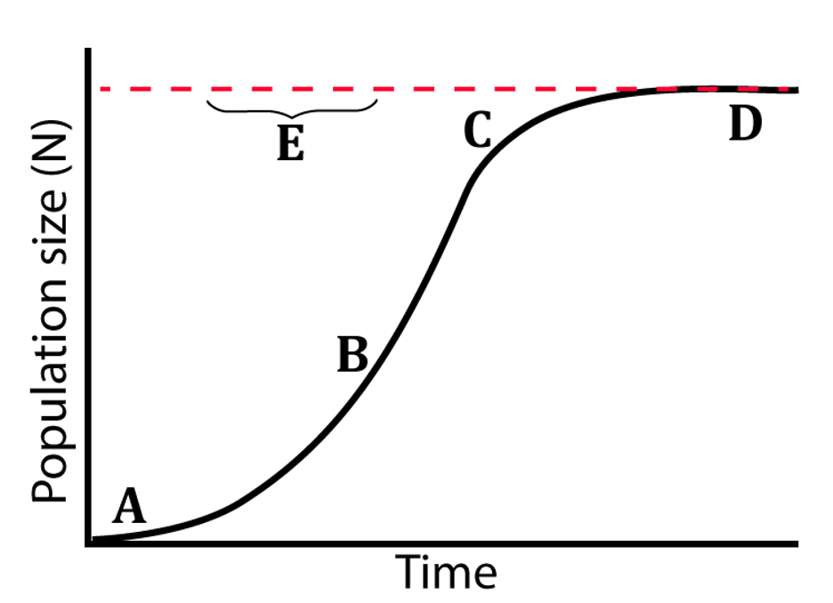

- Data interpretation of Competition.

The biologists Lotka and Volterra theorized that no two species with similar requirements for resources (food, shelter, etc.) could coexist in the same niche without competition driving one to local extinction.

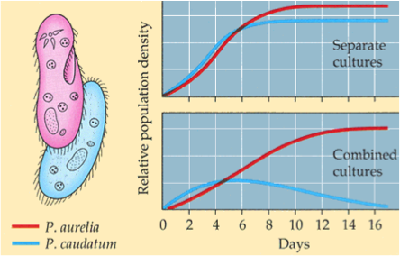
In the 1930s G.F. Gause tested the Lotka-Volterra theory by growing two Paramecium species in identical conditions. However, he found that if he grew them together that only one species prevailed.

  - Using what you know, explain the findings of G.F. Gause. You must describe the trends you see in the graph in your explanation

2.1 U8 A population is a group of organisms of the same species living in the same area at the same time
2.1.U9 S and J population curves describe a generalized response of populations to a particular set of conditions (abiotic and biotic factors).
2.1.U10 Limiting factors will slow population growth as it approaches the carrying capacity of the system
2.1 A1 Explain populations growth curves in terms of numbers and rates
2.1.S1 Interpret graphical representations or models of factors that affect an organism's niche. Examples include predator prey relationships, competition, and organism abundance over time

- Identify the limiting factors in:
Plants Animals

- Without limiting factors, there will be exponential growth (there is nothing limiting population size) Is this realistic for most populations? Justify your answer

- Compare density -dependent and density-independent factors. Identify named example

- Outline what is represented in S and J curves.

- Draw and label the S population curve

- Draw and label the J population curve.

- In reality populations tend to fluctuate around the carrying capacity. What type of feedback loop would this represent?

- List three biotic and abiotic factors which may limit population growth

Abiotic | Biotic

- Complete the table below on The Characteristics of Carrying Capacity in K and r strategy Organisms

Characteristic | r-strategy | K-strategy
Life span | short
Number of offspring

Onset of maturity |  | late
Body size

Reproduction | once during lifetime
Parental care

Environment |  | stable

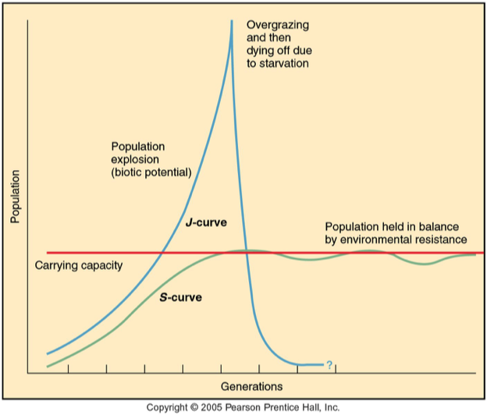
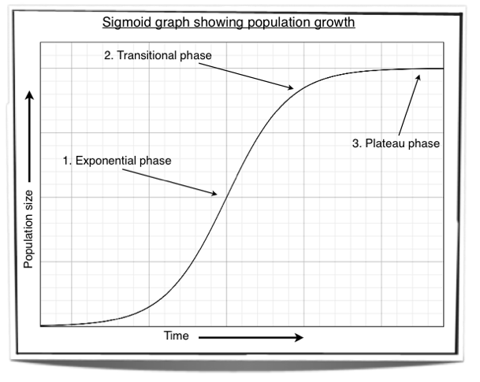
- Using the information from these two graphs, explain how populations can change over a period of time.

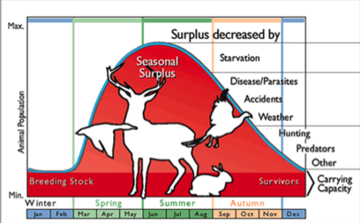
- Discuss how any two limiting factors in the diagram of the elk (Cervus canadensis) may limit populations during the summer and autumn

- Using the data below, draw a graph of the population of the two species over time. Explain the pattern in the graph
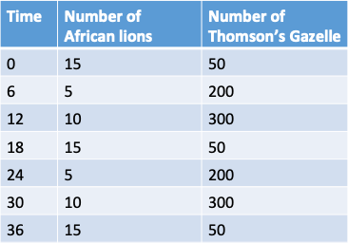

- Explain how humans have affected the carrying capacity of certain ecosystems? Try to think of how we have increased the carrying capacity of some ecosystems, not just decreased.

Theory of knowledge:
- Through the use of specialized vocabulary, is the shaping of knowledge more dramatic in some areas of knowledge compared to others?

ESS can be like learning a new language. So many words are not commonly used in everyday English. This can be challenging. To help you keep up with ESS Terms, you will need to create your own ESS DICTIONARY. You should add to this over the year and keep it in your notebook or on a page file THAT YOU CAN UPDATE AND ADD TO EASILY. Most of the vocabulary words can be found either on your STUDY GUIDE or at mrgscience.com.
You will be responsible for learning the words and their meaning. Periodic quizzes will be given on the words. So, make your dictionary creative and you will remember the words more easily.

KEY TERMS

niche

predation

parasitism

​S-curve

fundamental niche

abiotic factors

biotic factors

environmental resistance

predator

prey

​interspecific

commensalism

​carrying capacity

density effect

realized niche

interactions

​natality

species

community

parasitism

terrestrial

​biosphere

​intraspecific

​amensalism

​biotic potential

r-selected

​mortality

population

communities

mutualism

​organisms

neutralism

​intrinsic rate

​k-selected

limiting factors

​interspecies

habitat

​ecology

ecosystem

immigration

​migration

​competition

herbivory

​population density

​J-curve

survivorship curves

