Understandings, Applications and Skills (This is what you may be assessed on)

Significant ideas
- The interactions of species with their environment result in energy and nutrient flows.
- Photosynthesis and respiration play a significant role in the flow of energy in communities.
- The feeding relationships of species in a system can be modelled using food chains, food webs and ecological pyramids. ​
Big questions
- What strengths and weaknesses of the systems approach and the use of models have been revealed through this topic?
- What are the strengths and weaknesses of models of food chains, food webs, and ecological pyramids?
- How can pyramids of productivity be used to predict the effect of human activities on ecosystems?
- How can systems diagrams be used to show energy flow through ecosystems? What are the strengths and weaknesses of such diagrams?

 | Statement | Guidance
2.2.U1 | A community is a group of populations living and interacting with each other in a common habitat.
2.2.U2 | An ecosystem is a community and the physical environment with which it interacts
2.2.U3 | Respiration and photosynthesis as processes with inputs, outputs and transformations of energy and matter. | The details of chloroplasts, light-dependent and light-independent reactions, mitochondria, carrier systems, adenosine tripohosphate (ATP) and specific intermediate biochemicals are not expected
2.2.U4 | Respiration is the conversion of organic matter into carbon dioxide and water in all living organisms, releasing energy. | The details of chloroplasts, light-dependent and light-independent reactions, mitochondria, carrier systems, adenosine tripohosphate (ATP) and specific intermediate biochemicals are not expected
2.2.U5 | During respiration, large amounts of energy are dissipated as heat, increasing the entropy in the ecosystem while enabling organisms to maintain relatively low entropy and so high organization.
2.2.U6 | Primary producers in most ecosystems convert light energy into chemical energy in the process of photosynthesis. | The details of chloroplasts, light-dependent and light-independent reactions, mitochondria, carrier systems, adenosine tripohosphate (ATP) and specific intermediate biochemicals are not expected
2.2.U7 | The photosynthesis reaction is can be represented by the following word equation. carbon dioxide + water yields glucose + oxygen
2.2.U8 | Photosynthesis produces the raw material for producing biomass | Biomass, measured in unite of mass (for example, g m-2) should be distinguished from productivity, measured in units of flow (for example, g m-2 hr-1 or J m-2 hr-1)
2.2U9 | The trophic level is the position that an organism occupies in a food chain, or the position of a group of organisms in a community that occupy the same position in food chains
2.2.U10 | Producers (autotrophs) are typically plants or algae that produce their own food using photosynthesis and form the first trophic level in a food chain. Exceptions include chemosynthetic organisms that produce food without sunlight.
2.2.U11 | Feeding relationships involve producers, consumers and decomposers. These can be modelled using food chains, food webs and ecological pyramids | The distinction between storage of energy illustrated by boxes i energy-flow diagrams (representing the various trophic levels), and the flows of energy or productivity often sown as arrows (sometimes of varying widths) needs to be emphasized.
2.2.U12 | Ecological pyramids include pyramids of numbers, biomass and productivity and are quantitative models that are usually measured for a given area and time
2.2.U13 | In accordance with the second law of thermodynamics, there is a tendency for numbers and quantities of biomass and energy to decrease along food chains; therefore, the pyramids become narrower towards the apex | This topic should be actively linked with sub-topic 1.3 as questions will arise requiring students to use their knowledge of thermodynamics with energy flow in ecosystems
2.2.U14 | Bioaccumulation is the build-up of persistent or non-biodegradable pollutants within an organism or trophic level because they cannot be broken down
2.2.U15 | Biomagnification is the increase in concentration of persistent or non-biodegradable pollutants along a food chain
2.2.U16 | Toxins such as DDT and mercury accumulate along food chains due to the decrease of biomass and energy
2.2.U17 | Pyramids of numbers can sometimes display different patterns; for example, when individuals at lower trophic levels are relatively large (inverted pyramids)]
2.2.U18 | A pyramid of biomass represents the standing stock or storage of each trophic level, measured in units such as grams of biomass per square metre (g m-2) or Joules per square metre (J m-2)(units of biomass or energy) | Although there is variation in the literature, for this syllabus pyramids of biomass refers to a standing crop (a fixed point in time) and pyramids of productivity refer to the rate of flow of biomass or energy
2.2.U19 | Pyramids of biomass can show greater quantities at higher trophic levels because they represent the biomass present at a fixed point in time, although seasonal variations may be marked. | Although there is variation in the literature, for this syllabus pyramids of biomass refers to a standing crop (a fixed point in time) and pyramids of productivity refer to the rate of flow of biomass or energy
2.2.U20 | Pyramids of productivity refer to the flow of energy through a trophic level, indicating the rate at which that stock/storage is being generated
2.2.U21 | Pyramids of productivity for entire ecosystems over a year always show a decrease along the food chain.
2.2.A1 | Explain the transfer and transformation of energy as it flows through an ecosystem
2.2.A2 | Analyse the efficiency of energy transfers through a system.
2.2.A3 | Explain the relevance of the laws of thermodynamics to the flow of energy through ecosystems
2.2.A4 | Explain the impact of a persistent or non-biodegradable pollutant in an ecosystem
2.2.S1 | Construct models of feeding relationships such as food chains, food webs and ecological pyramids from given data
2.2.S1 | Construct system diagrams representing photosynthesis and respiration.

IB often asks for named examples, be sure to use specific examples and use specific names (scientific names are not required).

For example, if you just say tiger this refers to 1 of 10 species versus Bengal tiger is specific to one region and one species!

For a named example of a habitat or ecosystem
Be specific; The Giant Kelp Forest off the coast of Monterey Bay California is much better than the beach. Give as much detail as possible; The Sundarbans is the largest mangrove forest in Southern Bangladesh and South-eastern India

2.2 U1 A community is a group of populations living and interacting with each other in a common habitat.
2.2.U2 An ecosystem is a community and the physical environment with which it interacts

Ecosystems such as lakes and forests can exist across political boundaries.
- Theory of Knowledge:
  - Why is there so much specialised vocabulary in this topic?

  - Why are we spending a lot of time learning the definitions of these words?

  - Does the use of specialised vocabulary affect how we learn?

2.2.U3 Respiration and photosynthesis as processes with inputs, outputs and transformations of energy and matter.
2.2.U4 Respiration is the conversion of organic matter into carbon dioxide and water in all living organisms, releasing energy.
2.2.U5 During respiration, large amounts of energy are dissipated as heat, increasing the entropy in the ecosystem while enabling organisms to maintain relatively low entropy and so high organization.
2.2.U6 Primary producers in most ecosystems convert light energy into chemical energy in the process of photosynthesis.
2.2.U7 The photosynthesis reaction is can be represented by the following word equation. carbon dioxide + water yields glucose + oxygen
2.2.U8 Photosynthesis produces the raw material for producing biomass
2.2.S2 Construct system diagrams representing photosynthesis.
2.2.A1 Explain the transfer and transformation of energy as it flows through an ecosystem.
2.2.S2 Construct system diagrams representing respiration.

- Define photosynthesis

  - write out the word and chemical equation for photosynthesis

- Define respiration:

  - write out the word and chemical equation for respiration

- Annotate the diagram below to show the inputs, processes, transformations and outputs associated with photosynthesis.

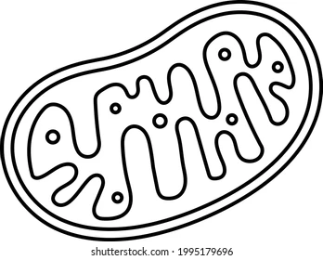
- Annotate the diagram below to show the inputs, processes, transformations and outputs associated with respiration.

- Explain how the transfers of energy and matter through photosynthesis support the first and second laws of thermodynamics.

2.2.U9 The trophic level is the position that an organism occupies in a food chain, or the position of a group of organisms in a community that occupy the same position in food chains
2.2.U10 Producers (autotrophs) are typically plants or algae that produce their own food using photosynthesis and form the first trophic level in a food chain. Exceptions include chemosynthetic organisms that produce food without sunlight.
2.2.U11 Feeding relationships involve producers, consumers and decomposers. These can be modelled using food chains, food webs and ecological pyramids

- Watch this video as an introduction to Trophic Levels https://www.youtube.com/watch?v=0glkXIj1DgE&feature=emb_logo

- State how chemosynthetic organisms are able to produce food without sunlight?
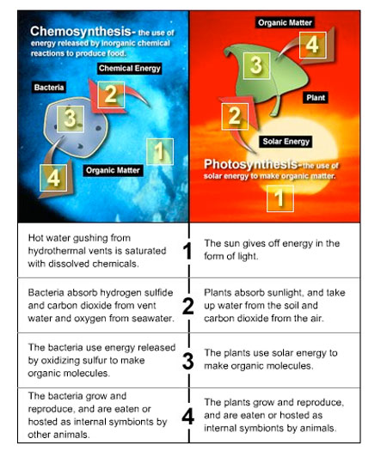

[Source: https://deepoceaneducation.org/resources/chemosynthesis/]

- Define ‘trophic level’

- Food chains represent the flow of energy and nutrients in a series of feeding relationships.
  - Construct a systems diagram showing the transfers of energy and matter through an marine ecosystem (min. 4 organisms) (Don’t forget to draw a boundary line)

  - Construct a systems diagram showing the transfers of energy and matter through an terrestrial ecosystem (min. 4 organisms) (min. 4 organisms) (Don’t forget to draw a boundary line)

  - For each of the food chains you have draw above, do the following
- label the type of consumer (e.g. carnivore, herbivore, omnivore)
- label the producer
- rank each consumer

- Complete the table.

Group | Level | Energy Source | Function/Service
Primary Consumer  (PP) | 1st | Solar energy  (autotrophs)
Secondary Consumer  (Herbivores) | 2nd |  | - Disperse seeds  - Consume green plants and keep them in check through negative feedback loops
Secondary & Tertiary Consumers  (omnivores or carnivores) |  | Consume herbivores and other carnivores, sometimes PP
Decomposers  (bacteria & fungi) |  | Dead organisms by secreting enzymes that break down organic matter | Both have the ecosystem service of  - Breaking down dead organisms  - Releasing nutrients to cycle  - Controlling the spread of disease
Detritivores  (snails, worms, slugs, maggots, vultures) |  | Heterotrophs  (consume PP)

- Watch the video clip on food webs https://youtu.be/MGODmyXkkPU

- Construct a freshwater food web based on the following information:
(You may need to research some of the organisms to learn what they are)

Organism | Energy sources
Water crowfoot | Sunlight
Cased caddisfly larva | Micro-plants, algae, particles of dead plants and animals
Damselfly nymph | Micro-plants, algae, particles of dead plants and animals
Mayfly nymph | Micro-plants, algae, particles of dead plants and animals
Dragonfly | Other adult insects and small flies
Duck | All nymphs, all plants, snails, tadpoles, young frogs
Freshwater Shrimp | Particles of dead plants and animals
Water vole | Plants
Algae | Sunlight
Otter | Fish, frogs and newts
Water starwort | Sunlight
Pond snail | Microplants, all water plants and algae
Alderfly nymph | Micro-plants, algae, particles of dead plants and animals
Pond skater | Particles of dead plants and animals
Frog | Mayfly, pond skater, caddisfly, small flies
Tadpole | Micro-plants, algae
Micro-plants | Sunlight
Great diving beetle | Water flea, snails, tadpole, all nymphs
Bullhead fish | Diving beetle, tadpole, all nymphs, snail,

Create your food web in the space below. For the food web created above:
  - Identify organisms in each of the trophic levels.
  - Identify organisms that fit more than one trophic level.
  - Identify those which could be classed as detritivores

- Suggest why it is sometimes difficult to classify organisms into trophic levels.

- Outline why numbers of organisms are smaller at higher trophic levels.

- State the original source of energy for almost all communities

- Case study and Interactive lab

http://whalingecosystems.weebly.com/ecosystem.html
How whaling affects ecosystems – make questions on this

Annenberg Learner Interactive Ecology Lab
http://www.learner.org/courses/envsci/interactives/ecology/

EXCELLENT summary to systems approach to ecosystems
- http://www.wadsworthmedia.com/biology/0495119814_starr/big_picture/ch41_bp.html

2.2.U12 Ecological pyramids include pyramids of numbers, biomass and productivity and are quantitative models that are usually measured for a given area and time
2.2.U13 In accordance with the second law of thermodynamics, there is a tendency for numbers and quantities of biomass and energy to decrease along food chains; therefore, the pyramids become narrower towards the apex
2.2.A3 Explain the relevance of the laws of thermodynamics to the flow of energy through ecosystems
2.2.U17 Pyramids of numbers can sometimes display different patterns; for example, when individuals at lower trophic levels are relatively large (inverted pyramids)]
2.2.U18 A pyramid of biomass represents the standing stock or storage of each trophic level, measured in units such as grams of biomass per square metre (g m-2) or Joules per square metre (J m-2)(units of biomass or energy)
2.2.U19 Pyramids of biomass can show greater quantities at higher trophic levels because they represent the biomass present at a fixed point in time, although seasonal variations may be marked.
2.2.U20 Pyramids of productivity refer to the flow of energy through a trophic level, indicating the rate at which that stock/storage is being generated
2.2.U21 Pyramids of productivity for entire ecosystems over a year always show a decrease along the food chain.
2.2.A2 Analyse the efficiency of energy transfers through a system.
2.2.S1 Construct models of feeding relationships such as food chains, food webs and ecological pyramids from given data

- An ecological pyramid is a graphical representation designed to show the biomass or bio productivity at each trophic level in a given ecosystem. Watch to video as an introduction https://www.youtube.com/watch?v=wGfOoRrICto&feature=emb_logo

- Pyramid of Numbers - Numbers (standing crop) units # of organisms at each trophic level per unit area N/m2
Strengths | Weaknesses

- Pyramid of Biomass (standing crop) mass of organic material in organisms or ecosystems. Unit mass per unit area (g/m2)
Strengths | Weaknesses

- Pyramid Productivity (flow of biomass or energy over time) Unit – Joules or grams over an area over a time (J/m2/yr or g/m2/yr)
Strengths | Weaknesses

- Unlike the other ecological pyramids the pyramid of productivity in a healthy ecosystem is always pyramid shaped. This is due to the 10% rule and the energy efficiency. Watch this video on the 10% rule. https://youtu.be/ScizkxMlEOM. Explain how energy flows through a community, including why energy transfers are never 100% efficient referring to the Laws of Thermodynamics in your answer.

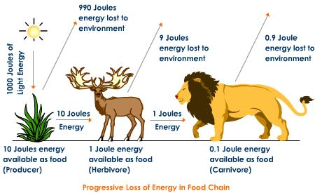

- Identify 3 sources of energy loss between each successive trophic level. Which source do you think accounts for the greatest energy loss? Support your answer with scientific reasoning and evidence from a reliable source

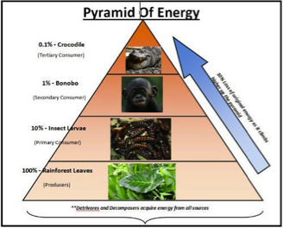

- Define biomass and outline how it can be collected and measured. Draw a labelled example of a pyramid of biomass found in a grassland which contains 500 kg m-2 of grass. Grasshoppers eat the grass and frogs eat the crickets. 20% of the energy is transferred to the second trophic level, and 10% is transferred to the third level.

- Draw a labelled example of a pyramid of productivity found in a deciduous forest which contains 1500 g m-2 yr-1. Calculate the energy transfer between trophic levels

- Using the following table, draw a pyramid of numbers. Calculate the efficiency of energy transfer through each trophic level. Why is efficiency this value?

Species | # of individuals
Kelp | 28,500,000
Sea Urchin | 4,670
Sea Otter | 154,000
Killer Whale | 170

2.2.U14 Bioaccumulation is the build-up of persistent or non-biodegradable pollutants within an organism or trophic level because they cannot be broken down
2.2.U15 Biomagnification is the increase in concentration of persistent or non-biodegradable pollutants along a food chain
2.2.U16 Toxins such as DDT and mercury accumulate along food chains due to the decrease of biomass and energy
2.2.A4 Explain the impact of a persistent or non-biodegradable pollutant in an ecosystem.

- Distinguish between bioaccumulation and biomagnification

- Define non-biodegradable pollutants.

- DDT is used as a pesticide. The material is persistant: explain what this means

- Watch this video on biomagnification and bioaccumulation in California. Explain the impact of a persistent or non-biodegradable pollutant in the ecosystem https://www.youtube.com/watch?v=FdPGRiYxKXg&feature=emb_logo

- Calcuate the % increase in toxicity from the plankton to the osprey
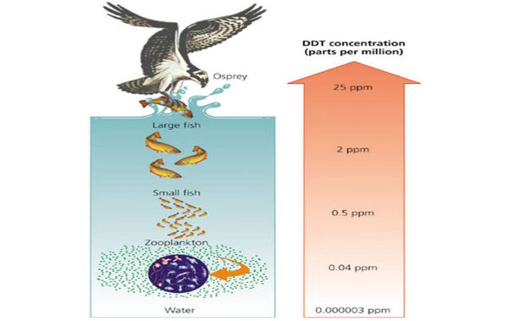

  - Suggest why apex predators are significantly affected by toxins

- What are the ecological effects of bioaccumulation and biomagnification? Use examples to support your explanation.
- Research two examples: Minamata Bay disaster, Bald Eagles https://www.youtube.com/watch?v=ihFkyPv1jtU&feature=emb_logo Minamata Bay
https://www.youtube.com/watch?v=fVI0QhJnT_c&feature=emb_logo Bald Eagles
- What were these chemicals used for?
- How did they enter ecosystems?
- What are the effects on the organisms within the ecosystem?
- What effect does this have on humans?
- Are there any solutions to the problem?
- How do you think this incident has influenced present day thinking about environmental issues?
- Record the names of any papers/websites you and use these to reference parts of your essay.

Theory of knowledge:
- Feeding relationships can be represented by different models—how can we decide when one model is better than another?

ESS can be like learning a new language. So many words are not commonly used in everyday English. This can be challenging. To help you keep up with ESS Terms, you will need to create your own ESS DICTIONARY. You should add to this over the year and keep it in your notebook or on a page file THAT YOU CAN UPDATE AND ADD TO EASILY. Most of the vocabulary words can be found either on your STUDY GUIDE or at mrgscience.com.
You will be responsible for learning the words and their meaning. Periodic quizzes will be given on the words. So, make your dictionary creative and you will remember the words more easily.

KEY TERMS

consumer

pyramid of biomass

bioaccumulation

predation

non-biological toxin

productivity

respiration

ecological pyramids

laws of thermodynamics

decomposer

pyramid of productivity

biomagnification

bio-concentration

autotroph

​heterotroph
​
trophic level

biomass

carnivore

community

photosynthesis

​chemosynthesis

energy

entropy

​DDT & Mercury
​
food chain

food web

herbivore

population

ecosystem

respiration

​photosynthesis

​Flow vs Stock/Storage

producer

pyramid of numbers

omnivore

habitat

top carnivore

transfer

​transformation

ecosystem

detritivores

