Understandings, Applications and Skills (This is what you may be assessed on)

Significant ideas
- Ecosystems are linked together by energy and matter flows.
- The Sun’s energy drives these flows, and humans are impacting the flows of energy and matter both locally and globally.
Big questions
- What strengths and weaknesses of the systems approach and the use of models have been revealed through this topic?
- How are the issues addressed in this topic of relevance to sustainability or sustainable development?
- Why are maximum sustainable yields equivalent to the net primary or net secondary productivity of a system? Why would harvesting biomass at a rate greater than NPP or GPP be unsustainable?
- How can systems diagrams of carbon and nitrogen cycles be used to who the effect of human activities on ecosystems? What are the strengths and weaknesses of such diagrams?
 | Statement | Guidance
2.3.U1 | As solar radiation (insolation) enters the Earth's atmosphere, some energy becomes unavailable for ecosystems as this energy is absorbed by inorganic matter or reflected back into the atmosphere
2.3.U2 | Pathways of radiation through the atmosphere involve a loss of radiation through reflection and absorption as shown in figure 4
2.3.U3 | Pathways of energy through an ecosystem include: conversion of light energy to chemical energy, transfer of chemical energy from one trophic level to another with varying efficiencies, overall conversion of ultraviolet and visible light to heat energy by an ecosystem, re-radiation of heat energy to the atmosphere.
2.3.U4 | The conversion of energy into biomass for a given period of time is measured as productivity | You need to be able to measure biomass and productivity experimentally. You could design experiments to compare productivity in different systems
2.3.U5 | Net primary productivity (NPP) is calculated by subtracting respiratory losses (R) from gross primary productivity (GPP). NPP = GPP - R | The distinction between storages of energy illustrated by boxes in energy-flow diagrams (representing the various trophic levels), and the flows of energy or productivity often shown as arrows (sometimes of varying widths) needs to be emphasized. The former are measured as the amount of energy or biomass per unit area dn the latter are given as rates, for example, J m-2 yr-1  ​Values for GPP and NPP should be compared from various biomes
2.3.U6 | Gross secondary productivity (GSP) is the total energy or biomass assimilated by consumers and is calculated by subtracting the mass of fecal loss from the mass of food consumed. GSP = food eaten - fecal loss
2.3.U7 | Net secondary productivity (NSP) is calculated by subtracting respiratory losses (R) from GSP.  NSP = GSP – R
2.3.U8 | Maximum sustainable yields are equivalent to the net primary or net secondary productivity of a system. Matter also flows through ecosystems linking them together. This flow of matter involves transfers and transformations.
2.3U9 | The carbon and nitrogen cycles are used to illustrate this flow of matter using flow diagrams. These cycles contain storages (sometimes referred to as sinks) and flows, which move matter between storages.
2.3.U10 | Storages in the carbon cycle include organisms and forests (both organic), or the atmosphere, soil, fossil fuels and oceans (all inorganic).
2.3.U11 | Flows in the carbon cycle include consumption (feeding), death and decomposition, photosynthesis, respiration, dissolving and fossilization.
2.3.U12 | Storages in the nitrogen cycle include organisms (organic), soil, fossil fuels, atmosphere and water bodies (all inorganic).
2.3.U13 | Flows in the nitrogen cycle include nitrogen fixation by bacteria and lightning, absorption, assimilation, consumption (feeding), excretion, death and decomposition, and denitrification by bacteria in water-logged soils.
2.3.U14 | Human activities such as burning fossil fuels, deforestation, urbanization and agriculture impact energy flows as well as the carbon and nitrogen cycles
2.3.A1 | Analyse quantitative models of flows of energy and matter
2.3.A2 | Analyse the efficiency of energy transfers through a system.
2.3.A3 | Discuss human impacts on energy flows, and on the carbon and nitrogen cycles.
2.3.S1 | Construct a quantitative model of the flows of energy or matter for given data.
2.3.S2 | Calculate the values of both GPP and NPP from given data.
2.3.S3 | Calculate the values of both GSP and NSP from given data.

2.3.U1 As solar radiation (insolation) enters the Earth's atmosphere, some energy becomes unavailable for ecosystems as this energy is absorbed by inorganic matter or reflected back into the atmosphere
The Sun’s energy drives these flows, and humans are impacting the flows of energy and matter both locally and globally.
2.3.U2 Pathways of radiation through the atmosphere involve a loss of radiation through reflection and absorption as shown in figure 4
2.3.U3 Pathways of energy through an ecosystem include: conversion of light energy to chemical energy, transfer of chemical energy from one trophic level to another with varying efficiencies, overall conversion of ultraviolet and visible light to heat energy by an ecosystem, re-radiation of heat energy to the atmosphere.

- Briefly describe the electromagnetic spectrum. Here is a nice video overview https://www.youtube.com/watch?v=m7c4-EO7ECE

- Using the data. draw a diagram to show the fate of the solar radiation reaching the Earth. You will notice that your diagram may be different from the diagram above. Explain the difference in the models.

Reflection | Absorption
Scatter 3% | Molecules and Dust 17%
Clouds 19% | Clouds 3%
Ground 9% | Ground 49%
Total 31% | Total 69%

- Roughly what percentage of the Sun’s radiation is available to plants for photosynthesis?

- Define biomass

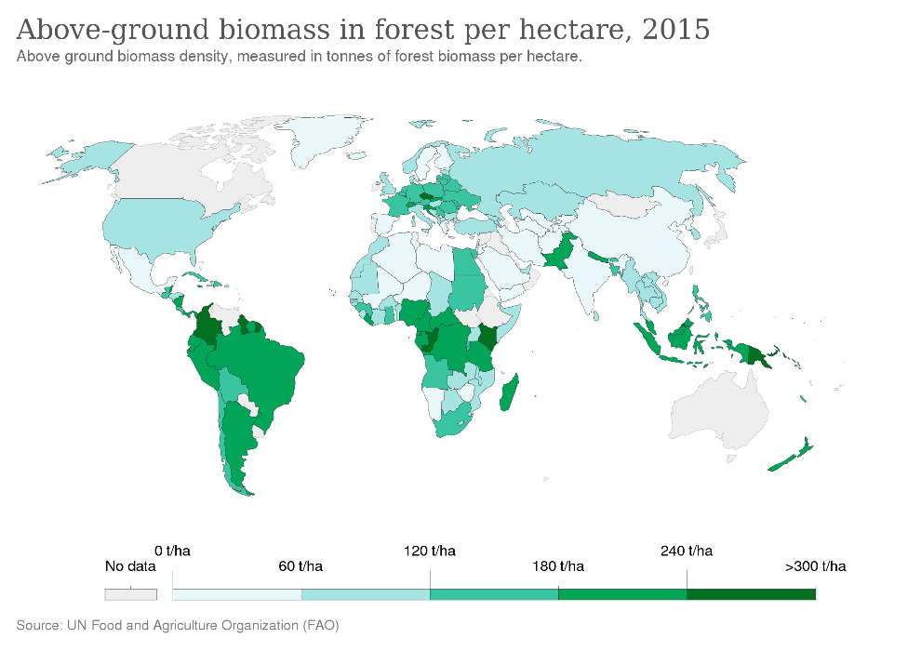
- Identify the areas with the greatest above ground biomass. State why these areas have high biomass

2.3.U4 The conversion of energy into biomass for a given period of time is measured as productivity
2.3.U5 Net primary productivity (NPP) is calculated by subtracting respiratory losses (R) from gross primary productivity (GPP). NPP = GPP - R
2.3.U6 Gross secondary productivity (GSP) is the total energy or biomass assimilated by consumers and is calculated by subtracting the mass of fecal loss from the mass of food consumed. GSP = food eaten - fecal loss
2.3.U7 Net secondary productivity (NSP) is calculated by subtracting respiratory losses (R) from GSP.
NSP = GSP – R
2.3.A1 Analyse quantitative models of flows of energy and matter
2.3.A2 Analyse the efficiency of energy transfers through a system
2.3.S1 Construct a quantitative model of the flows of energy or matter for given data

- Complete the table below summarizing the details of productivity:

Productivity type | Abbr. | Calculation | Units
Net primary
productivity
 |  | Food eaten – fecal loss
 | NSP

- Evaluate the global variation in NPP in the graph (https://www.youtube.com/watch?v=0hAiaQGHOQI)

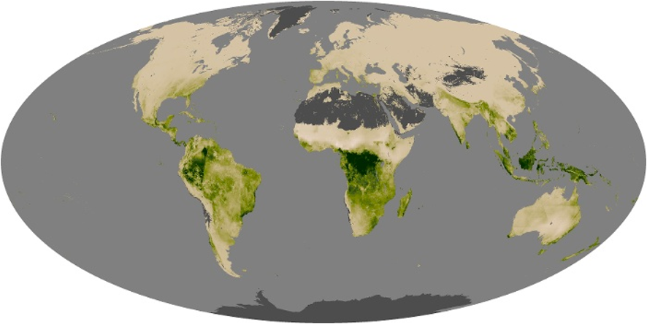

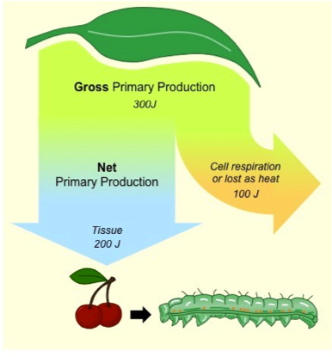
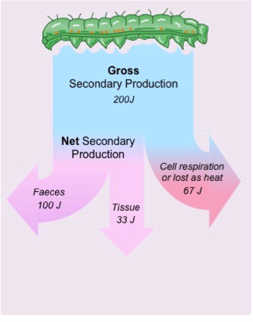

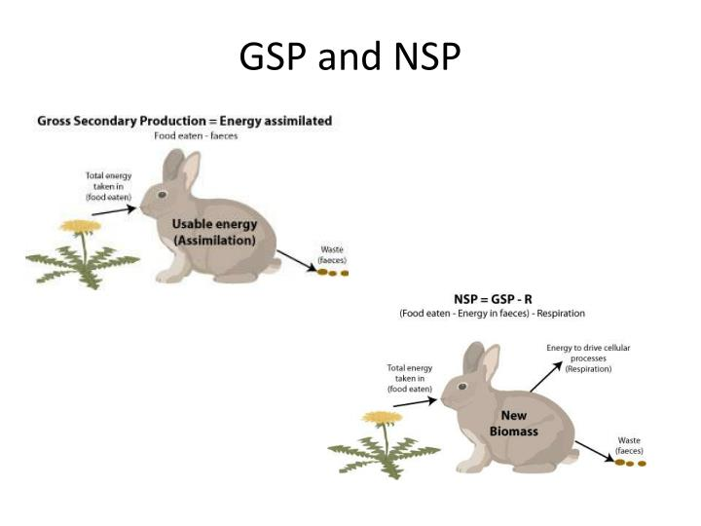

- Measuring productivity:

  - Harvest method –

  - CO2 assimilation-

  - O2 production-

  - Radioisotope method-

  - Chlorophyll measurement-

- Draw a systems diagram to summarise the pathways of energy through an ecosystem.

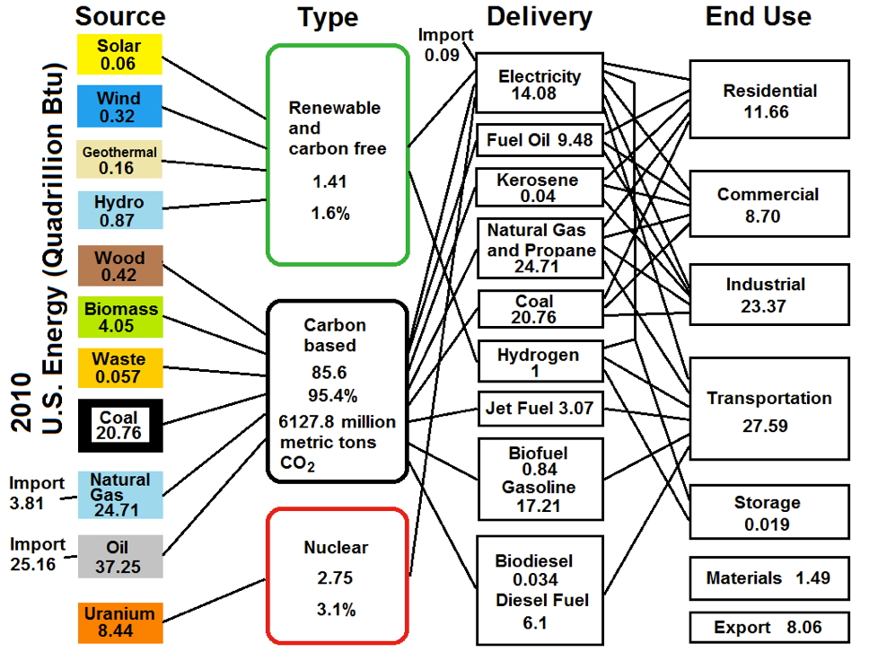
- There is a lot of data in this flowchart
- What patterns do you see?
- How do the source and type numbers impact ecosystems?

- State how the ecological efficiency can be calculated.

NOTE: Efficiency generally means you will have to calculate a percentage (%) Pay attention to units as well-they may be required in the IB ESS Exam

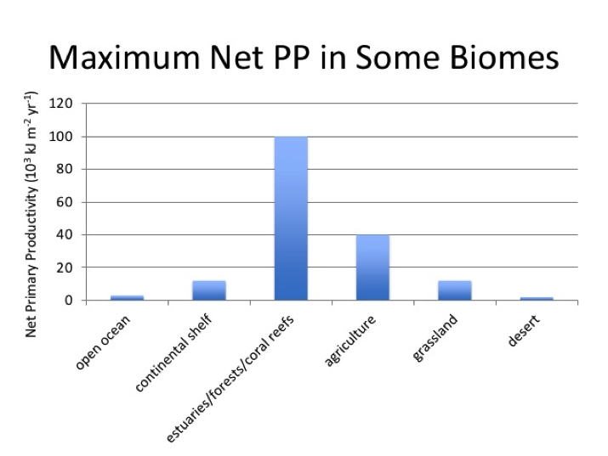
- Using the figure on the right, compare and contrast the maximum net PP in different biomes

2.3.U8 Maximum sustainable yields are equivalent to the net primary or net secondary productivity of a system. Matter also flows through ecosystems linking them together. This flow of matter involves transfers and transformations.
2.3.S2 Calculate the values of both GPP and NPP from given data
2.3.S3 Calculate the values of both GSP and NSP from given data

- Define the following
  - sustainability sustainable yield

  - maximum sustainable yield

- Use the data from the Selous Game Reserve in Tanzania as a named example of maximum sustainable yield.
- Current population = 1,000
- Average annual births = 78
- Average annual deaths = 48
- Natural income = 30 lions/year

- This is an old video but it is entirely relevant. Watch the video and note the calculations performed for GSP and NSP https://www.youtube.com/watch?v=8CXSd9FUl5Q

- The data in the table below relate to the transfer of energy in a small clearly defined habitat. The units in each case are in kJ m⁻² yr⁻¹
Trophic Level | Gross Production | Respiratory Loss | Loss to Decomposers
Primary Producer | 60724 | 36120 | 477
Primary consumer | 21762 | 14700 | 3072
Secondary consumer | 714 | 576 | 42
Tertiary consumer | 7 | 4 | 1
Respiratory loss by decomposers | --- | 3120 | ---

- Construct an energy flow model to represent all these data – Label each arrow with the appropriate amount from the data table above.
- Use boxes to represent each trophic level and arrows to show the flow of energy
- Calculate the Net Productivity for
  - NPP for Producers
  - NSP for 1°Consumers, 2°Consumers, 3°Consumers
  - NSP for Decomposers

2.3U9 The carbon and nitrogen cycles are used to illustrate this flow of matter using flow diagrams. These cycles contain storages (sometimes referred to as sinks) and flows, which move matter between storages.
2.3.U10 Storages in the carbon cycle include organisms and forests (both organic), or the atmosphere, soil, fossil fuels and oceans (all inorganic).
2.3.U11 Flows in the carbon cycle include consumption (feeding), death and decomposition, photosynthesis, respiration, dissolving and fossilization.
2.3.U12 Storages in the nitrogen cycle include organisms (organic), soil, fossil fuels, atmosphere and water bodies (all inorganic).
2.3.U13 Flows in the nitrogen cycle include nitrogen fixation by bacteria and lightning, absorption, assimilation, consumption (feeding), excretion, death and decomposition, and denitrification by bacteria in water-logged soils.
2.3.U14 Human activities such as burning fossil fuels, deforestation, urbanization and agriculture impact energy flows as well as the carbon and nitrogen cycles
2.3.A3 Discuss human impacts on energy flows, and on the carbon and nitrogen cycle

- Watch these videos on the Carbon Cycle as a nice review https://www.youtube.com/watch?v=hgFpvDNfXOk&feature=emb_logo
https://www.youtube.com/watch?v=HrIr3xDhQ0E&feature=emb_logo

- This is a great video review of the nitrogen cycle. https://www.youtube.com/watch?v=vZ9b5c8BOT4&feature=emb_logo
https://www.youtube.com/watch?v=pdY4I-EaqJA&feature=emb_logo

- Draw a diagram of the nitrogen and carbon cycle, showing as many energy and matter transfers and transformations as you can. You will need to look up cycles in your books or the internet.

Diagram Requirements
- Inputs should be shown as yellow arrows entering the system
- Outputs should be shown as orange arrows leaving the system
- Use red boxes for storages (Label the name of the storage inside)
- Use blue arrows for flows between storages
- Write Tr on arrows that demonstrates a transfer
- Write Tfm on arrows that demonstrate a transformation

- Discuss how the burning of fossil fuels or deforestation affects the carbon cycle? Be specific,
  - Note the sources
  - Note the uses
  - Explain the impact on the environment
  - Explain the social and economic costs of this problem
  - Explain what the world is doing to construct treaties to manage the impacts, identify possible solutions to the issue
  - How do these relate to the C and N cycle?
    - Inputs
    - Outputs
    - Storages

- Discuss how urbanization and agriculture affect either the carbon cycle? Be specific,
  - Note the sources
  - Note the uses
  - Explain the impact on the environment
  - Explain the social and economic costs of this problem
  - Explain what the world is doing to construct treaties to manage the impacts, identify possible solutions to the issue
  - How do these relate to the C and N cycle?
    - Inputs
    - Outputs
    - Storages

- Nitrogen is a major building block of plant biomass. What happens to the cycle when commercial crops are harvested and removed from a location? What happens when composting is used to improve soils
Use the article below to summarise each of the different ways that humans have altered the nitrogen cycle. Restrict your notes to no more than 3 bullet points.
http://www.esa.org/esa/documents/2013/03/issues-in-ecology-issue-1.pdf

Process | Impact
Human driven nitrogen fixation
Nitrogen fertilizer
Nitrogen-fixing crops
Fossil fuel burning
Mobilisation of stored nitrogen

- Consider:
Biomass contains energy in its molecular bonds. Removing biomass disrupts energy flows in ecosystems. Relate these ideas to growing plant crops, raising livestock, and harvesting wild animals such as fish

Theory of knowledge:

- The Sun’s energy drives energy flows, and throughout history there have been “myths” about the importance of the Sun—what role can mythology and anecdotes play in the passing on of scientific knowledge?

ESS can be like learning a new language. So many words are not commonly used in everyday English. This can be challenging. To help you keep up with ESS Terms, you will need to create your own ESS DICTIONARY. You should add to this over the year and keep it in your notebook or on a page file THAT YOU CAN UPDATE AND ADD TO EASILY. Most of the vocabulary words can be found either on your STUDY GUIDE or at mrgscience.com.
You will be responsible for learning the words and their meaning. Periodic quizzes will be given on the words. So, make your dictionary creative and you will remember the words more easily.

KEY TERMS

producers

biomass

autotroph

heterotroph

denitrification

chlorophyll

inorganic

productivity

energy

storage

urbanization

efficiency​

consumers

processes

energy flow

gross productivity

biogeochemical cycles

nitrogen fixation

primary productivity

insolation

​transformations

​fossilization

​excretion

energy subsidy

energy transfer

net productivity

transformations

nitrification

mitochondria

faecal matter

​reflection

​matter

​fossil fuels

deforestation

photosynthesis

gross secondary productivity

gross primary productivity

net primary productivity

net secondary productivity

solar radiation incident

energy flow diagram

​absorption

sustainable yield

​carbon fixation

respiration

solar radiation

trophic level

carbon cycle

nitrogen cycle

assimilation

reflection

macronutrients

​transfers

​flows and sinks

​energy budget

