Understandings, Applications and Skills (This is what you may be assessed on)

Significant ideas
- Climate determines the type of biome in a given area, although individual ecosystems may vary due to many local abiotic and biotic factors.
- Succession leads to climax communities that may vary due to random events and interactions over time. This leads to a pattern of alternative stable steady states for a given ecosystem.
- Ecosystem stability, succession and biodiversity are intrinsically linked.
Big questions
- What strengths and weaknesses of the systems approach and the use of models have been revealed through this topic?
- How are the issues addressed in this topic of relevance to sustainability or sustainable development?
- What are the strengths and weaknesses of models of succession and zonation?
- How could the R/R ration be used to estimate whether the harvesting of a natural capital, such as trees, is sustainable or not?

 | Statement | Guidance
2.4.U1 | Biomes are collections of ecosystems sharing similar climatic conditions which can be grouped into five major classes-aquatic, forest, grassland, desert and tundra. Each of these classes will have characteristic limiting factors, productivity and biodiversity. | You are encouraged to study at least four contrasting pairs of biomes of interest, such as temperate forests and tropical seasonal forests; or tundras and deserts; or tropical coral reefs and hydrothermal vents; or temperate bogs and tropical mangrove forests
2.4.U2 | Insolation, precipitation, and temperature are the main factors governing distribution of biomes.
2.4.U3 | The tricellular model of atmospheric circulation explains the distribution of precipitation and temperature influencing structure and relative productivity of different terrestrial biomes.
2.4.U4 | Climate change is altering the distribution of biomes and causing biome shifts.
2.4.U5 | Zonation refers to changes in community along an environmental gradient due to factors such as changes in altitude, latitude, tidal level or distance from shore (coverage by water). | It is important to distinguish zonation (a spacial phenomenon) from succession (a temporal phenomenon)  ​  Named examples of organisms from the pioneer, intermediate and climax communities should be provided
2.4.U6 | Succession is the process of change over time in an ecosystem involving pioneer, intermediate and climax communities. | It is important to distinguish zonation (a spacial phenomenon) from succession (a temporal phenomenon)  ​[Named examples of organisms from the pioneer, intermediate and climax communities should be provided
2.4.U7 | During succession, the patterns of energy flow, gross and net productivity, diversity, and mineral cycling change over time
2.4.U8 | Greater habitat diversity leads to greater species and genetic diversity..
2.4U9 | r- and K-strategist species have reproductive strategies that are better adapted to pioneer and climax communities, respectively
2.4.U10 | In early stages of succession, gross productivity is low due to the unfavourable initial conditions and low density of producers. The proportion of energy lost through community respiration is relatively low too, so net productivity is high—that is, the system is growing and biomass is accumulating.
2.4.U11 | In later stages of succession, with an increased consumer community, gross productivity may be high in a climax community. However, this is balanced by respiration, so net productivity approaches 0 and the productivity–respiration (P:R) ratio approaches 1.
2.4.U12 | In a complex ecosystem, the variety of nutrient and energy pathways contributes to its stability.
2.4.U13 | There is no one climax community, but rather a set of alternative stable states for a given ecosystem. These depend on the climatic factors, the properties of the local soil and a range of random events that can occur over time
2.4.U14 | Human activity is one factor that can divert the progression of succession to an alternative stable state by modifying the ecosystem; for example, the use of fire in an ecosystem, the use of agriculture, grazing pressure, or resource use (such as deforestation). This diversion may be more or less permanent depending upon the resilience of the ecosystem.
2.4.U15 | An ecosystem’s capacity to survive change may depend on its diversity and resilience.
2.4.A1 | Explain the distributions, structure, biodiversity and relative productivity of contrasting biomes
2.4.A2 | Discuss the impact of climate change on biomes.
2.4.A3 | Describe the process of succession in a given example.
2.4.A4 | Explain the general pattern of change in communities undergoing succession
2.4.A5 | Discuss the factors that could lead to alternative stable states in an ecosystem. | You need to be able to discuss the factors which could lead to alternative stable states in an ecosystem, and discuss the link between ecosystem stability, succession, diversity, and human activity
2.4.A6 | Distinguish the roles of r and K selected species in succession.
2.4.S1 | Analyse data for a range of biomes
2.4.S2 | Interpret models or graphs related to succession and zonation.

Climate determines the type of biome in a given area, although individual ecosystems may vary due to many local abiotic and biotic factors.
2.4.U2 Insolation, precipitation, and temperature are the main factors governing distribution of biomes.
2.4.U3 The tricellular model of atmospheric circulation explains the distribution of precipitation and temperature influencing structure and relative productivity of different terrestrial biomes.

- Explain how angle of insolation affects the temperature at different latitudes referring to the
diagram below:
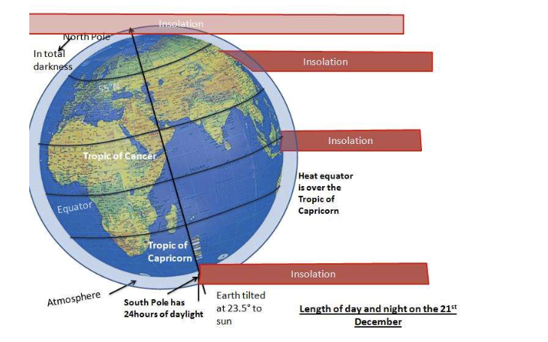

- Define the following terms with a specific example

Term | Definition | Explain how it governs the distribution of biomes
Insolution

Precipitation

Temperature

Climate

Latitude

Altitude

Ocean currents

Winds

Rain shadow

- Watch the video demonstration. Warm water has been placed on the left side and ice water has been placed on the right side. https://www.youtube.com/watch?v=7xWWowXtuvA&feature=emb_logo
  - Draw a diagram of what you notice in the demonstration. Use arrows to indicate the flow and direction.

  - Explain why the dye moves in the direction you notice.

  - What natural systems have convection cells?

  - Why are these convection cells important?

  - Complete the diagram below to represent the tri-cellular model of atmospheric circulation.

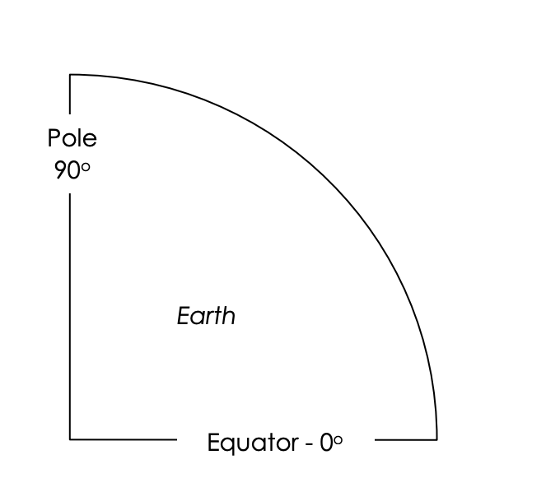

  - With reference to the tri-cellular model, summarise what is happening in terms of air movement and precipitation at the following places:

Location | Air/Precipitation
ITCZ | Warm air rises. Water condenses as it rise so there is high amount of precipitation
Between 90º and 60º
At 60º
Between 60º and 30º

  - Explain why the tropics are generally wetter than the polar zones and spring, summer and fall are wetter than winter. Describe how the Hadley Cell impacts climate.

- The distribution of biomes is largely affected by productivity, which is influenced by photosynthesis. State how the following climatic variables affect the rate of photosynthesis

Climate Variable | Effect on photosynthesis Insolation
Temperature

Precipitation

Insolution

- Other than climate, what other factors can influence the distribution of biomes?

2.4.U1 Biomes are collections of ecosystems sharing similar climatic conditions which can be grouped into five major classes-aquatic, forest, grassland, desert and tundra. Each of these classes will have characteristic limiting factors, productivity and biodiversity.
2.4.A1 Explain the distributions, structure, biodiversity and relative productivity of contrasting biomes
2.4.S1 Analyse data for a range of biomes

- Identify the 5 major biomes

- Look at the biome precipitation and temperature graphs. What are the trends? What are the similarities and differences?
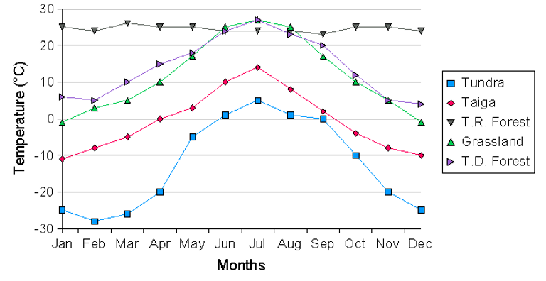
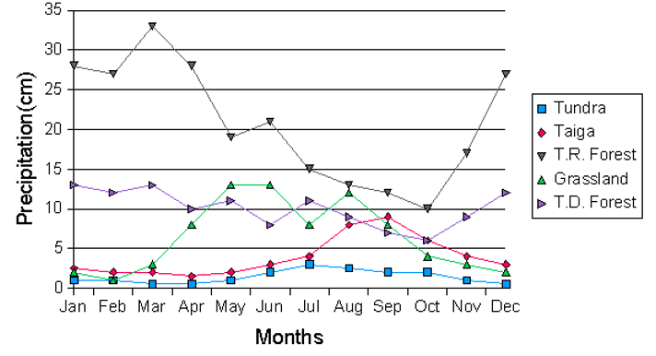

- Complete the table below of the limiting factors within each biome

Aquatic | Forest | Grassland | Desert | Tundra
Water absorbs some light and limits photosynthesis |  | Less precipitation than forest, but more than deserts
 | High rainfall leaches nutrients from soils (TFR)
 |  |  |  | Photosynthesis limited from frozen water in winter and saturated soils after thaw
Freshwater may freeze in temperate or polar winters |  |  | Photosynthesis limited - low H₂O

- Complete the table below of productivity within each biome

Aquatic | Forest | Grassland | Desert | Tundra
Tropical coral reef=high |  | Moderate to low |  | Low due to short days and low temperatures
 | Temperature rainforests also high productivity but lower in autumn and winter |  | Water needed for photosynthesis

- Complete the table below of biodiversity within each biome
Aquatic | Forest | Grassland | Desert | Tundra
 | Very high |  | Low | Limited
 |  | Diverse plant life and soils rich in nutrients support extensive food webs
Temperature freshwater=moderate to low

The relationship between the major terrestrial biomes and climate is shown below.
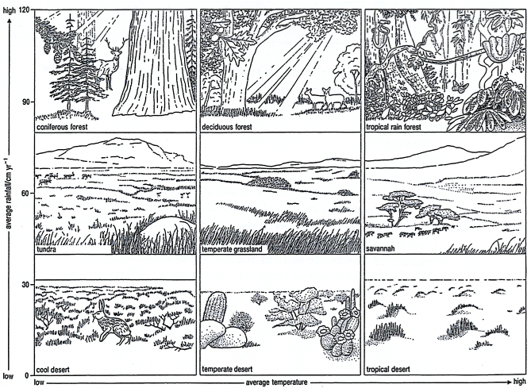

- Evaluate the graph with reference to NPP and biome. Suggest reasons for these differences
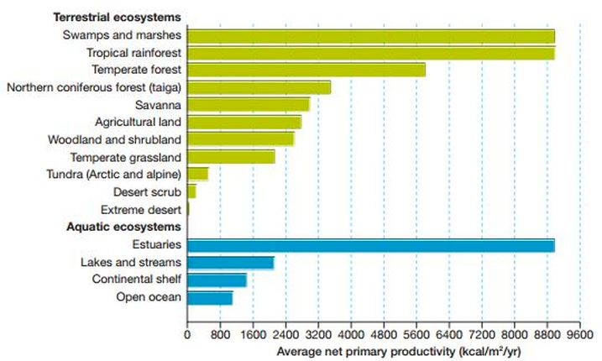
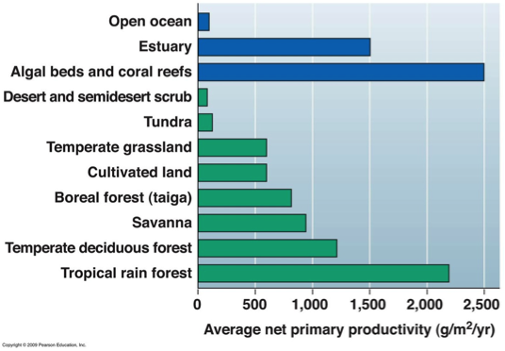
- Analyse the graph. Describe why productivity is greater in lower altitudes (nearest to the equator) that the upper altitudes

- Precipitation to evaporation ratios (P/E) influence soil conditions. Explain why a high P/E results in low soil fertility and a low P/E results in salinization of soil.

2.4.U4 Climate change is altering the distribution of biomes and causing biome shifts.
2.4.A2 Discuss the impact of climate change on biomes.

- Outline the changes to biomes that are occurring worldwide as a consequence of global climate change.

  - Briefly explain the ways some species are moving in response to climate change.

  - Summarise the limits to species movement and migration

- Compare the changes in tree biomass, grass biomass, and total biomass across Africa between 2008 and 2010
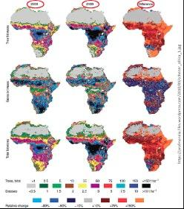

  - Identify and describe the patterns you see

  - Explain why these shifts may occur, with reference to the tricellular model

- Read the article below and watch the video “Climate Change Serengeti https://www.youtube.com/watch?v=a5wVVPeOoe
“By 2100, global climate change will modify plant communities covering almost half of Earth's land surface and will drive the conversion of nearly 40 percent of land-based ecosystems from one major ecological community type -- such as forest, grassland or tundra -- toward another, according to a new NASA and university computer modelling study.”
http://www.sciencedaily.com/releases/2011/12/111218221321.htm
  - From the information presented, discuss the impact on climate change and biome shifts.

2.4.U5 Zonation refers to changes in community along an environmental gradient due to factors such as changes in altitude, latitude, tidal level or distance from shore (coverage by water).

For each species there is an ecological niche. That niche has boundary limits and outside these, the species cannot live. There are many abiotic and biotic factors that influence these limits. The most important on mountains are:
- Temperature – decreases with altitude
- Precipitation – most rainfall is at middle altitudes
- Soil insolation – more intense at higher altitudes
- Soil type – decomposition is faster at warmer zones so lower altitudes are more fertile
- Interactions between species -competition may crowd out some species and grazing may alter plant composition

Here is a great video on Rocky Shore Zonation https://www.youtube.com/watch?v=mHai7iZKCIM

Human activities such as road building on mountains may allow tourism into previously inaccessible areas or deforestation or agriculture altering zonation.

- Zonation occurs on different scales that can be both local and global. Define zonation

- Complete the table to help you understand the different types of zonation
Type of Zonation | Abiotic Factors Changing | Named Examples
Biomes

Montane or Altitude Zonation

Ocean Zonation

Littoral or Intertidal Zonation

Tidal Deltas

- State how the following factors can change a community

Factor | Change
Temperature

Precipitation

Insoluation

Soil type

Species interaction

Latitude

Tidal level

Distance from shore

Graphic representations of zonation is often by a kite diagram where the width of the kites corresponds to the number of that species. Kite diagrams are a chart that shows the number of animals (or percentage cover for plants) against distance along a transect. The distribution of organisms in a habitat is affected by the presence of other living organisms, such as herbivores or predators that might eat them. It is also affected by abiotic factors (physical factors) such as availability of light or water. The width of the “kite” represents the number of species.
The kite diagram is frequently used to show zonation along a transect. A gradual change in the distribution of species across a habitat is called zonation. It can happen because of a gradual change in an abiotic factor. A transect is line across a habitat or part of a habitat. It can be as simple as a string or rope placed in a line on the ground. The number of organisms of each species can be observed and recorded at regular intervals along the transect.
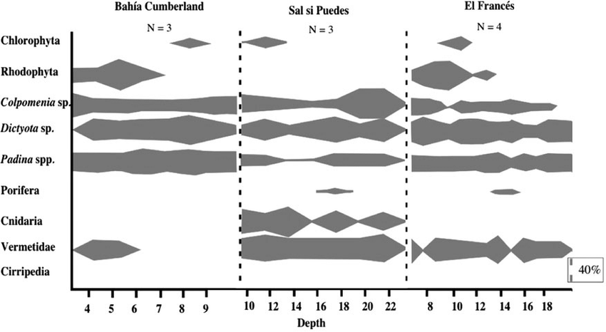

Image from https://www.researchgate.net/figure/Kite-diagrams-of-benthic-species-zonation-by-depth-at-the-three-study-sites-Scale-bar_fig4_236619081

Kite diagrams of benthic species zonation by depth at the three study sites. Scale bar represents 40% of cover in 0.25 m 2 quadrats. Number of transects (N) are given per site.

- Kite diagrams are an effective way to show how species abundance changes along an environmental gradient. Use the kite diagram below to answer the questions
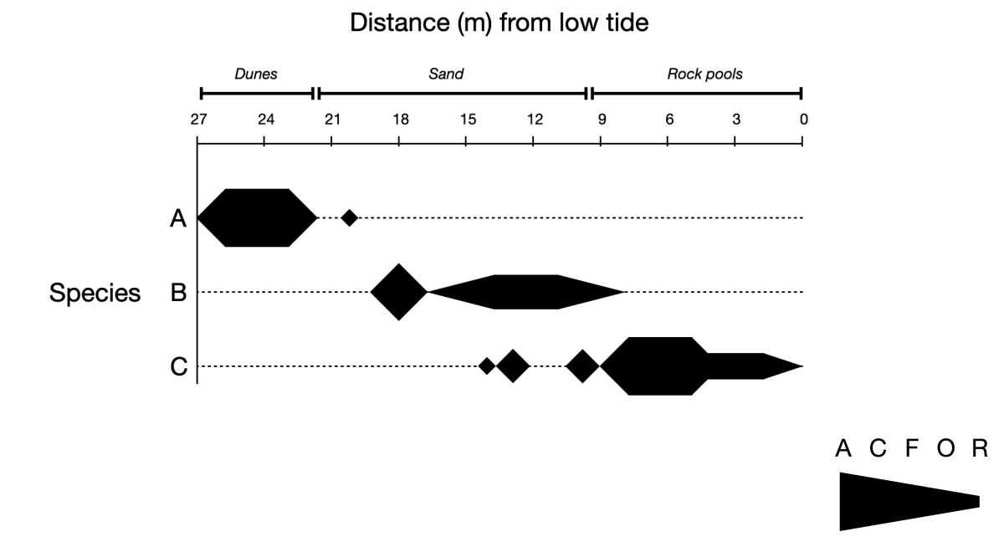
  - State which species is most abundant in rock pools

  - State which species is present furthest from the shoreline

  - Using the ACFOR scale, state the maximum abundance of the following species in the specified location:
Series | Location | Abundance (ACFOR)
A | Sand
B | Sand
C | Sand
A | Rock Pools

2.4U9 r- and K-strategist species have reproductive strategies that are better adapted to pioneer and climax communities, respectively
2.4.A6 Distinguish the roles of r and K selected species in succession.

Species differ in the rate at which their populations increase in numbers. As an extreme example, populations of bacteria increase in size rapidly, while populations of elephants increase in size much more slowly. Population ecologists have identified two main strategies shown by organisms.

- Define the terms r-strategists and K–strategists

- Complete the following table to illustrate the differences between r- and k- strategists.

FEATURES | r-strategists | K-strategists
Size
Life span
Colonizing ability
Number of offspring
Care of the young
Competitive ability
Adaptability
Reproductive episodes
Reproductive cycle
Dispersal
Population density
Examples of organisms

r- and K-strategists between represent idealised categories and many organisms occupy a place on the continuum.

- Annotate the survivorship curve below
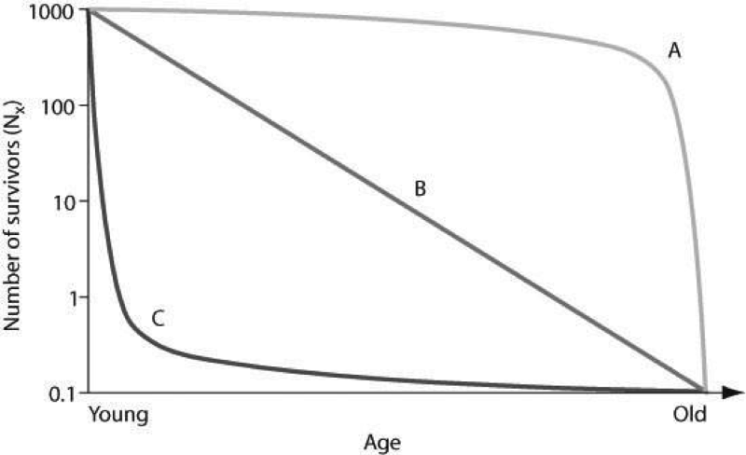

2.4.U6 Succession is the process of change over time in an ecosystem involving pioneer, intermediate and climax communities.
2.4.U7 During succession, the patterns of energy flow, gross and net productivity, diversity, and mineral cycling change over time
2.4.U8 Greater habitat diversity leads to greater species and genetic diversity..
2.4.U10 In early stages of succession, gross productivity is low due to the unfavourable initial conditions and low density of producers. The proportion of energy lost through community respiration is relatively low too, so net productivity is high—that is, the system is growing and biomass is accumulating.
2.4.U11 In later stages of succession, with an increased consumer community, gross productivity may be high in a climax community. However, this is balanced by respiration, so net productivity approaches 0 and the productivity–respiration (P:R) ratio approaches 1.
2.4.U12 In a complex ecosystem, the variety of nutrient and energy pathways contributes to its stability.
2.4.U13 There is no one climax community, but rather a set of alternative stable states for a given ecosystem. These depend on the climatic factors, the properties of the local soil and a range of random events that can occur over time
2.4.U15 An ecosystem’s capacity to survive change may depend on its diversity and resilience.
2.4.A6 Discuss the links between stability, succession, diversity and human activity
2.4.S2 Interpret models or graphs related to succession and zonation.
2.4.A3 Describe the process of succession in a given example
2.4.A4 Explain the general pattern of change in communities undergoing succession
2.4.A5 Discuss the factors that could lead to alternative stable states in an ecosystem

- Define succession.

- Distinguish between primary and secondary succession

- Complete the boxes to show the stages of primary succession

Stage | Terrain/Soil | Biota
Bare surface | No real soil. Only mineral particles. | None
Stage 1: colonisation

Stage 2: Establishment

Stage 3: Competition

Stage 4: Stabilisation

Climax community

- Outline how the following change throughout succession

NPP

GPP

Productivity:Respiration ratio

Soil depth

Complexity of ecosystem

Energy flow

Average organism size

- Explain the changes in both NPP and GPP that occur throughout succession.

- The critical aspects of resilience includes:

- The growth of new forest during secondary succession produces a habitat that is very different to the original. Secondary forests tend to display denser growth and contain species not found in the original primary forest. Suggest what this could be
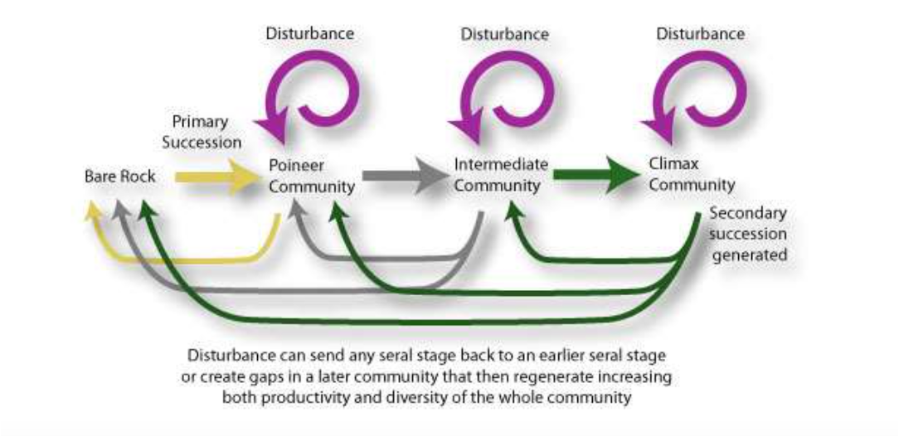

- Why does the makeup of communities change with time in undisturbed ecosystems? Consider species richness and species evenness during each of succession
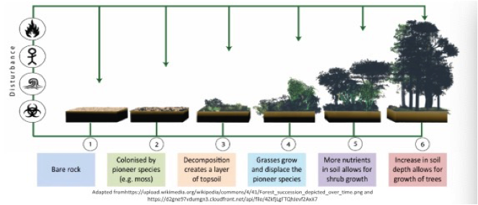

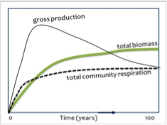
- Explain the levels of productivity, diversity, and biomass from disturbance to climax community. Describe what is happening in the graph on the right

- Read the following extract:

Krakatoa – an example of primary succession ( a Lithosere).

Extract taken from “The Living Planet” by David Attenborough

It was one of the Indonesian volcanoes that produced the most catastrophic explosion yet recorded. In 1883, a small island named Krakatau, 7 kilometers long by 5 kilometers wide, lying in the straits between Sumatra and Java, began to emit clouds of smoke. The eruptions continued with increasing severity day after day. Ships sailing nearby had to make their way through immense rafts of pumice that floated on the surface of the sea. Ash rained down on their decks and electric flames played along their rigging. Day after day, enormous quantities of ash, pumice and lava blocks were thrown out from the crater, accompanied by deafening explosions. But the subterranean chamber from which all this material was coming was slowly emptying. At 10 a.m. on 28 August, the rock roof of the chamber, insufficiently supported by lava beneath, could bear the weight of the ocean and its floor no longer. It collapsed. Millions of tons of water fell on to the molten lava in the chamber and two-thirds of the island tumbled on top of it. The result was an explosion of such magnitude that it produced the loudest noise ever to echo around the world in recorded history. It was heard quite distinctly over 3000 kilometers away in Australia. Five thousand kilometers away, on the small island of Rodriguez, the commander of the British garrison thought it was the sound of distant gunfire and put out to sea. A tempest of wind swept away from the site and circled the earth seven times before it finally died away. Most catastrophic of all, the explosion produced an immense wave in the sea. As it travelled towards the coast of Java, it became a wall of water as high as a four-story house. It picked up a naval gunboat, carried it bodily nearly 2 kilometers inland and dumped it on top of a hill. It overwhelmed village after village along the thickly populated coast. Over 36,000 people died.

Krakatau shows how complete a recovery can be. Fifty years after the catastrophe, a small vent spouting fire arose from the sea. The people called it Anak – the child – of Krakatau. Already it has thickets of casuarina and wild sugar cane growing on its flanks. A remnant of the old island, now called Rakata, lies a mile or so away across the sea. The slopes that a century ago were bare are now covered by a dense tropical forest. Some of the seeds from which it sprang must have floated here across the sea. Others were carried by the wind or brought on the feet or in the stomach of birds. In this forest live many winged creatures – birds, butterflies and other insects – that clearly had little difficulty in reaching the island from the mainland a mere 40 kilometers away. Pythons, monitor lizards and rats have also arrived here, perhaps on floating rafts of vegetation that frequently get swept down tropical rivers. But evidence of the newness of the forest, and the cataclysm that preceded it, is easy to find. The tree roots cover the surface of the ground with a lattice that clasps the earth together, but here and there, a stream has undermined them, and a tree has toppled to reveal the still loose and powdery volcanic dust beneath. Once the plant cover has been broken in this way, the loose ash is easily eroded by the stream and a narrow gorge, 6 or 7 meters deep, appears beneath a roof of interlaced roots. But these breaks are the exception. The tropical forest has, within a century, reclaimed Krakatau.

  - Explain the ecological changes that have occured on Krakatoe since its formation in 1883. Include justified predictions about its future development.”

- Review the table below
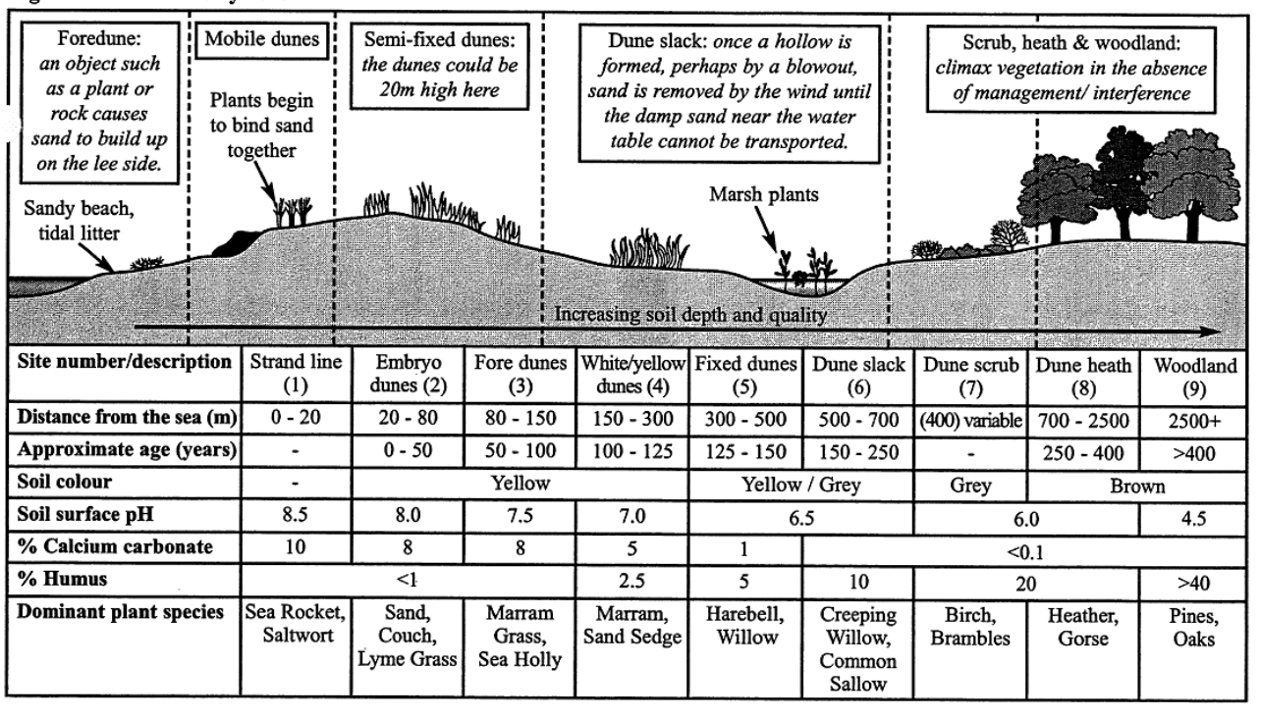
On the axes below, sketch a line showing the change of soil pH, humus content of soil, species diversity and mineral content of soil over time. Don’t forget to include a key that identifies each line
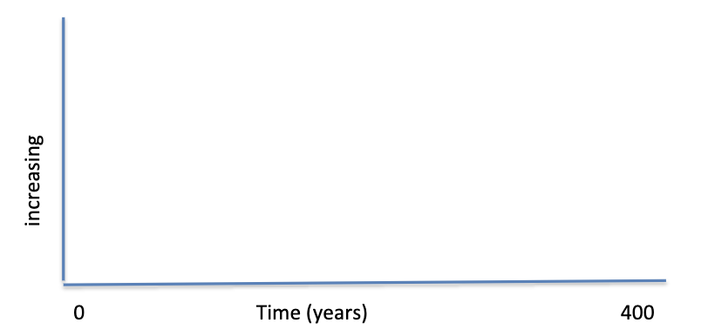

2.4.U14 Human activity is one factor that can divert the progression of succession to an alternative stable state by modifying the ecosystem; for example, the use of fire in an ecosystem, the use of agriculture, grazing pressure, or resource use (such as deforestation). This diversion may be more or less permanent depending upon the resilience of the ecosystem.

- A climax community produced by the action of humans is called a PLAGIOCLIMAX. List how this may occur

  - List the ways in which humans can disrupt the process of succession.

  - When succession is disrupted, the system may recover quickly or slowly from the disruption, depending on its resilience. Explain what is meant by ecosystem resilience.

Theory of knowledge:
- Ecosystems are studied by measuring biotic and abiotic factors—how can you know in advance which of these factors are significant to the study?

ESS can be like learning a new language. So many words are not commonly used in everyday English. This can be challenging. To help you keep up with ESS Terms, you will need to create your own ESS DICTIONARY. You should add to this over the year and keep it in your notebook or on a page file THAT YOU CAN UPDATE AND ADD TO EASILY. Most of the vocabulary words can be found either on your STUDY GUIDE or at mrgscience.com.
You will be responsible for learning the words and their meaning. Periodic quizzes will be given on the words. So, make your dictionary creative and you will remember the words more easily.

KEY TERMS

atmosphere

desert

temperate grassland

insolation

deciduous

arid

permafrost

Coriolis Effect

zonation

​tricellular model

secondary succession

hydrosphere

tropical rainforest

global location

structure

latitude

semi arid

monospecific

​succession

​precipitation

​insolation

biome shift

​disturbance

resilience

temperature

geosphere

taiga (boreal)

species diversity

stratified

ecotones

fertile

​pioneer species

​limiting factor

​primary succession

​climax community

biomes

arctic tundra

productivity

understory

scrub-lands

muskegs

​insolation

r-strategy

​gross productivity

​latitude

savannah

temperate forest

canopy

evergreen

broad leaf

browsing

​latitude

primary succession

​k-strategy

​temperature

​net productivity

