Topic 2.5 Investigating Ecosystems

Understandings, Applications and Skills (This is what you maybe assessed on)

Significant ideas
- The description and investigation of ecosystems allows for comparisons to be made between different ecosystems and for them to be monitored, modelled and evaluated over time, measuring both natural changes and human impacts.
- Ecosystems can be better understood through the investigation and quantification of their components.

 | Statement | Guidance
2.5.U1 | The study of an ecosystem requires that it be named and located ex: Sundarban’s, Bangladesh, a Mangrove forest along the South-western coastline of Bangladesh
2.5.U2 | Organisms in named and located an ecosystem can be identified using a variety of tools including dichotomous keys, comparisons to herbarium/ specimen collections, technologies and scientific expertise. | When constructing identification keys, students should be reminded that generic  terms such as “big” or “small” are not useful. Comparative, quantitative descriptors  and simple identification of the presence or absence of external features are most  useful in keys.
2.5.U3 | Sampling strategies may be used to measure biotic and abiotic factors and their change in space, along an environmental gradient, over time, through succession or before and after a human impact, for example as part of an EIA. | The design of sampling strategies needs to be appropriate for its purpose and  provide a valid representation of the system being investigated. Suitable sampling  techniques include random or systematic in a uniform environment, or transects  over an environmental gradient.  Students should be familiar with the measurement of at least three abiotic factors.  These could come from different ecosystems, such as:  – marine—salinity, pH, temperature, dissolved oxygen, wave action  – freshwater—turbidity, flow velocity, pH, temperature, dissolved oxygen  – terrestrial—temperature, light intensity, wind speed, particle size, slope,  soil moisture, drainage, mineral content.
2.5.U4 | Measurements should be repeated to increase reliability of data. The number of repetitions required depends on the factor being measured.
2.5.U5 | Methods for estimating the biomass and energy of trophic levels in a community include measurement of dry mass, controlled combustion, and extrapolation from samples. Data from these methods can be used to construct ecological pyramids.
2.5.U6 | Methods for estimating the abundance of non-motile organisms include the use of quadrats for making actual counts, measuring population density, percentage coverage, and percentage frequency. | Percentage cover is an estimate of the area in a given frame size (quadrat)  covered by the plant in question. Percentage frequency is the number of  occurrences divided by the number of possible occurrences; for example, if a plant  occurs in 5 out of 100 squares in a grid quadrat, then the percentage frequency is  5%.
2.5.U7 | Direct and indirect methods for estimating the abundance of motile organisms can be described and evaluated. Direct methods include actual counts and sampling. Indirect methods include the use of capture-mark-recapture with the application of the Lincoln Index. | Formulae do not need to be memorized but should be applied to given data.
2.5.U8 | Species richness is the number of species in a community and is a useful comparative measure.
2.5U9 | Species diversity is a function of the number of species and their relative abundance and can be compared using an index. There are many versions of diversity indices but students are only expected to be able to apply and evaluate the results of the Simpson Diversity Index. Using its formula, the higher the result, the greater the species diversity. This indication of diversity is only useful when comparing two similar habitats or the same habitat over time. | Formulae do not need to be memorized but should be applied to given data.
2.5.A1 | Evaluate sampling strategies. | The design of sampling strategies needs to be appropriate for its purpose and  provide a valid representation of the system being investigated. Suitable sampling  techniques include random or systematic in a uniform environment, or transects  over an environmental gradient.
2.5.A2 | Evaluate methods to measure at least three abiotic factors in an ecosystem.
2.5.A3 | Evaluate methods to investigate the change along an environmental gradient and the effect of a human impact in an ecosystem. | Suitable human impacts might include toxins from mining activity, landfills,  eutrophication, effluent, oil spills, overexploitation and change of land use (for  example, deforestation, development or use for tourism activities).
2.5.A4 | Evaluate methods for estimating biomass at different trophic levels in an ecosystem. | The design of sampling strategies needs to be appropriate for its purpose and  provide a valid representation of the system being investigated. Suitable sampling  techniques include random or systematic in a uniform environment, or transects  over an environmental gradient.  Students should be familiar with the measurement of at least three abiotic factors.  These could come from different ecosystems, such as:  – marine—salinity, pH, temperature, dissolved oxygen, wave action  – freshwater—turbidity, flow velocity, pH, temperature, dissolved oxygen  – terrestrial—temperature, light intensity, wind speed, particle size, slope,  soil moisture, drainage, mineral content.
2.5.A5 | Evaluate methods for measuring/estimating populations of motile and non-motile organisms
2.5.A6 | Calculate and interpret data for species richness and diversity
2.5.S1 | Design and carry out ecological investigations. | Interesting studies can be made using historic maps or geographic information  system (GIS) data to track land use change.  All ecosystem investigations should follow the guidelines in the IB animal  experimentation policy.
2.5.S2 | Construct simple identification keys for up to eight species. | When constructing identification keys, students should be reminded that generic  terms such as “big” or “small” are not useful. Comparative, quantitative descriptors  and simple identification of the presence or absence of external features are most  useful in keys.
2.5.S3 | Calculate and interpret data for species richness and diversity | Similar habitats can be compared using D; a lower value in one habitat may  indicate human impact. Low values of D in the Arctic tundra, however, may  represent stable and ancient sites.
2.5.S4 | Draw graphs to illustrate species diversity in a community over time or between communities. | Interesting studies can be made using historic maps or geographic information  system (GIS) data to track land use change.

IB Animal Experimental Policy

You may not perform an experimentation using animals that involves:
- Pain, undue stress, damage to health of animal
- Death of animal
- Drug intake or dietary change beyond those easily tolerated by the animal

Consider:
- Using cells, plants or simulations instead
- If using humans, you MUST have written permission
- AISD safety contracts apply at ALL times during ALL labs
- No experiments may be done that have any risk of transferring blood-borne pathogens

Review of Zonation and Succession

An environmental gradient is a trend in one or more abiotic and/or biotic components of an ecosystem. These can be spatial and static i.e. ZONATION or dynamic and taking place over long periods of time i.e. SUCCESSION.

- Place the following examples into their correct place in the table (some examples can fit into both categories although this is unusual):-

- ROCKY SHORES i.e. populations of organisms changing from salt-resistant species to more common inland species with increasing distance from the sea.
- TROPICAL RAINFORESTS i.e. the formation of a tropical rainforest over thousands of years after a volcanic event.
- ABANDONED FARMLAND turning slowly into lowland scrub due to lack of management.
- The transition of a SHALLOW POND into oak woodland.
- The transition from DECIDUOUS WOODLAND to ALPINE FOREST / HIGHLAND SCRUB when hiking up a large mountain.
- SAND DUNE COLONISATION i.e. the change in the populations of plant species found with increasing distance from the sea as the dunes stabilize over time to create distinct vegetational zones at various points along the dune transect.

SUCCESSION | ZONATION

It is important to understand how to measure these areas in order to determine number of species and biodiversity within the ecosystems. We estimate populations because it would take way too long to count every living thing in a given ecosystem.

2.5.U1 The study of an ecosystem requires that it be named and located ex: Sundarban’s, Bangladesh, a Mangrove forest along the South-western coastline of Bangladesh

The use of internationally standardized methods of ecological study are necessary when making comparisons across international boundaries.

- Name a protected and studied ecosystem in your home country:

  - Name

  - Location (draw map )

  - Biome type

  - Famous/protected flora and fauna:

  - Other significant features:

2.5.U3 Sampling strategies may be used to measure biotic and abiotic factors and their change in space, along an environmental gradient, over time, through succession or before and after a human impact, for example as part of an EIA.
2.5.A1 Evaluate sampling strategies
2.5.A2 Evaluate methods to measure at least three abiotic factors in an ecosystem.

Watch the video on Sampling Strategies

- Identify the importance of sampling strategies

- What is the best way to determine your sampling size?

- Evaluate random, systematic and stratified sampling

Random Sampling
Advantages | Disadvantages

Systematic Sampling
Advantages | Disadvantages

Stratified Sampling
Advantages | Disadvantages

- Outline what the following abiotic variables are and summarize the methods used to measure them

Abiotic factor (units) | Marine | Freshwater | Terrestrial
Light intensity
(candela or lux)
Temperature
(C)
pH

Wind Speed
(m/sec)
Soil Particle size
(%)
Slope angle
(degrees)

Soil moisture
(%)
Soil Mineral Content

Flow Velocity
(m/sec)
Salinity
(ppt)
Dissolved Oxygen
(% mg/L or ppm)
Wave Action

Turbidity
(cm)

2.5.U5 Methods for estimating the biomass and energy of trophic levels in a community include measurement of dry mass, controlled combustion and extrapolation from samples. Data from these methods can be used to construct ecological pyramids

- Briefly fill in the following table

Sampling Method | Target Organisms | Resulting Information
Transect
(line or belt)
Quadrates
Capture – Mark - Recapture

2.5.U4 Measurements should be repeated to increase reliability of data. The number of repetitions required depends on the factor being measured.

- State the important of repeated measurements

- Using the targets below as a metaphor for experimental data use the terms valid/invalid and reliable/not reliable to describe each set of “data” (Hint: valid is how close the data comes to the true value (also called accuracy) and reliable is how repeatable each data point is (precision)

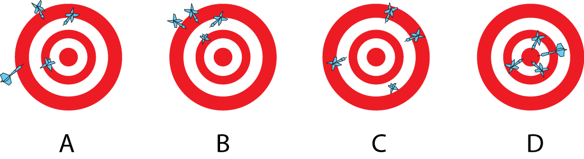

- Briefly summarise a method to measure productivity of plant material.

- Briefly summarise a method for measuring net secondary productivity.

- Explain the reason behind the inverted biomass pyramid from the English Channel
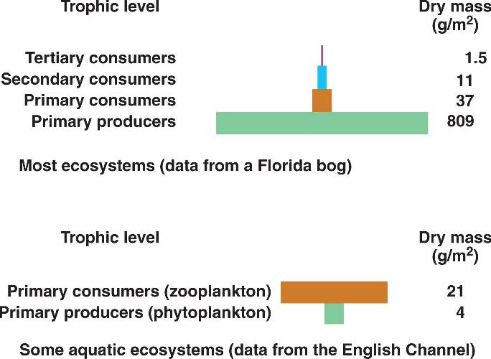

- Identify the advantages and disadvantages of measuring biomass

Biomass
Advantages | Disadvantages

- Identify the advantages and disadvantages of measuring Secondary Productivity

Secondary Productivity
Advantages | Disadvantages

2.5.U6 Methods for estimating the abundance of non-motile organisms include the use of quadrats for making actual counts, measuring population density, percentage coverage, and percentage frequency.
2.5.A3 Evaluate methods to investigate the change along an environmental gradient and the effect of a human impact in an ecosystem.

- How do you choose the quadrat size?

- For each measurement, explain what the term means, the units of measure, and any applicable formulas. Use the sample quadrates below to help you draw an example of how each measurement could be taken

  - Population density

  - Percent frequency

  - Percent coverage

- Compare and contrast line and belt transects

Kite diagrams are used as a visual representation of a belt transect
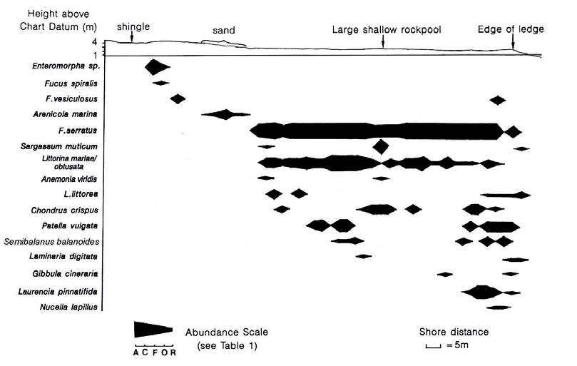
N.B. ACFOR scale = A- Abundant, C – Common, F- Frequent, O – Occasional, R - Rare

Evaluation of quadrats for assessing number of individuals, percentage frequency and population density.

Advantages | Disadvantages

Evaluation of quadrats for assessing percentage coverage
Advantages | Disadvantages

2.5.U7 Direct and indirect methods for estimating the abundance of motile organisms can be described and evaluated. Direct methods include actual counts and sampling. Indirect methods include the use of capture-mark-recapture with the application of the Lincoln Index.

Capturing animals

Advantages | Disadvantages

- Direct methods include actual counts and sampling. Indirect methods include use of capture-mark-recapture with the application of the Lincoln index
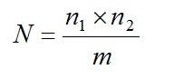
  - Define each variable in this equation

N =

n₁ =

n₂ =

m =

  - State the assumptions used in the application of the Lincoln index

- Estimate the site of population of the mountain gorillas. Calculate the percent error. Gorilla hunting is illegal in some regions and carefully controlled in others, though there is a high demand for illegal bush-meat.

Year | 2003 | 2004 | 2005 | 2006 | 2007 | 2008
n1 | 23 | 26 | 27 | 16 | 18 | 17
n2 | 25 | 30 | 35 | 18 | 19 | 24
m | 18 | 22 | 21 | 15 | 16 | 17
P

  - Deduce between which two years illegal hunters were active in the forest.

  - Explain the long recovery time for the population.

- State the possible error when using the Lincoln Index

2.5.U8 Species richness is the number of species in a community and is a useful comparative measure.

- Define species richness

- Define species evenness

- Which ecosystem (A or B) is more RICH? Explain your answer. Which ecosystem is more EVEN? What does this mean?

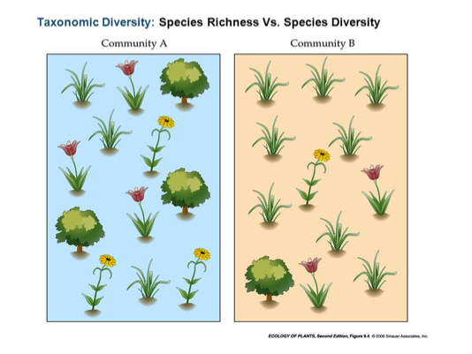

2.5U9 Species diversity is a function of the number of species and their relative abundance and can be compared using an index. There are many versions of diversity indices but students are only expected to be able to apply and evaluate the results of the Simpson Diversity Index. Using its formula, the higher the result, the greater the species diversity. This indication of diversity is only useful when comparing two similar habitats or the same habitat over time.
2.5.A6 Calculate and interpret data for species richness and diversity

- Using this formula, the higher the result (D), the greater the species diversity. This indication of diversity is only useful when comparing two similar habitats, or the same habitat over time. Define each variable in this formula. Explain which term represents evenness and which term represent richness.
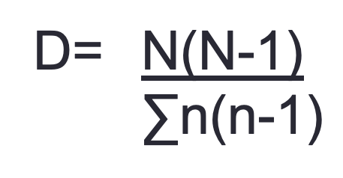

D =

N =

n =

  - High D value indicates:

  - Low D value indicates:

- Analyze the diversity of the two different locations
 | Number of individuals (n)
Flower Species | Sample 1 | Sample 2
Daisy | 300 | 20
Dandelion | 335 | 49
Buttercup | 365 | 931
Total (N) | 1000 | 1000

- The insects in two meadows are being investigated. The following data was collected. Compare the diversity of the two meadows

Organisms | Description | Meadow 1 | Meadow 2
Orthoptera (grasshopper) | Green with red legs | 16 | 25
Orthoptera (grasshopper) | Brown with yellow stripe. | 5 | 2
Lepidoptera (butterfly) | Large, blue | 26 | 17
Lepidoptera (butterfly) | Small, blue | 3 | 9
Coleoptera (beetle) | Red & Blue | 12
Hymenoptera (wasp) | Black |  | 12
Hymenoptera (wasp) | Purple |  | 4
Hymenoptera (bee) | Striped |  | 5

2.5.U2 Organisms in named and located an ecosystem can be identified using a variety of tools including dichotomous keys, comparisons to herbarium/ specimen collections, technologies and scientific expertise.
2.5.S2 Construct simple identification keys for up to eight species.

- Why is species identification an important part of studying an ecosystem and its biodiversity?

- Write the common name and scientific name of a known organism in your country? Do not use the ones listed on in the presentation

- Using the worksheet, create a dichotomous key for the salamander species.
  - Remember each decision must have only TWO options. YES or NO descriptions
  - Traits should be used that ANYONE would be able to observe and come to the same conclusion

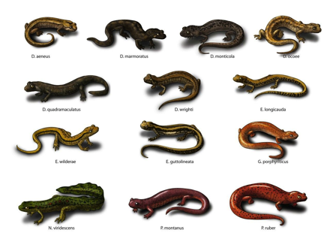

  - Dichotomous Key
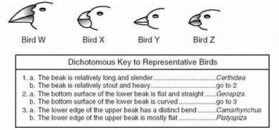
  - Herbarium

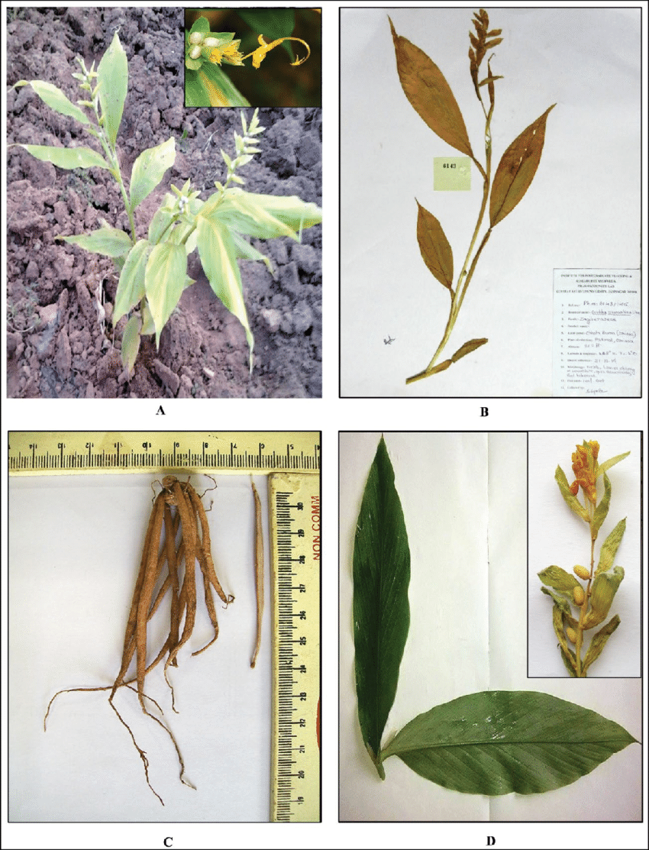
  - Specimen collection

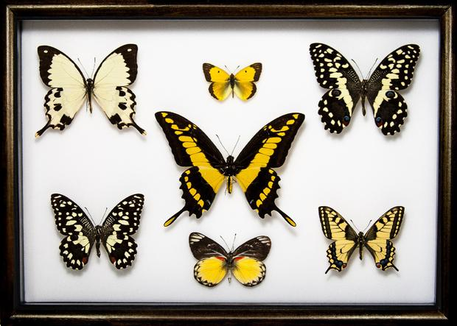

Ecosystems can be better understood through the investigation of quantification of components

The use of internationally standardized methods of ecological study are necessary when making comparisons across international boundaries.

2.5.S1 Design and carry out ecological investigations.

IB Animal Experiment Policy

You may not perform an experimentation using animals that involves:
- Pain, undue stress, damage to health of animal
- Death of animal
- Drug intake or dietary change beyond those easily tolerated by the animal
Consider:
- Using cells, plants or simulations instead
- If using humans you MUST have written permission
- AISD safety contracts apply at ALL times during ALL labs
- No experiments may be done that have any risk of transferring blood-borne pathogens

32. Choose a one factor from each type of ecosystem and research how it is measured. Produce a detailed methodology with supporting diagrams if necessary.
- Marine: Salinity, pH, temperature, dissolved oxygen, wave action.
- Freshwater: Turbidity, flow velocity, pH, temperature, dissolved oxygen.
- Terrestrial: Temperature, light intensity, wind speed, particle size, slope, soil moisture, drainage, mineral content.

Theory of knowledge
34. When is quantitative data superior to qualitative data in giving us knowledge about the world?

35. Controlled laboratory experiments are often seen as the hallmark of the scientific method, but are not possible in fieldwork—to what extent is the knowledge obtained by observational natural experiment less scientific than the manipulated laboratory experiment?

36. If you were studying the following ecosystems, which key abiotic factors would you focus on measuring and what equipment would you require?

37. N.B. the three most significant / influential abiotic factors should be chosen and how these may vary with depth, time or distance should also be stated.

ECOSYSTEM | Significant Abiotic Factors | Equipment required | Possible variation in time, depth or space (choose one)?
TROPICAL RAINFOREST | 1
 | 2
 | 3
ESTUARINE  MUDFLAT (i.e. near the mouth of a river) | 1
 | 2
 | 3
A POND | 1
 | 2
 | 3
DEEP OCEAN | 1
 | 2
 | 3
ROCKY SHORE | 1
 | 2
 | 3
A STREAM | 1
 | 2
 | 3
MOUNTAIN SUMMIT | 1
 | 2
 | 3
CONIFEROUS FOREST FLOOR | 1
 | 2
 | 3

38. Complete the following table to remind you of some of the measuring techniques discussed. (Remember you have evaluated these techniques already and should be aware of their strengths and limitations)

BIOTIC COMPONENT | Equipment required | Formula required | Possible abiotic factors which may have had an influence
SPECIES PRESENCE  / ABSENCE |  | NONE
POPULATION SIZE (SESSILE ORGANISMS) |  | Running average of no. found in one quadrat x total area
POPULATION SIZE (MOTILE ORGANISMS) i.e. | VARIABLE i.e.   | LINCOLN INDEX  =
Soil organisms | Tullgren funnel
Small insects
Small crawling organisms
Small mammals | Longworth mammal trap
Flying / swimming organisms
PRODUCTIVITY  /BIOMASS / ORGANIC MATTER |  | Humus = (Initial mass(g) – final mass(g)) x 100 Content % Initial mass(g)
SPECIES DIVERSITY | Quadrat

MEASURING CHANGES CAUSED BY HUMAN ACTIVITY

39. Measuring changes over time is also important when assessing the impact of human activity on an ecosystem e.g. toxins from mining activities, landfills, eutrophication, effluent, oil spills and overexploitation. Depending on the scale of the activity, repeated measurements can be made from the ground (see below) or from satellite images and maps.

For each measurement technique, state how it could be used to monitor a specific environmental problem to detect whether any detrimental changes have occurred within the ecosystem in response to human interference.

INSTRUMENT | PHYSICAL FACTOR MEASURED | HOW COULD THE INFORMATION BE USED TO MONITOR POLLUTION? (What  kind?)
Light Meter | Light Intensity | Density of algal blooms created by eutrophication from fertilizers.
Dissolved Oxygen Meter | Dissolved oxygen
pH Meter | pH
Total Dissolved Solids (TDS) Meter | Total Dissolved Solids
Current Meter | Flow rate
Secchi Disc | Turbidity
Wind Meter | Wind speed and direction

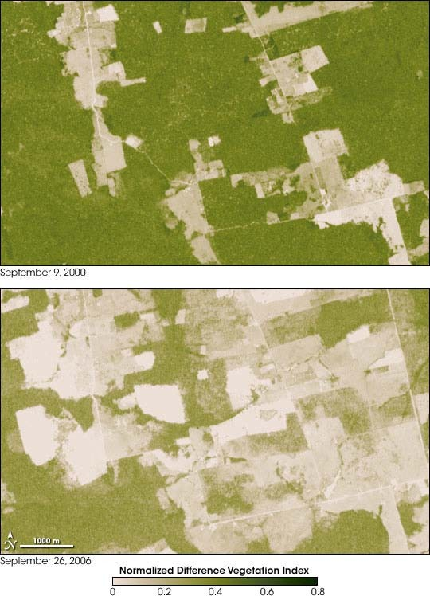
Satellite images and maps are particularly useful when studying human impact over a large area e.g. decline in productivity in an area due to the overexploitation of resources.

NASA’s Earth Observatory is currently assessing current trends in deforestation, a
major global issue:-

http://earthobservatory.nasa.gov/Features/Deforestation/deforestation_update4.php

40. Do you think there were other satellite images of the same area recorded during this time period? Explain your answer.

41. How could these maps help to determine the rate of destruction of the natural vegetation in this area?

42. Suggest reasons why this change may have occurred (try to include economic and social reasons as well as environmental ones).

43. Explain the impact that this change may have on the community of organisms living in the area (consider productivity, complexity, stability, diversity etc. in your answer).

44. Why is it important to have records in the form of data, maps, satellite images or photographs of areas which have yet to be influenced by any human activity? How could this information prove useful if human interference did start to occur
ESS can be like learning a new language. So many words are not commonly used in everyday English. This can be challenging. To help you keep up with ESS Terms, you will need to create your own ESS DICTIONARY. You should add to this over the year and keep it in your notebook or on a page file THAT YOU CAN UPDATE AND ADD TO EASILY. Most of the vocabulary words can be found either on your STUDY GUIDE or at mrgscience.com.
You will be responsible for leaning the words and their meaning. Periodic quizzes will be given on the words. So, make your dictionary creative and you will remember the words more easily.

KEY TERMS

atmosphere

desert

temperate grassland

insolation

deciduous

arid

permafrost

Coriolis Effect

zonation

​tricellular model

secondary succession

hydrosphere

tropical rainforest

global location

structure

latitude

semi arid

monospecific

​succession

​precipitation

​insolation

biome shift

​disturbance

resilience

temperature

geosphere

taiga (boreal)

species diversity

stratified

ecotones

fertile

fragmentation

​pioneer species

​limiting factor

​primary succession

​climax community

biomes

arctic tundra

productivity

understory

scrub-lands

grazing

muskegs

​insolation

r-strategy

precipitation

​gross productivity

​latitude

savannah

temperate forest

canopy

evergreen

broad leaf

browsing

​latitude

primary succession

​k-strategy

​temperature

​net productivity

​climate change

