Understandings, Applications and Skills (This is what you maybe assessed on)

Significant ideas
- Biodiversity can be identified in a variety of forms, including species diversity, habitat diversity and genetic diversity.
- The ability to both understand and quantify biodiversity is important to conservation efforts

Big Questions:
- How are issues addressed in this topic of relevance to sustainability or sustainable development
- In what ways might the solutions explored in this topic alter our predictions for the state of human societies and the biosphere some decades from now?
- Unsustainable development can lead to species extinction. Given the five mass extinctions of the past, is this something that the human race should be concerned about?
- What effects could species extinctions have on human societies in years to come?

 | Statement | Guidance
3.1.U1 | Biodiversity is a broad concept encompassing the total diversity of living systems, which includes the diversity of species, habitat diversity and genetic diversity.
3.1.U2 | Species diversity in communities is a product of two variables: the number of species (richness) and their relative proportions (evenness) | Species diversity within a community sis a component of the broader description of the biodiversity of an entire ecosystem
3.1.U3 | Communities can be described and compared through the use of diversity indices. When comparing communities that are similar, low diversity could be indicative of pollution, eutrophication or recent colonization of a site. The number of species present in an area is often indicative of general patterns of biodiversity
3.1.U4 | Habitat diversity refers to the range of different habitats in an ecosystem or biome.
3.1.U5 | Genetic diversity refers to the range of genetic material present in a population of a species.
3.1.U6 | Quantification of biodiversity is important to conservation efforts so that areas of high biodiversity may be identified, explored, and appropriate conservation put in place where possible.
3.1.U7 | The ability to assess changes to biodiversity in a given community over time is important in assessing the impact of human activity in the community
3.1.A1 | Distinguish between biodiversity, diversity of species, habitat diversity and genetic diversity.
3.1.A2 | Comment on the relative values of biodiversity data. | Interpreting diversity is complex; low diversity can be present in natural; ancient and unpolluted sites
3.1.A3 | Discuss the usefulness of providing numerical values of species diversity to understanding the nature of biological communities and the conservation of biodiversity.

Wildlife on our planet is being threatened, directly or indirectly, by the relentless exploitation of the natural world by humans. The growth of human populations, combined with greater urbanisation and consumption of resources, is linked to an increase in deforestation, desertification, global warming and pollution. The richness of the natural world, generally referred to as BIODIVERSITY, appears to be in dramatic decline. Biodiversity is an umbrella term that includes ecosystem complexity, genetic variation, biochemical diversity (useful compounds found in organisms e.g. drugs, dyes, fuels etc.) and species richness.

3.1.U1 Biodiversity is a broad concept encompassing the total diversity of living systems, which includes the diversity of species, habitat diversity and genetic diversity.
3.1.A1 Distinguish between biodiversity, diversity of species, habitat diversity and genetic diversity.

- Watch the TedEd video on Biodiversity https://www.youtube.com/watch?v=GK_vRtHJZu4&disable_polymer=true

- Distinguish between
  - Biodiversity

  - Species diversity

  - Genetic diversity

  - Habitat diversity

- Identify the benefits of biodiversity

- Identify the factors that affect biodiversity

- Evaluate the diagram below and answer the following questions:
  - Give an example of the intrinsic value of biodiversity
  - Give an example of the utilitarian value of biodiversity
  - Give an example of the ecological services of biodiversity

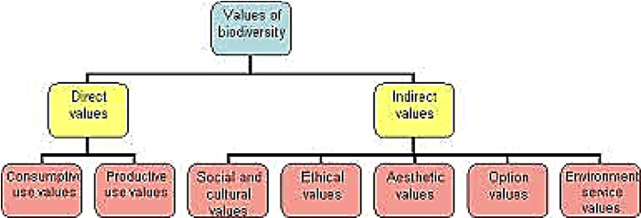

3.1.U2 Species diversity in communities is a product of two variables: the number of species (richness) and their relative proportions (evenness)

- Define the term species and give an example of one (including its binomial name).

- Compare species Richness and species evenness

3.1.U3 Communities can be described and compared through the use of diversity indices. When comparing communities that are similar, low diversity could be indicative of pollution, eutrophication or recent colonization of a site. The number of species present in an area is often indicative of general patterns of biodiversity
3.1.A2 Comment on the relative values of biodiversity data.

The most commonly used measure of biodiversity is a species diversity index. This is expressed as a single number, calculated using the number of species present (species richness) and the abundance of each species.
The Simpson species diversity index is one of several mathematical formulae for calculating a species diversity index:
The index can be related to the abiotic harshness of an environment (e.g. during different stages of ecological succession) or the level of pollution in an ecosystem. Generally, the species diversity is greater in habitats in which abiotic conditions are less demanding or in which pollution levels are lower.

N.B. One weakness of the Simpson’s index is that it makes no allowance for differences in size of individuals; one elephant is treated as equal to one snail or even one bacterium. Also, it may be difficult to calculate the index for plants because it is not always easy to decide what constitutes an individual plant e.g. a grove of birch trees may be genetically a single plant that pushes up stems from a single root system.

- Review the formula for the Simpson’s Diversity Index

- Compare two named examples of a high value “D” and low value “D” ecosystem.
NOTE: When comparing similar communities' low diversity could indicate pollution, eutrophication or recent colonization.

- Look at the data comparing fish species in two ponds

 | Pond A | Pond B
Fish species 1 | 30 | 54
Fish species 2 | 25 | 13
Fish species 3 | 36 | 0
Fish species 4 | 18 | 3
Richness
Evenness
D

  - Complete the boxes to state the species richness (a number and species evenness (more even or less even) for each pond
  - Using the Simpson’s Index (D) to ascertain which of the ponds has a higher species diversity . Show Your Work

3.1.U4 Habitat diversity refers to the range of different habitats in an ecosystem or biome.

- Define habitat diversity. Give a named example

3.1.U5 Genetic diversity refers to the range of genetic material present in a population of a species.

- With reference to two named examples, describe what is meant by “low genetic diversity” and “high genetic diversity.

- Watch this video on genetics and biodiversity https://youtu.be/XOxsjdB4-ZQ. State how genetic diversity is crucial for survival.

3.1.U6 Quantification of biodiversity is important to conservation efforts so that areas of high biodiversity may be identified, explored, and appropriate conservation put in place where possible.

- Why should we care about biodiversity?

- With reference to two named examples, describe hotspots.

- Identify the most bio diverse countries. What is the problem with these areas?

- Outline why it is important to quantify diversity

- List the criteria used to designate an area as a biodiversity hotspot

- State the issues associated with identifying hotspots

- Outline the reasons why tropical biomes should be conserved.

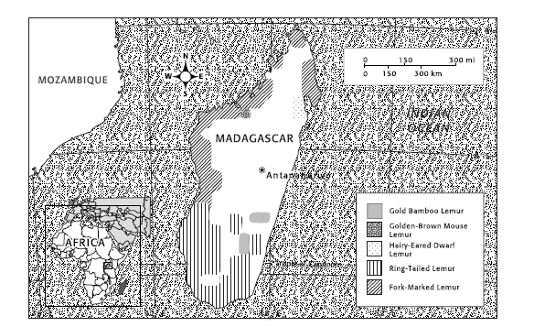
The island nation of Madagascar is part of one of the world’s 25 biodiversity hotspots. A biodiversity hotspot is a region with an especially large number of species. Madagascar is the world’s only home of lemurs, a primitive primate. Of the more than 40 species of lemurs, most are either endangered or at some risk of becoming so. This map shows distribution of populations of five lemur species.

- Use the map above to answer the questions below.
  - Using a Key which lemur species has the largest population distribution? Which has the smallest?

  - Using a Key what is the status of the hairy-eared dwarf lemur?

  - Analyzing Data which two lemur species are found near the distribution area of the ring-tailed lemur?

  - Making Conclusions The golden bamboo lemur is the most endangered species shown on the map. However, it does not have the smallest distribution. Why do you think this might be?

3.1.U7 The ability to assess changes to biodiversity in a given community over time is important in assessing the impact of human activity in the community

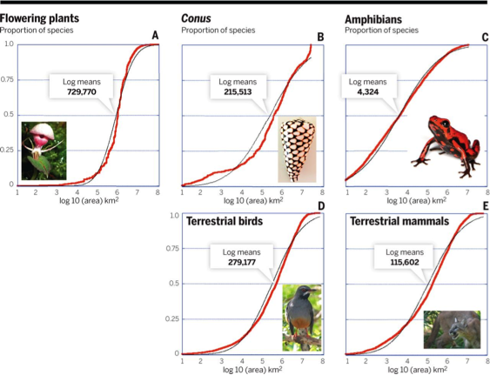

- Explain why assessing changes in biodiversity over time can be important.

3.1.A3 Discuss the usefulness of providing numerical values of species diversity to understanding the nature of biological communities and the conservation of biodiversity.

Theory of knowledge:
- The term “biodiversity” has replaced the term “nature” in much literature on conservation issues—does this represent a paradigm shift?

- Diversity index is not a measure in the true sense of a word, but merely a number (index), as it involves a subjective judgment on the combination of two measures: proportion and richness. Are there examples in other areas of knowledge of the subjective use of numbers
ESS can be like learning a new language. So many words are not commonly used in everyday English. This can be challenging. To help you keep up with ESS Terms, you will need to create your own ESS DICTIONARY. You should add to this over the year and keep it in your notebook or on a page file THAT YOU CAN UPDATE AND ADD TO EASILY. Most of the vocabulary words can be found either on your STUDY GUIDE or at mrgscience.com.
You will be responsible for learning the words and their meaning. Periodic quizzes will be given on the words. So, make your dictionary creative and you will remember the words more easily.

KEY TERMS

biodiversity

behavior

stability

genetic diversity

species

species diversity

diversity index

species richness

inbreed

offspring

habitat

habitat diversity

resilience

population

gene pool

diversity

limited resources

