Understandings, Applications and Skills (This is what you may be assessed on)

Significant ideas
- Evolution is a gradual change in the genetic character of populations over many generations, achieved largely through the mechanism of natural selection.
- Environmental change gives new challenges to species, which drives the evolution of diversity.
- There have been major mass extinction events in the geological past.

Big Questions:
- How are the issues addressed in this topic of relevance to sustainability or sustainable development
- In what ways might the solutions explored in this topic alter your predictions for the state of human societies and the biosphere some decades from now?
- Unsustainable development can lead to species extinction. Given the five mass extinctions of the past, is this something that the human race should be concerned about?
- What effects could species extinctions have on human societies in years to come?

 | Statement | Guidance
3.2.U1 | Biodiversity arises from evolutionary processes.
3.2.U2 | Biological variation arises randomly and can either be beneficial to, damaging to, or have no impact on, the survival of the individual
3.2.U3 | Natural selection occurs through the following mechanism; 1) Within a population of one species, there is genetic diversity, which is called variation, 2) Due to natural variation, some individuals will be fitter than others, 3) Fitter individuals have an advantage and will reproduce more successfully than individuals who are less fit, 4) The offspring of fitter individuals may inherit the genes that give that advantage | Natural selection is an evolutionary driving force, sometimes called “survival of the  fittest”. In this context, the meaning of “fittest” is understood to be “best-suited to  the niche”.
3.2.U4 | This natural selection will contribute to the evolution of biodiversity over time
3.2.U5 | Environmental change gives new challenges to species: those that are suited will survive, and those that are not suited will not survive
3.2.U6 | Speciation is the formation of new species when populations of a species become isolated and evolve differently from other populations.
3.2.U7 | Isolation of populations can be caused by environmental changes forming barriers such as mountain formation, changes in rivers, sea level change, climatic change or plate movements. The surface of the Earth is divided into crustal, tectonic plates that have moved throughout
3.2.U8 | The distribution of continents has also caused climatic variations and variation in food supply, both contributing to evolution
3.2.U9 | Mass extinctions of the past have been caused by various factors, such as tectonic plate movements, super-volcanic eruption, climatic changes (including drought and ice ages), and meteorite impact—all of which resulted in new directions in evolution and therefore increased biodiversity
3.2.A1 | Explain how plate activity has influenced evolution and biodiversity.
3.2.A2 | Discuss the causes of mass extinction

Evolution is a gradual change in the genetic character of populations over many generations, achieved largely through the mechanisms of natural selection
3.2.A1 Explain how plate activity has influenced evolution and biodiversity.

3.2.U1 Biodiversity arises from evolutionary processes.

- Watch the video how Evolution Works https://www.youtube.com/watch?v=hOfRN0KihOU
  - Species have formed by a process of continuous change – EVOLUTION. This is the __________________, ________________ in the genetic characteristics of ______________________ of a species or race of an organism, ultimately giving rise to species or races different from the _________________________

- Watch the video on plate tectonics. https://youtu.be/kwfNGatxUJI.
  - Label each figure by writing the type of plate boundary it shows

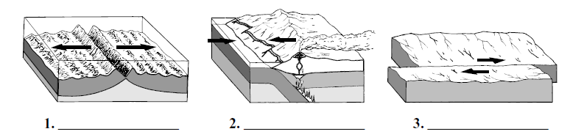

(The plates move at approximately the same pace as a fingernail growing!)

The theory of plate tectonics predicts that the continents have slowly moved and changed shape over time. The diagrams below show what the distribution of land and sea are thought to have been at various times over the last 450 million years.

As the plates move they may either slide past each other (e.g. San Andreas fault line, California), diverge (mid-Atlantic ridge where plates are slowly moving apart), or converge. When plates converge they are either both forced upward (forming mountains, e.g. Himalayas), or the heavier plate slides under the lighter plate (forming ocean trenches, and volcanic island chains, e.g. Nazca plate under the Pacific on west coast South America forming Andes).
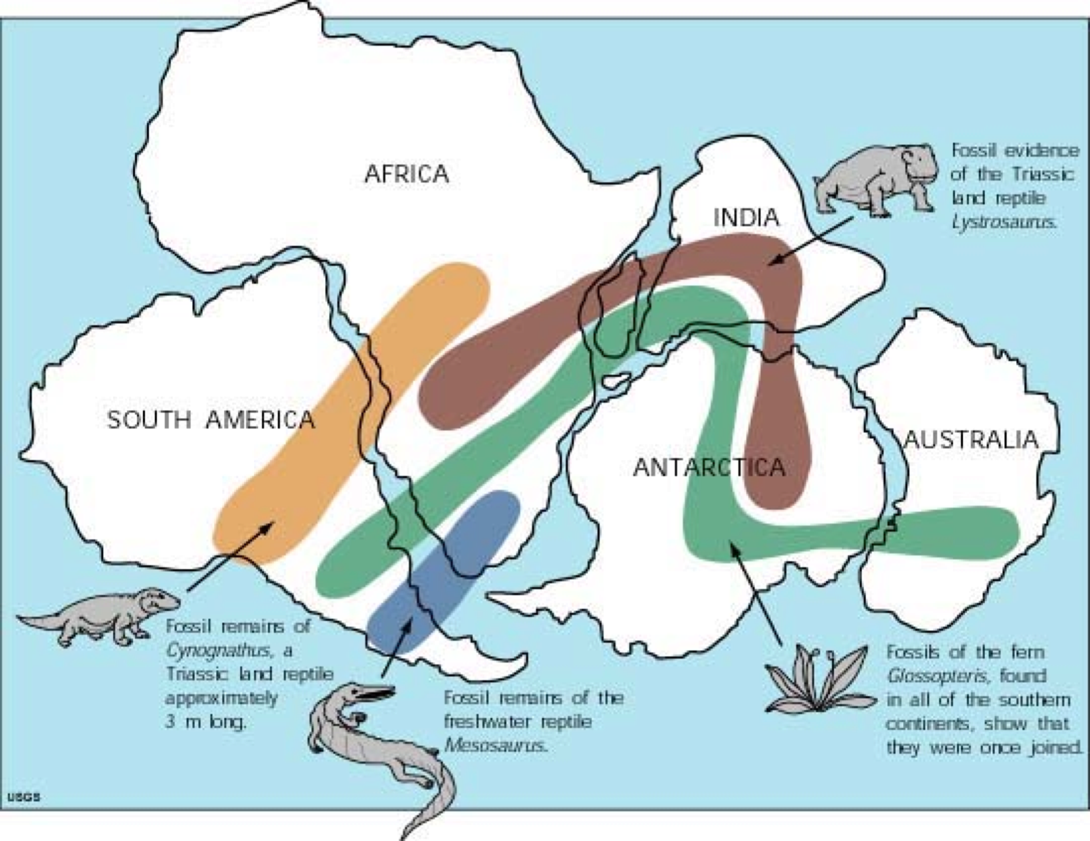

At present day, the two great land masses of the Northern Hemisphere i.e. N. America and Eurasia have very similar mammals e.g. deer, bears, lynx etc., whereas the three main southern continents have sharply contrasting ones e.g. kangaroos, giraffes, tapirs etc. . If, however, you look at a present day map of the world, you will see that whereas South America, Africa and Australia are separated from each other by great bodies of water, North America and Eurasia are separated only by a shallow strait (the Bering Strait), less than 100km wide. Also, there is evidence that in the geological past a continuous land bridge linked these two northern land masses across what is now the strait. Consequently, we can assume that different mammals evolved in the two land masses, but the geographical closeness of the two regions kept their faunas together and preventing them from diverging too much. On the other hand, the wide separation of the three continents of the Southern Hemisphere meant that only very rarely were there any exchange of mammals between them, so the mammals each evolved independently along their own line.

Other fossil evidence suggests that continental drift has taken place in some parts of the world which helps to explain the presence of the same fossils in different continents, suggesting that at some point they were linked together e.g. Africa and South America both having Mesosaurus fossils.

- Watch the video on the Great American Interchange https://youtu.be/PddQvyiBfdc

- In your own words, state the theory of plate tectonics

- Define the following terms:
  - natural selection:

  - evolution:

  - speciation:

  - adaptation:

- The evidence of evolution is important in helping us understand how species hve changed over millions of years. Watch the video on Evolution and Fossils https://youtu.be/iYr3sYS9e0w. Complete the table below

Evidence | Importance of Evidence
Artifical selection

Convergent evolution

Embryology

Vestigial structures

Biogeographical distribution

Fossil record

3.2.U2 Biological variation arises randomly and can either be beneficial to, damaging to, or have no impact on, the survival of the individual

- Outline the causes of evolutionary change

3.2.U3 Natural selection occurs through the following mechanism; 1) Within a population of one species, there is genetic diversity, which is called variation, 2) Due to natural variation, some individuals will be fitter than others, 3) Fitter individuals have an advantage and will reproduce more successfully than individuals who are less fit, 4) The offspring of fitter individuals may inherit the genes that give that advantage

- Using the table, summarise the mechanism of natural selection.

Details
Variation

Fitness

Reproductive success

Inheritance

3.2.U4 This natural selection will contribute to the evolution of biodiversity over time

- Within the human population, distinct characteristics have evolved within different populations through natural selection and exposure to the environmental conditions that were unique to the regions of those populations. How has globalization altered some of the environmental factors that were formerly unique to different human populations?

3.2.U5 Environmental change gives new challenges to species: those that are suited will survive, and those that are not suited will not survive

- Wathc the video clip on the Peppered Moth. https://www.youtube.com/watch?v=Pop-xetGaBM&t=6s. Outline the evolution of the peppered moth

3.2.U6 Speciation is the formation of new species when populations of a species become isolated and evolve differently from other populations.
3.2.U7 Isolation of populations can be caused by environmental changes forming barriers such as mountain formation, changes in rivers, sea level change, climatic change or plate movements. The surface of the Earth is divided into crustal, tectonic plates that have moved throughout
3.2.U8 The distribution of continents has also caused climatic variations and variation in food supply, both contributing to evolution

Populations are groups of interbreeding individuals of the same species, occupying the same habitat at the same time. But within each population there are breeding subunits called demes. Individuals within a deme tend to breed with each other more often than they do with individuals of other demes. Although they remain part of the same gene pool, the flow of genes between separate demes slows, or may even cease.
Each deme may evolve along separate lines so that eventually the demes may become so different that, even if they were to be reunited, they would not be able to breed successfully with each other.

They would become separate species, each with their own gene pool.
This process is known as SPECIATION.

- Watch this video on speciation https://youtu.be/8yvEDqrc3XE
  - List three physical barriers that might separate populations.

- Distinguish between convergence and divergence evolution

- Outline the factors which might provide different selection pressures on populations that have been split and separated.

- If the new generation, which has become better adapted to its environment, can interbreed with the main population, this can “dilute” the effect of the new variety. However, if the new generation is somehow isolated in a new area (with a new environment and different environmental pressures!) the isolated new variety can change and adapt by natural selection according to the new conditions. The isolated populations may be subjected to different selective pressures. For example, the more northern population B will live in a colder climate. So selection will favor animals that are larger and have more fur. The southern population lives in a warmer, drier climate so smaller individuals with shorter fur will have a selective advantage. Because of the effects of natural selection on each gene pool, the two populations may become genetically different enough to be reproductively isolated, producing new species.
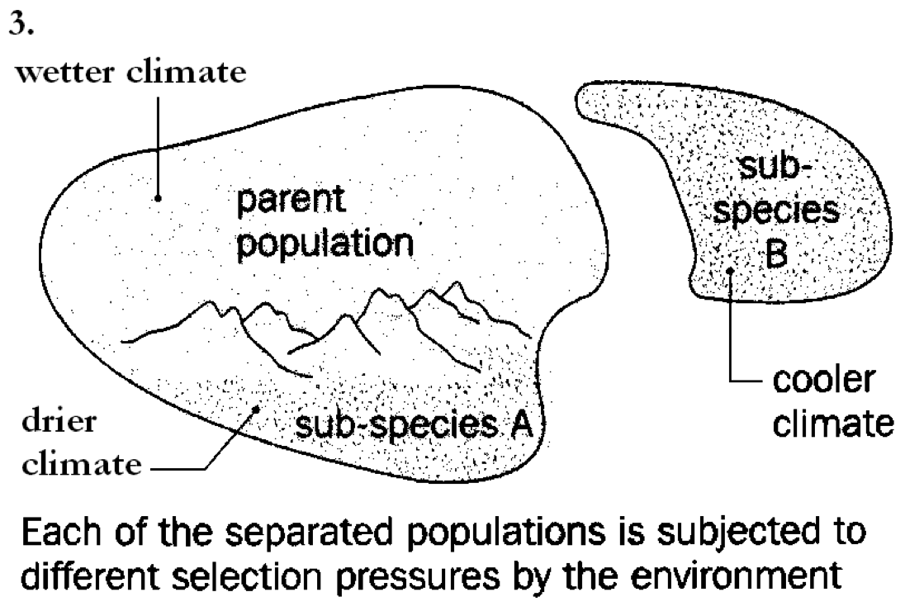

  - Using a named example, explain how gene flow between two subpopulations creates a new species

- Large flightless birds: e.g. the emu, ostrich, cassowary and rhea. They only occur on those continents that were once part of Gondwana land (Africa, Australia/New Zealand, and South America). However, because Gondwana land split up a very long time ago the species are not closely related.
- Australasia (and Antarctica) split from Gondwana land a long time ago. At that time, both marsupials and early placental mammals lived in the same area. In South America and Africa placental mammals out-competed marsupials while in Australia the opposite occurred and now marsupials are only found in Australia and Papua New Guinea. The placental mammals present in Australia are rare and came either by sea (seals) or air (bats) or were introduced by humans (cats, dogs, rabbits and rats)
- The cichlid fish in the lakes of East Africa are one of the largest families of vertebrates. In Lake Victoria there are 170 species of cichlids; in Lake Tanganyika 126 species; and in Lake Malawi 200 species. These populations have probably been isolated for millions of years and have been exposed to different selection pressures because of there slightly different environments. Therefore, the fish have adapted to their specific environments. As long as the population is large enough, isolated populations can thrive, if the populations become too small they will die out.

  - Using a specific example, explain how the distribution of continents has caused climatic variations and variations in food supply contributing to evolution

  - Outline the effect the splitting up of Pangea 200 million years ago had on species diversity and distribution.

  - Using a specific example, explain how plate activity has influenced evolution and biodiversity

3.2.U9 Mass extinctions of the past have been caused by various factors, such as tectonic plate movements, super-volcanic eruption, climatic changes (including drought and ice ages), and meteorite impact—all of which resulted in new directions in evolution and therefore increased biodiversity
3.2.A2 Discuss the causes of mass extinction

- Human impact has increased the rate at which some mass extinctions have occurred on a global scale.

- Outline mass extension and background or normal extinction

15. Watch the video on Mass Extensions. https://youtu.be/FlUes_NPa6M

- Outline three factors that may have resulted in mass extinctions in the past. Include portions of the families that were affected by the extinction.

16. Watch the video on the Sixted Extention https://youtu.be/z9gHuAwxwAs Describe how the Sixth Extinction different from previous events?

Theory of knowledge:
- The theory of evolution by natural selection tells us that change in populations is achieved through the process of natural selection—is there a difference between a convincing theory and a correct one?

Additional Review Questions
- The industrial revolution caused a viscous cycle to begin between technology and the destruction of ecosystems. Describe the 3 specific aspects of these cycles.

- Do you think humans will ever become extinct? Why or Why not?

- The table below shows the bird biomass per square km, the total number of birds per square km, the number of species of birds, and the diversity (as measured by a diversity index) for three types of habitats in the same country

 | City | Farmland | Forest
Bird biomass / kg km^{–2} | 213 | 30 | 22
Number of birds km^{–2} | 1 089 | 371 | 297
Number of bird species | 21 | 80 | 54
Diversity index | 1.13 | 3.40 | 3.19
[A Goudie, The Human Impact on the Natural Environment, 5th edition, (Blackwell, 2000).
Reproduced with permission of Wiley-Blackwell.]

  - Define the terms species diversity and habitat diversity. (2)

  - Describe and explain the data in the table above. (4)

- Define the term speciation. (1)

  - Outline how natural selection may influence speciation. (2)

  - Explain how the isolation of a population of organisms (e.g. on an island) could alter the characteristics of the species, over time. (2)

- What is the likely consequence of the isolation of a land mass due to crustal plate movement? (1)
  - The extinction of most of the organisms
  - An increase in the biodiversity of the land mass
  - A decrease in the biodiversity of the land mass
  - The development of a unique collection of animals and plants

- Define the term species diversity. (1)

  - Explain how natural selection may produce new species. (2)

  - State two natural factors that might lead to a loss of biodiversity. (2)

  - State two types of human activity that might lead to a loss of biodiversity. (2)

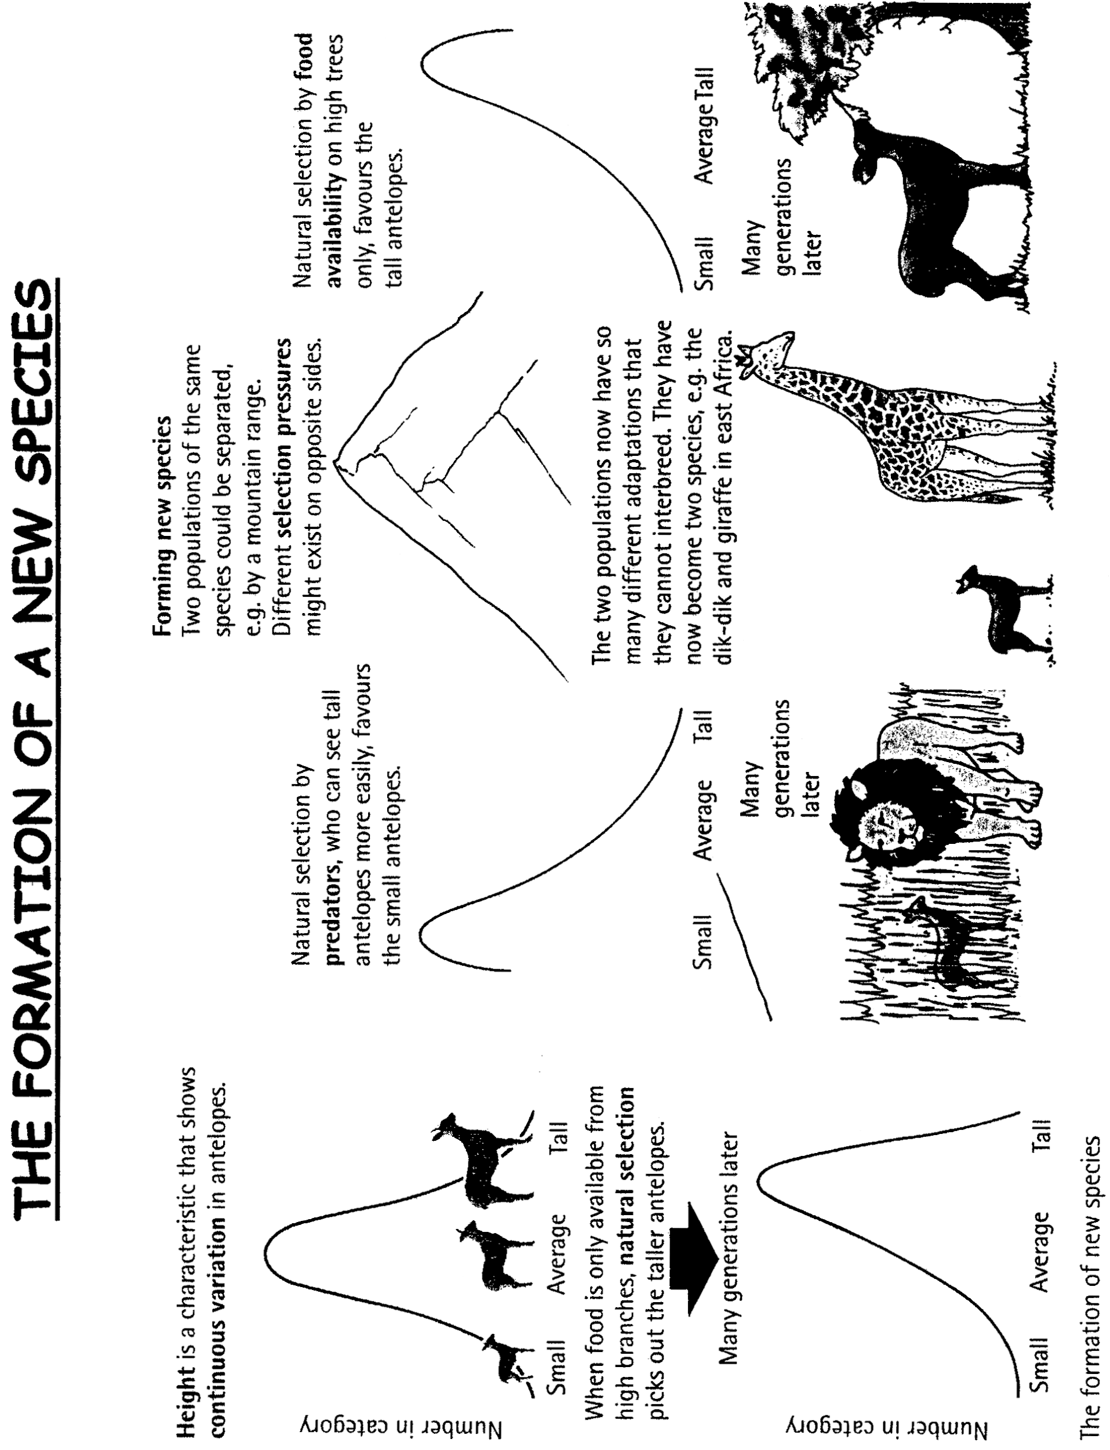

Geographical Distribution

The camel family, Camelidae, consists of six modern-day species that have survived on three continents: Asia, Africa and South America. They are characterised by having only two functional toes, supported by expanded pads for walking on sand or snow. The slender snout bears a cleft upper lip. The recent distribution of the camel family is fragmented. Geophyscial forces such as plate tectonics and the ice age cycles have controlled the extent of their distribution. South America, for example, was separated from North America until the end of the Pliocene, about 2 million years ago. Three general principles about the dispersal and distribution of land animals are:
- When very closely related animals (as shown by their anatomy) were present at the same time in widely separated parts of the world, it is highly probable that there was no barrier to their movement in one or both directions between the localities in the past.
- The most effective barrier to the movement of land animals (particularly mammals) was a sea between continents (as was caused by changing sea levels during the ice ages).
- The scattered distribution of modern species may be explained by the movement out of the area they originally occupied, or extinction in those regions between modern species.

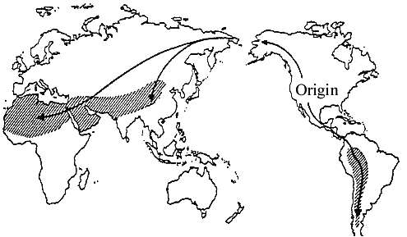

- The early camel ancestors were able to move into the tropical regions of Central and South America. Give a possible reason why this was prevented in southern Asia and southern Africa:

- Arabian camels are found wild in the Australian Outback. Explain how they got there and why they were absent during prehistoric times:

- The camel family originated in North America. Explain why there are no camels in North America now:

- Suggest how early camels managed to get to Asia from North America:

- Describe the present distribution of the camel family and explain why it is scattered (discontinuous):

ESS can be like learning a new language. So many words are not commonly used in everyday English. This can be challenging. To help you keep up with ESS Terms, you will need to create your own ESS DICTIONARY. You should add to this over the year and keep it in your notebook or on a page file THAT YOU CAN UPDATE AND ADD TO EASILY. Most of the vocabulary words can be found either on your STUDY GUIDE or at mrgscience.com.
You will be responsible for leaning the words and their meaning. Periodic quizzes will be given on the words. So, make your dictionary creative and you will remember the words more easily.

KEY TERMS

Biodiversity

Behaviour

Stability

genetic diversity

species

fertile

succession

species diversity

inbreed

offspring

habitat

habitat diversity

lithosphere

resilience

competition

climax community

population

gene pool

diversity

inertia

limited resources

