Understandings, Applications and Skills (This is what you may be assessed on)

Significant ideas
- The hydrological cycle is a system of water flows and storage that may be disrupted by human activity
- The ocean circulation system (ocean conveyor belt) influences the climate and global distribution of water (matter and energy)
Big Questions:
- What strengths and weaknesses of the systems approach and the use of models have been revealed through this topic?
- To what extent have the solutions emerging from this topic been directed at preventing environmental impacts, limiting the extent of the environmental impacts, or restoring systems in which environmental impacts have already occurred?
- How are the issues addressed in this topic of relevance to sustainability or sustainable development?
- In what ways might the solutions explored in this topic alter your predictions for the state of human societies and the biosphere some decades from now?
- Many horological cycles cross international boundaries. How does this affect the management of water?
- Identify the solutions to the impacts of agriculture, deforestation and urbanization on the hydrological cycle
- Can agriculture, deforestation and urbanization allow for the natural functioning of the hydrological cycle?
- In what ways may population growth and human activities have an impact on the hydrological cycle of the future?
 | Statement | Guidance
4.1.U1 | Solar radiation drives the hydrological cycle
4.1.U2 | Fresh water makes up only a small fraction (approximately 2.6% by volume) of the Earth's water storages
4.1.U3 | Storage's in the hydrological cycle include organisms, soil and various water bodies, including oceans, groundwater (aquifers), lakes, rivers, atmosphere, glaciers and ice caps
4.1.U4 | Flows in the hydrological cycle include evaporation, sublimation, evaporation, condensation, convection (wind-blown movement), precipitation, melting, freezing, flooding, surface runoff, infiltration, percolation, and stream-flow or currents
4.1.U5 | Human activities such as agriculture, deforestation and irrigation have a significant impact on surface runoff and infiltration
4.1.U6 | Ocean circulation systems are driven by differences in temperature and salinity. The resulting difference in water density drives the ocean conveyor belt, which distributes heat round the world, and thus affects climate
4.1.A1 | Discuss human impact on the hydrological cycle | The effect of urbanization on water flows and potential of flash floods should be  covered.

4.1.U2 Fresh water makes up only a small fraction (approximately 2.6% by volume) of the Earth's water storages
We have a water planet. 75% of Earth’s surface is covered with water, only 25% is covered with land. Where is Earth's water located and in what forms does it exist? You can see how water is distributed by viewing these bar charts. The left-side bar shows where the water on Earth exists; about 97 percent of all water is salt water, found in oceans, bays, and saltwater lakes. Only 3% of all water is freshwater. The middle bar breaks that 3% down into its parts. Almost 69% is locked up (frozen!) in glaciers and icecaps, mainly in Greenland and Antarctica. A little over 30% of all freshwater is ground water. This leaves 0.9% coming from other sources (atmosphere, plants and animals, etc.) and a tiny 0.3% of all freshwater coming from surface water. The right-side bar shows the distribution of the surface water. Notice that only 2% of the 0.3% of freshwater comes from rivers.
- Draw a diagram to summarise the relative proportions of the Earth’s storages of water.

Ground vs. Surface Water
Used by Humans
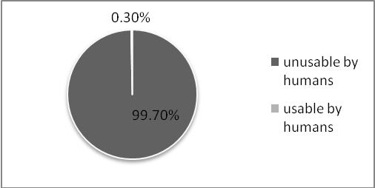
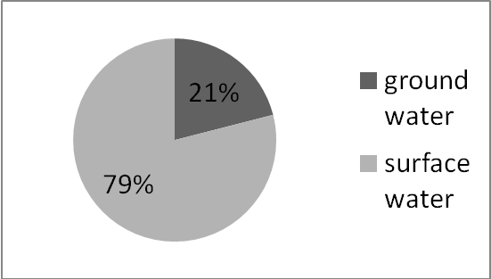
Usable vs. Unusable Water on Earth

- The left-side pie chart shows that over 99 percent of all water (oceans, seas, ice, and atmosphere) is not available for our uses. And even of the remaining 0.3 percent (the small slice in the left pie chart), much of that is out of reach. Most of the water we use in everyday life comes from rivers. The right-side pie shows that not only do we use surface water to meet many of our needs, ground water is used as well.
Information taken from http://ga.water.usgs.gov/edu/
  - Humans can only use freshwater for most needs (drinking, watering animals and crops, hydroelectric plants, etc.) Much of the freshwater on Earth is “locked up” and unavailable to be used because it is in what form?

  - What percentage of Earth’s freshwater is in a frozen form?

  - From the pie charts, what are the sources of water that are usable by humans?

  - Which of those sources is most used by humans?

  - Looking at one of the pie charts, how much water of all the water on Earth’s surface is usable and how much is unusable by humans?

- Roughly how long is the turnover time for water in each of the following storages?

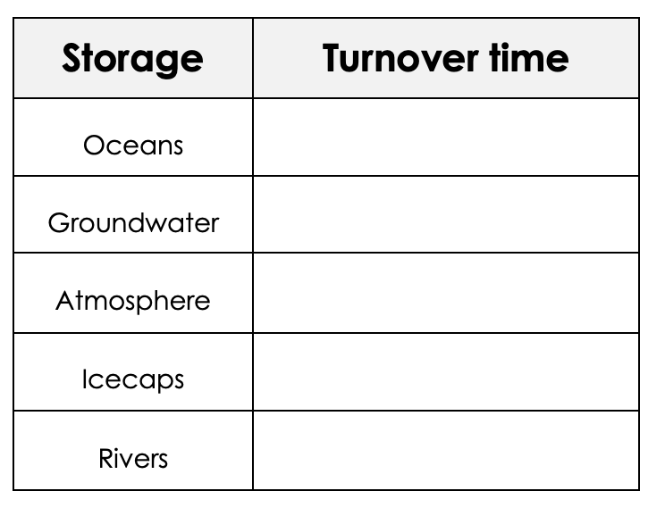

4.1.U1 Solar radiation drives the hydrological cycle
4.1.U3 Storage's in the hydrological cycle include organisms, soil and various water bodies, including oceans, groundwater (aquifers), lakes, rivers, atmosphere, glaciers and ice caps
4.1.U4 Flows in the hydrological cycle include evapotranspiration, sublimation, evaporation, condensation, convection (wind-blown movement), precipitation, melting, freezing, flooding, surface runoff, infiltration, percolation, and stream-flow or currents

- Use the following terms to draw a systems diagram of the hydrological cycle. Make sure that you identify them as inputs, outputs, flows, storages, transformation or transfers;
Evaporation Sublimation Evapotranspiration Condensation
Convection Precipitation Melting Freezing
Runoff Infiltration Percolation Stream-flow
Aquifers Flooding Surface runoff Oceans
Rivers Organisms Transpiration Sublimation
Advection (wind)

- Outline how the following human activities can impact the water cycle:
  - Withdrawals
  - Discharges
  - Changing the speed of flow
  - Diverting rivers

- Explain how urbanisation can lead to flash floods.

- Draw a systems diagram of the water budget and cycle showing the flows and storages given in the table.
  - Make your storage boxes and width of flow arrows correspond to the proportions of these volumes.
  - Label all these storages and flows.
Storages | Water volume  (km² x 10³) | Flows | Water volume  (km² x 10³)
Snow and ice | 27000 | Precipitation over oceans | 385
Ground water and aquifers | 9000 | Precipitation over land | 110
Lakes and rivers | 250 | Ice melt | 2
Oceans | 1350000 | Surface run off | 40
Atmosphere | 13 | Evapotranspiration over land | 70
Soil | 35000 | Evaporation form sea | 425

4.1.U6 Ocean circulation systems are driven by differences in temperature and salinity. The resulting difference in water density drives the ocean conveyor belt, which distributes heat around the world, and thus affects climate
- Label each of the currents on the blank ocean currents map by writing the name next to the arrow.
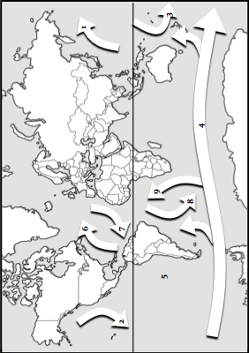

  - Choose two different colored pencils. Shade in the arrows that represent the cold-water currents in one color and the warm-water currents in another color.
  - Include a key to identify which colors represent the cold and warm currents.
Number | Name of Surface Current | Characteristic Temperature of Water Transported by Current
1 | Kuroshio Current | warm
2 | California Current | cold
3 | East Australian Current | warm
4 | Antarctic Circumpolar Current | cold
5 | Peru Current (Humboldt) | cold
6 | Gulf Stream | warm
7 | Canary Current | cold
8 | Brazil Current | warm
9 | Benguela Current | cold

- Outline what is meant by thermohaline circulation.

- In terms of temperature and density, explain how global ocean currents move

- Suggest what determine whether a current carries warm or cold water?

  - Explain how ocean currents affect climate

  - Explain how climate affects ocean currents

  - Find the United States on the map. Look at the pattern of currents in the Northern Hemisphere. What current affects the eastern coast of the United States? How do you think this current affects the climate on the east coast?

  - Look at the pattern of currents in the Northern Hemisphere. What current affects the western coast of the United States? How do you think this current affects the climate in the western coast?

  - At what locations on the Earth would you expect to find very cold and saline water? How would this water cause the deep currents in the ocean?

- EL NINO WEBQUEST

Go to:
https://spaceplace.nasa.gov/el-nino/en/

  - Where does this weather phenomenon often begin?

  - Normally, how does the direction that the wind is blowing impact the temperature of ocean water near South America’s coast?

  - What is different about the wind patterns during an El Niño event in this region?

  - Why do many of the fish leave the coastline of South America during El Niño events?

  - How did this natural phenomenon get its name?

  - How might weather patterns change during an El Niño event?

Not only does the El Niño modify weather patterns around the world, but it also has an impact on living
organisms. Read the article and watch the video entitled “NASA Examines El Niño’s Impact on Ocean’s
Food Source” and answer the questions below. https://www.nasa.gov/feature/goddard/2016/nasa-examines-el-nino-impact-on-ocean-food-source

  - What normally occurs during upwelling that helps the ocean’s food chain?

  - Why does the El Niño impact this normal chain of events?

  - What does the change in ocean color seen by NASA satellites tell us about the impact on the ocean food chain?

  - Based on the satellite data, what did researchers conclude occurred to green chlorophyll off the coast of Chile during the 1997-1997 El Niño?

Watch this short data animation that shows various NASA satellite data sets that will
help scientists better understand El Niño events. https://www.youtube.com/watch?v=_titsRUo4t4. Use the information from the video to answer these questions.

  - What two things are changing in the Pacific Ocean to cause an El Niño event?

  - What three types of data do we see in this animation?

  - What happens to the amount of chlorophyll during El Niño?

- Upwelling
Answer the following questions using this website:
http://ww2010.atmos.uiuc.edu/(Gh)/guides/mtr/eln/upw.rxml

  - What is upwelling?

  - Why does upwelling occur?

  - What is a thermocline? How does it affect sea surface temperatures?

  - How are layers of the ocean divided?

  - Why does a deeper thermocline (seen in El Nino years) affect fish?

- Global Effects of El Nino
Use the websites below to answer each set of questions.
http://oceanworld.tamu.edu/students/elnino/elnino2.htm

  - How is southeast Texas affected?

  - What parts of the world experience drought conditions?

  - Which areas of the world are warmer than average?

http://www.oar.noaa.gov/k12/html/elnino2.html
  - How often do El Nino events occur?
  - How long do most El Nino events last?
http://www.cpc.ncep.noaa.gov/products/analysis_monitoring/enso_advisory/ensodisc.pdf
  - Are we currently in an El Nino, La Nino, or Neutral pattern?

  - When is this condition expected to change?

Theory of knowledge:
- The hydrological cycle is represented as a systems model—to what extent can systems diagrams effectively model reality, given that they are only based on limited observable features?

ESS can be like learning a new language. So many words are not commonly used in everyday English. This can be challenging. To help you keep up with ESS Terms, you will need to create your own ESS DICTIONARY. You should add to this over the year and keep it in your notebook or on a page file THAT YOU CAN UPDATE AND ADD TO EASILY. Most of the vocabulary words can be found either on your STUDY GUIDE or at mrgscience.com.
You will be responsible for learning the words and their meaning. Periodic quizzes will be given on the words. So, make your dictionary creative and you will remember the words more easily.

KEY TERMS

surface water

hydrology

rivers

irrigation

evaporation

evapotranspiration

salt water

soil moisture

hydroelectric

hydrologic cycle

consumptive water

condensation

upwelling

fresh water

aquifer

drought

la nina

watershed

cloud seeding

freezing

melting

ground water

ponds

el nino

zone of saturation

watershed management

transpiration

turnover time

lakes

water table

recharge zone

heat capacity

