Understandings, Applications and Skills (This is what you may be assessed on)

Significant ideas
- The supplies of freshwater resources are inequitably available and unevenly distributed, which can lead to conflict and concerns over water security.
- Freshwater resources can be sustainably managed using a variety of different approaches.
Big Questions:
- What strengths and weaknesses of the systems approach and the use of models have been revealed through this topic?
- To what extent have the solutions emerging from this topic been directed at preventing environmental impacts, limiting the extent of the environmental impacts, or restoring systems in which environmental impacts have already occurred?
- How are the issues addressed in this topic of relevance to sustainability or sustainable development?
- In what ways might the solutions explored in this topic alter your predictions for the state of human societies and the biosphere some decades from now?
- How does a systems approach help in our understanding of unequal access to water resources?
- To what extent are there solutions for increasing greater access to freshwater resources?
- Outline the opportunities and barriers to managing freshwater resources sustainably.
- Suggest how and why access to freshwater resources is likely to change in the future.

 | Statement | Guidance
4.2.U1 | Access to an adequate freshwater supply varies widely | Consider examples of unequal distribution and inequitable supply.
4.2.U2 | Climate change may disrupt rainfall patterns and further affect this access
4.2.U3 | As populations, irrigation and industrialization increase, the demand for fresh water increases
4.2.U4 | Freshwater supplies may become limited through contamination and unsustainable abstraction
4.2.U5 | Water supplies can be enhanced through reservoirs, redistribution, desalination, artificial recharge of aquifers and rainwater harvesting schemes. Water conservation (including grey-water recycling) can help to reduce demand but often requires a change in attitude by the water consumers
4.2.U6 | The scarcity of water resources can lead to conflict between human populations, particularly where sources are shared
4.2.A1 | Evaluate the strategies that can be used to meet an increasing demand for fresh water
4.2.A2 | Discuss, with reference to a case study, how shared freshwater resources have given rise to international conflict

4.2.U1 Access to an adequate freshwater supply varies widely
4.2.U2 Climate change may disrupt rainfall patterns and further affect this access
4.2.U3 As populations, irrigation and industrialization increase, the demand for fresh water increases

- Watch the video clip on “World’s Water Crisis” https://youtu.be/C65iqOSCZOY. Complete the following questions as you watch the video

  - What is day zero for water access?

  - Identify three cities running out of water?

  - How much of the Earth's water is salt water?

  - How much of all the Earth's water is available to use by humans?

  - Over human history where have humans settled and why?

  - What is the challenge of using aquifers as a water source?

  - Why is Mexico city prone to flooding?

  - Why is Mexico City sinking?

  - Why are the world's aquifers being depleted?

  - What is most freshwater used for?

  - Which common product has the most embedded water?

  - Why isn't the "cost" of water included in a burger?

  - Give three examples of water intensive crops grown in dry areas of the world.

  - What would be an advantage of increasing the price of water?

  - What is a consequence of having a low price of water on water infrastructure?

  - What is an inefficient method of irrigation?

  - What does the Colorado river supply water to?

  - Name three examples of regions that are suffering from water conflict?

  - What is the challenge of desalination?

  - When was access to water recognised as a human right?\

  - What is a compromise to get over the challenge of access to water for poor people?

  - How did Philadelphia experiment with a price on water?

  - How did the use of "Day Zero" change behaviour?

- Describe and explain the distribution of freshwater and water scarcity around the globe.

- How can we reduce the amount of water we use?

Check out these interactive activities that show individual and global water use
http://www.home-water-works.org/calculator
http://environment.nationalgeographic.com/environment/freshwater/freshwater-101-interactive/ needs flash
http://environment.nationalgeographic.com/environment/freshwater/embedded-water/
needs flash
http://environment.nationalgeographic.com/environment/freshwater/global-water-footprint/
click on the different food items on the left-hand side of the screen

- Read the following article (source: http://www.gracelinks.org/2380/the-impact-of-climate-change-on-water-resources)
The relationship between water, energy, agriculture and climate is a significant one. More and more, that relationship is falling out of balance jeopardizing food, water and energy security. Climate change is a phenomenon we can no longer deny as its effects have become increasingly evident worldwide. On the list of warmest years on record, almost every year since 1992 is included and, according to NASA and NOAA data, 2015 was the hottest.
As the earth's temperature continues to rise, we can expect a significant impact on our fresh water supplies with the potential for devastating effects on these resources. As temperatures increase, evaporation increases, sometimes resulting in droughts. The US is currently in one of the most severe, multi-state, multi-year droughts in decades.
In addition, rising temperatures are melting glacial ice at an unprecedented rate. Glaciers are an important source of freshwater worldwide, and some, like those at Glacier National Park, are in danger of disappearing within the 21st century. Once these glaciers have melted away, they can't be restored. Areas that previously depended on glaciers for freshwater will then have to seek other sources.
More than 50 percent of the world's freshwater comes from mountain runoff and snowmelt.
Complicating this potential outcome is the prediction that in a warmer environment, more precipitation will occur as rain rather than snow. Although more rain than snow may seem like a plus, it could mean more frequent water shortages. When snow and ice collect on mountaintops, water is released slowly into reservoirs as it melts throughout the spring and summer. When rain falls, reservoirs fill quickly to capacity in the winter, which can also result in excess water runoff that can't be stored. Because rain flows faster than melting snow, higher levels of soil moisture and groundwater recharge are less likely to occur. Areas that rely on snowmelt as their primary freshwater source could increasingly experience water shortages, like having low water supplies by summer's end.
The relationship between climate change and water doesn't end there. The systems used to treat and move public water supplies require large amounts of energy, produced mainly by burning coal, natural gas, oil and other fossil fuels. So, when we use water we also use energy and contribute to climate change. In addition, bottled water is a small but real contributor to greenhouse gas emissions, because it takes fuel to make plastic bottles and ship them around the country (and even the world). This is unnecessary when you consider that bottled water is often just filtered tap water.
There's a lot we can do to reduce emissions, prevent climate change and protect our threatened freshwater sources. Using less energy is a great place to start. This can be done by turning off lights, better insulating our homes to conserve heat and air conditioning, driving more fuel efficient cars and driving less. Cars and light trucks (like vans and SUVs) are responsible for about 20 percent of U.S. energy-related carbon emissions. In addition, eating lower on the food chain, even going meatless just one day a week can have a significant impact on environmental resources because industrial meat production has significant greenhouse gas emissions associated with it.
Conserving water, food and other resources is an important step towards reducing overall energy use, because most everything that is made, transported and thrown away requires the use of fuel and water. By carpooling, using public transportation, driving less, and reducing our consumption of food and consumer goods, each individual can make an impact on curbing greenhouse gases.
  - Summarize the article in five bullet points

- Review these videos on the comparison of extreme rainfall in the Midwest U.S. and Africa. Discuss how climate change is affecting the access to fresh water
- https://www.youtube.com/watch?v=pNMm90nzT4o
- https://www.youtube.com/watch?v=DK1uKpJ49Jo
- https://www.youtube.com/watch?v=7Fp6HYCEWp4

- Explain why the freshwater requirements of a nation increases over time with respect to; population, industrial Development and expansion of farmland

- Briefly describe the ways that the following can limit the supply of freshwater.
  - Industrialisation
  - Irrigation of farmland
  - Use of pesticides
  - Use of fertilisers
  - High extraction rates from aquifer

- Explain how the following issues linked to climate change can influence the availability of water.
  - Rising sea leve
  - Changing rainfall patterns
  - Changes in amount and
  - Timing of snow melt

- Match up potential solutions with the issues listed below by writing the number(s) into the spaces provided
ISSUES | Number | SOLUTIONS
Climate change may be disrupting rainfall patterns, even changing monsoon rains, causing further inequality of supplies |  | 1. Increase freshwater supplies by:  - Reservoirs  - Redistribution  - Desalination  - Rainwater harvesting systems  - Artificially recharging aquifers
Low water levels in rivers and streams |  | 2. Reduce domestic use of freshwater by using water efficient appliances
Slow water flow in the lower courses of river results in sedimentation, which makes the already shallow river even shallower and may extend deltas further into the sea |  | 3. Wash cars in car washes with a closed water system
Underground aquifers are being exhausted (affects agriculture, damages buildings and shrinking soil) |  | 4. Grey water recycling
Pumping rates form aquifers too fast causing a cone of exhaustion making the well unusable |  | 5. Irrigation  - Closed pipes instead of open canals  - Trickle systems instead of sprinklers/sprayers  - Subsurface drip irrigation
Freshwater becomes contaminated |  | 6. Reduce fertilizer and pesticide use
Irrigation results in soil degradation  Water evaporates before it has a chance to be absorbed causing salinization (rendering soil unusable for agriculture) |  | 7. Prevent overspray (so fertilizers and pesticides don’t end up in streams)
Fertilizers and pesticides pollute streams and rivers |  | 8. Replace chemical fertilizers with organic ones
Industries release pollutants into water bodies |  | 9. Use highly selective pesticides or biological control methods
Industry and electricity plants release warm water into rivers. |  | 10. Industries can remove pollutants from their wastewater with water treatment plants
 |  | 11. Regulate maximum temperatures of released cooling water, cooling towers that evaporate the water can be used

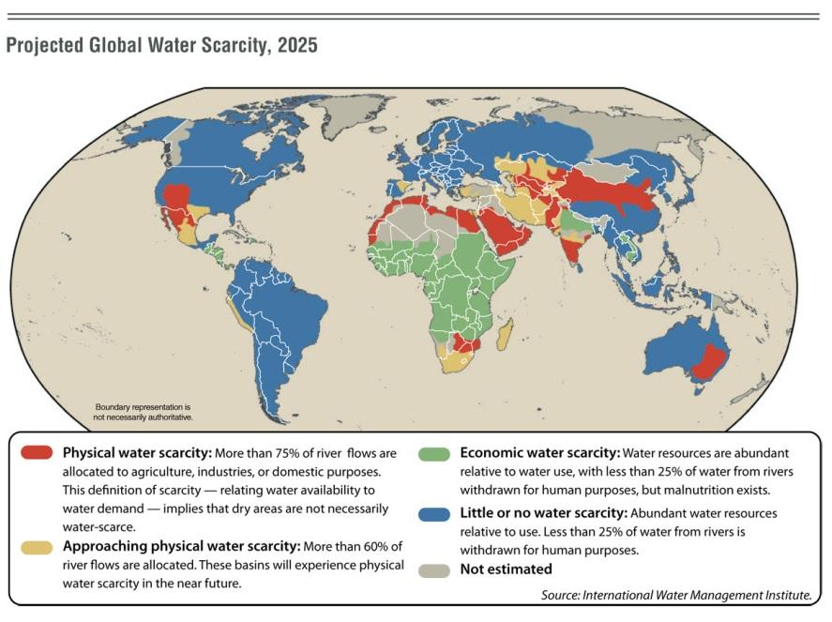

- Which countries have…
  - Few problems with water scarcity?

  - Physical water scarcity?

  - Approaching physical water scarcity?

  - Economic water scarcity?

- The demand for freshwater has grown extremely quickly in the last 100 years. State three reasons for why you think this is…

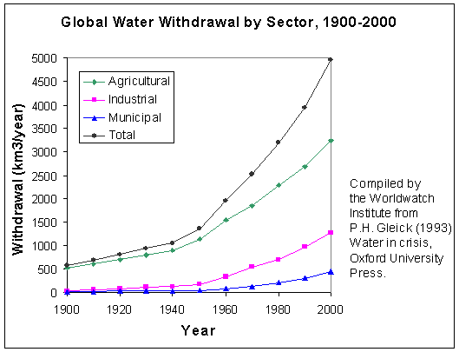

4.2.U4 Freshwater supplies may become limited through contamination and unsustainable abstraction
4.2.U5 Water supplies can be enhanced through reservoirs, redistribution, desalination, artificial recharge of aquifers and rainwater harvesting schemes. Water conservation (including grey-water recycling) can help to reduce demand but often requires a change in attitude by the water consumers
Freshwater resources can be sustainably managed using a variety of different approaches
4.2.A1 Evaluate the strategies that can be used to meet an increasing demand for fresh water

- Sustainable Water use strategies in Western Cape, South Africa Watch the video https://www.youtube.com/watch?v=7C5vh7g5snM
https://www.westerncape.gov.za/110green/water/reduce-water-consumption

- Define each of the following terms:

Key Term | Definition
Reservoirs
Desalination
Artificial recharge of aquifers
Rainwater harvesting
Grey water

- State a similarity and difference between white and grey water.

- Draw a labeled diagram to show the structure of an aquifer.

- Describe and evaluate the following ways to increase water supply.
  - Build reservoirs
  - Redistribute water
  - Desalination
  - Rainwater harvesting
  - Recharging aquifers
  - Closed-water car washes
  - Grey water recycling
  - Use drought resistant crops
  - Reduce fertilizer and pesticide use
  - Use organic (instead of chemical) fertilizers
  - Water treatment by factories
  - Reduce temperature of water discharge

4.2.U6 The scarcity of water resources can lead to conflict between human populations, particularly where sources are shared
A.2.A2 Discuss with reference to a case study, how shared freshwater resources have given rise to international conflict

- Outline how water scarcity can lead to conflict.

- CASE STUDIES: https://oxfamblogs.org/education/water_for_all/water/problem/index_pupil.htm

DAMS | WAR | HEALTH AND HYGIENE
Problems: | Problems: | Problems:
Solutions: | Solutions: | Solutions:
DROUGHT | TOURISM AND TRADE | LARGE SCALE IRRIGATION
Problems: | Problems: | Problems:
Solutions: | Solutions: | Solutions:

- Choose two environmental value systems and compare the attitudes people of each value system may have to diverting rivers to provide water for human use.”

Theory of knowledge:
- Aid agencies often use emotive advertisements around the water security issue—to what extent can emotion be used to manipulate knowledge and actions?

ESS can be like learning a new language. So many words are not commonly used in everyday English. This can be challenging. To help you keep up with ESS Terms, you will need to create your own ESS DICTIONARY. You should add to this over the year and keep it in your notebook or on a page file THAT YOU CAN UPDATE AND ADD TO EASILY. Most of the vocabulary words can be found either on your STUDY GUIDE or at mrgscience.com.
You will be responsible for leaning the words and their meaning. Periodic quizzes will be given on the words. So, make your dictionary creative and you will remember the words more easily.

KEY TERMS

pollution

​esalination

​irrigation

​flooding

​saline

​aquifer

​effluent

freshwater

drought resistant

water wars

overpopulation
​potable water
​individualization
​contamination
​brine
​wastewater
recharge
​surface water
​drip irrigation

water diversion

​stream-flow

​cholera

heavy metals

​reservoir

grey-water

scarcity

degradation

xeriscape

rainwater collection

thermokarst

​drought

​salt pans

​redistribution

​black-water

sustainable

evaporation

dissolved oxygen

