Understandings, Applications and Skills (This is what you may be assessed on)

Significant ideas
- Aquatic systems provide a source of food production.
- Unsustainable use of aquatic ecosystems can lead to environmental degradation and collapse of wild fisheries.
- Aquaculture provides potential for increased food production
Big Questions:
- What strengths and weaknesses of the systems approach and the use of models have been revealed through this topic?
- To what extent have the solutions emerging from this topic been directed at preventing environmental impacts, limiting the extent of the environmental impacts, or restoring systems in which environmental impacts have already occurred?:
- How are the issues addressed in this topic of relevance to sustainability or sustainable development?
- In what ways might the solutions explored in this topic alter your predictions for the state of human societies and the biosphere some decades from now?
- How far does a systems approach help our understanding of aquatic food production systems?
- Compare and contrast the environmental impact of capture fisheries and aquaculture
- To what extent can fisheries be managed sustainably?
- Outline the likely pressures on, and potential solutions for the world fisheries in decades to come.

 | Statement | Guidance
4.3.U1 | Demand for aquatic food resources continues to increase as the human population grows and diet changes. | When looking at the increase in demand for food resources, consideration should be given to changes in attitude towards “health foods” and food fashions
4.3.U2 | Photosynthesis by phytoplankton supports a highly diverse range of food webs.
4.3.U3 | Aquatic (freshwater and marine) flora and fauna are harvested by humans.
4.3.U4 | The highest rates of productivity are found near coastlines or in shallow seas, where upwellings and nutrient enrichment of surface waters occurs.
4.3.U5 | Harvesting some species, such as seals and whales, can be controversial. Ethical issues arise over biorights, rights of indigenous cultures and international conservation legislation.
4.3.U6 | Developments in fishing equipment and changes to fishing methods have led to dwindling fish stocks and damage to habitats. | Wild fisheries are also known as “capture fisheries”.  Consider how two contrasting fisheries have been managed and relate to the  concept of sustainability; for example, cod fisheries in Newfoundland and Iceland.  Issues that should be covered include: improvements to boats, fishing gear (trawler bags), and detection of fisheries and boats via satellites. Management aspects should include; use of quotas, designation of marine protected areas (exclusion zones), and restriction on types and size of fishing gear (including mesh size of nets).
4.3.U7 | Unsustainable exploitation of aquatic systems can be mitigated at a variety of levels (international, national, local and individual) through policy, legislation and changes in consumer behaviour.
4.3.U8 | Aquaculture has grown to provide additional food resources and support economic development and is expected to continue to rise.
4.3.U9 | issues around aquaculture include: loss of habitats, pollution (with feed, antifouling agents, antibiotics and other medicines added to fish pens), spread of diseases and escaped species (some involving genetically modified organisms).
4.3.A1 | Discuss, with reference to a case study, the controversial harvesting of a named species.
4.3.A2 | Evaluate strategies that can be used to avoid unsustainable fishing. | Students should understand maximum sustainable yield (MSY) as applied to fish stocks.
4.3.A3 | Explain the potential value of aquaculture for providing food for future generations.
4.3.A4 | Discuss a case study that demonstrates the impact of aquaculture.

4.3.U2 Photosynthesis by phytoplankton supports a highly diverse range of food webs.
4.3.U3 Aquatic (freshwater and marine) flora and fauna are harvested by humans.

- List the components of a marine ecosystem

- Compare the marine productivity of the continental shelf to deep oceans

- Identify the different oceans zones
Zone | Depth
Epipelagic zone

 | depth of 200m to 1,000m
Abyssopelagic zone

 | depth of more than 6,000m

- Distinguish between phytoplankton and zooplankton:

- Use the information in the table below to construct a marine food web
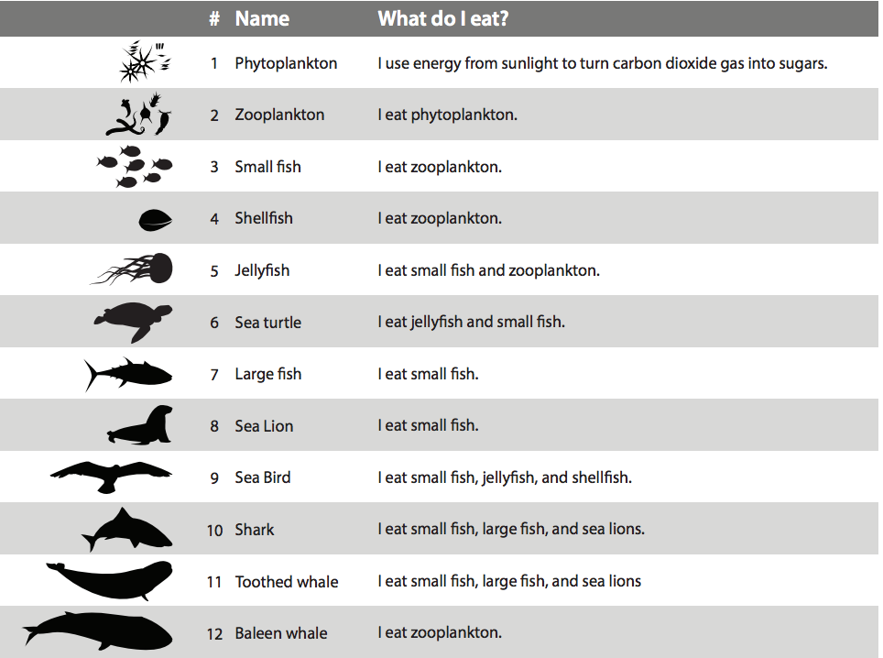

- Complete the table below
Freshwater Zone | Description
Littoral zone:

Limnetic zone:

Euphotic zone:

Profundal zone:

Benthic zone:

- Explain the distribution of varying productivity in marine ecosystems.

- Explain why the territorial water of a country is of significant value to a nation.

4.3.U1 Demand for aquatic food resources continues to increase as the human population grows and diet changes.
Aquatic systems provide a source of food production
4.3.U4 The highest rates of productivity are found near coastlines or in shallow seas, where upwellings and nutrient enrichment of surface waters occurs.
4.3.U6 Developments in fishing equipment and changes to fishing methods have led to dwindling fish stocks and damage to habitats.
4.3.U7 Unsustainable exploitation of aquatic systems can be mitigated at a variety of levels (international, national, local and individual) through policy, legislation and changes in consumer behaviour.
Successful management of marine and some freshwater fisheries requires partnerships between different nations
4.3.A2 Evaluated strategies that can be used to avoid unsustainable fishing
Unsustainable use of aquatic ecosystems can lead to environmental degradation and collapse of wild fisheries

- Define fishery

- Watch the videos “ The Four Fish We Are Overeating” https://www.youtube.com/watch?v=_jaWs87t5UM. The Last Fish (https://youtube.com/watch?v=lQoVQRqQhlI) Trouble Waters (https://youtube.com/watch?v=YACTNvuijQY) The Case For Fish Farming (https://youtube.com/watch?v=a7cDt5r2pGY) and How I Feel In Love with Fish (https://youtube.com/watch?v=4EUAMe2ixCI)

Produce a summary graphic on aquatic food production that summarises these ideas. You should include:
  - Methods of fishing and aquaculture
  - Problems raised by these methods
  - Solutions for the future (include international, national measure and personal / community level solutions). This is also known as mitigation of overexploitation.

- State and explain the trend in demand for aquatic food resources over time.

- Explain how modern fishing practices and technology contribute to the unsustainability of the wild fishing industry.
Method | Description
Dredging
Gillnets
Trawling
Blast fishing
GPS navigation

At-sea refrigeration techniques

Indiscriminate
fishing
equipment

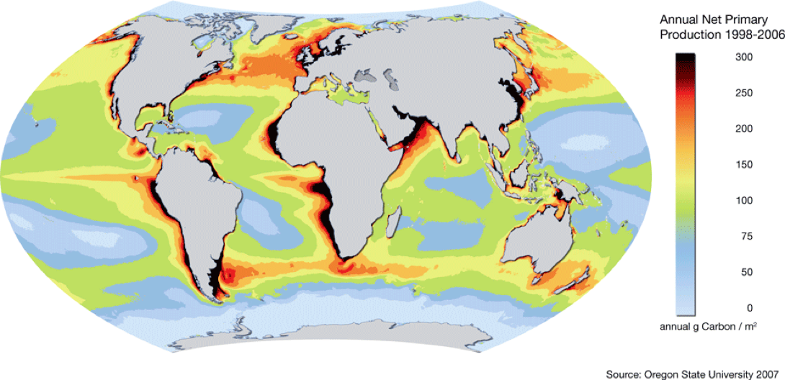
- The most productive sea areas, presented in this map, are those with the highest biodiversity and biomass. These are also, in most cases, the areas with the highest harvesting pressure. The unit used in this global map is the annual Net Primary Productivity (NPP). Evaluate the figure on the right.

- Define the following terms
  - Sustainable yield

  - Maximum sustainable yield

  - Optimum sustainable yield

- Watch this video on Fisheries Economics https://www.youtube.com/watch?v=7DNhqtYf47E

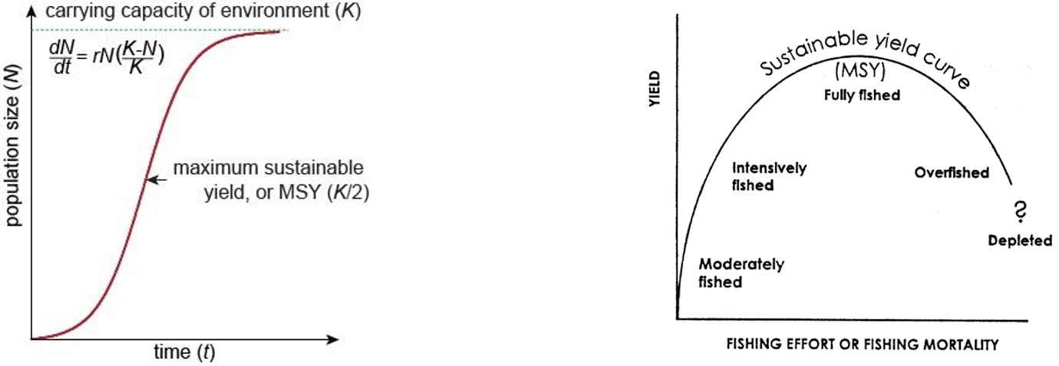

- Summarise ways in which unsustainable exploitation of aquatic systems can be mitigated.

- Research three factors that make it difficult to enforce fishing regulations

- Identify at least one international conflict

- Outline the tragedy of the commons (https://www.youtube.com/watch?v=CxC161GvMPc&t=22s)

- Read the article on the Tragedy of the Commons – the Tuna example. Describe in your own words the tragedy.(https://dotearth.blogs.nytimes.com/2008/11/26/the-tuna-tragedy-of-the-commons/ )

- Go to http://overfishing.org/pages/what_can_I_do_to_help.php . State four strategies for combating overfishing.

- Out of the four strategies, which do you think is the most effective? Explain why?

- Out of the four strategies, which do you think is the most challenging? Explain why?

- How would you rank the four strategies in the following categories?
- Most effective to least effective?
- Most expensive to least expensive
- Most time consuming to least time consuming

- Evaluate strategies that can be used to avoid unsustainable fishing.
STRATEGY | ADVANTAGES | DISADVANTAGES
Fishing Quotas
Equipment Restrictions
Socioeconomic Controls
Exclusion Zones
4.3.U5 Harvesting some species, such as seals and whales, can be controversial. Ethical issues arise over biorights, rights of indigenous cultures and international conservation legislation.
4.3.A1 Discuss, with reference to a case study, the controversial harvesting of a named species.

- Describe what is meant by the term “biorights”

- What type of environmental value system is expressed by a person who puts a strong emphasis on biorights?

Theory of knowledge:
- The Inuit people have an historical tradition of whaling—to what extent does our culture determine or shape our ethical judgments?

- Watch the video on “The Grind: Whaling in the Faroe island.
https://www.youtube.com/watch?v=HYOTkwFhe-w
Divide your paper into two columns, for and against. When watching the video place arguments for and against the Grind in each column

- Here is another great case study

Japan and the whale
By Rupert Wingfield-Hayes
BBC News, Tokyo
8 February 2016
Hunting whales is irrelevant to feeding Japan's population, draws global condemnation and is certainly not economic. So why does Japan still do it?
The answer from the Japanese government is that whaling is an ancient part of Japanese culture, that fishermen have caught whales for centuries, and that Japan will never allow foreigners to tell its people what they can and cannot eat.
One Japanese official once said to me: "Japanese people never eat rabbits, but we don't tell British people that they shouldn't". I pointed out that rabbits are not exactly an endangered species.
Still, there is some merit to the government's argument.
A number of coastal communities in Japan have indeed hunted whales for centuries, and continue to do so. Taiji in Wakayama prefecture is well known, many would say infamous, for its annual dolphin hunts. There are other places, in Chiba Prefecture and in Ishinomaki in northern Japan, that also do coastal whaling.

So, yes, coastal whaling is part of Japanese culture, like Norway and Iceland and the Inuit of northern Canada. But only Japan continues to sail a fleet of ships half way across the globe to hunt whales in the Antarctic and maintains a large factory ship that can process hundreds of whales at sea.
Nothing about these Antarctic whaling expeditions is historic. Japan's first whaling voyage to the Antarctic took place in the mid-1930s but the really huge hunts didn't get going until after World War Two.
Japan lay in ruins, its population starving. With the encouragement of General Douglas MacArthur, Japan converted two huge US Navy tankers into factory ships and set sail for the Southern Ocean.
From the late 1940s to the mid-1960s whale meat was the single biggest source of meat in Japan. At its peak in 1964 Japan killed more than 24,000 whales in one year, most of them enormous fin whales and sperm whales.
Today Japan can afford to import meat from Australia and America. There is no deep-sea commercial whaling in Japan. The fleet that is now hunting in Antarctic waters is paid for by Japanese taxpayers to carry out what the Japanese government describes as "scientific research".
Japan's other justification is that it needs to kill hundreds of whales each year to study them. But the International Court of Justice (ICJ) has systematically dismantled that argument. In 2014 it ruled that there was no scientific case for Japan's programme of "lethal research" in the Southern Ocean, and ordered Tokyo to stop.
For a year Japan stopped. But last year it sent its fleet to sea again insisting, to widespread disbelief, that it’s new, smaller, Antarctic whaling programme satisfies the ICJ's requirements.
Junko Sakuma used to work for Greenpeace in Japan. For the last 10 years she has been researching Japan's whaling industry.
"There is no benefit to Japan from whaling...but nobody knows how to quit," she tells me at Tokyo's famously chaotic Tsukiji fish market, the biggest in the world renowned for its pre-dawn tuna auctions.
Of the thousands of fish wholesalers in Tsukiji only two still deal in whale meat.
At one stand we find a few large hunks of minke whale meat, deep red and oozing blood. At the next there are two long slabs of lighter-coloured fin whale meat, an endangered species its trading banned by CITES.
Business is bad, complains the stall owner. Last year Japan caught no whales in the Antarctic, so there is less minke whale meat available, he says.
If there is a whale meat shortage, the price should be soaring. But according to Junko it is not.
"The fact is, most Japanese people do not eat whale meat," she says. "Consumption has been falling for years," and adds that "even as the amount of whale meat decreases, the price doesn't go up".
According to Junko's research, the average consumption of whale meat by Japanese people in 2015 was just 30g (one ounce) per person.
If eating whale is such an integral part of Japanese culture, why are so few eating it?
I turn to my old friend Etsuo Kato. Over the 20 years we have known each other he has, on occasion, tried to persuade me to eat whale meat with him. Kato-San grew up in Kita-Kyushu in western Japan, close to the big whaling port at Shimonoseki.
We are sitting in a cosy restaurant in Tokyo's notorious red light district, Kabukicho. Above us hangs a very large, and rather ancient, mummified whale penis. On the wall are picture of whales.
The first plate to arrive is whale sashimi - it is raw. The owner points to the different delicacies; steak, heart, tongue and even raw whale skin.
My stomach turns, but I steel myself. Gingerly, I put a bit of raw whale steak into my mouth. It has a strong gamey flavour, chewy and fibrous. Next, I try the tongue. It is salty and fishy. Kato-San points to the heart. I politely decline.
"When I was a child I ate this every day," he says. "Meat meant whale meat. I didn't know what beef was, or pork. Steak was whale steak, bacon meant whale bacon."
But if Japan stopped whale hunting you would be sad?
He looks at me smiling and gently shaking his head.
"I don't need whale hunting" he says. "Once you have eaten beef there is no need to eat whale meat."
The other customers in the restaurant are all middle-aged salary men. Eating a bit of whale meat is nostalgic, remembering school meals 50 years ago.
So I come back again to my original question: why does Japan still do it?
Recently I was at a private briefing with a high-ranking member of the Japanese government. Japan had just announced it was going to resuming whaling. I outlined to him why I thought it made no sense, and asked him to respond. His answer was astonishingly frank.
"I agree with you," he said. "Antarctic whaling is not part of Japanese culture. It is terrible for our international image and there is no commercial demand for the meat. I think in another 10 years there will be no deep sea whaling in Japan."
"So why not stop now?" asked another journalist.
"There are some important political reasons why it is difficult to stop now." he said. He would say no more.
But Junko Sakuma thinks the answer lies in the fact that Japan's whaling is government-run, a large bureaucracy with research budgets, annual plans, promotions and pensions.
"If the number of staff in a bureaucrat's office decreases while they are in charge, they feel tremendous shame," she says.
"Which means most of the bureaucrats will fight to keep the whaling section in their ministry at all costs. And that is true with the politicians as well. If the issue is closely related to their constituency, they will promise to bring back commercial whaling. It is a way of keeping their seats."
It may seem incredibly banal. But Japan's determination to continue whaling may come down to a handful of MPs from whaling constituencies and a few hundred bureaucrats who don't want to see their budgets cut.

Questions

  - List some of the products made from whales.

  - What is the main controversy surrounding Japan’s whaling programme?

  - What reasons are given for the existence of the whaling programme?

  - Is governmental policy on whaling supported by the Japanese population?

  - State and justify your opinion on the harvesting of whales.

4.3.U8 Aquaculture has grown to provide additional food resources and support economic development and is expected to continue to rise.
4.3.U9 issues around aquaculture include: loss of habitats, pollution (with feed, antifouling agents, antibiotics and other medicines added to fish pens), spread of diseases and escaped species (some involving genetically modified organisms).
4.3.A3 Explain the potential value of aquaculture for providing food for future generations.
4.3.A4 Discuss a case study that demonstrates the impact of aquaculture.

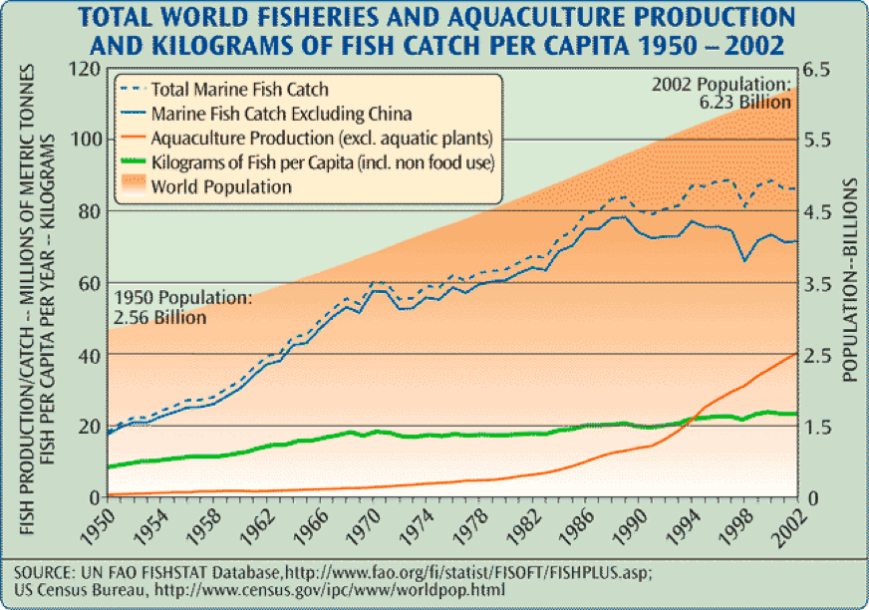
- Look at the graph below. The amount of food provided by wild-catch fish is plateauing worldwide, while the amount provided by aquaculture is increasing. Suggest reasons for this.

- Describe what is meant by the term “aquaculture”.

- Compare the advantages and disadvantages of aquaculture in a table

Advantages of aquaculture | Disadvantages of aquaculture

- Explain the need for more sustainable aquaculture.

- Describe ways in which aquaculture is becoming more sustainable.

- Have a look at http://www.naturskyddsforeningen.se/sites/default/files/dokument-media/murky_waters.pdf
Don’t worry – you aren’t expected to read a 64 page document – although it is really interesting. Instead – you can summarize the main points for each of the sections listed below

Shrimp farming in Bangladesh

Effect of shrimp farming on….  (information begins on page # listed) | Summary
Mangrove and forest ecosystems
P8
Climate and natural disasters
P17
Populations of wild shrimp
P14
Social responsibility and human rights
P21
Pollution
P28

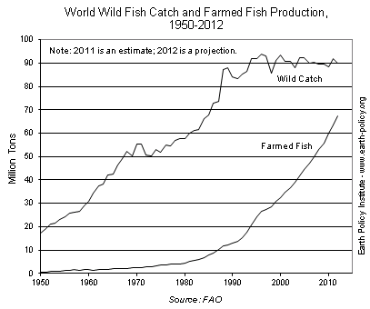
- Describe the trend shown for wild fish catches and compare to farmed fish catches

- Why is the number of wild fish caught decreasing and the number of farmed fish increasing?

ESS can be like learning a new language. So many words are not commonly used in everyday English. This can be challenging. To help you keep up with ESS Terms, you will need to create your own ESS DICTIONARY. You should add to this over the year and keep it in your notebook or on a page file THAT YOU CAN UPDATE AND ADD TO EASILY. Most of the vocabulary words can be found either on your STUDY GUIDE or at mrgscience.com.
You will be responsible for learning the words and their meaning. Periodic quizzes will be given on the words. So, make your dictionary creative and you will remember the words more easily.

KEY TERMS

carrying capacity

​ammonia

nitrogenous wastes

​spawning

​wild fish

​fish stock

​SOFIA

International Court of Justice​

suspended solids

fisheries

algae bloom

​urea

​game fish

​sustainability

​FIP

​polyculture

​aquaculture

overfishing

cage culture

phytoplankton

ornamental fish

​maximum sustainable yield

​Marine Stewardship Council

​GMOs

​raceway

​hatchery

​fisheries

​UNFAO

total allowable catches

​bioright

Tragedy of the Commons

