Topic 4.3 Carbon Cycling Skeleton Notes
​Essential idea: Continued availability of carbon in ecosystems depends on carbon cycling.

 | Statement | Guidance
4.3.U1 | Autotrophs convert carbon dioxide into carbohydrates and other carbon compounds.
4.3.U2 | In aquatic ecosystems carbon is present as dissolved carbon dioxide and hydrogen carbonate ions.
4.3.U3 | Carbon dioxide diffuses from the atmosphere or water into autotrophs.
4.3.U4 | Carbon dioxide is produced by respiration and diffuses out of organisms into water or the atmosphere.
4.3.U5 | Methane is produced from organic matter in anaerobic conditions by methanogenic archaeans and some diffuses into the atmosphere or accumulates in the ground.
4.3.U6 | Methane is oxidized to carbon dioxide and water in the atmosphere.
4.3.U7 | Peat forms when organic matter is not fully decomposed because of acidic and/or anaerobic conditions in waterlogged soils.
4.3.U8 | Partially decomposed organic matter from past geological eras was converted either into coal or into oil and gas that accumulate in porous rocks.
4.3.U9 | Carbon dioxide is produced by the combustion of biomass and fossilized organic matter.
4.3.U10 | Animals such as reef-building corals and mollusca have hard parts that are composed of calcium carbonate and can become fossilized in limestone.
4.3.A1 | Estimation of carbon fluxes due to processes in the carbon cycle. | Carbon fluxes should be measured in gigatonnes.
4.3.A2 | Analysis of data from air monitoring stations to explain annual fluctuations.
4.3.S1 | Construct a diagram of the carbon cycle.

4.3.S1 Construct a diagram of the carbon cycle

1. Practice drawing of Carbon Cycle
(pool/sink) = reserve of the element; long term storage
(flux) = process/ transfer of the element from one pool to another.

2. Between which sinks would you add a flux showing volcanoes and the weathering of rocks?

3. What additional sink would you add to show the role of corals and shellfish?

4. What additional flux would be needed?

5. In some environments water is unable to drain out of soils so they become waterlogged and anaerobic. This prevents the decomposition of dead organic matter forming peat deposits [4.3.U7]. Peat can be dried and burnt as a fuel. Suggest how peat could be added to the carbon cycle.

6. Explain why fossil fuels are classified as non-renewable resources when the carbon cycle indicates they are renewed (hint: refer to the pictorial carbon cycle).

7. Diffusion is a flux that moves CO₂ from the atmosphere to the hydrosphere and back again. Taken together these fluxes are largest in the cycle suggest why.

- Volcanoes release CO₂ into atmosphere, weathering consumes CO₂ in rain.
- Weathering products carried to ocean – sedimentation, subducted which becomes heated liberating CO₂ which rises through the magma.
- Absorb CO₂ from dissolved CaCO₃. When they die, corals and shells deposited, compacted to form Limestone.
- Peat – death – combustion - atmosphere
- Specific condition required for production of fossil fuel pool. Pool is not being replensihed.
- 71% of earth’s surface is covered by water

4.3.U1 Autotrophs convert carbon dioxide into carbohydrates and other carbon compounds.

8. State the role of photosynthesis in the carbon cycle

9. List the organic compounds glucose can be convered into

n.b. Although most autotrophs fix carbon by photosynthesis. A few are Chemoautotrophs can fix carbon by utilising the energy in the bonds of inorganic compounds such as hydrogen sulfide.

4.3.U2 In aquatic ecosystems carbon is present as dissolved carbon dioxide and hydrogen carbonate ions.

10. Outline the process that converts CO2 to hydrogen carbonate ion in water

11. State the effect of increased levels of hydrogen carbonate on aquatic ecosystems

12. Write the formula for this process

4.3.U3 Carbon dioxide diffuses from the atmosphere or water into autotrophs

13. Plants must have a constant supply of carbon dioxide (CO₂) to continually____________________

14. Define diffusion

15. State how carbon dioxide diffuses into a plant leaf

*Some aquatic plants, e.g. water lilies have stomata, but in many fully submerged plants diffusion happens directly through the surface tissues.

4.3.U4 Carbon dioxide is produced by respiration and diffuses out of organisms into water or the atmosphere.

16. Organisms carry out respiration to release energy in the form of ATP. Carbon dioxide is a ___________________ of cell respiration .

17. List the three main categories of organisms that carry out respiration

4.3.U7 Peat forms when organic matter is not fully decomposed because of acidic and/or anaerobic conditions in waterlogged soils.

18. Define peat

19. Why is peat a highly effective carbon sink

20. Outline the formation of peat

4.3.U8 Partially decomposed organic matter from past geological eras was converted either into coal or into oil and gas that accumulate in porous rocks.

21. Outline the formation of coal, oil and gas

4.3.U10 Animals such as reef-building corals and mollusca have hard parts that are composed of calcium carbonate and can become fossilized in limestone.

23. State how molluscs and corals protect themselves

24. Outline the formation of limestone.

25. State how limestone is such large sink

4.3.U9 Carbon dioxide is produced by the combustion of biomass and fossilized organic matter

26. Define combustion.

27. State the products of a combustion reaction.

28. State sources of fuel for a combustion reaction.

4.3.U5 Methane is produced from organic matter in anaerobic conditions by methanogenic archaeans and some diffuses into the atmosphere or accumulates in the ground

29. Outline the role of methanogenic archaea in the transformation of organic material into methane.

30. Identify where Methanogens can be found

4.3.U6 Methane is oxidized to carbon dioxide and water in the atmosphere.

31. State how long methane can stay in the atmosphere

32. State how methane can be removed from the atmosphere

33. Identify the equation for the removal of methane

4.3.A1 Estimation of carbon fluxes due to processes in the carbon cycle.

It is not possible to measure the size of carbon sinks and the fluxes between them. Estimates are based on many different measurements are often published with large uncertainties as a result.
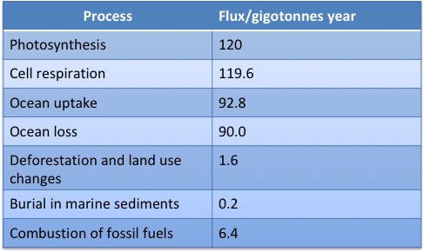

HOMEWORK:
4.3.A2 Analysis of data from air monitoring stations to explain annual fluctuations

34. What is the evidence for increasing levels of CO2 in the atmosphere? Sketch a graph of the annual fluctuation in atmospheric carbon dioxide concentration and explain the annual fluctuation in atmospheric carbon dioxide concentration in the northern hemisphere.

4.3.A2 Analysis of data from air monitoring stations to explain annual fluctuations.

Plot annual fluctuations and long-term trends for one of these sites

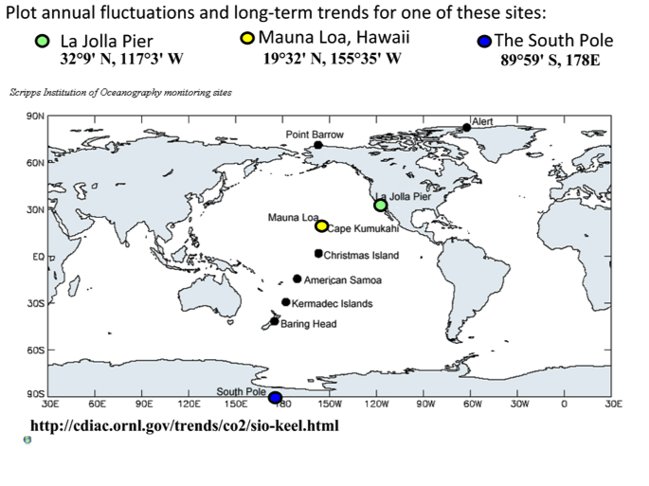

Data analysis task: Atmospheric CO2 measurements

The Carbon Dioxide Information Analysis Center (CDIAC) has a huge database of infomration regarding carbon dioxide measureements. In this task, use one set of data from their field observations in this list
http://cdiac.ess-dive.lbl.gov/trends/co2/sio-keel.html

Visit the webpage and make notes on
- Station name
- Coordinates
- Period of record
- Situation (type of environment)

Using the spreadsheet:
- Open the digigal data page
- Selectall data for the past 5 years
- Paste into Google Form
- Adjust the spreadsheet to make sure all columns and rows are corect
- Produce a line graph, presented to met requirements for Presenting Processed Data

Look at the graphics for the overall trends. What trends can you see? Using your own graph, explain the annual cycles in the data

Biology can be like learning a new language. So many words are not commonly used in everyday English. This can be challenging. To help you keep up with Biology Terms, you will need to create your own BIOLOGY DICTIONARY. You should add to this over the year and keep it in your notebook or on a page file THAT YOU CAN UPDATE AND ADD TO EASILY. Most of the vocabulary words can be found either on your STUDY GUIDE or at mrgscience.com.
You will be responsible for leaning the words and their meaning. Periodic quizzes will be given on the words. So, make your dictionary creative and you will remember the words more easily.

Key Terms

Carbon

glucose

​carbon dioxide

​peat

​carbon fixation

monoatomic oxygen

​fossilized organic matter

hydrogen carbonate

methanogenesis

organic acids

acetate

​Archaeans

​combustion

​sedimentary rock

methanogenic

​carbohydrate

​fossil fuels

​hydrocarbons

carbonic acid

​hydroxyl radicals

limestone

​coal

carbonates

​excretion

​cycling

​limestone

Ruminant mammals

​Peat

carbon flux

