Understandings, Applications and Skills (This is what you may be assessed on)

Significant ideas
- Water pollution, both to groundwater and surface water, is a major global problem, the effects of which influence human and other biological systems.
Big Questions:
- What strengths and weaknesses of the systems approach and the use of models have been revealed through this topic?
- To what extent have the solutions emerging from this topic been directed at preventing environmental impacts, limiting the extent of the environmental impacts, or restoring systems in which environmental impacts have already occurred?:
- How are the issues addressed in this topic of relevance to sustainability or sustainable development?
- In what ways might the solutions explored in this topic alter your predictions for the state of human societies and the biosphere some decades from now?
- How far does a systems approach help our understanding of aquatic food production systems?
- Compare and contrast the environmental impact of capture fisheries and aquaculture
- to what extent can fisheries be manages sustainably?
- Outline the likely pressures on, and potential solutions for the world fisheries in decades to come.

 | Statement | Guidance
4.4.U1 | There are a variety of freshwater and marine pollution sources | Sources of freshwater pollution should include runoff, sewage, industrial discharge  and solid domestic waste.  Sources of marine pollution should include rivers, pipelines, atmosphere and  activities at sea (operational and accidental discharges).
4.4.U2 | Types of aquatic pollutants include floating debris, organic material, inorganic plant nutrients (nitrates and phosphates), toxic metals, synthetic compounds, suspended solids, hot water, oil, radioactive pollution, pathogens, light, noise and biological pollutants (invasive species).
4.4.U3 | A wide range of parameters can be used to directly test the quality of aquatic systems, including pH, temperature, suspended solids (turbidity), metals, nitrates and phosphates | With respect to measuring aquatic pollution, a polluted and an unpolluted site (for example, upstream and downstream of a point source) should be compared.
4.4.U4 | ​Biodegradation of organic material utilizes oxygen, which can lead to anoxic conditions and subsequent anaerobic decomposition, which in turn leads to formation of methane, hydrogen sulfide and ammonia (toxic gases).
4.4.U5 | Biochemical oxygen demand (BOD) is a measure of the amount of dissolved oxygen required to break down the organic material in a given volume of water through aerobic biological activity. BOD is used to indirectly measure the amount of organic matter within a sample.
4.4.U6 | Some species can be indicative of polluted waters and can be used as indicator species.
4.4.U7 | A biotic index indirectly measures pollution by assaying the impact on species within the community according to their tolerance, diversity and relative abundance. Local and individual) through policy, legislation and changes in consumer behaviour.
4.4.U8 | Eutrophication can occur when lakes, estuaries and coastal waters receive inputs of nutrients (nitrates and phosphates), which results in an excess growth of plants and phytoplankton. | The role of positive and negative feedback in the process of eutrophication should  be covered. Coastal eutrophication can lead to red tide blooms.
4.4.U9 | Dead zones in both oceans and fresh water can occur when there is not enough oxygen to support marine life.
4.4.U10 | Water pollution management strategies include: 1) reducing human activities that produce pollutants (for example, alternatives to current fertilizers and detergents), 2) reducing release of pollution into the environment (for example, treatment of wastewater to remove nitrates and phosphates), 3) removing pollutants from the environment and restoring ecosystems (for example, removal of mud from eutrophic lakes and reintroduction of plant and fish species).
4.4.A1 | Analyse water pollution data
4.4.A2 | Explain the process and impacts of eutrophication.
4.4.A3 | Evaluate the uses of indicator species and biotic indices in measuring aquatic pollution.
4.4.A4 | Evaluate pollution management strategies with respect to water pollution.

4.4.U1 There are a variety of freshwater and marine pollution sources
4.4.U2 Types of aquatic pollutants include floating debris, organic material, inorganic plant nutrients (nitrates and phosphates), toxic metals, synthetic compounds, suspended solids, hot water, oil, radioactive pollution, pathogens, light, noise and biological pollutants (invasive species).
- List three freshwater and three marine pollution sources
Freshwater | Marine

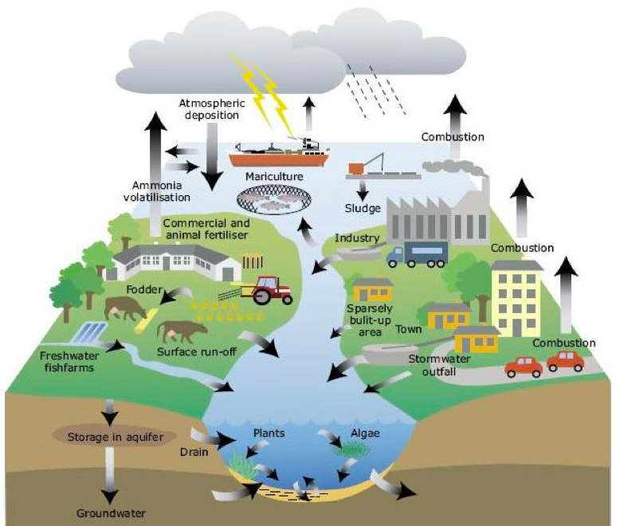
- Pollution sources in this diagram are primarily freshwater sources
  - How do they become marine sources?

  - What other sources not included in the diagram may be specific to marine ecosystems?

- Pollutants may be point or nonpoint. Give three examples of each and state their possible effect
Pollution type | Example | Effect
Point
Non-point

- Compare direct and indirect pollution sources. Give three examples of each and state their possible effect
Pollution type | Example | Effect
Direct
Indirect

- Watch the following video clips
  - Great Garbage Patch (https://www.youtube.com/watch?v=3RLrTCVmLCc)
  - Deep water Horizons (https://youtu.be/zcZ9MLDuIl0)

- Describe each of the aquatic pollutants with a named example
Pollutant | Example
Floating debris
Organic material
Inorganic plant nutrients

Toxic metals
Synthetic compounds

Suspended solids

Hot water

Oil

Radioactive pollution

Pathogens

Light/Sound

Biological

- Eichhornia crassipes is an alien hydrophyte introduced in India. Identify the problems posed by this plant

4.4.U3 A wide range of parameters can be used to directly test the quality of aquatic systems, including pH, temperature, suspended solids (turbidity), metals, nitrates and phosphates
4.4.U4 Biodegradation of organic material utilizes oxygen, which can lead to anoxic conditions and subsequent anaerobic decomposition, which in turn leads to formation of methane, hydrogen sulfide and ammonia (toxic gases).
4.4.U5 Biochemical oxygen demand (BOD) is a measure of the amount of dissolved oxygen required to break down the organic material in a given volume of water through aerobic biological activity. BOD is used to indirectly measure the amount of organic matter within a sample.
Theory of knowledge:
- A wide range of parameters are used to test the quality of water and judgments are made about causes and effects of water quality—how can we effectively identify cause–effect relationships, given that we can only ever observe correlation?

- Watch the video clip on water sampling (https://youtu.be/m8m6HiQbYHs). Describe each parameter for testing aquatic systems
Parameter | Testing Method
Nutrients
Physical Properties
Organics
Solids

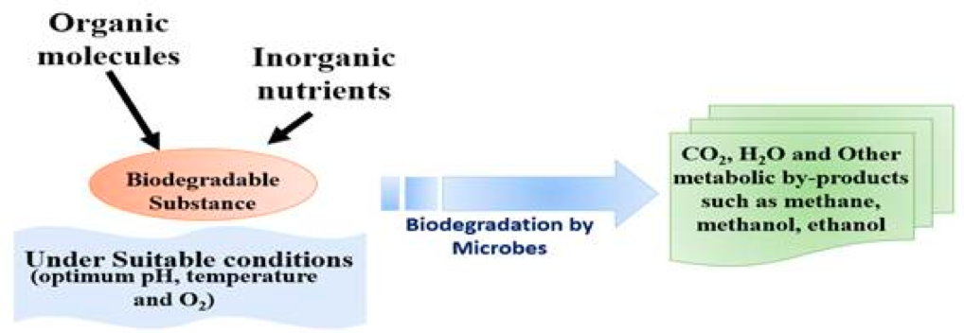
- Define anoxic

- Evaluate the advantages and disadvantages of biodegradation

Advantages | Disadvantages

- Explain the effects of biodegradation on an aquatic ecosystem

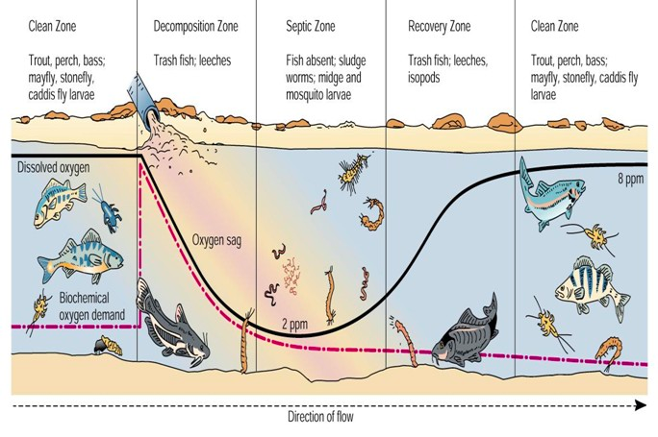
- Evaluate the graph on the right.

  - Explain how oxygen concentration is affected in the river, when sewage is discharged into it?

  - Describe what is meant by the term Biochemical Oxygen Demand (BOD).

  - What is the relationship between dissolved oxygen and Biochemical Oxygen Demand (BOD)?

  - Describe the effect on aquatic life in the river.

4.4.U6 Some species can be indicative of polluted waters and can be used as indicator species.
4.4.U7 A biotic index indirectly measures pollution by assaying the impact on species within the community according to their tolerance, diversity and relative abundance .local and individual) through policy, legislation and changes in consumer behaviour.
4.4.A3 Evaluate the uses of indicator species and biotic indices in measuring aquatic pollution.

- Describe what is meant by the term biotic index.

- Identify two aquatic indicator species. Outline how indicator species can be used to assess pollution levels in water.

Indicator Species | Assess Pollution Levels
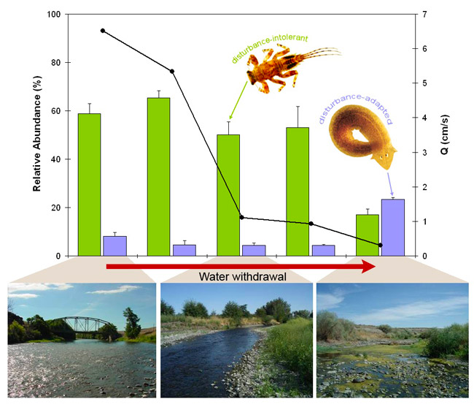

- Evaluate the graph on the right.

- The following are data samples:
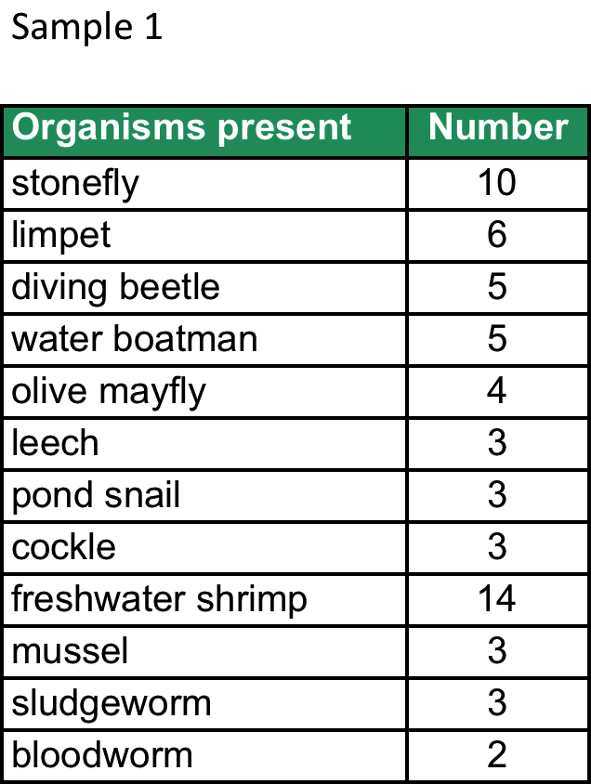
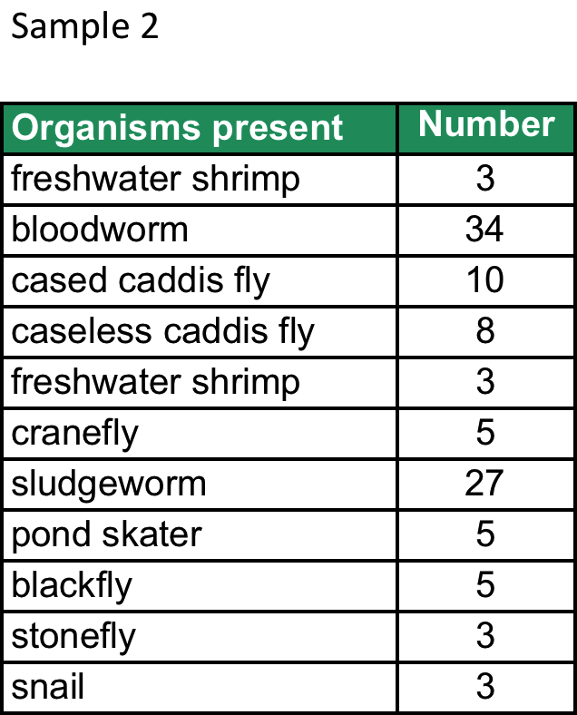
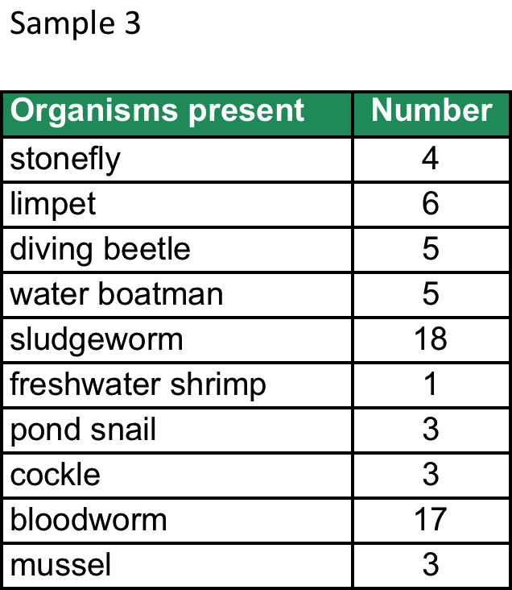

  - Plot a graph showing the different indicator species and their number found for the different samples. Which sample appears to be the most polluted? Sample A and Sample C are from the same location but taken at different times of the year, suggest what may have caused this change?

- Suggest why plants are not used as indicators of water pollution.

4.4.U8 Eutrophication can occur when lakes, estuaries and coastal waters receive inputs of nutrients (nitrates and phosphates), which results in an excess growth of plants and phytoplankton.
4.4.A2 Explain the process and impacts of eutrophication.
4.4.U9 Dead zones in both oceans and fresh water can occur when there is not enough oxygen to support marine life.

- With the help of a diagram, describe the process of eutrophication. Include each of the following:
Addition of fertilisers, Plant/algae growth, Sunlight blocked, Decomposition, Oxygen depletion, Death of organisms

4.4.U10 Water pollution management strategies include: 1) reducing human activities that produce pollutants (for example, alternatives to current fertilizers and detergents), 2) reducing release of pollution into the environment (for example, treatment of wastewater to remove nitrates and phosphates), 3) removing pollutants from the environment and restoring ecosystems (for example, removal of mud from eutrophic lakes and reintroduction of plant and fish species).
4.4.A4 Evaluate pollution management strategies with respect to water pollution.
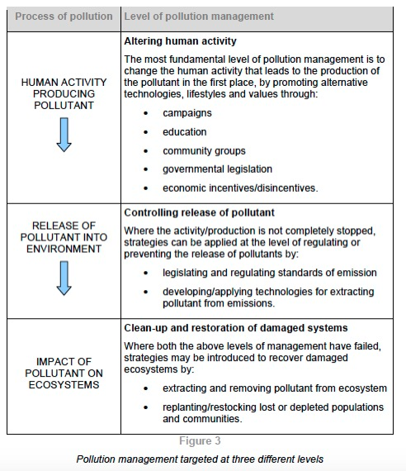
- You MUST be able to apply the 3-tiered approach to pollution management to any and all types of pollution encountered. The strategies may be more or less effective depending on the pollutant and the situation, but the strategies will remain the same in all ESS case studies
Types of aquatic pollution
- Floating debris
- Organic material
- Inorganic plant nutrients (nitrates and phosphates)
- Toxic metals
- Synthetic compounds
- Suspended solids
- Hot water
- Oil
- Radioactive pollution
- Pathogens
- Light, noise
- Biological pollutants (invasive species)

  - Complete the table below
3-Tier Approach | Strategy | Evaluation
Alter human activity | try to minimize the impact on the environment by  encouraging people to be restrained
 | minimize fertilizer use and replace with organic nutrientis | natural, renewable, biodegradable, environmentally friendly  effectiveness is limited seasonally, however may not release nutrients when needed, can be overused
 | stop leaching of slurry or sewage
Control release | treat wastewater before release to remove phosphates and nitrates | stops release of toxin into aquatic systems
 | educate farmers about timing for fertilizer useage
 | ban or limit detergents with phosphates | can be hard to identify who is the  cause of the pollution so hard to  target educational campaigns  effectively
 | educational campaigns to encourage people to use less detergent/more environmentally friendly detergent, use ecodetergents | technocentric solutions may increase  the costs of e.g. detergents/may  require a financial commitment
 | pumping air through lakes to avoid low oxygen content
 | minimize the amount of water used by employing more efficient irrigation systems.
Cleanup & Restoration | plant buffer zones to absorb the excess nutrients
 | precipitation (e.g. treatment with a solution of aluminium or ferrous salt to precipitate phosphates)
 | restock ponds with new fish

4.4.A1 Analyse water pollution data

- Link data to demographic and economic patterns in the countries shown
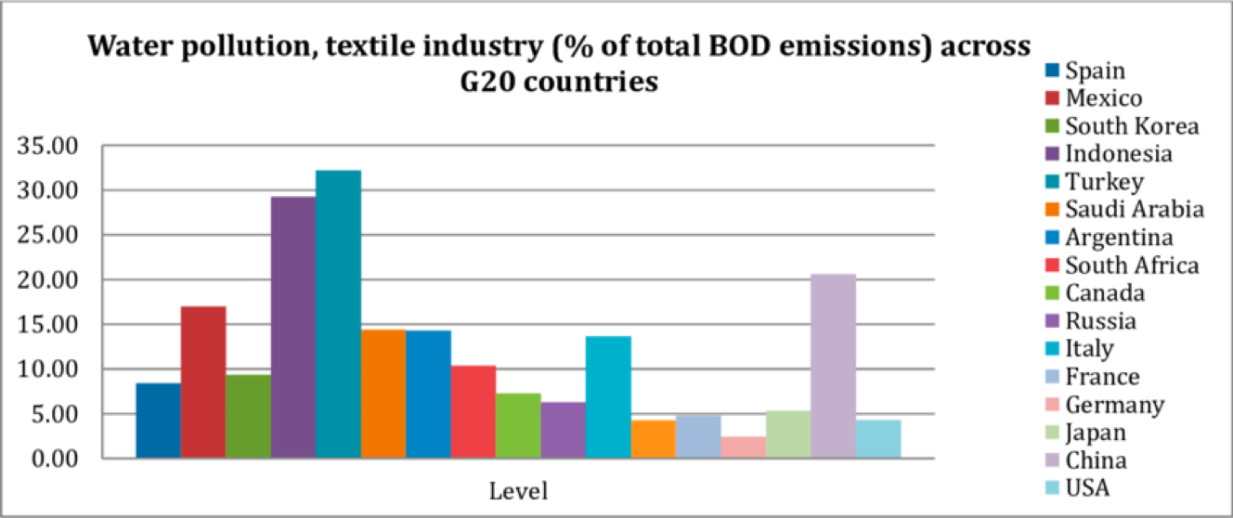

- Identify and describe patterns evident in this fish kill data from Ireland. Propose possible causes of the fish kills related to various sources shown. Evaluate the effectiveness of pollution management strategies for agriculture vs those for industry.
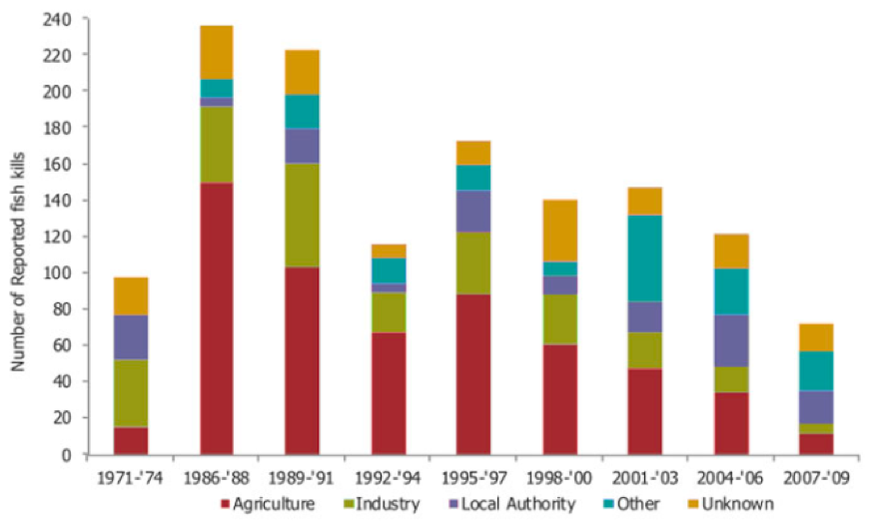

Case Study Area A
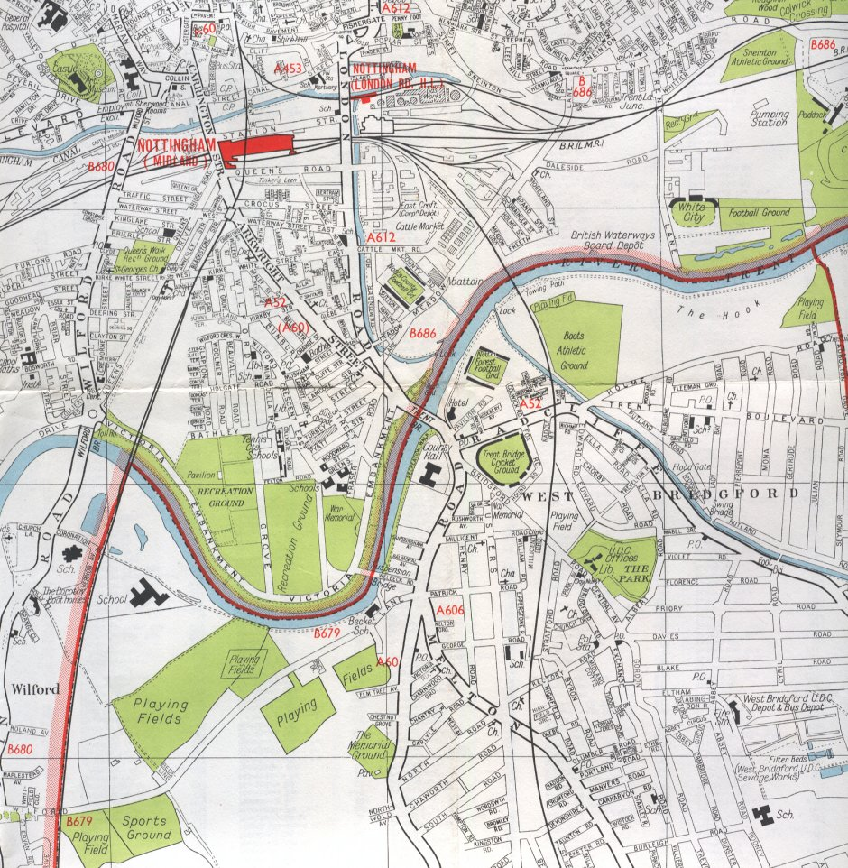

Scientists began taking samples just after the point where an outlet from a factory enters the river. They then took more samples every 10 m downstream. The results are shown in the tables below.

A

Sludgeworm Freshwater shrimp. Bloodworm Stonefly

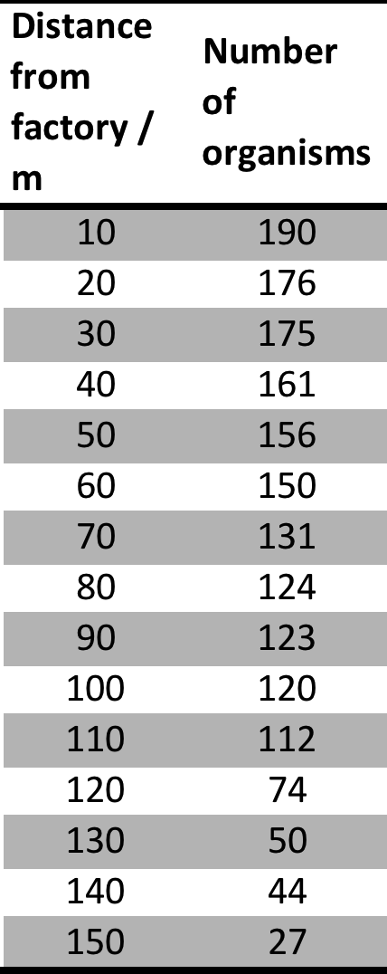
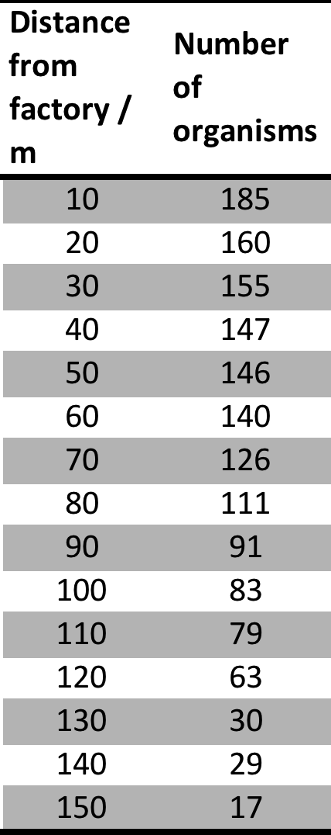
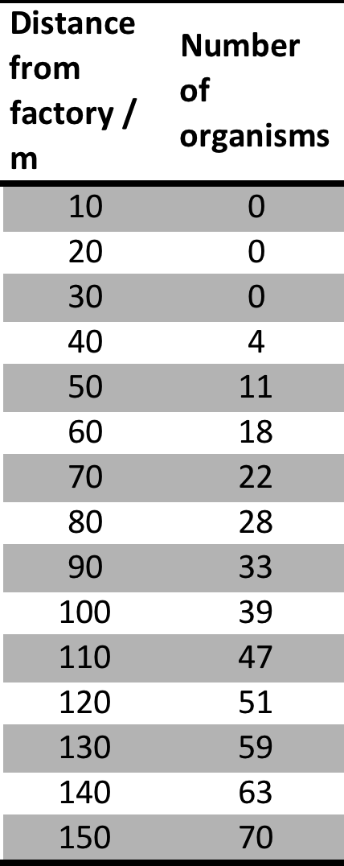
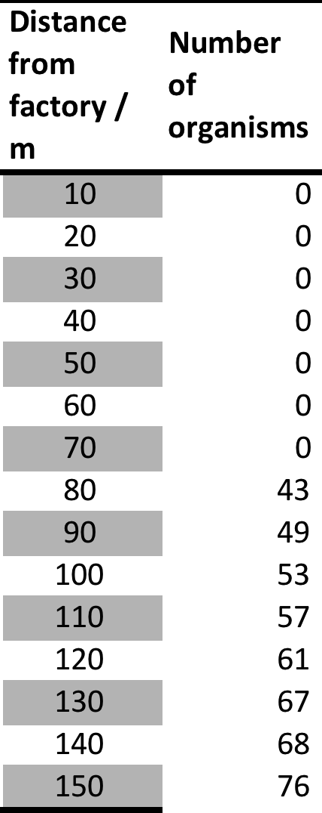
How does the number of the different organisms change as you move further away from the factory?

What does this tell you about the river?

What else could you do to support your findings?

Across the river from a factory is a farm. The farmer regularly uses fertilisers. Could this have contributed to the pollution? Explain how.

Case Study 2: Area B

Area B is just after a bend in the river. It is on the edge of parkland near a residential area, there are no factories nearby. Scientists sampled every 10 m along a 100 m stretch.

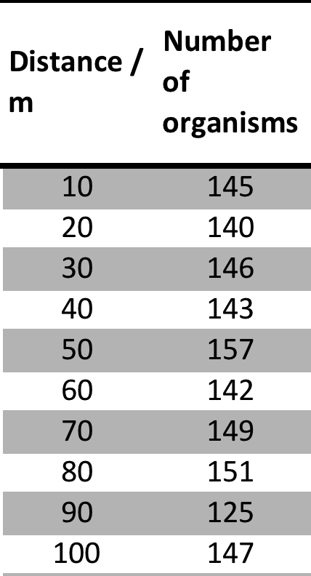
Sludgeworm Freshwater shrimp Bloodworm Stonefly
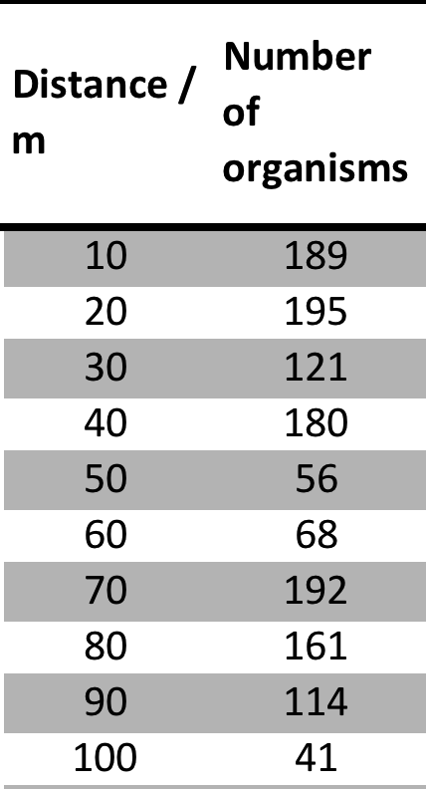
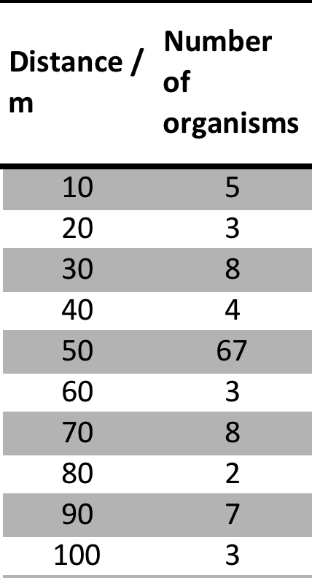
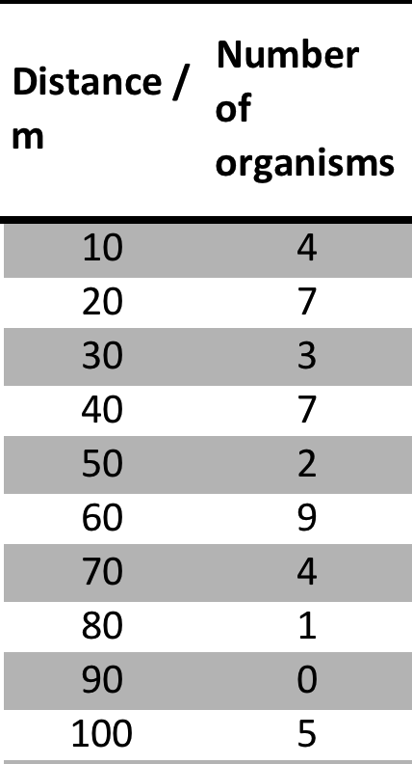

B

How does the number of the different organisms change?

What does this tell you about the river?

Is the data consistent or are there anomalies? What could have caused these?

What else could you do to support your findings or improve the reliability of the results?

- Name a Dead Zone Case Study
  - Identify the primary causes of the dead zone.
  - Outline why the dead zone is located where it is
  - Discuss pollution management strategies to address the root cause of the dead zone

ESS can be like learning a new language. So many words are not commonly used in everyday English. This can be challenging. To help you keep up with ESS Terms, you will need to create your own ESS DICTIONARY. You should add to this over the year and keep it in your notebook or on a page file THAT YOU CAN UPDATE AND ADD TO EASILY. Most of the vocabulary words can be found either on your STUDY GUIDE or at mrgscience.com.
You will be responsible for learning the words and their meaning. Periodic quizzes will be given on the words. So, make your dictionary creative and you will remember the words more easily.

KEY TERMS

eutrophication

leaching

non-point source

dead zone

phosphate stripping

pH

ppm

ppt

wave action

fresh water

fertilizer

runoff

dissolved oxygen

detergents

sediment

temperature

light intensity

turbidity

freshwater

drainage​

nitrates

organic nutrients

lake aeration

zooplankton

secchi circle​

​direct monitoring

biotic

point source

aquatic invertebrates

phosphates

decomposition

epiphytic

oxygen meter

salinity

marine

biochemical oxygen demand (BOD)

indicator species

dissolved oxygen (DO)

algae bloom

point source

effluent

plankton

aeration

biotic index

anaerobic

recovery zone

indirect monitoring

aerobic

clean zone​

