Understandings, Applications and Skills (This is what you may be assessed on)

 | Statement | Guidance
5.1.U1 | Evolution occurs when heritable characteristics of a species change.
5.1.U2 | The fossil record provides evidence for evolution.
5.1.U3 | Selective breeding of domesticated animals shows that artificial selection can cause evolution.
5.1.U4 | Evolution of homologous structures by adaptive radiation explains similarities in structure when there are differences in function.
5.1.U5 | Populations of a species can gradually diverge into separate species by evolution.
5.1.U6 | Continuous variation across the geographical range of related populations matches the concept of gradual divergence.
5.1.A1 | Development of melanistic insects in polluted areas.
5.1.A2 | Comparison of the pentadactyl limb of mammals, birds, amphibians and reptiles with different methods of locomotion.

Useful Sources:

5.1 U1: Evolution occurs when heritable characteristics of a species change. (From the Youtube video)

- What is the definition of a “theory”?
A set of s_____________or p______________devised to explain a group of facts or phenomena.
Most theories that are accepted by scientist have been repeatedly tested by
experiments and can be used to make predictions about natural phenomena.
- What is the definition of “evolution”?
The cumulative change in the heritable characteristics of a population
* cumulative change =

* heritable characteristics =

* population =

- 3 main pieces of evidence for evolution stem from fossils, selective breeding and homologous structures. Take notes on the following:
Type of Evidence | Brief overview | Examples
Evidence from  Fossils  5.1 U2:  The fossil record provides evidence for evolution.  Additional Link: http://www.pbs.org/wgbh/nova/evolution/fossil-evidence.html | - Layers of sedimentary rock are put down, the inorganic components of plants, animals and prokaryotes are preserved. Basically - deeper they are, the older they are.  - FOSSIL =  - Two types of evidence:  - DIRECT =  - INDIRECT =  - FOSSIL RECORD =  - DIMENSION OF TIME →  - GAP IN FOSSILS  - Special circumstances are required for fossilization  - Only hard parts of organism preserved  - Fossils damaged, only fragments remain  - TRANSITIONAL FOSSILS = show links between groups or species by exhibiting traits common to both ancestral group/species and its derived descendant groups/ species. | 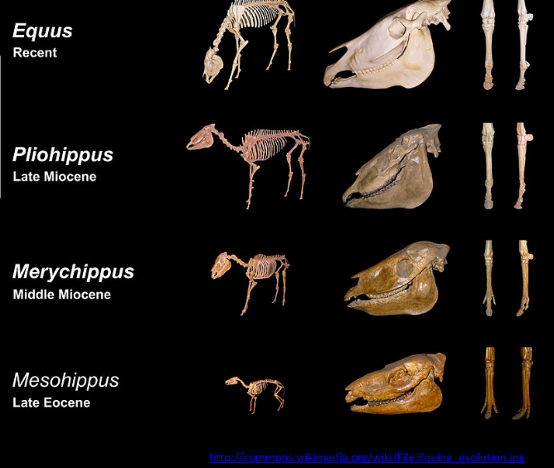  Equus - genus that includes horses, zebras, etc  - Fossils have been discovered of organisms that no longer exists. (ex trilobites and dinosaurs)  - Most cases, no fossils can be found of organisms that do exist today  - Suggests that ancestral species evolved into modern species.
Type of Evidence | Brief overview | Examples
Evidence from  Selective Breeding  5.1 U3:  Selective breeding of domesticated animals shows that artificial selection can cause evolution. | - SELECTIVE BREEDING (artificial selection)  - DOMESTIC BREEDS | 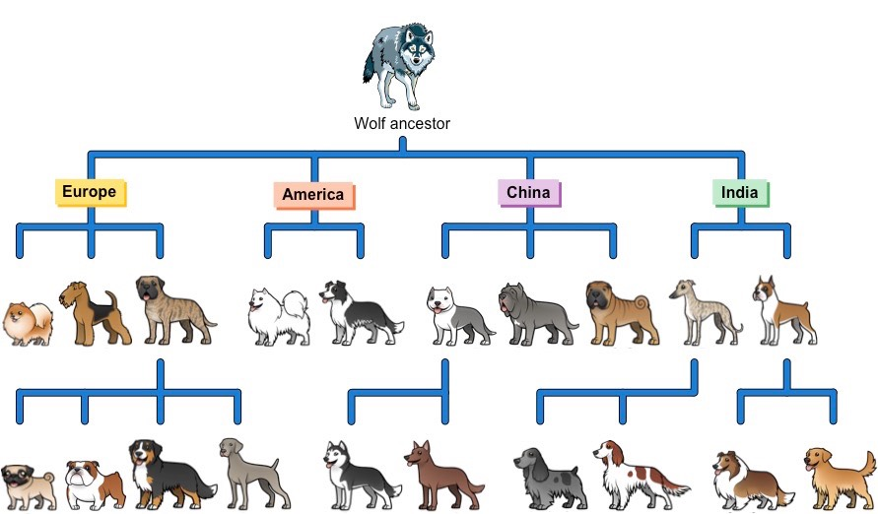  - BREEDING DOGS → herding (ex: sheepdogs) raciing (Ex: greyhounds)  - COWS → bred for milk yield or meat  - CROPS → bred for increased yield and/or disease resistance  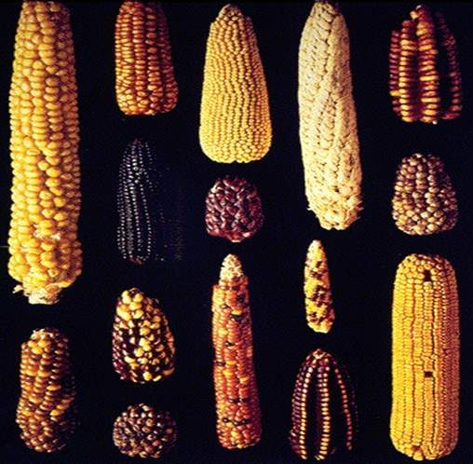  - CORN (sweet yellow corn) - recessive trait
Type of Evidence | Brief overview | Examples
Evidence from  Homologous Structures  5.1 U4: Evolution of homologous structures by adaptive radiation explains similarities in structure when there are differences in function. | HOMOLOGOUS STRUCTURE =  - Structures imply they share a COMMON ANCESTRY  - Used in different ways in different species  ADAPTIVE RADIATION = features that stem from the SAME origin but have become different because they perform different functions.  CONVERGENT EVOLUTION = an evolutionary interpretations that certain features have different origins but have become similar because they perform the same or similar function.  - ANALOGOUS STRUCTURES: features that seem similar but when studied closely are very different.  “Rudimentary organs”: | 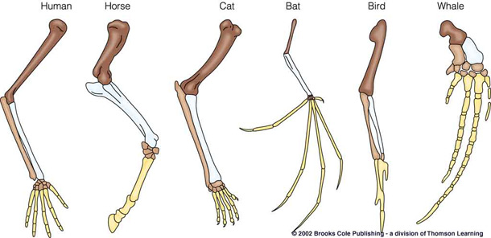  Example:  Pentadactyl Limb (continue next page)  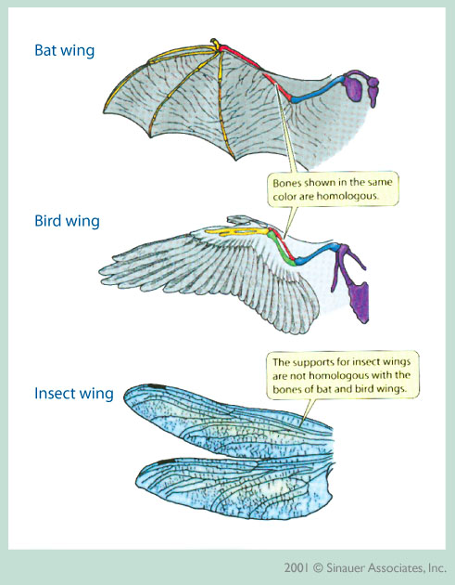

5.1 A3: Comparison of the pentadactyl limb of mammals, birds, amphibians and reptiles with different methods of locomotion.

PENTADACTYL LIMB: In vertebrates is an example of Homologous structure
- It is adapted to different mode of locomotion in particular environment
Examples:
  - Dolphin fin → s___________
  - Bat wing → f___________
  - Monkey hand →g______________
  - Horse hoof → g______________

What are some OTHER EXAMPLES:

- NOS: despite obvious differences, all organisms share the same bones.
  - May vary in size and shape
  - All vertebrates have five fingered ‘hands’ at the end of each limb

PRACTICE: Choose a colour code for the types of bones in a pentadactyl limb and colour the diagrams.

5.1 U5: Populations of a species can gradually diverge into separate species by evolution. | - SEPARATION: If organisms are separated, will likely experience d__________  e______________ c______________  - DIVERGE: over many generations, shape may change, food preference, mating rituals, etc will diverge as a result of natural selection.  - IF MIGRATE BACK: will not easily mate with mainland flies  - Mating rituals are different  - Genetic differences result in offspring infertility.  - GENES CANNOT FLOW BETWEEN POPULATIONS: said to evolve into separate species.  THIS ENTIRE PROCESS IS CALLED: Speciation | 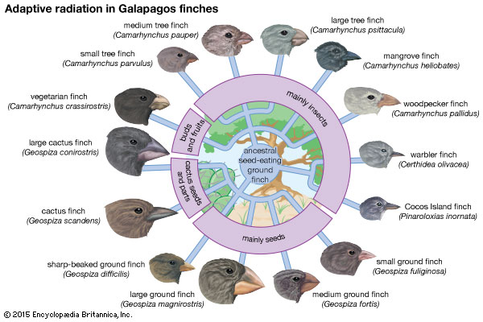

5.1 U6: Continuous variation across the geographical range of related populations matches the concept of gradual divergence. | The GREATER the GEOLOGICAL SEPARATION and the longer the populations have been separated, the GREATER the DIVERGENCE. | EXAMPLE: Red grouse of Britain and willow ptarmigan of Norway (Lagopus lagopus)  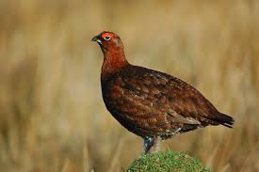  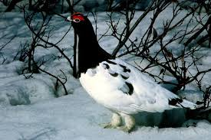  - Sometimes classified as the same species, sometimes as separate  - Species can gradually diverge over long periods of time and between

5.1 A1: Development of melanistic insects in polluted areas.
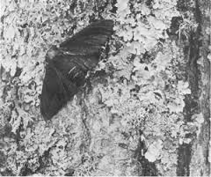
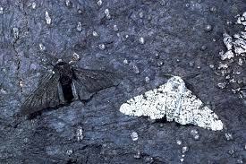

MELANISTIC: Dark varieties of typically light coloured insects.

EXAMPLE: The peppered moth (Biston betularia)

Industrial melanism followed the industrial revolution, look at the link below and run the simulation to find out more about industrial melanism

Activity: https://www.biologycorner.com/worksheets/pepperedmoth.html

HOMEWORK:
- Complete the Peppered Moth Simulation, answer Questions #1-12
- DATA-BASED questions on pg 248-249

