Understandings, Applications and Skills (This is what you maybe assessed on)

Significant ideas
- The soil system is a dynamic ecosystem that has inputs, outputs, storages and flows.
- The quality of soil influences the primary productivity of an area.
Big Questions:
- What strengths and weaknesses of the systems approach and the use of models have been revealed through this topic?
- To what extent have the solutions emerging from this topic been directed at preventing environmental impacts, limiting the extend of the environmental impacts, or restoring systems in which environmental impacts have already occurred:
- What value systems can you identify at play in the cases and approaches to resolving the issues addressed in this topic?
- In what ways might the solutions explored in this topic alter your predictions for the state of human societies and the biosphere some decades from now?
- How does the systems approach help our understanding of soils and soil processes?
- With respect to soils, how might the environmental value systems of a large-scale commercial farmer differ from that of a traditional subsistence farmer?
- How might the pressure on soils change over the next 20 years? Give reasons to support your answer

 | Statement | Guidance
5.1.U1 | The soil system may be illustrated by a soil profile that has a layered structure (horizons) | Studies of specific soil profiles, such as podsol, are not required.
5.1.U2 | Soil system storages include organic matter, organisms, nutrients, minerals, air and water.
5.1.U3 | Transfers of material within the soil, including biological mixing and leaching (minerals dissolved in water moving through soil), contribute to the organization of the soil.
5.1.U4 | ​ There are inputs of organic material including leaf litter and inorganic matter from parent material, precipitation and energy. Outputs include uptake by plants and soil erosion.
5.1.U5 | Transformations include decomposition, weathering and nutrient cycling.
5.1.U6 | The structure and properties of sand, clay and loam soils differ in many ways, including mineral and nutrient content, drainage, water-holding capacity, air spaces, biota and potential to hold organic matter. Each of these variables is linked to the ability of the soil to promote primary productivity.
5.1.U7 | A soil texture triangle illustrates the differences in composition of soils. | Familiarity with the soil texture triangle diagram used for soil type classification based on the percentage of sand, silt, and clay in the soil is required.
5.1.A1 | Outline the transfers, transformations, inputs, outputs, flows and storages within soil systems.
5.1.A2 | Explain how soil can be viewed as an ecosystem.
5.1.A3 | Compare and contrast the structure and properties of sand, clay and loam soils, with reference to a soil texture diagram, including their effect on primary productivity

5.1.U2 Soil system storages include organic matter, organisms, nutrients, minerals, air and water.
The soil system is a dynamic ecosystem that has inputs, outputs, storages and flows
5.1.U3 Transfers of material within the soil, including biological mixing and leaching (minerals dissolved in water moving through soil), contribute to the organization of the
5.1.U4 There are inputs of organic material including leaf litter and inorganic matter from parent material, precipitation and energy. Outputs include uptake by plants and soil erosion.
5.1.U5 Transformations include decomposition, weathering and nutrient cycling.
5.1.A1 Outline the transfers, transformations, inputs, outputs, flows and storages within soil systems.
5.1.A2 Explain how soil can be viewed as an ecosystem.

- Watch the video clip on “What Is Soil” https://www.youtube.com/watch?v=I6HGPoQ3dZY&feature=emb_logo Briefly describe the statement “'From soil comes everything.'

- Explain what you understand by this diagram

- Identify the factors affecting soil characteristics

- During the formation of soil there are three stages; 1) Rock weather, 2) Introduction to living organisms, 3) Redistribution of material within the soil
  - Using diagrams, explain some of the processes involved in each of these stages

  - Explain how these processes can be affected by location and climate

  - Explain why soil is different in different locations

  - Explain how humans can impact the formation of soil

- Draw and label the soil system diagrams

- Label the processes in the system diagram showing the role of carbon cycling in soil. Can you improve the labeling? Which flows are transfers and which are transformations?
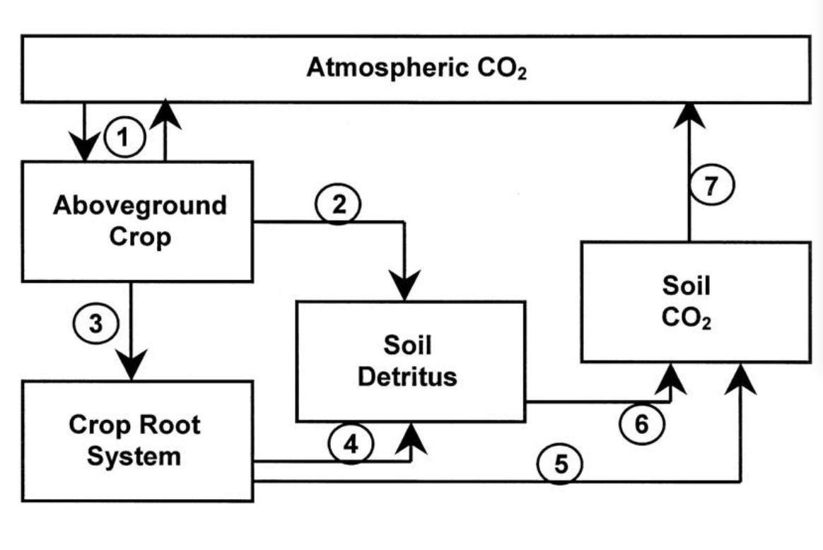

- Draw a systems diagram of the soil system and cycle of the following data
  - Inputs – organic material including leaf litter, inorganic matter from parent rock, precipitation, energy
  - Storages – organic matter, organisms, nutrients, minerals, air and water
  - Outputs – leaching, uptake by plants, mass movement, radiation, erosion
  - Transfers within soil – biological mixing (organism living in soil mix nutrients & minerals in with organic matter), translocation (movement of soil particles in suspension
  - Transformations – decomposition, weathering, nutrient cycling
.

Nice review of the nitrogen cycle. Notice the interactions of the soil system ecosystem

- Identify a food chain from the soil food web

- In the space below draw a named soil system food web

5.1.U1 The soil system may be illustrated by a soil profile that has a layered structure (horizons)
5.1.U6 The structure and properties of sand, clay and loam soils differ in many ways, including mineral and nutrient content, drainage, water-holding capacity, air spaces, biota and potential to hold organic matter. Each of these variables is linked to the ability of the soil to promote primary productivity.
5.1.A3 Compare and contrast the structure and properties of sand, clay and loam soils, with reference to a soil texture diagram, including their effect on primary productivity

- Label the soil horizon. Identify the components of each horizon. Relate the diagram to the following key words:
  - Translocation

  - Salinization

  - Leaching

- Explain the importance of Soil porosity and permeability

- Describe the structure and properties of sand, clay and loam soils
Soil Type | Sand | Clay | Loam
Particle Size

Mineral/Nutrient Content
Drainage
Water-holding capacity
Air spaces

Biota

Organic Matter

Link to primary production

5.1.U7 A soil texture triangle illustrates the differences in composition of soils.

- Read each side of the triangle like an axis on an X.Y coordinate lane in math. Follow each line from the % of sand=silt-clay, and [lot a point where the percentages intersect. The point identifies the type of soil
Calculate the following textures of the following should sample
0% clay, 50% sand, and 20% silt

7% clay, 10% sand, and 83% silt

- Use the soil texture by feel flowchart. Determine the soil texture of a given sample of soil.

- State which soils are the most desirable for agriculture use. Justify your answer

Homework:
Theory of knowledge:
- The soil system may be represented by a soil profile—since a model is, strictly speaking, not real, how can it lead to knowledge?

- Explain why soil is a non-renewable resource

- Explain the importance of nitrates, phosphates and potassium (NPK) and how they can be replaced in soils

- Explain why the crop yield on a farm may consistently decrease over a ten-year period whether fertilizers are used or not

ESS can be like learning a new language. So many words are not commonly used in everyday English. This can be challenging. To help you keep up with ESS Terms, you will need to create your own ESS DICTIONARY. You should add to this over the year and keep it in your notebook or on a page file THAT YOU CAN UPDATE AND ADD TO EASILY. Most of the vocabulary words can be found either on your STUDY GUIDE or at mrgscience.com.
You will be responsible for leaning the words and their meaning. Periodic quizzes will be given on the words. So, make your dictionary creative and you will remember the words more easily.

KEY TERMS

Soil

parent material

transformation

water holding capacity

soil texture

​minerals

Lithosphere

Precipitation

Decomposition

Biota

Sand

Porosity

soil profile

infiltration

weathering

clay

permeability

bedrock

deposition

leaching

nutrient cycle

mineral content

silt

soil horizon

organic material

drainage

loam

humus

glacial moraines

sheet wash

