Understandings, Applications and Skills (This is what you may be assessed on)

Significant ideas
- The sustainability of terrestrial food production systems is influenced by socio-political, economic and ecological factors.
- Consumers have a role to play through their support of different terrestrial food production systems.
- The supply of food is inequitably available and land suitable for food production is unevenly distributed among societies, and this can lead to conflict and concerns.
Big Questions:
- Which strengths and weaknesses of the systems approach and of the use of models have been revealed through this topic?
- To what extent have the solutions emerging from this topic been directed at preventing environmental impacts. limiting the extent of the environmental impacts, or restoring systems in which environmental impacts have already occurred?
- What value systems are at play in the causes and approaches to resolving the issues addressed in this topic?
- How are the issues addressed in this topic relevant to sustainability or sustainable development?
- How can systems diagrams be used to show the impact of farming methods on natural systems?
- What are the limitations of such diagrams?
- How can the choice of farming systems prevent environmental impacts, or limit the extent of environmental impacts?
- How do EVSs influence the choice of farming systems?
- What are the issues relating to sustainable terrestrial food production? Is sustainable agriculture possible?

 | Statement | Guidance
5.2U1 | The sustainability of terrestrial food production systems is influenced by factors such as scale; industrialization; mechanization; fossil fuel use; seed, crop and livestock choices; water use; fertilizers; pest control; pollinators; antibiotics; legislation; and levels of commercial versus subsistence food production.
5.2.U2 | Inequalities exist in food production and distribution around the world.
5.2.U3 | Food waste is prevalent in both LEDCs and more economically developed countries (MEDCs), but for different reasons. | Food waste is an issue arising in MEDCs, where regulatory standards may be set according to commercial preferences so that consumable food is discarded. It can also be an issue in LEDCs, where the necessary refrigeration and transport infrastructure is insufficient to avoid food spoilage.
5.2U4 | ​Socio-economic, cultural, ecological, political and economic factors can be seen to influence societies in their choices of food production systems.
5.2.U5 | As the human population grows, along with urbanization and degradation of soil resources, the availability of land for food production per capita decreases.
5.2.U6 | The yield of food per unit area from lower trophic levels is greater in quantity, lower in cost and may require fewer resources.
5.2.U7 | Cultural choices may influence societies to harvest food from higher trophic levels
5.2.U8 | Terrestrial food production systems can be compared and contrasted according to inputs, outputs, system characteristics, environmental impact and socioeconomic factors.
5.2.U9 | Increased sustainability may be achieved through:  – altering human activity to reduce meat consumption and increase consumption of organically grown and locally produced terrestrial food products  – improving the accuracy of food labels to assist consumers in making informed food choices  – monitoring and control of the standards and practices of multinational and national food corporations by governmental and intergovernmental bodies  – planting of buffer zones around land suitable for food production to absorb nutrient runoff.
5.2.A1 | Analyse tables and graphs that illustrate the differences in inputs and outputs associated with food production systems
5.2.A2 | Compare and contrast the inputs, outputs and system characteristics for two given food production systems | Possible examples for contrasting terrestrial food production systems include North American cereal farming and subsistence farming in Southeast Asia, or intensive beef production in South America and the Maasai tribal use of livestock. These examples are not meant to be prescriptive and appropriate local examples are also encouraged.
5.2.A3 | Evaluate the relative environmental impacts of two given food production systems. | Factors to be used in comparing and contrasting food production systems include:  – inputs, such as fertilizers (artificial or organic); water (irrigation or rainfall); pest control (pesticides or natural predators); labour (mechanized and fossil- fuel dependent or physical labour); seed (genetically modified organisms— GMOs—or conventional); breeding stock (domestic or wild); livestock growth promoters (antibiotics or hormones versus organic or none)  – outputs, such as food quality, food quantity, pollutants (air, soil, water), consumer health, soil quality (erosion, degradation, fertility); common pollutants released from food production systems include fertilizers, pesticides, fungicides, antibiotics, hormones and gases from the use of fossil fuels; transportation, processing and packaging of food may also lead to further pollution from fossil fuels  – system characteristics, such as diversity (monoculture versus polyculture); sustainability; indigenous versus introduced crop species  – environmental impacts, such as pollution (air, soil, water); habitat loss; biodiversity loss; soil erosion or degradation; desertification; disease  epidemics from high-density livestock farming  – socio-economic factors, such as farming for profit or subsistence, for export or local consumption, for quantity or quality; traditional or commercial farming.
5.2.A4 | Discuss the links that exist between socio-cultural systems and food production systems.
5.2.A5 | Evaluate strategies to increase sustainability in terrestrial food production systems.

5.2.U2 Inequalities exist in food production and distribution around the world.
Consumers have a role to play through their support of different terrestrial food production systems

- Watch the video “Inside Story: Feeding global Hunger, https://www.youtube.com/watch?v=rqfZ6rsoy-E

- Define the following terms
  - malnutrition
  - lacking
  - excessive
  - inbalanced

- Consumers in MEDCs have more food choices than poorer consumers in LEDCs. Those choices result from differences in distribution due to:
- Wealth
- Infrastructure
- Government subsidies, tariffs, and taxes
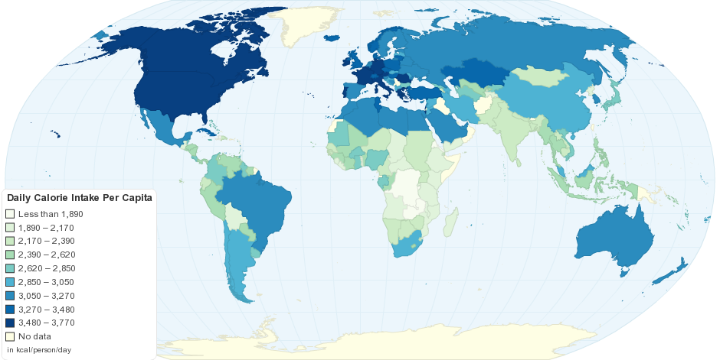

  - Compare and contrast the inequalities that exists between a named LEDC and MEDC

  - Explain the difference between lacking excessive and unbalanced malnutrition

  - Provide statistics on the world regarding malnutrition and the different types (how many, where and why)

5.2.U3 Food waste is prevalent in both LEDCs and more economically developed countries (MEDCs), but for different reasons.

- Complete the table below to show the highest type of food loss/food wasted using the data form the graph above plus your own knowledge
http://www.nationalgeographic.com/magazine/2016/03/global-food-waste-statistics/

Food loss/waste | Type of food | Example of food | Reason it is probably lost/wasted
Agriculture (growing and harvesting | Roots and tubers | potatoes | Retailers have set the quality standards so high that a lot of the crop is not considered acceptable for sale in supermarkets etc.
Postharvest (storage and transport)
Processing
Distribution (transport)
Consumption

The key issues in food waste can be summarized as follows:
Supply
Transportation
Increased demand for meat
Food waste
Climate change
Increasing food prices
Decreased demand for agricultural work in LEDCs
Infrastructure
Marketing
Middle-men
Management of resources
Customer behavior
Supply chain
Education
Processing and packaging

- Compare food waste in LEDCs and MEDCs.

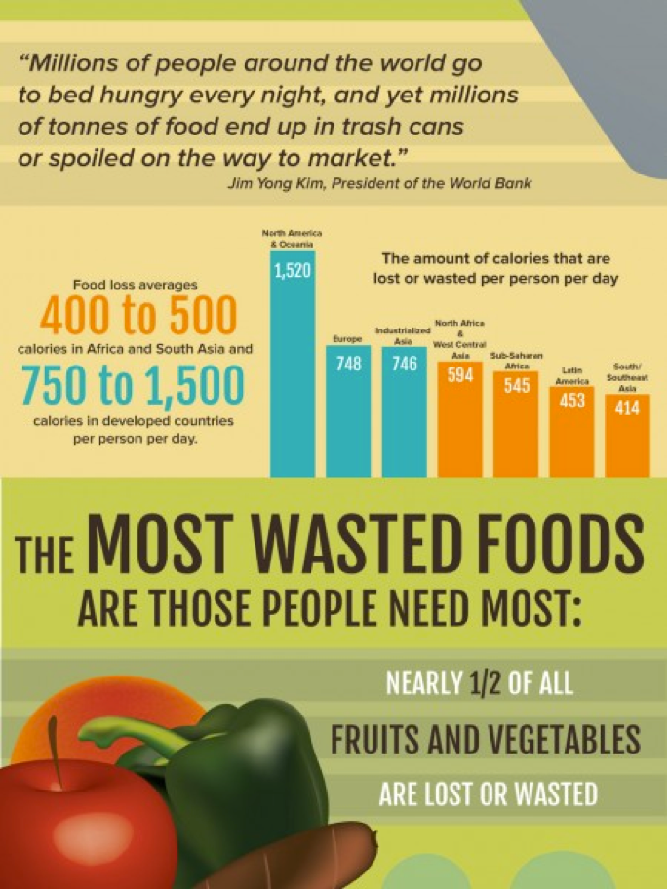
- Evaluate the infographic on the right

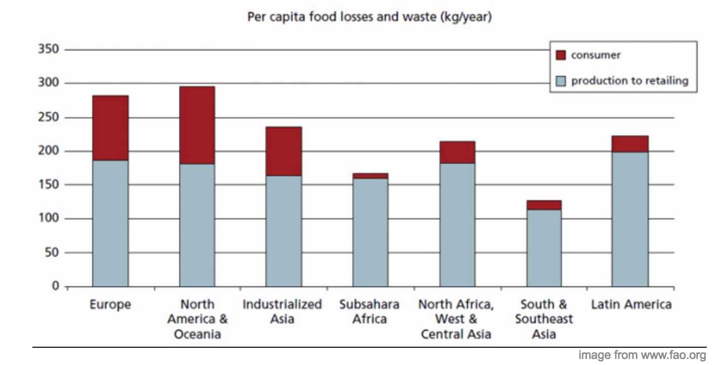
- Why do MEDCs waste more food compared to LEDCs? Refer to the graph to support your answer.

- According to researchers, there is enough food produced to feed everybody on the planet, yet many people in the world still live in food poverty. Using the headings below, explain why food distribution is not equal:
  - Climate

  - Land suitability

  - Cash cropping in LEDCs

  - Food waste in food production systems

5.2U4 Socio-economic, cultural, ecological, political and economic factors can be seen to influence societies in their choices of food production systems.
5.2A4 Discuss the links that exist between socio-cultural systems and food production systems

In some cultures, meat consumption is a sign of wealth because it is more expensive compared to plant-based foods. Therefore, eating from higher trophic levels may be considered a status symbol Frequency of meat consumption (1t 100-80-40-20-0% of meat) also impacts land use
Food choices can be influenced by culture, religion or regional food production differences

- Explain the 4 factors which affect a society’s food choices
  - Climate
  - Culture and religion
  - Politics
  - Socio-economic

- Research
  - How many calories does an average person need per day
  - How much food is produced around the world, in calories per day
  - State whether there is enough food being produced to feed everyone in the world

- Explain your opinion regarding world food supply. How can we feed everyone? Should we try?

5.2.U8 Terrestrial food production systems can be compared and contrasted according to inputs, outputs, system characteristics, environmental impact and socioeconomic factors.
5.2.U7 Cultural choices may influence societies to harvest food from higher trophic levels
5.2.A1 Analyse tables and graphs that illustrate the differences in inputs and outputs associated with food production systems
5.2.A2 Compare and contrast the inputs, outputs and system characteristics for two given food production systems.

- Outline subsistence and commercial farming.

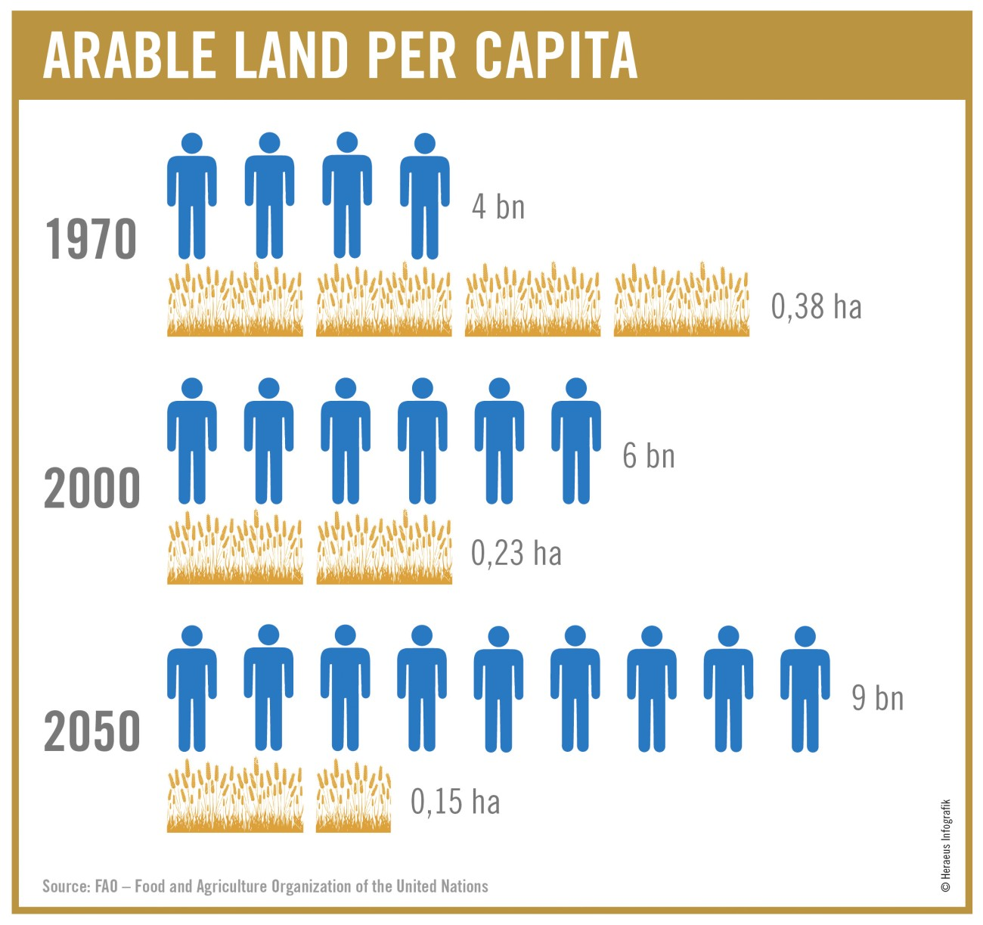
- Draw a simple line graph from the numbers provided in the infographic and describe the overall trend shown in the data provided.

- Complete the data tables
Type of farming system | Intensive commercial farming | Intensive subsistence farming | Nomadic herding | Shifting agriculture
Inputs
Outputs

- Complete a systems diagram of two given food production systems

- You are required to be able to compare and contrast two differing food production systems regarding their inputs and outputs. Make notes here on either:
- Rice production in Borneo vs California.
- Intensive beef production in South America vs Extensive beef production by the Masai.
- Norwegian salmon farming vs Thai Rice-fish farming (this one is the most interesting

Factor | Examples
Inputs | e.g. water, pest control, labor, seed (GM or not), breeding stock, livestock growth promoters
Outputs | Food quality, yield, pollutants, transportation, processing, packaging
System characteristics | Diversity
 | Sustainability
Environmental impacts | Pollution
 | Habitat loss
 | Biodiversity loss
 | Soil erosion/degradation
 | Desertification
 | Disease epidemics
Socio-economic factors | Subsistence or for sale crop
 | Traditional or commercial
 | For export or local consumption
 | For quality or quantity

5.2U1 The sustainability of terrestrial food production systems is influenced by factors such as scale; industrialization; mechanization; fossil fuel use; seed, crop and livestock choices; water use; fertilizers; pest control; pollinators; antibiotics; legislation; and levels of commercial versus subsistence food production.
5.2.U5 As the human population grows, along with urbanization and degradation of soil resources, the availability of land for food production per capita decreases.
5.2.U6 The yield of food per unit area from lower trophic levels is greater in quantity, lower in cost and may require fewer resources than the higher trophic levels
5.2.U7 Cultural choices may influence societies to harvest food from higher trophic levels
- Outline why the amount of space per capita is reduced:

- Complete the table
 | MEDC | LEDC
Size/Scale

Industrilization

Level of mechanism

Fossil fuel

Water use

Fertilizer/Pesticide

Antibiotics

Pollinators

- Find out why humans started domesticating animals before they grew crops. http://repository.ias.ac.in/21961/1/333.pdf

- Define the factors that contribute to the decrease in agricultural land use:

Key term | Definition
soil erosion
salinization
desertification
urbanisation

- Explain why producing food from livestock is generally less efficient than producing food from crops on the same land.

- Outline reasons why members of a society may tend to harvest from higher tropic levels despite the limitations in efficiency.

This is not a comprehensive table, but it is a good starting point for food system analysis of inputs, outputs and characteristics
Terrestrial | Aquatic
Consum from lower trophic level (cow/rice) due to taste and cultural demand | Consume from higher trophic level (salmon) due to taste and cultural demand
Less efficient | Hihger efficiency, however, the initial available solar energy is slower due to reflection and absorption of light by water

5.2.U9 Increased sustainability may be achieved through: increasing consumption of organically grown, seasonal, and locally produced food products
5.2.A5 Evaluate strategies to increase sustainability in terrestrial food production systems.

Watch the video clip on sustainable agriculture https://www.youtube.com/watch?v=7TRI7yeeYQQ&feature=emb_logo.
- Outline how the following methods could be used to increase the sustainability of food production systems:
  - Altering human activities

  - Improving food labels

  - Government control and monitoring

  - Creating buffer zones

Food shortages could force world into vegetarianism, warn scientists
John Vidal, environment editor for The Guardian
Sunday 26 August 2012 19.00 BST
Water scarcity's effect on food production means radical steps will be needed to feed population expected to reach 9bn by 2050

A bull grazes on dry wheat husks in Logan, Kansas, one of the regions hit by the record drought that has affected more than half of the US and is expected to drive up food prices.

Leading water scientists have issued one of the sternest warnings yet about global food supplies, saying that the world's population may have to switch almost completely to a vegetarian diet over the next 40 years to avoid catastrophic shortages.

Humans derive about 20% of their protein from animal-based products now, but this may need to drop to just 5% to feed the extra 2 billion people expected to be alive by 2050, according to research by some of the world's leading water scientists.

"There will not be enough water available on current croplands to produce food for the expected 9 billion population in 2050 if we follow current trends and changes towards diets common in western nations," the report by Malik Falken mark and colleagues at the Stockholm International Water Institute (SIWI) said. "There will be just enough water if the proportion of animal-based foods is limited to 5% of total calories and considerable regional water deficits can be met by a … reliable system of food trade."

Dire warnings of water scarcity limiting food production come as Oxfam and the UN prepare for a possible second global food crisis in five years. Prices for staples such as corn and wheat have risen nearly 50% on international markets since June, triggered by severe droughts in the US and Russia, and weak monsoon rains in Asia. More than 18 million people are already facing serious food shortages across the Sahel.

Oxfam has forecast that the price spike will have a devastating impact in developing countries that rely heavily on food imports, including parts of Latin America, North Africa and the Middle East. Food shortages in 2008 led to civil unrest in 28 countries.

Adopting a vegetarian diet is one option to increase the amount of water available to grow more food in an increasingly climate-erratic world, the scientists said. Animal protein-rich food consumes five to 10 times more water than a vegetarian diet. One third of the world's arable land is used to grow crops to feed animals. Other options to feed people include eliminating waste and increasing trade between countries in food surplus and those in deficit.

"Nine hundred million people already go hungry and 2 billion people are malnourished in spite of the fact that per capita food production continues to increase," they said. "With 70% of all available water being in agriculture, growing more food to feed an additional 2 billion people by 2050 will place greater pressure on available water and land."

The report is being released at the start of the annual world water conference in Stockholm, Sweden, where 2,500 politicians, UN bodies, non-governmental groups and researchers from 120 countries meet to address global water supply problems.

Competition for water between food production and other uses will intensify pressure on essential resources, the scientists said. "The UN predicts that we must increase food production by 70% by mid-century. This will place additional pressure on our already stressed water resources, at a time when we also need to allocate more water to satisfy global energy demand – which is expected to rise 60% over the coming 30 years – and to generate electricity for the 1.3 billion people currently without it," said the report.

Overeating, undernourishment and waste are all on the rise and increased food production may face future constraints from water scarcity.

"We will need a new recipe to feed the world in the future," said the report's editor, Anders Jägerskog.

A separate report from the International Water Management Institute (IWMI) said the best way for countries to protect millions of farmers from food insecurity in sub-Saharan Africa and south Asia was to help them invest in small pumps and simple technology, rather than to develop expensive, large-scale irrigation projects.

"We've witnessed again and again what happens to the world's poor – the majority of whom depend on agriculture for their livelihoods and already suffer from water scarcity – when they are at the mercy of our fragile global food system," said Dr Colin Chartres, the director general.

"Farmers across the developing world are increasingly relying on and benefiting from small-scale, locally-relevant water solutions. [These] techniques could increase yields up to 300% and add tens of billions of US dollars to household revenues across sub-Saharan Africa and south Asia."

- Outline the benefits of vegetarianism/eating less meat? Use the study guide and the article above:

5.2.A3 Evaluate the relative environmental impacts of two given food production systems.
- Consider the impacts of food production systems on soil degradation, desertification, eutrophication, insecticides, pesticide, and fertilizer pollution, salinization, lowered water tables, habitat loss, disease epidemics in the case studies from the prevision information or other food production systems you have studied.
Factors to be used in comparing and contrasting food production systems include:
– inputs, such as fertilizers (artificial or organic); water (irrigation or rainfall); pest control (pesticides or natural predators); labour (mechanized and fossil- fuel dependent or physical labour); seed (genetically modified organisms— GMOs—or conventional); breeding stock (domestic or wild); livestock growth promoters (antibiotics or hormones versus organic or none)
– outputs, such as food quality, food quantity, pollutants (air, soil, water), consumer health, soil quality (erosion, degradation, fertility); common pollutants released from food production systems include fertilizers, pesticides, fungicides, antibiotics, hormones and gases from the use of fossil fuels; transportation, processing and packaging of food may also lead to further pollution from fossil fuels
– system characteristics, such as diversity (monoculture versus polyculture); sustainability; indigenous versus introduced crop species
– environmental impacts, such as pollution (air, soil, water); habitat loss; biodiversity loss; soil erosion or degradation; desertification; disease
epidemics from high-density livestock farming
– socio-economic factors, such as farming for profit or subsistence, for export or local consumption, for quantity or quality; traditional or commercial farming.

Theory of Knowledge:
- Consumer behavior plays an important role in food production systems—are there general laws that can describe human behavior
ESS can be like learning a new language. So many words are not commonly used in everyday English. This can be challenging. To help you keep up with ESS Terms, you will need to create your own ESS DICTIONARY. You should add to this over the year and keep it in your notebook or on a page file THAT YOU CAN UPDATE AND ADD TO EASILY. Most of the vocabulary words can be found either on your STUDY GUIDE or at mrgscience.com.
You will be responsible for learning the words and their meaning. Periodic quizzes will be given on the words. So, make your dictionary creative and you will remember the words more easily.
KEY TERMS

food production

herbivores

nitrates

mixed crops

herbicides

pastoral

​arable

​antibiotic

crop rotation

​undernourishment

​outputs

food distribution

socio-cultural

GMO

fertilizer

​cash crop

​mixed crop

​fossil fuel

​trophic level

​vegetarian
​
terrestrial

environmental impact

shifting cultivation

organic

​extensive

​domesticate

​seed crop

​hunger

intensive
​
aquatic

slash and burn

subsistence

growth hormones

​agribusiness

​Intensive

​pollinator

​livestock

​malnourishment
​
pbroducers

biodiversity

monoculture

pesticides

buffer zone

​urbanisation​

​desertification

​salinization

​​soil erosion

