Understandings, Applications and Skills (This is what you may be assessed on)

Significant ideas
- Fertile soils require significant time to develop through the process of succession.
- Human activities may reduce soil fertility and increase soil erosion.
- Soil conservation strategies exist and may be used to preserve soil fertility and reduce soil erosion.

Big Questions:
- What strengths and weaknesses of the systems approach and the use of models have been revealed through this topic?
- To what extent have the solutions emerging from this topic been directed at preventing environmental impacts, limiting the extent of the environmental impacts, or restoring systems in which environmental impacts have already occurred?
- What value systems can you identify at play in the causes and approaches to resolving the issues addressed in this topic?
- In what ways might the solutions explored in this topic alter your predictions for the state of human societies and the biosphere some decades from now?
- How might ecocentrists and technocentrists differ over methods of soil conservation?
- Could there be new methods of food production that may help feed the world's growing population?

 | Statement | Guidance
5.3U1 | Soil ecosystems change through succession. Fertile soil contains a community of organisms that work to maintain functioning nutrient cycles and that are resistant to soil erosion
5.3.U2 | Human activities that can reduce soil fertility include deforestation, intensive grazing, urbanization and certain agricultural practices (such as irrigation and monoculture).
5.3.U3 | Commercial, industrialized food production systems generally tend to reduce soil fertility more than small-scale subsistence farming methods.
5.3.U4 | ​Reduced soil fertility may result in soil erosion, toxification, salinization and desertification.
5.3.U5 | Soil conservation measures include soil conditioners (such as organic materials and lime), wind reduction techniques (wind breaks, shelterbelts), cultivation techniques (terracing, contour ploughing, strip cultivation) and avoiding the use of marginal lands.
5.3.A1 | Explain the relationship between soil ecosystem succession and soil fertility
5.3.A2 | Discuss the influences of human activities on soil fertility and soil erosion.
5.3.A3 | Evaluate the soil management strategies of a given commercial farming system and of a given subsistence farming system. | Applying knowledge of specific food production systems to their associated soil degradation and consequent soil conservation management strategies is recommended.

5.3U1 Soil ecosystems change through succession. Fertile soil contains a community of organisms that work to maintain functioning nutrient cycles and that are resistant to soil erosion
5.3.A1 Explain the relationship between soil ecosystem succession and soil fertility

- Watch the video clip “Soils 101” https://www.youtube.com/watch?v=CZNanlXMXk4.
From what you learned from the video, why are soils so important?

- Go to http://higheredbcs.wiley.com/legacy/college/strahler/0471417416/animations/ch10/animation1.htm

Use the animation to explain what is happening in each stage of soil formation shown in the table below

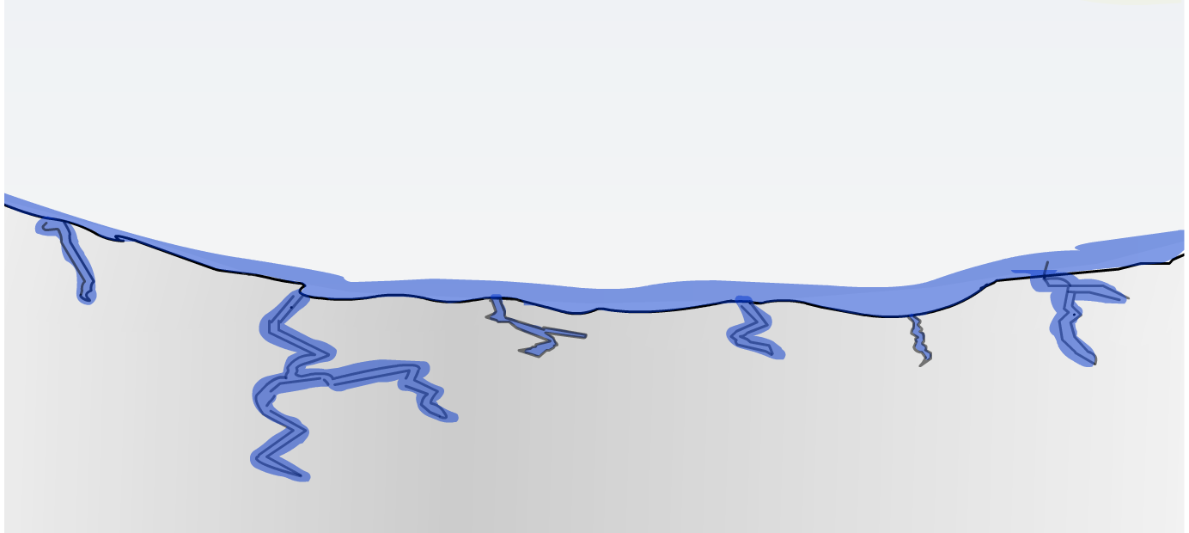
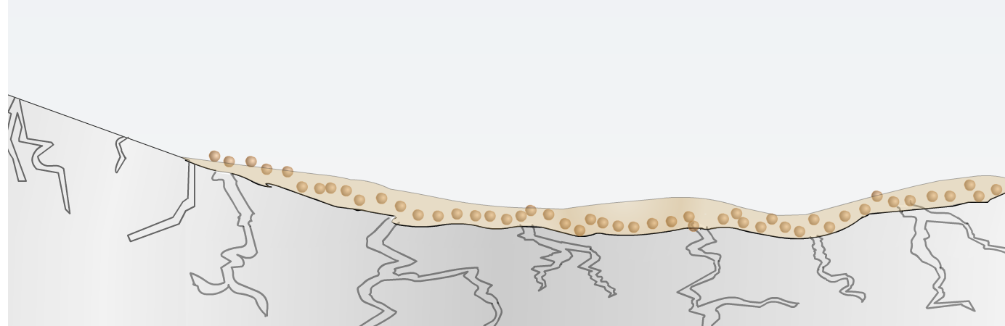
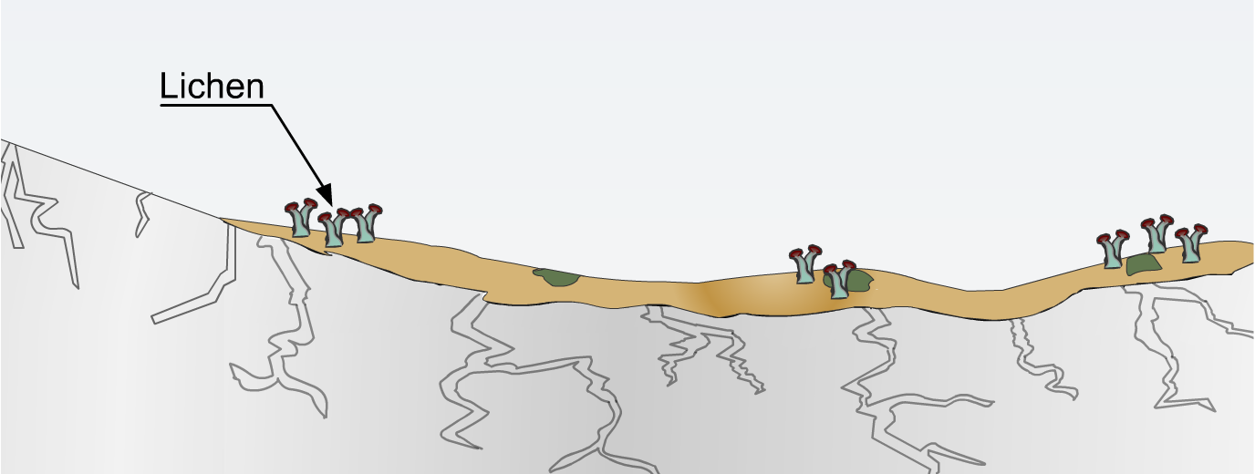
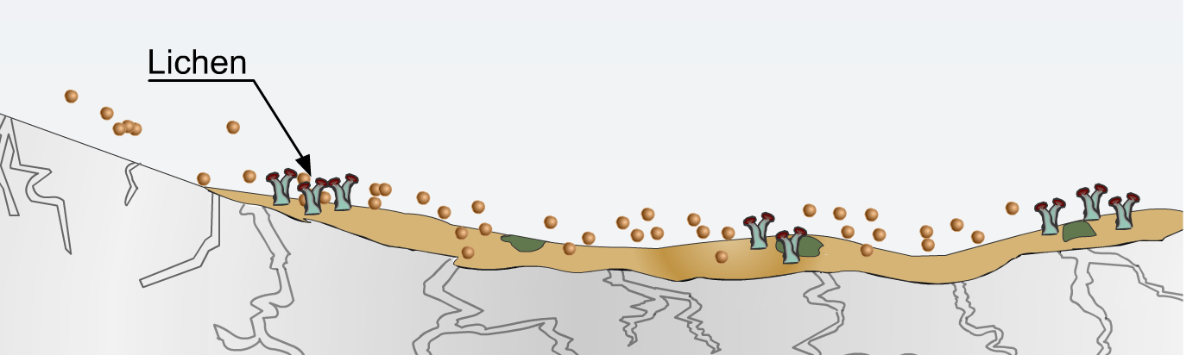
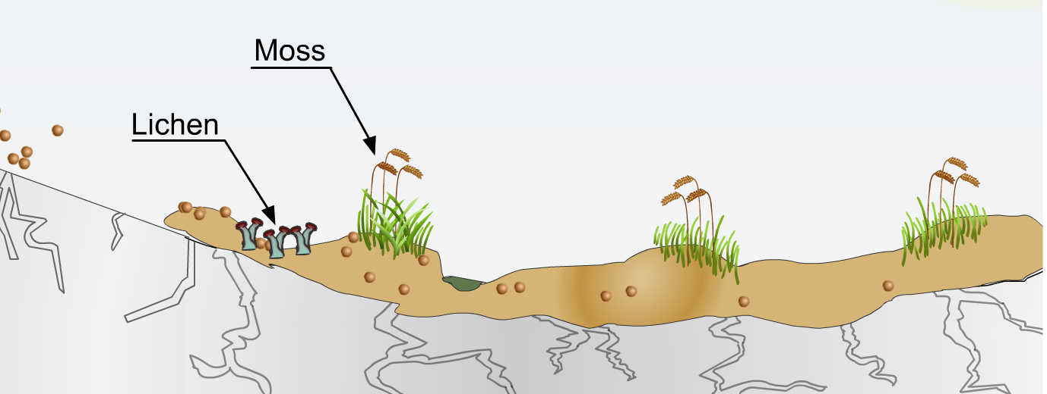
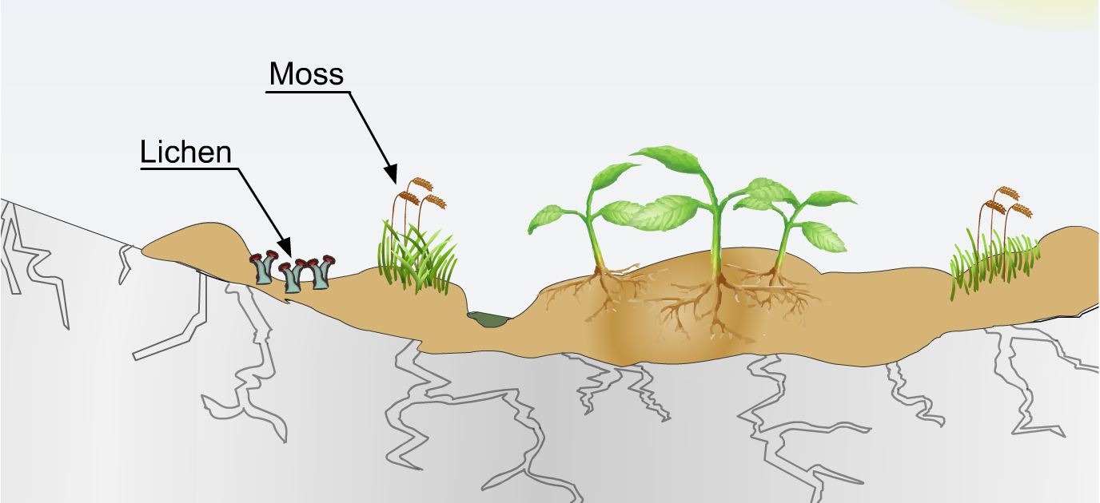

5.3.U2 Human activities that can reduce soil fertility include deforestation, intensive grazing, urbanization and certain agricultural practices (such as irrigation and monoculture).
5.3.A2 Discuss the influences of human activities on soil fertility and soil erosion.
5.3.U4 Reduced soil fertility may result in soil erosion, toxification, salinization and desertification.
5.3.U3 Commercial, industrialized food production systems generally tend to reduce soil fertility more than small-scale subsistence farming methods.

- This is a great video on effects of deforestation on soil fertility https://youtu.be/BONcnWALAAk

- This video will be a good review of intensive grazing https://www.youtube.com/watch?v=9h6jfppneO0

- Identify the effects of urbanization on soil fertility

- The Dust Bowl prompted investment into the study of soils to find solutions to the problem. In 1935, the US Soil Erosion Act came into force to encourage soil conservation practices. Watch this short video clip on the Dust Bowl. https://www.youtube.com/watch?v=EeeH2CcYCV0

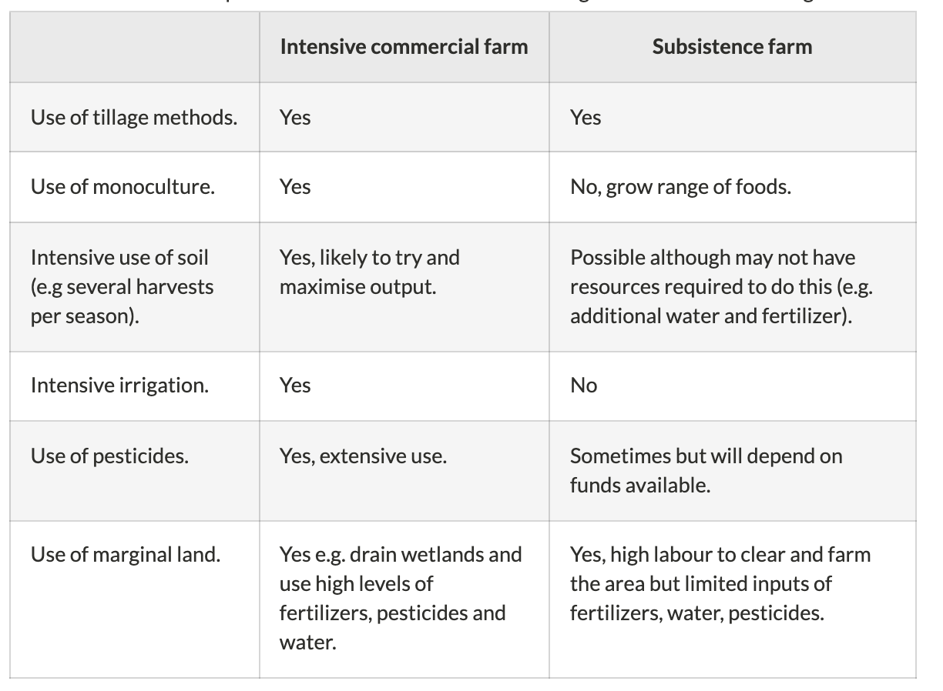

- This video compares intensive and sustainable farming https://youtu.be/iloAQmroRK0

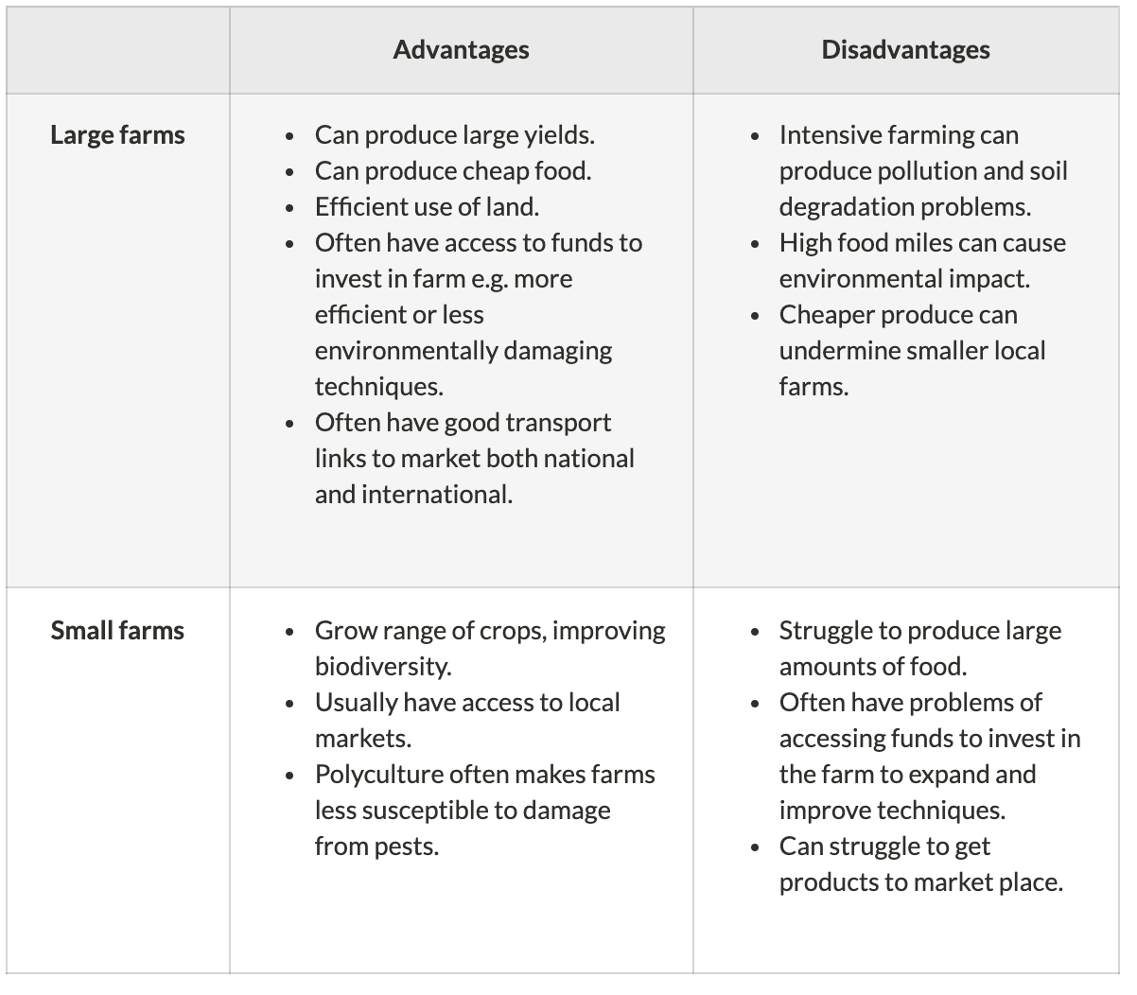
- This is a great video to show the effects of wind erosion, https://www.youtube.com/watch?v=4RXmD_QJYdw
- See more on soil erosion around the world. https://www.youtube.com/watch?v=s0F2c1ECuo4&feature=youtu.be

- This is a great case study on the salinization issues in Australia https://www.youtube.com/watch?v=P4pX5W_WwU4

- This video will help you with the Sahil Case Study https://www.youtube.com/watch?v=s0F2c1ECuo4&feature=youtu.be
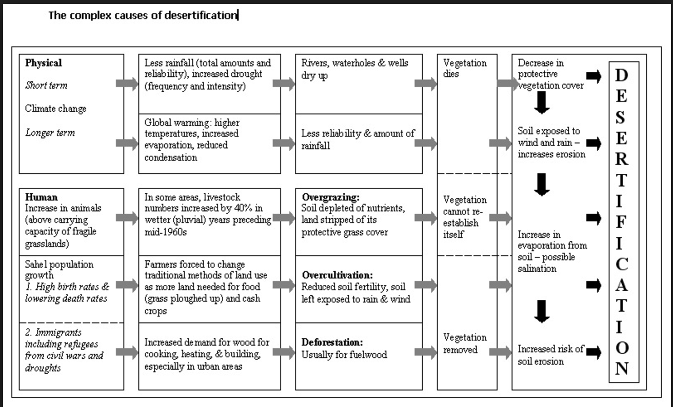

More information at http://www.acegeography.com/causes-of-desertification.html

- Describe the effect of each of the following factors on soil health

Factor | Explanation
Intensive grazing
Overcropping
Deforestation
Unstable Agricultural methods
Urbanization

- Watch the Case Study on the Amazon Rainforest in NW Brazil https://www.youtube.com/watch?v=s0F2c1ECuo4

- Watch this video on Overgrazing https://www.youtube.com/watch?v=LbFefdUM55Q. The go back and review the video on the Sahel and Evaluate this Case Study. Why does overgrazing take place when the consequences of this process must be obvious?

- Dr. Allan Savory has a different take on deforestation and overgrazing. Write a brief summary of his presentation. After watching the video, does this change your mind about grazing cattle? Justify your answer. https://www.youtube.com/watch?v=vpTHi7O66pI

- Complete the table below.

 | Processes | Consequences
Overgrazing |  | Increase in sol erosions by wind and water and can lead to desertification
Deflorestation | Removal of forest cover
Unsustainable agriculture
Irrigation
Erosion |  | Impact on water quality-can cause flood  impact on air quality-dust
Desertification | Enlargement of deserts

- Briefly state the different reasons for soil degradation in temperate and tropical areas.

- Evaluate sustainable agricultural systems and commercial and industrialized food production systems
 | Intensive commercial | Subsistence
Tillage methods

Monoculture

Intensive use of soil

Intensive irrigation

Use of pesticides

Use of marginal land

- Match the causes of soil degradation from unsustainable agricultural techniques to their descriptions.

Unsustainable technique | Letter |  | Description
- Total removal of crops after harvest |  |  | - This will leave ready-made channels for rainwater to flow down taking soil with it
- Growing crops in rows with uncovered soil in between |  |  | - In the long run this makes soil too toxic for further agricultural use. This is called toxification.
- Ploughing the direction of the slope |  |  | - Leaves soil open to erosion
- Excessive use of pesticides |  |  | - Land in cities is paved and built upon so removing it as a source of agricultural land and increasing run-off which may erode soil elsewhere. Many cities expand into prime agricultural land.
- Irrigation |  |  | - This is when the same crops are grown year after year. This means that the same nutrients are depleted form the soil and the soil loses its fertility
- Monocultures |  |  | - Erosion will occur, especially if the crops are grown on a slope and the rows are in the direction of the slope
- Urbanization |  |  | - In many irrigation systems a major part of the water evaporates before reaching the crops. The minerals dissolved in the irrigation water remain in the top layer of the soil and form a hard, salty crust that makes the land unsuitable for growing crops. This process is called salinization (making soil salty)

5.3.U5 Soil conservation measures include soil conditioners (such as organic materials and lime), wind reduction techniques (wind breaks, shelterbelts), cultivation techniques (terracing, contour ploughing, strip cultivation) and avoiding the use of marginal lands.
5.3.A3 Evaluate the soil management strategies of a given commercial farming system and of a given subsistence farming system.

This is a good video to help understand the concept of “No Till” Conservation https://youtu.be/LpltrgkLqWc

- Complete the table below (you may need to research some of the methods)

Soil conservation method | Description | Advantage | Disadvantage
Addition of soil conditioner
Wind reduction by planting trees between fields
Growing cover crops
Terracing
Ploughing
Contour farming
Improved irrigation techniques
Stop ploughing marginal lands
Crop rotation

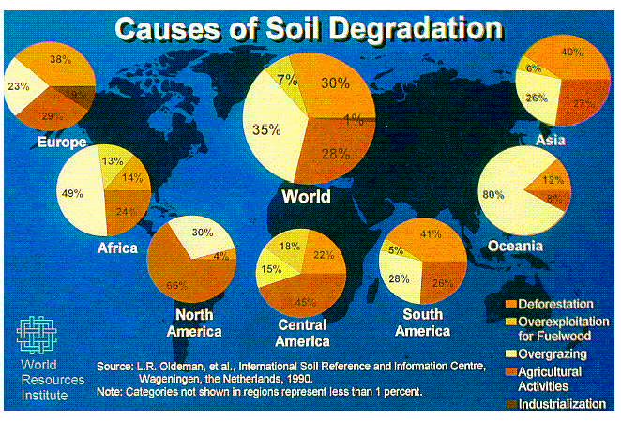
- Using the maps find and report on how two countries or regions are managing and conserving (or not) their soil resources
One commercial farming country/region

One subsistence farming country/region

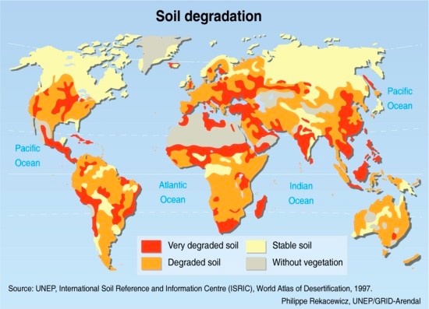
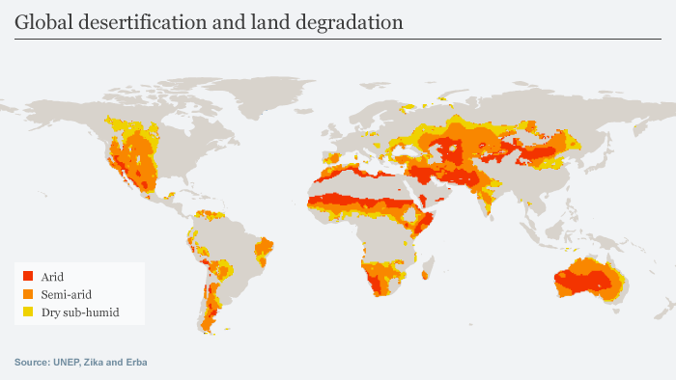

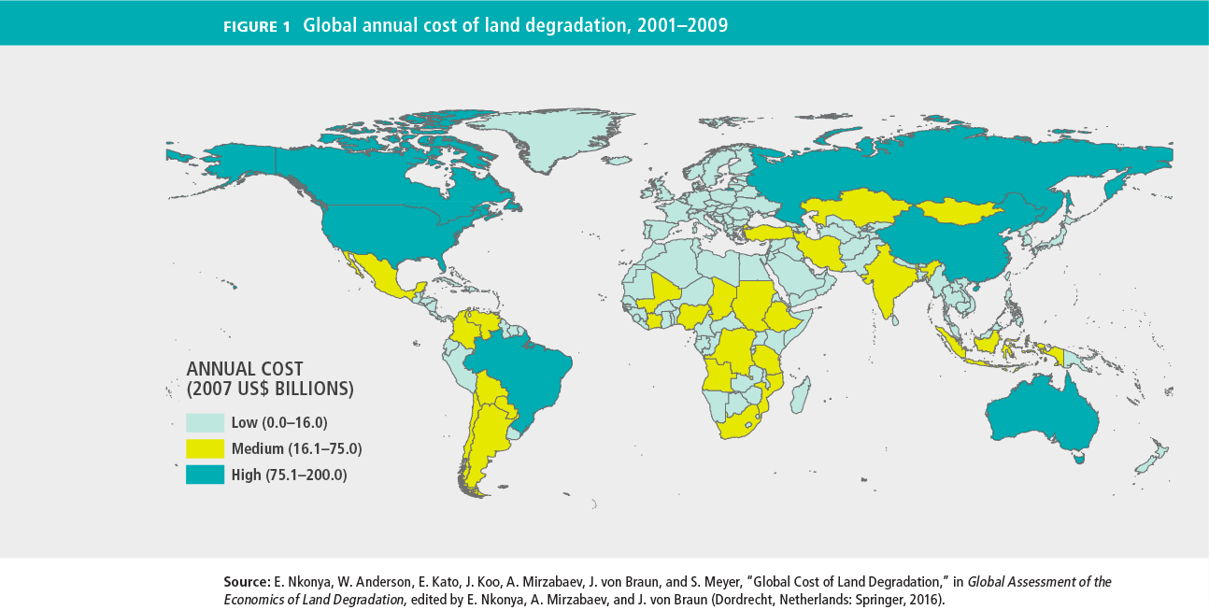

- Explain whether the majority of SOIL CONSERVATION TECHNIQUES are ECO- or TECHNO-centric

- A relatively new intervention called BIOCHAR is beginning to make headlines in East Africa and Asia. Research this topic on reliable websites. Check out and read the information available on the sites, and respond to the following prompts.
  - What are the benefits of biochar?
  - Limitations?
  - Risks?
  - Rewards?
  - Is biochar a sustainable agricultural practice that should be promoted, or is it something that should be avoided as it is too risky? Justify your answer with evidence.

ESS can be like learning a new language. So many words are not commonly used in everyday English. This can be challenging. To help you keep up with ESS Terms, you will need to create your own ESS DICTIONARY. You should add to this over the year and keep it in your notebook or on a page file THAT YOU CAN UPDATE AND ADD TO EASILY. Most of the vocabulary words can be found either on your STUDY GUIDE or at mrgscience.com.
You will be responsible for learning the words and their meaning. Periodic quizzes will be given on the words. So, make your dictionary creative and you will remember the words more easily.
KEY TERMS

deforestation

desertification

lime

contour plowing

relief

soil texture

gullying

unsustainable

wind breaks

slope

porosity

wind erosion

field capacity

weathering

degradation

shelterbelts

waterlog
calcification

duff

deposition

leaching

soil erosion

strip cultivation

acidificiation

shrinking limit

mass movement

drainage

overgrazing

toxificiation

terracing

sheet wash

plastic limit

