 | Statement | Guidance
5.4.U1 | A clade is a group of organisms that have evolved from a common ancestor.
5.4.U2 | Evidence for which species are part of a clade can be obtained from the base sequences of a gene or the corresponding amino acid sequence of a protein.
5.4.U3 | Sequence differences accumulate gradually so there is a positive correlation between the number of differences between two species and the time since they diverged from a common ancestor.
5.4.U4 | Traits can be analogous or homologous.
5.4.U5 | Cladograms are tree diagrams that show the most probable sequence of divergence in clades.
5.4.U6 | Evidence from cladistics has shown that classifications of some groups based on structure did not correspond with the evolutionary origins of a group or species.
5.4.A1 | Cladograms including humans and other primates.
5.4.A2 | Reclassification of the figwort family using evidence from cladistics.
5.4.S1 | Analysis of cladograms to deduce evolutionary relationships.

5.4.U5 Cladograms are tree diagrams that show the most probable sequence of divergence in clades.

- A ____________________ is a tree diagram showing the similarities and differences between different species.

- The branching points on cladograms are called n_________________

- Cladograms are mostly based on D________ b ____________ s______________ or the a_________ a___________ s____________ in a protein

5.4.U5 Cladograms are tree diagrams that show the most probable sequence of divergence in clades.

- Species may evolve over time to form a new species. Consequently there are g________ of s_______________ derived from a c______________ a________________

  - Such groups are called c___________________
  - Note all members of a clade may exist today
  - Common ancestors often do not exist, they have evolved into modern species or have become e__________________________

5.4.U5 Cladograms are tree diagrams that show the most probable sequence of divergence in clades.

- DNA evidence can be used to build a CLADOGRAM OF PRIMATES
  - Humans are included
  - Used to estimate when species d___________________ and hence when the c________________ a______________ e__________________

5.4.U2 Evidence for which species are part of a clade can be obtained from the base sequences of a gene or the corresponding amino acid sequence of a protein.
5.4.U3 Sequence differences accumulate gradually so there is a positive correlation between the number of differences between two species and the time since they diverged from a common ancestor.

- ____________________ in the ___________ that persist and are inherited occur at a ___________________ __________________.

  - For example: MITOCHONDRIAL DNA from humans and primates has been completely sequenced and used to construct cladograms between them.

  - The rate at which mutations occurred at can be used as a molecular clock to calculate how long ago the species diverged.

  - If the DNA base sequences or two species are similar….

    - ….then FEW mutations have occurred….

    - ...therefore the species only diverged relatively recently.

5.4.U4 Traits can be analogous or homologous.

- H_______________________ S_______________ are similar because of COMMON ANCESTRY
For example:
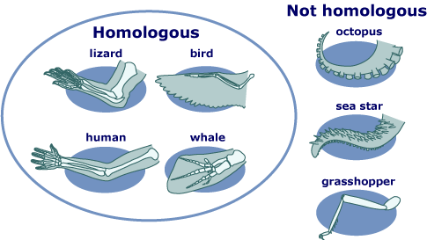

- A_______________________ S_______________________ are similar because of CONVERGENT EVOLUTION
For example:

5.4.A2 Reclassification of the figwort family using evidence from cladistics.

- DNA EVIDENCE identified the different common ancestors

Practice: Use pg 275 of your textbook to complete the reclassification of the figwort family

HOMEWORK: Use the Tree of Life interactive http://www.wellcometreeoflife.org/interactive/
- Look up points of evolution for
  - Chordata

