Understandings, Applications and Skills (This is what you may be assessed on)

Significant ideas
- The atmosphere is a dynamic system that is essential to life on Earth.
- The behaviour, structure and composition of the atmosphere influence variations in all ecosystems
Big Questions:
- To what extent have the solutions emerging from this topic been directed at preventing environmental impacts, limiting the extent of the environmental impacts, or restoring systems in which environmental impacts have already occurred?
- How are the issues addressed in this topic of relevance to sustainability or sustainable development?
- In what ways might the solutions explored in this topic alter your predictions for the state of human societies and the biosphere some decades from now?
- Can there ever be a stable climate?
- To what extent are human influences on climate greater?
 | Statement | Guidance
6.1.U1 | The atmosphere is a dynamic system (with inputs, outputs, flows and storages) that has undergone changes throughout geological time. | Students should recognize the atmosphere as a dynamic system. The composition of the atmosphere has changed throughout geological history. Living organisms (biotic components) have transformed the atmospheric composition of the Earth and vice versa throughout history
6.1.U2 | The atmosphere is a predominantly a mixture of nitrogen and oxygen, with smaller amounts of carbon dioxide, argon, water vapour and other trace gases. | The use of chemical symbols or chemical formulae for atmospheric gases is not required.
6.1.U3 | Human activities impact atmospheric composition through altering inputs and outputs of the system. Changes in the concentrations of atmospheric gases—such as ozone, carbon dioxide, and water vapour—have significant effects on ecosystems.
6.1.U4 | Most reactions connected to living systems occur in the inner layers of the atmosphere, which are the troposphere (0–10 km above sea level) and the stratosphere (10–50 km above sea level).
6.1.U5 | Most clouds form in the troposphere and play an important role in the albedo effect of the planet.
6.1.U6 | The greenhouse effect of the atmosphere is a natural and necessary phenomenon maintaining suitable temperatures for living systems.
6.1.A1 | Discuss the role of the albedo effect from clouds in regulating global average temperature.
6.1.A2 | Outline the role of the greenhouse effect in regulating temperature on Earth

6.1.U1 The atmosphere is a dynamic system (with inputs, outputs, flows and storages) that has undergone changes throughout geological time.
6.1.U2 The atmosphere is a predominantly a mixture of nitrogen and oxygen, with smaller amounts of carbon dioxide, argon, water vapour and other trace gases.

- Outline why the atmosphere can be considered a “dynamic system”.

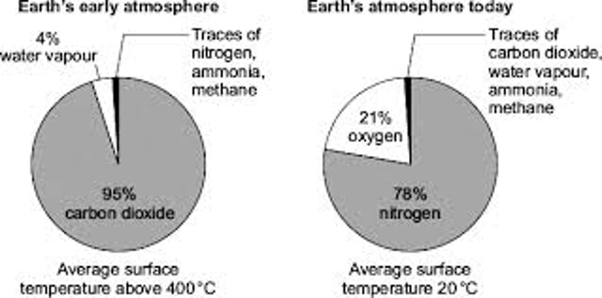
- Watch the video clip on Earth and Early Atmosphere https://www.youtube.com/watch?time_continue=15&v=Gyn754vw8ZQ&feature=emb_logo. The earth’s atmosphere is a dynamic system that has changed over time. Outline the changes that have occurred over time.

- Look at the graph below. What has happened to the levels of carbon dioxide over time?

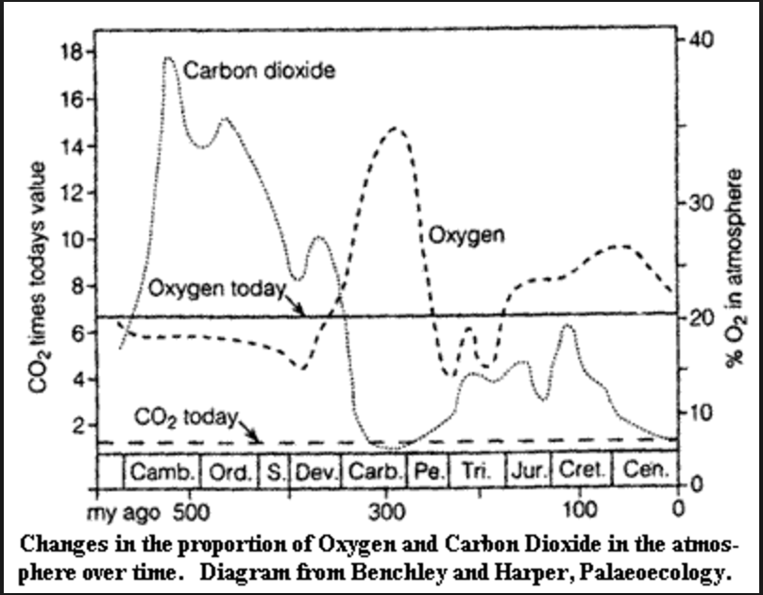

- Have a look at http://science.nationalgeographic.com/science/prehistoric-world/carboniferous/ Why did oxygen level increase during the Carboniferous period?

- Label the pie chart below to show the composition of the Earth’s atmosphere

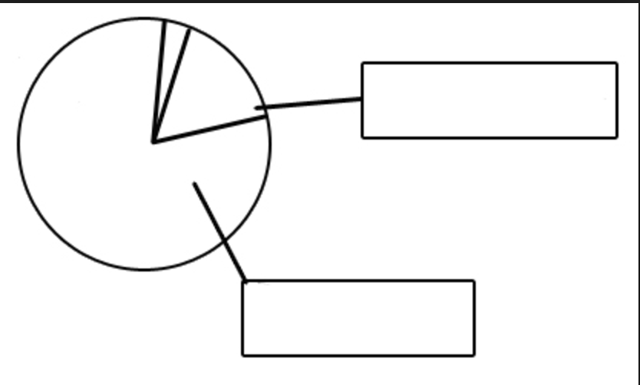

Pollutants - are normally found at high concentrations near the emission source but also disperse and are diluted by winds.

Water Vapor - ranges from 0-5% normally but has a much greater importance than the concentration as plays a large role in determining weather conditions.

Solids - dust, pollen and mold spores, smoke (black carbon), salt spray.

Watch the following video about airborne particles in Earth's atmosphere https://www.youtube.com/watch?time_continue=61&v=YtJzn8A725w&feature=emb_logo

- Identify the inputs, outputs, processes and storages in an atmosphere.

Create a systems diagram. Show inputs, outputs and what is present inside the system (stores). Use a different color to represent flows which are largely affected by human activity.
Remember that all of these components interact to produce a dynamic system. Gases, energy, matter and organisms enter and leave the atmosphere all the time.
Inputs | Processes | Outputs | Storages

- Watch the video Reveal Earth's Atmosphere | National Geographic https://www.youtube.com/watch?v=1YAOT92wuD8

6.1.U4 Most reactions connected to living systems occur in the inner layers of the atmosphere, which are the troposphere (0–10 km above sea level) and the stratosphere (10–50 km above sea level).

- Use the graph below to identify the layers of the atmosphere
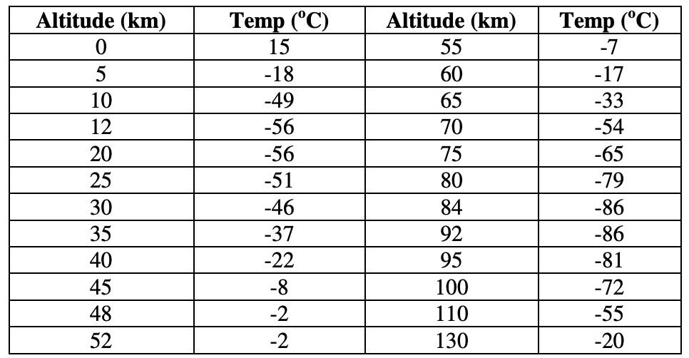
- Outline the vertical structure of the atmosphere. (Hints: include the temperature and pressure changes with altitude. Remember to name the different sections.)

6.1.U6 The greenhouse effect of the atmosphere is a natural and necessary phenomenon maintaining suitable temperatures for living systems.
6.1.A2 Outline the role of the greenhouse effect in regulating temperature on Earth

- Watch the video on the Greenhouse Effect. https://youtu.be/bpa0aFY--pE
- Draw and summarize the greenhouse effect

BE CAREFUL
The most common mistake is confusing the greenhouse effect (a good and necessary thing for life on Earth) with global warming or climate change (an existential threat caused by runaway greenhouse effect)

6.1.U5 Most clouds form in the troposphere and play an important role in the albedo effect of the planet.
6.1.A1 Discuss the role of the albedo effect from clouds in regulating global average temperature

- Watch the TedEd video clip on the albedo effect. https://www.youtube.com/watch?v=sDo7saKaEys

- Describe the role of the albedo effect in regulating global temperatures

- Outline a negative feedback loop involving climate and albedo.

- Outline a positive feedback loop involving climate and albedo.

6.1.U3 Human activities impact atmospheric composition through altering inputs and outputs of the system. Changes in the concentrations of atmospheric gases—such as ozone, carbon dioxide, and water vapour—have significant effects on ecosystems.
- The diagram only shows flows of carbon. How might land use change, fossil fuel combustion and cement production impact concentrations of other atmospheric gases?
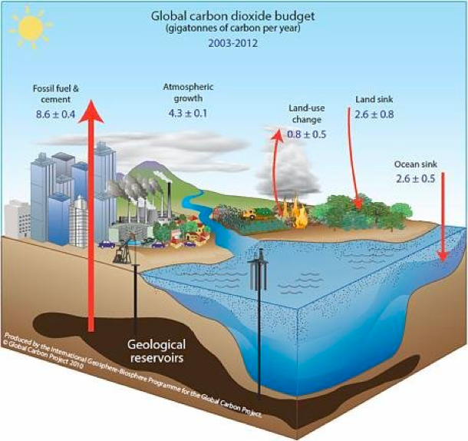

ESS can be like learning a new language. So many words are not commonly used in everyday English. This can be challenging. To help you keep up with ESS Terms, you will need to create your own ESS DICTIONARY. You should add to this over the year and keep it in your notebook or on a page file THAT YOU CAN UPDATE AND ADD TO EASILY. Most of the vocabulary words can be found either on your STUDY GUIDE or at mrgscience.com.
You will be responsible for learning the words and their meaning. Periodic quizzes will be given on the words. So, make your dictionary creative and you will remember the words more easily.

KEY TERMS

atmosphere

ozone

​radiation

albedo effect
​
greenhouse gases

inputs

transformations

ultraviolet light

systems

troposphere

greenhouse effect
​
reflection
​
water vapor
​
global warming
​
outputs
​
energy

mesosphere

conduction
​
shortwave radiation
​
climate change
​
storage
​
matter
​
dynamic

thermosphere

biosphere

convection

longwave radiation
​
absorption
​
transfers

atmospheric gases
​
open system

Karman Line

