Understandings, Applications and Skills (This is what you may be assessed on)

Significant ideas
- Stratospheric ozone is a key component of the atmospheric system because it protects living systems from the negative effects of ultraviolet radiation from the Sun.
- Human activities have disturbed the dynamic equilibrium of stratospheric ozone formation.
- Pollution management strategies are being employed to conserve stratospheric ozone.
Big Questions:
- To what extent have the solutions emerging form this topic been directed at preventing environmental impacts, limiting the extent of the environmental impacts or restoring systems in which environmental impacts have already occurred?
- How are the issues addressed in this topic of relevance to sustainability or sustainable development?
- In what ways might the solutions explored in this topic after your predictions for the state of human societies and the biosphere some decades from now?
- Why has the Montreal Protocol been so successful? Will it continue to be successful?
- Outline the links between stratospheric ozone and sustainability/sustainable development.
- What are the greatest threats to stratospheric ozone likely to be, and from where, in the decades to come?
 | Statement | Guidance
6.2.U1 | Some ultraviolet radiation from the Sun is absorbed by stratospheric ozone causing the ozone molecule to break apart. Under normal conditions the ozone molecule will reform. This ozone destruction and reformation is an example of a dynamic equilibrium. | The use of chemical symbols or chemical formulae for atmospheric gases is not required.
6.2.U2 | Ozone depleting substances (including halogenated organic gases such as chlorofluorocarbons—CFCs) are used in aerosols, gas-blown plastics, pesticides, flame retardants and refrigerants. Halogen atoms (such as chlorine) from these pollutants increase destruction of ozone in a repetitive cycle, allowing more ultraviolet radiation to reach the Earth.
6.2.U3 | Ultraviolet radiation reaching the surface of the Earth damages human living tissues, increasing the incidence of cataracts, mutation during cell division, skin cancer and other subsequent effects on health.
6.2.U4 | The effects of increased ultraviolet radiation on biological productivity include damage to photosynthetic organisms, especially phytoplankton, which form the basis of aquatic food webs.
6.2.U5 | Pollution management may be achieved by reducing the manufacture and release of ozone-depleting substances. Methods for this reduction include: recycling refrigerants; developing alternatives to gas-blown plastics,; halogenated pesticides, propellants and aerosols; developing non-propellant alternatives.
6.2.U6 | UNEP has had a key role in providing information, and creating and evaluating international agreements, for the protection of stratospheric ozone.
6.2.U7 | An illegal market for ozone-depleting substances persists and requires consistent monitoring.
6.2.U8 | The Montreal Protocol on Substances that Deplete the Ozone Layer (1987) and subsequent updates is an international agreement for the reduction of use of ozone-depleting substances signed under the direction of UNEP. National governments complying with the agreement made national laws and regulations to decrease the consumption and production of halogenated organic gases such as chlorofluorocarbons (CFCs).
6.2.A1 | Evaluate the role of national and international organizations in reducing the emissions of ozone-depleting substances.

Stratospheric ozone is a key component of the atmospheric system because it protects living systems from the negative effects of ultraviolet radiation from the Sun
6.2.U1 Some ultraviolet radiation from the Sun is absorbed by stratospheric ozone causing the ozone molecule to break apart. Under normal conditions the ozone molecule will reform. This ozone destruction and reformation is an example of a dynamic equilibrium.
- What issues have you hear regarding the ozone layer?

- How has the ozone layer changed over time

- Identify the waves that are blocked by the ozone layer.

- Identify the waves that are not blocked by the ozone layer? What affect do they have on living organisms?

- . Draw a molecule of ozone into the space below. State how the ozone layer is formed

- Evaluate the diurnal aviation of atmospheric ozone

6.2.U2 Ozone depleting substances (including halogenated organic gases such as chlorofluorocarbons—CFCs) are used in aerosols, gas-blown plastics, pesticides, flame retardants and refrigerants. Halogen atoms (such as chlorine) from these pollutants increase destruction of ozone in a repetitive cycle, allowing more ultraviolet radiation to reach the Earth.
Watch the two video on ozone depletion https://www.youtube.com/watch?v=IniJx-vRHG0 and https://www.youtube.com/watch?v=aU6pxSNDPhs

- Outline the process of ozone depletion

6.2.U3 Ultraviolet radiation reaching the surface of the Earth damages human living tissues, increasing the incidence of cataracts, mutation during cell division, skin cancer and other subsequent effects on health.
6.2.U4 The effects of increased ultraviolet radiation on biological productivity include damage to photosynthetic organisms, especially phytoplankton, which form the basis of aquatic food webs.

- List some effects of UV radiation on living organisms

- List the benefits of UV radiation

- Outline how UV-B radiation affects plant growth and the wider impacts this may have on an ecosystem.

THIS IS AN IMPORTANT CASE STUDY WE WILL DISCUSS IN CLASS

6.2.U6 UNEP has had a key role in providing information, and creating and evaluating international agreements, for the protection of stratospheric ozone.
6.2.U7 An illegal market for ozone-depleting substances persists and requires consistent monitoring.
6.2.U8 The Montreal Protocol on Substances that Deplete the Ozone Layer (1987) and subsequent updates is an international agreement for the reduction of use of ozone-depleting substances signed under the direction of UNEP. National governments complying with the agreement made national laws and regulations to decrease the consumption and production of halogenated organic gases such as chlorofluorocarbons (CFCs).
6.2.A1 Evaluate the role of national and international organizations in reducing the emissions of ozone-depleting substances.

We will look at the Montreal Protocol as an in-class case study

Watch the following video by UNEP which provides a summary of some the key issues of stratospheric ozone depletion. https://www.youtube.com/watch?v=AU0eNa4GrgU&feature=emb_logo
- Evaluate the role of national and international organizations in reducing the emissions of ozone-depleting substances. Your response must include named references to both national organizations and international organizations involved in the reduction of ozone-depleting emissions. Use the data shown in the graphs below, how effective has the Montreal Protocol been in limiting the manufacture of ozone depleting substances? Is there a significant difference between LEDCS and MEDCS? Why do you think this is?
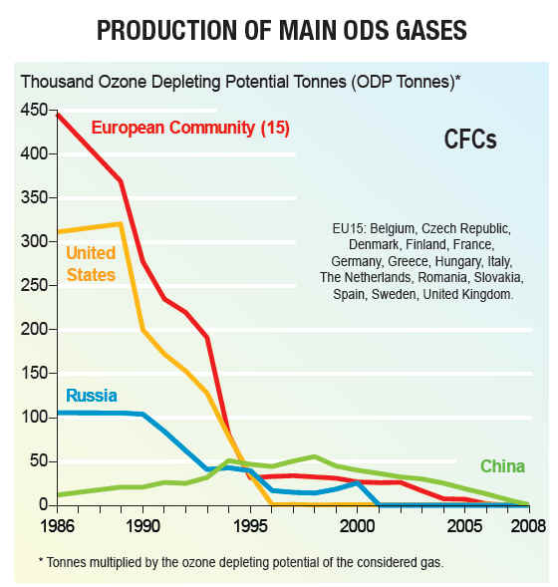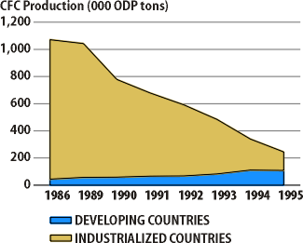

Watch the Landmark Deal video. https://www.youtube.com/watch?v=9D9JtaCIoXk&feature=emb_logo.
In 2019, governments realized that environmental issues need to be addressed at an intergovernmental level. There was a realization that changes in behavior are necessary to protect the environment in the future. In response to development in scientific understanding governments agreed to phase out the use of HFCs. This was set in the Kigali Amendment to the Montreal Protocol. Rich countries agreed to provide financial assistance for poorer countries to phase out HFCs because technological development has found alternatives to HFCs.
Advantages
- allows less developed countries more time to raise necessary funding;
- allows less developed countries time to develop/import necessary technology/infrastructure;
- allows less developed countries time to introduce significant changes in policy/governance;
- deadlines are more reasonable so more countries are likely to commit to change;
- issue can start being addressed sooner by more developed countries.

Disadvantages
- may prolong achievement of complete/global phasing out;
- may reduce action to a lower priority than necessary in some countries;
- may prompt some multinational companies to relocate to countries with later deadlines;
- developed countries, given shorter deadlines, may be more dependent on HFCs so have more to do;
- countries avoiding early phase out may benefit from production/trade of HFCs;
- cost of early change/application of untested substitutes may lead to conflict from more developed countries;
- conflicts arising from different treatments between countries may undermine overall agreement.

Watch the video Someone in East Asia is Damaging the Ozone Layer” http://fortune.com/2018/05/17/ozone-cfcs-east-asia/
- Identify the challenges that are still associated with ozone depleting substances

6.2.U5 Pollution management may be achieved by reducing the manufacture and release of ozone-depleting substances. Methods for this reduction include:; recycling refrigerants; developing alternatives to gas-blown plastics,; halogenated pesticides, propellants and aerosols; developing non-propellant alternatives.
- State the effective strategies used in stratospheric ozone management

- Explain why recycling refrigerants is a Tier 2 pollution management strategy

- Explain why developing alternatives to gas-blown plastics, halogenated pesticides and propellants and aerosol is a Tier 1 pollution management strategy

- Identify and justify developing non-propellant alternatives as a pollution management strategy. Which tier would it be classified as. Explain your answer.

- List some examples of methods to reduce the manufacture and release of ozone-depleting gases

- Evaluate the effectiveness of international contributors as a pollution management strategy

ESS can be like learning a new language. So many words are not commonly used in everyday English. This can be challenging. To help you keep up with ESS Terms, you will need to create your own ESS DICTIONARY. You should add to this over the year and keep it in your notebook or on a page file THAT YOU CAN UPDATE AND ADD TO EASILY. Most of the vocabulary words can be found either on your STUDY GUIDE or at mrgscience.com.
You will be responsible for leaning the words and their meaning. Periodic quizzes will be given on the words. So, make your dictionary creative and you will remember the words more easily.

KEY TERMS

Atmosphere

Ozone

​radiation

albedo effect
​
greenhouse gases

inputs

transformations

ultraviolet light

systems

troposphere

greenhouse effect
​
reflection
​
water vapor
​
global warming
​
outputs
​
energy

mesosphere

ionosphere

conduction
​
shortwave radiation
​
climate change
​
storage
​
matter
​
dynamic

thermosphere

biosphere

convection

longwave radiation
​
absorption
​
transfers

atmospheric gases
​
open system

