Understandings, Applications and Skills (This is what you may be assessed on)

Significant ideas
- The combustion of fossil fuels produces primary pollutants that may generate secondary pollutants and lead to photochemical smog, the levels of which can vary by topography, population density and climate.
- Photochemical smog has significant impacts on societies and living systems.
- Photochemical smog can be reduced by decreasing human reliance on fossil fuels.
Big Questions:
- To what extent have the solutions emerging from this topic been directed at preventing environmental impacts, limiting the extent of the environmental impacts, or restoring systems in which environmental impacts have already occurred?
- How are the issues addressed in this topic of relevance to sustainability or sustainable development?
- In what ways might the solutions explored in this topic alter your predictions for the state of human societies and the biosphere some decades from now?
- Outline the solutions to ground-level ozone. Why is there still ground-level ozone?
- Comment on the links between sustainability and photochemical smog
- Suggest how photochemical smog is likely to change in the decades to come.
 | Statement | Guidance
6.3.U1 | Primary pollutants from the combustion of fossil fuels include carbon monoxide, carbon dioxide, black carbon or soot, unburned hydrocarbons, oxides of nitrogen, and oxides of sulfur. | The use of chemical symbols, formula or equations is not required
6.3.U2 | In the presence of sunlight, secondary pollutants are formed when primary pollutants undergo a variety of reactions with other chemicals already present in the atmosphere.
6.3.U3 | Tropospheric ozone is an example of a secondary pollutant, formed when oxygen molecules react with oxygen atoms that are released from nitrogen dioxide in the presence of sunlight.
6.3.U4 | Tropospheric ozone is highly reactive and damages plants (crops and forests), irritates eyes, creates respiratory illnesses and damages fabrics and rubber materials. Smog is a complex mixture of primary and secondary pollutants, of which tropospheric ozone is the main pollutant.
6.3.U5 | The frequency and severity of smog in an area depends on local topography, climate, population density, and fossil fuel use.
6.3.U6 | Thermal inversions occur due to a lack of air movement when a layer of dense, cool air is trapped beneath a layer of less dense, warm air. This causes concentrations of air pollutants to build up near the ground instead of being dissipated by “normal” air movements.
6.3.U7 | Deforestation and burning may also contribute to smog
6.3.U8 | Economic losses caused by urban air pollution can be significant.
6.3.U9 | Pollution management strategies include:  - altering human activity to consume less fossil fuels—example activities  - include the purchase of energy-efficient technologies, the use of public or shared transit, and walking or cycling  - regulating and reducing pollutants at the point of emission through government regulation or taxation  - using catalytic converters to clean the exhaust of primary pollutants from car exhaust  - regulating fuel quality by governments​ adopting clean-up measures such as reforestation, regreening, and conservation of areas to sequester carbon dioxide
6.3.A1 | Evaluate pollution management strategies for reducing photochemical smog. | Reference to Figure 3 Pollution Management

The combustion of fossil fuels produces primary pollutants that may generate secondary pollutants and lead to photochemical smog, the levels of which can vary by topography population density and climate
6.3.U1 Primary pollutants from the combustion of fossil fuels include carbon monoxide, carbon dioxide, black carbon or soot, unburned hydrocarbons, oxides of nitrogen, and oxides of sulfur.
6.3.U2 In the presence of sunlight, secondary pollutants are formed when primary pollutants undergo a variety of reactions with other chemicals already present in the atmosphere.
6.3.U3 Tropospheric ozone is an example of a secondary pollutant, formed when oxygen molecules react with oxygen atoms that are released from nitrogen dioxide in the presence of sunlight.

- Define air pollution

- Look at the table below. How are air quality standards measured?

- Outline how primary pollutants are classified. Give two examples

- Which pollutants are emitted from the burning of fossil fuels? Identify their characteristics. State the effects of these pollutants on organisms

- With reference to the map, evaluate the carbon dioxide levels in the Unites States

- Give examples of air particulate matter. State how they are formed. What hazarders are associated with suspended air particles

- State how oxides of nitrogen are produced

- From the figure on the right, evaluate the sulfur dioxide levels of the United States

- Watch the video clip on the Science of Smog. https://www.youtube.com/watch?time_continue=18&v=CdbBwIgq4rs&feature=emb_logo

- Distinguish between primary pollutants and secondary pollutants

- Describe how secondary pollutants are formed

- State how tropospheric ozone is formed (The use of chemical symbols, formula or equations is not required)

- From the figure on the right, explain the differences in secondary pollutions between summer and winter

6.3.U4 Tropospheric ozone is highly reactive and damages plants (crops and forests), irritates eyes, creates respiratory illnesses and damages fabrics and rubber materials. Smog is a complex mixture of primary and secondary pollutants, of which tropospheric ozone is the main pollutant.

Air quality indices are numbers used by government agencies to characterize the quality of the air at a given location
Category | AQI level | Pollution concentration breakpoint/ ppb | Health Effect
Very good | 0-15 | 0-23 | None in healthy people
Good | 16-31 | 24-50 | None in healthy people
Moderate | 32-49 | 51-80 | - Respiratory irritation in sensitive people during vigorous exercise  - Some risk for people with heart/lung disorders  - Damage to very sensitive plants
Poor | 50-99 | 81-149 | - Respiratory irritation in sensitive people when breathing  - Possible lung damage in sensitive people when active  - Damage to some plants
Very poor | 100+ | 150+ | - Serious respiratory effects during light physical exercise  - High risk for people with heart/lung disorders  - More vegetation damage

- List specific examples of the effect of tropospheric ozone on plants and humans
Watch the video clip on the effects of air pollution on human health https://youtu.be/88MK-lmU8QI

Air Pollution and Cancer
The World Health Organisation (WHO) has officially classified outdoor air pollution as carcinogenic (causing cancer). The IARC, a cautious organisation that only speaks out when the evidence is very strong, stated that air pollution from industrial and traffic fumes is a definite cause of lung cancer and is also linked to bladder cancer. Diesel engine exhaust fumes, solvents, metals and dusts have all been labelled as carcinogenic.
Air pollution is already known to increase the risk of respiratory and heart disease. Now it is recognised that the risk of developing lung cancer is significantly increased in people exposed to air pollution.
There are effective ways to reduce air pollution, and given the impacts of pollution, this needs to be addressed quickly. As the major sources are man-made, much can and should be done to protect the world’s population from exposure, especially those in urban and industrial areas.
Air Pollution and Low Birth Weight
Another recent study (by the Centre for Research in Environmental Epidemiology in Barcelona) has shown that children born to mothers who live in areas with air pollution and dense traffic are more likely to have low birth weight and smaller head circumferences. Even in areas relatively low levels of air pollution, babies were smaller – well below the European Union accepted limits.
The study found that for every increase of five micrograms per cubic metre of particulate matter, the risk of low birth weight increased by 18%. Although causation has not been proved, the link is a very strong one. The authors state that a substantial proportion of cases of low birth weight could be prevented in Europe if urban air pollution, especially particulate matter, was reduced.
Low birth weight is a concern since it frequently predicts poor health as children and later as adults. A smaller head circumference could predict problems with neurodevelopment.
The research was based on twelve countries, involving over 74,000 women between 1994 and 2011. It included a range of environments from rural to inner city. Other factors, such as smoking, were also included. In terms of location, poor people living in inner city areas, living on a poor diet, and where there was more traffic, were more likely to have low birth weight babies.
It is possible to reduce air pollution, although the advice is not always followed. The introduction of a low emission zone in London has had little effect on the concentration of particulate matter, although the mix of vehicles has changed. UK policy makers have resisted attempts to change diesel-powered taxis (which contribute 20% of London’s locally generated particulate matter) to cleaner petrol-powered ones.

6.3.U5 The frequency and severity of smog in an area depends on local topography, climate, population density, and fossil fuel use.
- Check out the air quality near where you live. To begin with go to http://www.epa.gov/airnow click on the “Air Quality Index” link.
  - What are the current conditions?
  - For particulates? For ozone?
  - Hover over the Maps and Data tab. Select Interactive Map. Where are the greatest problems with particulates and ozone?
  - Now click on the “Archives” link and then on your region (the regions are represented by different colors). Select “December 1, 2018”. (Once you select the month you may need to click your mouse outside the date to active the search)
  - Then select ozone and pm. What happened?
  - Now select “May 1, 2019. Then select ozone and pm. What happened?
  - Now select “July 1, 2019. Then select ozone and pm. What happened: Why were there differences between the months

- Describe how location, topography, climate and population affects the frequency and severity of photochemical smog

Watch the video clip on the London Fog https://youtu.be/ZOLNZjpo1CE
- Distinguish between the two different types of smog stated below:
http://apollo.lsc.vsc.edu/classes/met130/notes/chapter18/london_la.html

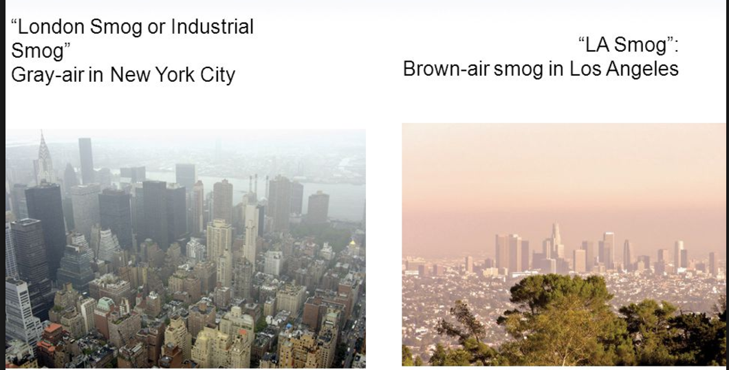

 | London-type smog | Los Angeles – type smog
Main pollutants
Climactic requirements
Temperature inversion required?

6.3.U6 Thermal inversions occur due to a lack of air movement when a layer of dense, cool air is trapped beneath a layer of less dense, warm air. This causes concentrations of air pollutants to build up near the ground instead of being dissipated by “normal” air movements.
Watch the video on Thermal Inversions https://www.youtube.com/watch?time_continue=118&v=T_U3TXHBt-0&feature=emb_logo

- Referring to the video and diagrams above, describe how a temperature inversion forms and how it leads to the presence of smog

6.3.U7 Deforestation and burning may also contribute to smog
Case study: Indonesia
by
Alex Morales
October 28, 2015 — 3:48 PM EDT October 28, 2015 — 3:48 PM EDT
https://www.bloomberg.com/news/articles/2015-10-28/how-indonesia-s-fires-made-it-the-biggest-climate-polluter

Indonesia’s forest fires have catapulted the southeast Asian nation to the top of the rankings of the world’s worst global warming offenders, with daily emissions exceeding those of China on at least 14 days in the past two months.
The nation’s total daily carbon dioxide emissions, including from power generation, transport and industry, exceeded those of the U.S. on 47 of the 74 days through Oct. 28, according to Bloomberg analysis of national emissions data from the World Resources Institute in Washington and Indonesian fire-emissions data from VU University in Amsterdam.
Smog caused by the fires has generated headlines and a diplomatic flare-up between Indonesia and its neighbors in southeast Asia. It’s a threat to human health and has disrupted flights in the region. At the same time, burning trees and peatlands are pumping heat-trapping gases into the atmosphere at a time when more than 190 nations are gearing up to sign a new agreement to stem global warming in Paris in December.
“The problem that we see in Indonesia with essentially unrestrained deforestation going on is a bad message for the world,” Bill Hare, chief executive officer of Potsdam, Germany-based policy researcher Climate Analytics, said in a phone interview. “If we can’t really control deforestation in this region, who’s going to be next? It would be a signal that countries can get away with this kind of deforestation without any real constraint.”
The fires are caused by clearing woodland for paper and palm oil plantations, and have been worsened by El Nino-related dry conditions.
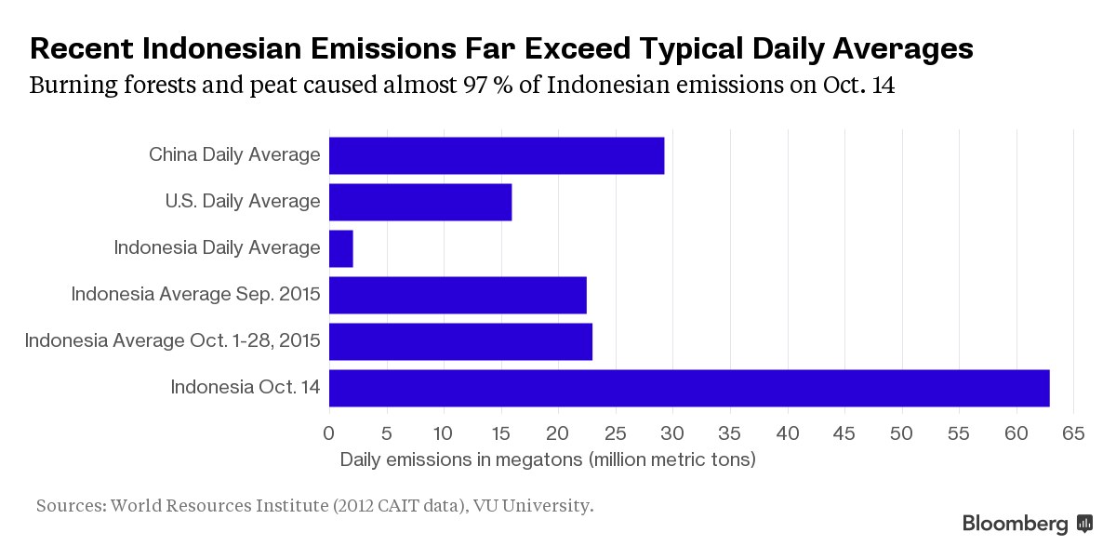
In a satellite record that began in 1997, 2015 is the second worst year on record for emissions from Indonesian forest fires, according to Guido van der Werf, professor of Earth sciences at VU University. It’s unlikely to exceed 1997, which itself was probably worse than any year predating the satellite record, he said.
“We have some confidence in the numbers because by using atmospheric models we can predict, based on our emissions, how elevated concentrations of gases and aerosols will be in the atmosphere,” van der Werf said in an e-mail. “That corresponds reasonably well with what we actually measure in the atmosphere.”
Without including land use changes and deforestation, Indonesia emits about 761 megatons (761 million metric tons) of carbon dioxide a year, according to 2012 data from the World Resources Institute. That works out at 2.1 megatons a day, compared with almost 16 for the U.S. and 29.3 for China.
Indonesian daily emissions from fires alone rose as high as 61 megatons on Oct. 14, according to van der Werf’s data, part of the Global Fire Emissions Database. That accounted for almost 97 percent of total national emissions for the day.

Exceeding China
Bottom of Form
The daily average emissions for Indonesia, including those of the wider economy, was 22.5 megatons in September and 23 megatons for Oct. 1 through Oct. 28, according to Bloomberg calculations. That’s more than the U.S. average for those two months, based on a typical year, though still short of China. Even so, daily emissions first exceeded those of China on Sept. 8, and most recently did so on Oct. 23.
“Put simply, this is a climate catastrophe,” Nigel Sizer, global director of WRI’s forests program said in an e-mailed reply. “The emissions from these fires are likely to add about 3 percent to total global greenhouse gas emissions from human activities for the year.”
The WRI posted analysis in an Oct 16 blog that showed emissions from the fire exceeding those of the entire U.S. economy. Indonesia has pledged to cut its emissions by 29 percent from a projected “business-as-usual” scenario by 2030 as part of the new UN deal on climate change. The plan, short on details, includes an unquantified commitment to reduce deforestation. The country already has a moratorium in place on clearing primary forests, and a ban on converting peatlands to other uses.

Failed Efforts

“An enormous amount of effort has gone in from different countries to support reductions in deforestation and burning of peat land and it’s really failed,” said Hare.
Van der Werf said it takes 100 years or more to grow trees that will absorb the CO2 released by burning primary forests. For carbon-rich peat soils that have been burnt, the lag is even bigger, he said.
“What is burning in Indonesia is for a large part peat that has accumulated over thousands of years and will not regrow so this is a net source of CO2, just like fossil fuel emissions,” he said. “Unless there is a dramatic change in land management these peatlands will not be restored.”

6.3.U8 Economic losses caused by urban air pollution can be significant.
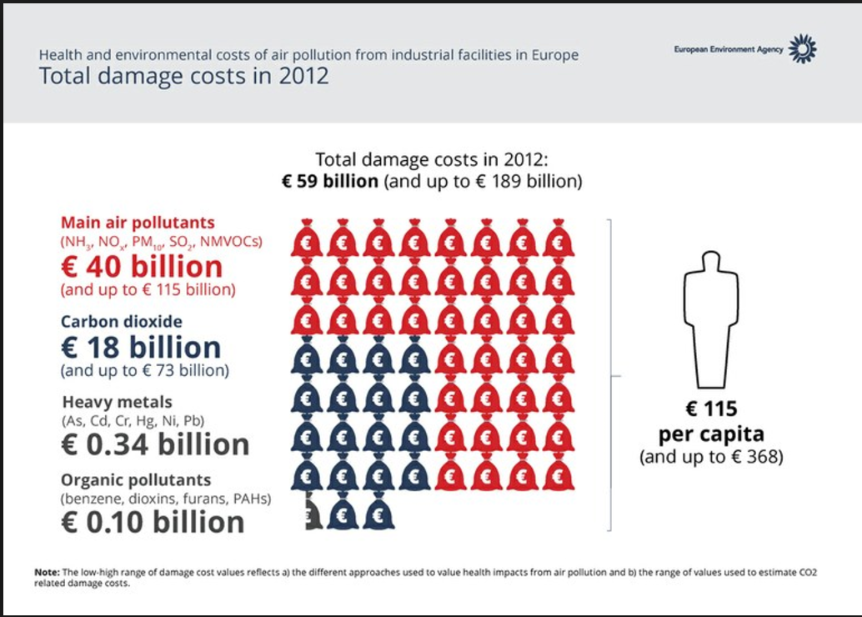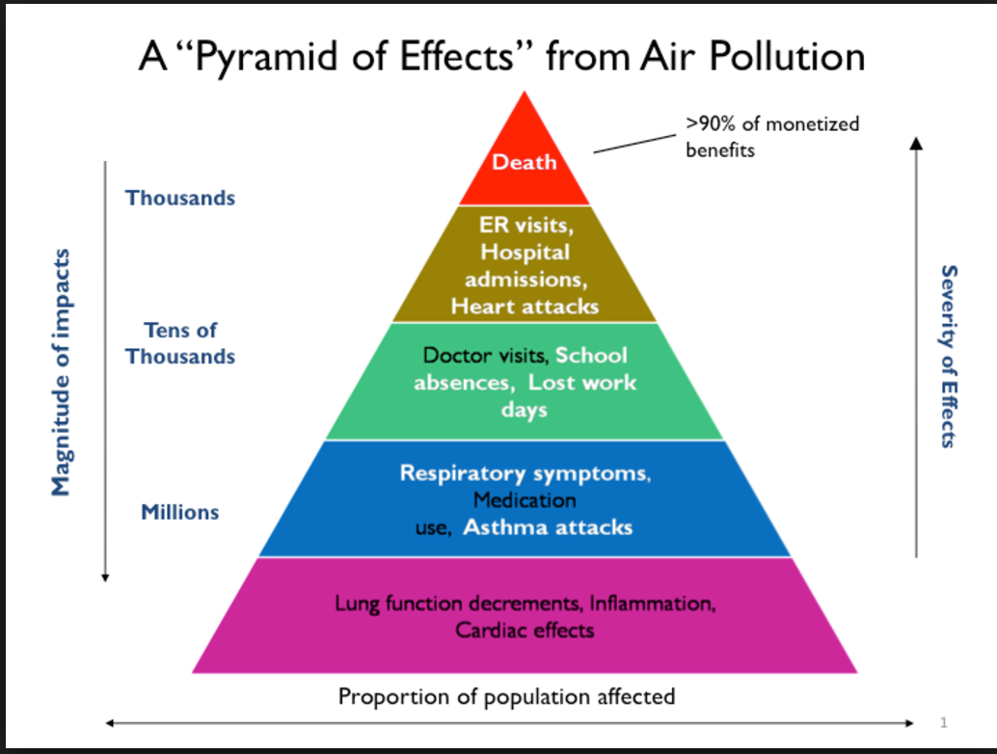

- Using the sources below, list the main impacts on the economy caused by air pollution

https://www.washingtonpost.com/news/energy-environment/wp/2016/01/29/the-staggering-economic-cost-of-air-pollution/?utm_term=.d21c85204d28

http://journalistsresource.org/studies/environment/pollution-environment/health-effects-costs-air-pollution-research-roundup

http://www.nature.nps.gov/air/aqbasics/economics.cfm

6.3.U9 Pollution management strategies include:
- altering human activity to consume less fossil fuels—example activities include the purchase of energy-efficient technologies, the use of public or shared transit, and walking or cycling
- regulating and reducing pollutants at the point of emission through government regulation or taxation
- using catalytic converters to clean the exhaust of primary pollutants from car exhaust
- regulating fuel quality by governments adopting clean-up measures such as reforestation, regreening, and conservation of areas to sequester carbon dioxide
6.3.A1 Evaluate pollution management strategies for reducing photochemical smog.
Watch the video clip on Human fingerprint on Global Air Quality https://www.youtube.com/watch?v=aMnDoXuTGS4&feature=emb_logo

- Altering human activity

- Controlling the Release of Pollution

- Cleanup and Restoration

Watch the video clip on Heavy Smog in China https://www.youtube.com/watch?v=atsGOWe9s-0&feature=emb_logo
Beijing Reacts to Record Smog Cloud

http://www.pbs.org/newshour/extra/2013/02/beijing-reacts-to-record-smog-cloud/
China is the world’s fastest growing major economy, but the resulting pollution from factories and vehicles has made it dangerous for some city residents to breathe the outside air. In January 2013, a thick cloud of smog hovered over the capital Beijing for weeks, causing health problems and raising questions about how to balance economic growth with a livable environment.
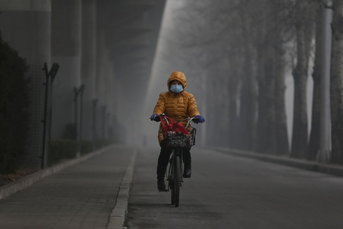
A woman wears a mask while riding a bicycle on the street during severe pollution on January 23, 2013 in Beijing, China. While masks may keep out some larger pollution particles, they are not very effective against fine particles.
The American Embassy in Beijing has been monitoring pollution from its roof since 2008. They system measures the number of fine pollution particles in the air and issues an Air Quality Index (AQI) score. Any number under 50 means it is safe to breathe, a score between 50 and 300 is unhealthy, and anything higher means people should not venture outdoors at all. The smog last month measured 750.
Hospitals were overwhelmed by residents coming in with difficulty breathing. Children and the elderly are more at risk. Sales of masks and air filters skyrocketed, but much of the pollution consists of particles too small to be blocked by anything other than a professional-grade gas mask.
The thick smog cloud was caused by a “temperature inversion,” meaning that cooler air and pollution from nearby coal-burning factories was trapped low in the atmosphere. It cleared February 1 when the temperature higher in the atmosphere cooled off and the winds picked up. But the index continues to climb periodically into the 200s and the scare has mobilized residents and the government into action.

What is being done about it?
In response to the crisis, the government temporarily closed 100 factories and took many government vehicles off the road. Beijing asked Chinese citizens to set off fewer fireworks for this year’s New Year’s celebration, which begins February 10th. Fewer fireworks are being produced and fewer retailers will be selling them.
Public anger has forced politicians to address the concerns of citizens. Wang Anshun, the newly appointed mayor of Beijing, told the legislature that the government must come up with a plan to curb the pollution.
“I hope we can have blue skies, clean water, less traffic and a more balanced education system,” Mr. Wang said at a session of the legislature, adding that “the current environmental problems are worrisome.”
The government announced plans to use clean fuel in government vehicles and plant trees over 250 square miles of land in the next five years, the state news agency, Xinhua, reported.
However, officials are still calling the dark air “fog” instead of “smog”.

Smog crisis forces media to report on pollution
Due to the government’s censorship of the media, Chinese citizens took to microblogs to get information and discuss the situation. On one microblog, businesswomen Zhang Xin reminded people that after thousands of people died as a result of air pollution in Britain in the 1950s, the government passed strict laws to improve air quality, the New York Times reported.
As Twitter feeds displayed photos of smog-filled streets and cloudy landscapes, the state-run news agency was forced to report on the pollution problem and the official reaction to it.
“I’ve never seen such broad Chinese media coverage of air pollution,” business consultant Jeremy Goldkorn told the New York Times.
But the road ahead is tricky as the government tries to balance concerns about pollution and the negative international attention with China’s powerful factory owners and industrial leaders who have brought China immense wealth and positioned the country to surpass the United States in total economic activity in the next few years.
– Compiled by Alyssa Goard for NewsHour Extra

Questions
- Since what year has the American Embassy in Beijing been monitoring the city’s pollution?

- What is considered a healthy score on the Air Quality Index (AQI)?

- What was the AQI rating in Beijing in January?

- What caused the smog cloud?

- Why did the smog eventually go away?

- What word are government officials using instead of “smog” to describe the dark air?

- Where did Chinese citizens get their news of the smog in Beijing?

- Why is it important that the government used the word “fog” to describe the situation in Beijing while other observers used the word “smog”?

- Why do you think the Chinese government censored media about the smog?

Evaluate management strategies used to deal with urban air pollution in China

Level | Strategy
Cause | Cars, buses and taxis | Reduce Demand for private cars through public transport  Promote cycle and bus lanes  Restrictions and tolls for car entry to urban areas  Promote cleaner fuels and hybrid or electrical models
 | Electricity | Reduce consumption of electricity through building design  Small scale green power on city buildings e.g. solar, wind  Locale power stations away from urban areas
Release and transfer | Cars, buses and taxis | Monitor and regulate exhaust emissions
 | Electricity and industry | Use cleaner fuels  Clean up emission
Effects | Smog prevention | Design and plan city building to promote natural cooling and circulation  Promote opening up and cleaning up of covered water courses to allow evaporative cooling
 | Health | Raise awareness of conditions and effects of breathing polluted air  Promote pollution related health checks ups  Activated charcoal masks  Provide public access to pollution monitoring

- Which of the strategies for combatting air pollution has Beijing chosen to implement? Do you think they will be successful? Explain your reasons why.

- Zipcar is an American car sharing company and a subsidiary of Avis Budget Group. Zipcar provides automobile reservations to its members, billable by the minute, hour or day; members may have to pay a monthly or annual membership fee in addition to car reservations charges. Check out this video on Zipcars http://www.zipcar.com/

ESS can be like learning a new language. So many words are not commonly used in everyday English. This can be challenging. To help you keep up with ESS Terms, you will need to create your own ESS DICTIONARY. You should add to this over the year and keep it in your notebook or on a page file THAT YOU CAN UPDATE AND ADD TO EASILY. Most of the vocabulary words can be found either on your STUDY GUIDE or at mrgscience.com.
You will be responsible for leaning the words and their meaning. Periodic quizzes will be given on the words. So, make your dictionary creative and you will remember the words more easily.
KEY TERMS

nitrogen dioxide

nitrogen monoxide

VOC

​Emissions

​Deforestation

photochemical smog

hydrocarbons

nitrogen oxide

​primary pollutant

​Combustion

Topography

tropospheric ozone

PAN

​secondary pollutant

​fossil fuels

thermal inversion

pollution

nitrogen cycle

​soot

catalytic converter

carbon monoxide

​fossil fuels

sulphur oxide

