Understandings, Applications and Skills (This is what you may be assessed on)

Significant ideas
- There is a range of different energy sources available to societies that vary in their sustainability, availability, cost and socio-political implications.
- The choice of energy sources is controversial and complex. Energy security is an important factor in making energy choices.
Big Questions:
- What strengths and weaknesses of the systems approach and the use of models have been revealed through this topic?
- To what extent have the solutions emerging from this topic been directed at preventing environmental impacts, limiting the extent of the environmental impacts, or restoring systems in which environmental impacts have already occurred
- What value systems can you identify at play in the causes and approaches to resolving the issues addressed this topic?
- How does your own value system compare with others you have encountered in the context of issues raised in this topic?
- How are the issues addressed in this topic of relevance to sustainability or sustainable development?
- In what ways might the solutions explored in this topic alter your predictions for the state of human societies and the biosphere some decades from now?
- How does the systems approach help our understanding of energy choices and security?
- Why do countries lack energy security?
- Why do some societies continue to use fossil fuels despite the damage they do to the environment?
- How do environmental value systems affect the choice of energy supply:
- Compare your environmental value systems with at least two other value systems in relation to energy consumption
- To what extent are global energy choices sustainable?
- How might energy choices evolve in the next decade?

 | Statement | Guidance
7.1.U1 | Fossil fuels contribute to the majority of humankind’s energy supply, and they vary widely in the impacts of their production and their emissions; their use is expected to increase to meet global energy demand. | Strengths and weaknesses of the use of a fossil fuel, of a renewable source of  energy, and of nuclear power should be considered.
7.1.U2 | Sources of energy with lower carbon dioxide emissions than fossil fuels include renewable energy (solar, biomass, hydropower, wind, wave, tidal and geothermal) and their use is expected to increase. Nuclear power is a low carbon low-emission non-renewable resource but is controversial due to the radioactive waste it produces and the potential scale of any accident.
7.1.U3 | Energy security depends on adequate, reliable and affordable supply of energy that provides a degree of independence. An inequitable availability and uneven distributions of energy sources may lead to conflict.
7.1.U4 | The energy choices adopted by a society may be influenced by availability; sustainability; scientific and technological developments; cultural attitudes; and political, economic and environmental factors. These in turn affect energy security and independence.
7.1.U5 | Improvements in energy efficiencies and energy conservation can limit growth in energy demand and contribute to energy security.
7.1.A1 | Evaluate the advantages and disadvantages of different energy sources.
7.1.A2 | Discuss the factors that affect the choice of energy sources adopted by different societies. | Use case studies to highlight the energy choices of different countries
7.1.A3 | Discuss the factors which affect energy security.
7.1.A4 | Evaluate the energy strategy of a given society.

There is a range of different energy sources available to societies that vary in their sustainability, availability, cost and socio-political implications
The choice of energy sources is controversial and complex. Energy security is an important factor in making energy choices
- What do you think is meant by “energy security”?

- Is energy security a concern for the US? Explain your response

- What is “energy poverty” and how might it be linked to energy security?

7.1.U1 Fossil fuels contribute to the majority of humankind’s energy supply, and they vary widely in the impacts of their production and their emissions; their use is expected to increase to meet global energy demand.

- Which country accounts for the world’s increase in energy consumption? Justify your answer

- Compare the per capita energy use between MEDCs and LEDCs

Watch the video at http://www.abc.net.au/btn/story/s4252941.htm and answer the questions below:

- Give examples of fossil fuels.

- How do living things turn into fossil fuels?

- Which substance is one of the main ingredients in fossil fuels?

- What three things are needed to create fossil fuels?

- What is meant by the following statement: Changing the recipe a little can change the fossil fuel you produce at the end.

- Fossil fuels are a renewable resource. True or false?

- What are the disadvantages of burning fossil fuels?

- What have seven of the wealthiest nations decided about using fossils fuels in the future?

- What are some other energy options that could be used instead of fossil fuels?

- Do you think it’s a good idea for countries to stop using fossil fuels by the end of the century? Explain your answer.

Go to http://data.worldbank.org/indicator/EG.USE.COMM.FO.ZS . Make sure it is showing the global consumption of fossil fuel energy (in %)

- Describe the trend in global fuel consumption between 1960 and 2013.

- What happened to the fossil fuel consumption between 1970 and 1985 – why do you think this is? (hint: click on the alternative and nuclear energy use graph button on the right-hand side)

- Scroll down the page to look at Turkey’s fossil fuel use in 1960 and compare it to its fossil fuel use in 2013. How has it changed?

7.1.A1 Evaluate the advantages and disadvantages of different energy sources.
- Use the table below to evaluate fossil fuels as an energy source
Advantages | Disadvantages

7.1.U2 Sources of energy with lower carbon dioxide emissions than fossil fuels include renewable energy (solar, biomass, hydropower, wind, wave, tidal and geothermal) and their use is expected to increase. Nuclear power is a low carbon low-emission non-renewable resource but is controversial due to the radioactive waste it produces and the potential scale of any accident.
- Identify the energy sector which shows the most growth between 1990 and 2040. suggest reasons for this growth. Which sector shows the greatest decline? Explain why.

- Which countries get more of their energy from low-carbon sources than the global average. Explain why

- Watch this video clip on the use of nuclear power. https://www.youtube.com/watch?v=rcOFV4y5z8c. Use the table below to evaluate nuclear power as an energy source
Advantages | Disadvantages

- Watch this video clip on the use of solar power. https://www.youtube.com/watch?v=xKxrkht7CpY&t=10s. Use the table below to evaluate solar power as an energy source
Advantages | Disadvantages

- Watch this video clip on the use of solar power. https://www.youtube.com/watch?v=xKxrkht7CpY&t=10s. Use the table below to evaluate solar power as an energy source
Advantages | Disadvantages

- Watch this video clip on the use of wind power. https://www.youtube.com/watch?v=SQpbTTGe_gk. Use the table below to evaluate wind power as an energy source
Advantages | Disadvantages

- Watch this video clip on the use of hydropower. https://www.youtube.com/watch?v=pEUzot8Zufo. Use the table below to evaluate hydropower as an energy source
Advantages | Disadvantages

- Watch this video clip on the use of geothermal power. https://www.youtube.com/watch?v=ij6h97f3wt4. Use the table below to evaluate geothermal power as an energy source
Advantages | Disadvantages

7.1.U4 The energy choices adopted by a society may be influenced by availability; sustainability; scientific and technological developments; cultural attitudes; and political, economic and environmental factors. These in turn affect energy security and independence.
24. State why countries use the energy sources they do?

- State the factors influencing energy security

- Watch the video clip on BP Statistical Review of World Energy 2012. https://www.youtube.com/watch?v=KtWoPZluI2E

- Reference the table below. Why do you think Australia uses more coal than China?

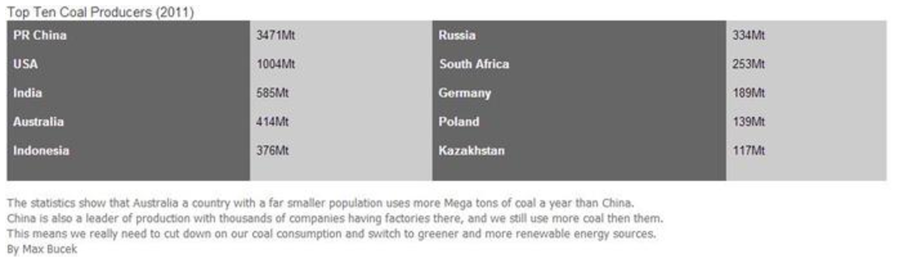

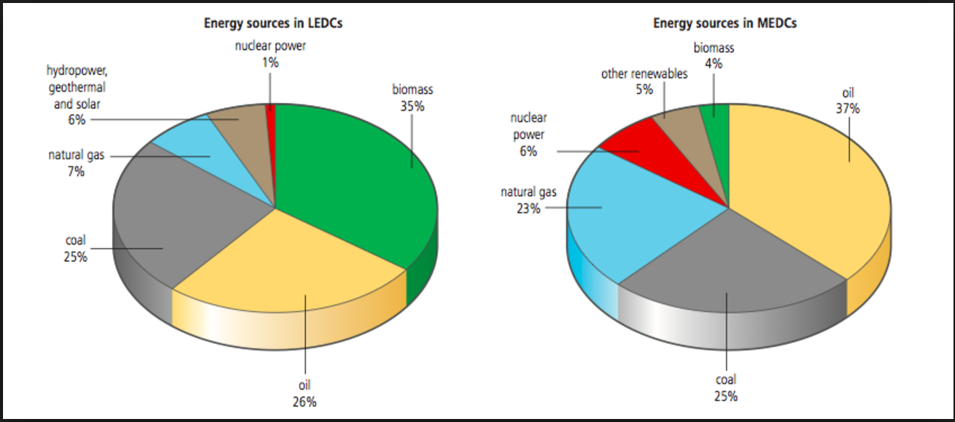

MEDCs have higher energy demands than LEDCs, as they depend on energy for many things such as transport, heating, air-conditioning, cooking and all other aspects of their lives.

The choice of what energy source should be used is different to countries. Some have large oil, coal and gas reserves and that makes fossil fuels an obvious choice for an energy source. However, generation of energy also depends on its availability, economy, cultural, environmental and technological factors. When an energy resource is available and close, it is easier and efficient to use.

Culture fears based on the fear of nuclear accidents and waste, have made it quite unpopular to choose. Cultural and tradition means that non-renewable resources are favored, and the places with renewable energy resources are limited. Renewable energy sources are not being used so much globally which means that it is still not ready to meet current demands. Renewable sources can be used more if the production prices of the non-renewable sources are increased. This may better the environment as higher costs of the fossil fuels means that peoples view will change. Peoples interest in renewable resources has led to an increased demand for renewable and non-pollution sources. This leads to a greater investment and research into more alternatives or improvements.

- Summarize why MEDCs have a higher dependence on fossil fuels when compared to LEDCs.

7.1.A2 Discuss the factors that affect the choice of energy sources adopted by different societies.

- Complete the table below to show how the following factors influence the energy choice of a country. Do some research to give an example of a country or a context to illustrate your description.

Factor | Description | Example
Availability
Economic
Cultural
Environmental
Technological

7.1.U3 Energy security depends on adequate, reliable and affordable supply of energy that provides a degree of independence. An inequitable availability and uneven distributions of energy sources may lead to conflict.
- Identify the various threats to energy security.

- Using the figure on the left, where would you expect there to be conflict?

CASE STUDY: Russia- Ukraine Gas Dispute

https://www.youtube.com/watch?v=KOzyww30vbk
https://www.youtube.com/watch?v=3AMsrxba3Sc

http://www.bbc.com/news/world-europe-29521564
By Paul Kirby, BBC News
31 October 2014
After several rounds of tough talks, a deal has been reached - through EU mediation - for Russia to resume gas supplies to Ukraine.
It is critically important for Ukraine as the harsh winter looms - as well as for many of its East European neighbors, who also rely on Russian gas.
Russia cut off Ukraine's gas in June as the conflict between the government in Kiev and pro-Russian rebels in the east escalated.

Why did Russia cut off Ukraine's gas?
Russia moved on 16 June to turn off the taps, after complaining that Ukraine had failed to pay off its debts, estimated at $5.3bn (£3.3bn; 4.2bn euros) by Russian state-run giant Gazprom. Gazprom had sought a repayment of $1.95bn.
It was not the first time: it cut supplies because of price disputes in 2006 and in the winter of 2008-09. Those earlier disputes led to gas shortages elsewhere in Eastern Europe, meaning hardship for many ordinary citizens in mid-winter.
In the tug-of-war between Russia and the EU over the future direction of Ukraine, the current gas row has been harder to resolve.

Why is gas so important?
Ukraine, until the current crisis, relied on Russia for half its gas supplies. Some EU member states such as Slovakia take all their gas from Russia. In total, Russia supplies 23% of the EU's gas.
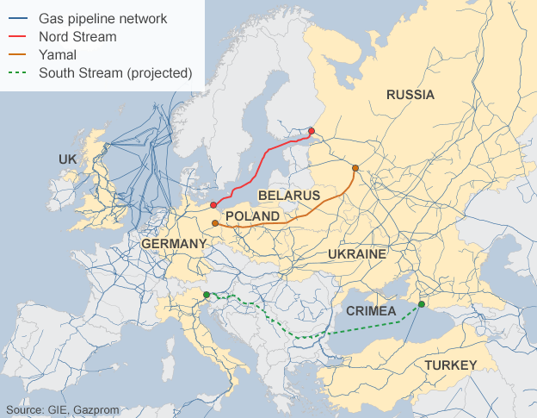
Russia's supply lines run through Ukraine to several EU countries and as much as 70% of its gas to the EU is carried through those pipes. So while Russia has in recent years tried to bypass Ukraine, in particular with the Nord Stream and South Stream projects, the two countries are, for now, inextricably linked.

Has Moscow tied its gas supply to the crisis in Ukraine?
The supply and price of Russian gas have been part of this crisis from the start.
In December 2013, Ukraine's then-President Viktor Yanukovych enraged protesters by signing a deal for cut-price gas in Moscow weeks after he ditched an agreement for closer ties to the EU at the last minute.
In April, the government in Moscow then raised the price by 80%: initially it went up from $268.5 per 1,000 cubic metres (cu m) to $385.5 because of unpaid bills, then up to $485, much higher than the market level, ostensibly because of the introduction of an export duty on gas.
Ukraine said the only reason for the price rise was politics although Gazprom insisted it wanted its bills paid and offered a lower price.
However, there was concern in September when gas supplies to Poland, Slovakia and Germany mysteriously dropped. This was seen by some as a warning signal not to extend EU sanctions on Russia, and also not to sell on to Ukraine some of the gas it was receiving from Russia.

What has been agreed now?
Ukraine will make two payments this year to clear most of its gas debt: a $1.45bn tranche "without delay", then a $1.65bn tranche.
This debt settlement will be based on the price of $268.5 per 1,000 cubic metres (cu m).
The EU agreed to act as guarantor for those payments.
Next year the rest of the debt is to be paid off - that quantity of debt and the gas price are to be determined by an independent court.
When the dispute erupted, Russia and Ukraine both took their cases to the international arbitration court at the Stockholm Chamber of Commerce. A final decision is only expected next summer.

Russia agreed to resume gas deliveries to Ukraine, for which Ukraine will pay monthly in advance.
These new deliveries will cost Ukraine $378 per 1,000 cu m to the end of 2014, and $365 in the first quarter of 2015.
Ukraine is free to order as much gas as it needs, the European Commission says.

How does this affect the rest of Europe?
With winter ahead, urgently sorting out the gas row was seen as a key reason why the EU delayed implementation of a free trade deal with Ukraine until January 2016.
Russia has strongly opposed the free trade deal, arguing that Ukraine could become a back door for cheap EU goods to flood into Russia. So delaying it could be seen as a concession to Russia.
After carrying out a series of "stress tests" on 38 European countries, the EU has warned that any prolonged disruption of Russia's gas supply could leave private households "out in the cold". Worst hit would be Finland and Estonia and the non-EU Balkan states of Serbia, Bosnia-Hercegovina and Macedonia.
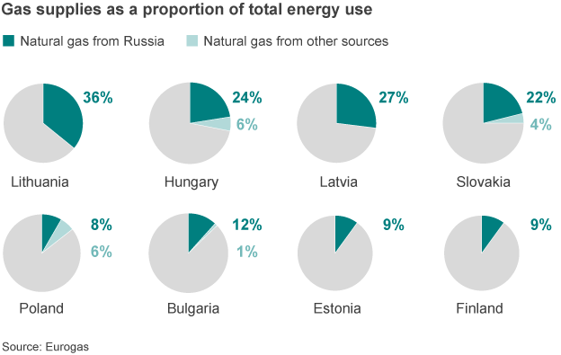
The Baltics, Slovakia and Hungary are among other EU states that rely heavily on Russian supplies.
But the European Commission says if countries work together rather than adopting "purely national measures" then fewer consumers would be hit.
Although Russia can avoid supplying Ukraine directly, several EU countries have passed on part of their gas supply to Ukraine through a process known as reverse flow.

Can Russia avoid sending its gas through Ukraine?
That is what it is trying to do - but it takes time. One of its biggest projects is South Stream, which runs through Bulgaria and Hungary, among a number of EU states.

Can Ukraine get its gas elsewhere?
Since Ukraine's Russian supply was cut off, it has worked hard to find alternative European providers in Germany, the Czech Republic, Slovakia and Poland. Slovakia's Eustream has pledged to provide Ukraine with year while Germany's RWE predicts it will supply a similar amount.
Norway's Statoil has signed a deal but has refused to disclose the volume and cost, apparently to avoid harming its efforts to tap the energy fields of the Arctic. Hungary was also providing Ukraine with gas until it announced in late September it was ending the practice.

How much more does it need?
Ukraine consumes about 50 bn cubic metres (bcm) of gas per year, producing about 20bcm but importing the rest. Gazprom officials believe Ukraine needs 18bcm to heat its population during the winter.
While the figures are unconfirmed, Ukraine's gas transit authority says it has stored 16.7bcm of gas underground.
It has succeeded in buying in supplies from several neighbors but still needs about 5bcm from Russia.

- Energy security depends on adequate, reliable and affordable supply of energy that provides a degree of independence. Explain how this case study demonstrates a lack of energy security for Ukraine.

7.1.A3 Discuss the factors which affect energy security.

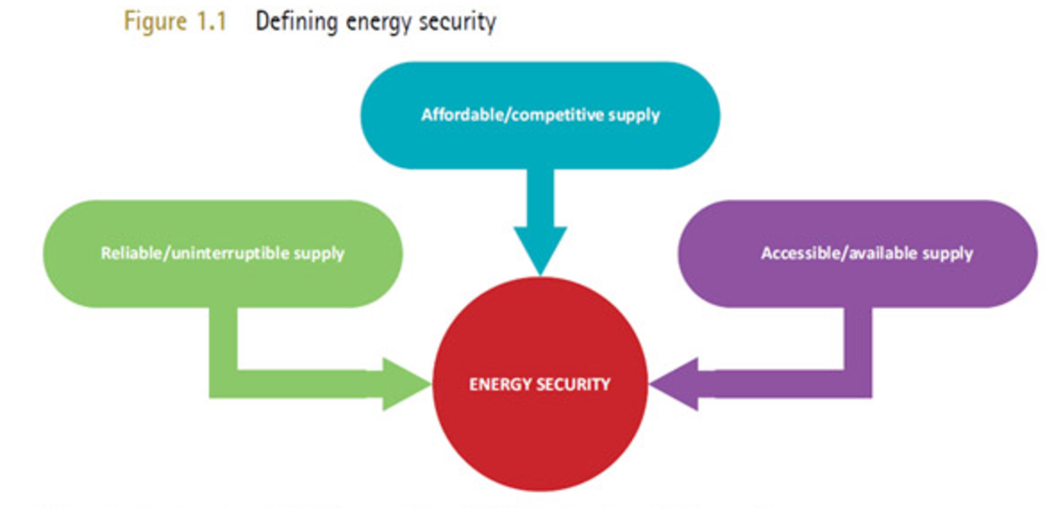

Case Study: United Kingdom

- Gas availability
  - Diminishing North Sea gas, expected to run out within 50 years
  - In 2004, over 90% of the UK’s gas supply was produced in the UK
  - In 2020, the gas supply from the UK is predicted to be less than 10%, with 20% expected to be imported from Norway, 40% from Europe (excluding Norway) and the rest from other parts of the world
  - Lead to decreasing political power of UK and increasing political power of gas rich nations, e.g. Russia (supplies 30% of European gas)

- Oil availability
  - Volatile oil prices
  - Potential for political instability between UK and oil producing states
  - Reached peak oil production in USA in 1970
  - Many argue global peak oil was reached in 2006

- Global warming and renewable energy concerns
  - Restrictions on over use of coal for energy
  - Limited amount of sun for solar panels
  - Concerns over nuclear safety and waste plus cost of building of nuclear plants

Read the article here https://www.theguardian.com/environment/2016/mar/01/uk-energy-policy-is-in-disarray-but-blackouts-are-unlikely and the infographic here https://www.ofgem.gov.uk/publications-and-updates/infographic-energy-security for more details

- Describe how the following three factors are causing uncertainties in the U. K’s energy security using examples from the article and the notes above

Factor | Effect on energy security
Availability of supply
Technological developments
Politics

- Now your turn. The factors: 1) supply and demand, 2) total reserves, 3) geopolitical development, 4) climate change 5) natural disasters
  - Research and identify on named example/country/location
  - State whether the energy security increased or decreased
  - Describe how the factor affected energy security

7.1.U5 Improvements in energy efficiencies and energy conservation can limit growth in energy demand and contribute to energy security.
- Define energy efficiency

- Define energy conservation

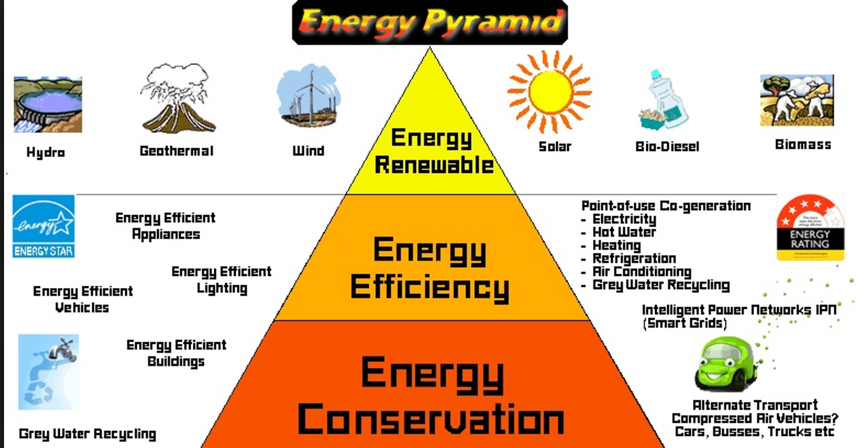

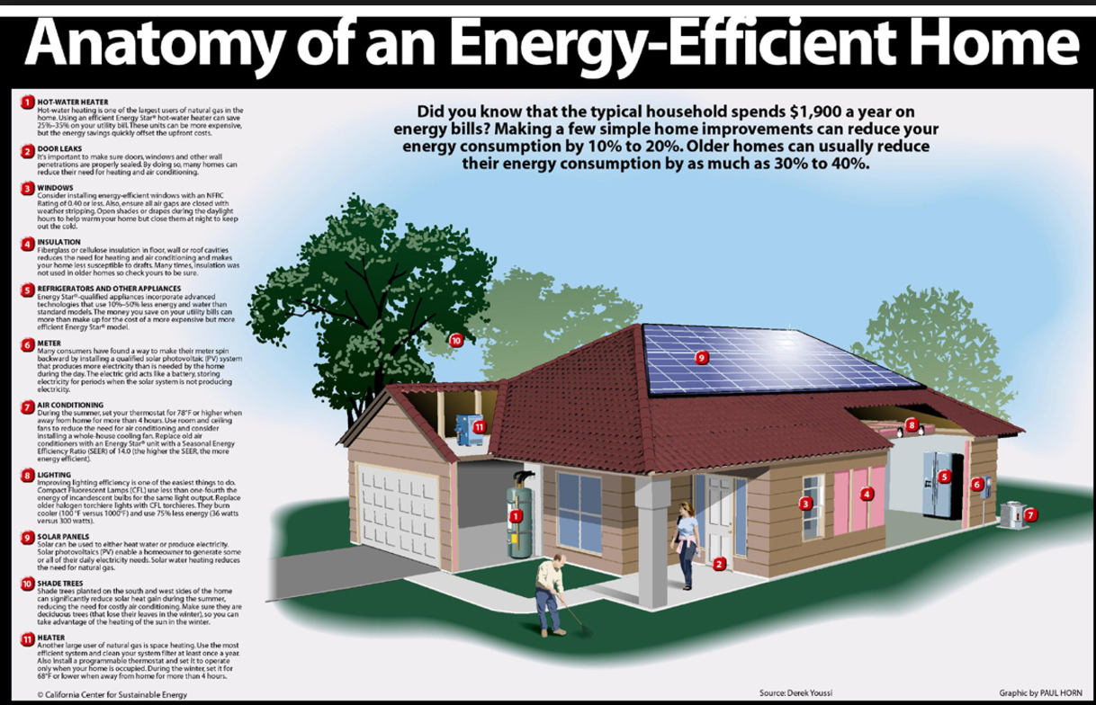
Larger version at http://www.aerosealbygreenhome.com/energy-efficiency/

- What are the benefits and limitations on an individual and a national scale for moving over to more energy efficient technologies?

7.1.A4 Evaluate the energy strategy of a given society.
CASE STUDY: ENERGY STRATEGY OF ICELAND

Video resources:
https://www.youtube.com/watch?v=DLL398lq-es
https://www.youtube.com/watch?v=MG-bXb4jXeU

Adapted from http://www.un.org/esa/agenda21/natlinfo/countr/iceland/energy.pdf
Iceland has abundant renewable energy resources. Its policy is to make the fullest use of these resources in a sustainable manner. This policy has been successful. Today nearly all of Iceland’s electricity and space heating is provided by renewable sources, i.e. hydropower and geothermal energy. This constitutes over 70% of all local energy consumption. The remaining 30% are provided by imported fossil fuels which are used for vehicles, vessels and some industrial processes.

Iceland converted from oil to geothermal district heating during the period 1940 to 1975. Today, 87% of space heating comes from geothermal resources and most of the rest is provided with renewable electricity. The direct utilisation of geothermal heat for district heating is still being increased with the support of the government, which assists small communities in obtaining long-term low interest loans for geothermal development. Iceland is sharing its experience of geothermal development with developing countries through the geothermal department of the University of the United Nations, located in Iceland.

The economic and environmentally viable potential for electrical production from renewable resources in Iceland has been estimated at over 50 TWh/a , of which only 17% have been harnessed. Iceland’s electrical consumption per capita is over 29 MWh/a, the highest in the world. Iceland strives to increase the use of its sustainable energy resources by offering the country as a site for power intensive industries, thus decreasing the global pollution caused by energy production with fossil fuels. This reflects Iceland’s policy of international cooperation for ensuring sustainable use of natural resources, a cornerstone of Iceland’s foreign policy.

The sustainable utilization of renewable energy is a key factor in ensuring a sustainable future of the world economy. Renewable energy is local by nature, but the globalization of the world economy has led to the internationalization of energy use. Products made with energy in one part of the world are consumed in another. The translocation of energy intensive industries to locations with abundant renewable energy resources has become an important task, which cannot be achieved without international cooperation.

Furthermore, Iceland is actively studying means to decrease its reliance on imported fossil fuels by utilizing its sustainable energy resources. Already in the year 1999, Iceland made clear its intention to proceed towards a Sustainable Hydrogen Economy. Hydrogen can be produced with any primary energy source, and its use as an energy carrier could enable Iceland to use its renewable energy to power on-land transportation and fishing vessels.

A public hydrogen fueling station has been built in Reykjavik with three hydrogen fuel cell buses operating as a part of the Ecological City Transport System Project (ECTOS), supported by the European Commission. Other parallel cooperation projects have already been initiated for developing and introducing hydrogen as a fuel carrier for ships and for exploring possibilities of exporting hydrogen.

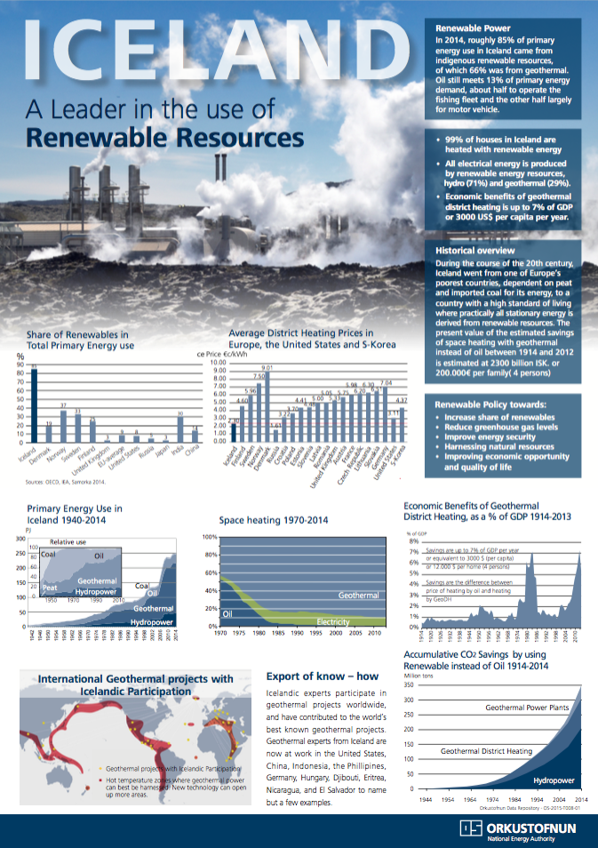

At the same time, Iceland is working on new technologies, which may increase the potential of Iceland’s renewable energy resources. Iceland is starting a deep drilling research program to maximize the utilization of geothermal energy. It is estimated that the energy from geothermal wells can be multiplied by drilling up to 4 – 5000 meter wells, two times deeper than at present. Furthermore, Iceland is mapping its considerable wind energy potential. Wind energy has not yet been used for electricity on the island because of higher cost in comparison with hydro- and geothermal resources.

- Weigh the impact of each of the following factors on Iceland’s energy source
  - Supply and demand
  - Total reserves
  - Geopolitical developments
  - Climate change
  - Natural disasters

ESS can be like learning a new language. So many words are not commonly used in everyday English. This can be challenging. To help you keep up with ESS Terms, you will need to create your own ESS DICTIONARY. You should add to this over the year and keep it in your notebook or on a page file THAT YOU CAN UPDATE AND ADD TO EASILY. Most of the vocabulary words can be found either on your STUDY GUIDE or at mrgscience.com.
You will be responsible for leaning the words and their meaning. Periodic quizzes will be given on the words. So, make your dictionary creative and you will remember the words more easily.

KEY TERMS

tidal

actual supply

reserve

​energy security

carbon emission

solar

renewable

potential supply

production

​thermal efficiency

​low emission

wind

non-renewable

rate of consumption

mineral resource​

​sustainability

​energy independence

hydropower

nuclear power

wind power

geothermal power

economic depletion

government subsidy

natural gas

geothermal

bio-fuel

depletion time

​fracking

​fossil fuel

​coal

