Understandings, Applications and Skills (This is what you maybe assessed on)

Significant ideas
- Climate change has been a normal feature of the Earth’s history, but human activity has contributed to recent changes.
- There has been significant debate about the causes of climate change.
- Climate change causes widespread and significant impacts on a global scale
Big Questions:
What strengths and weaknesses of the systems approach and the use of models have been revealed through this topic? How does a systems approach help our understanding of climate change.
To what extent have the solutions emerging from this topic been directed at preventing environmental impacts, limiting the extent of the environmental impacts, or restoring systems in which environmental impacts have already occurred? Evaluate the success of the Kyoto Protocol in stabilizing global climate change
What value systems can you identify at play in the causes and approaches to resolving the issues addressed in this topic? Explain why there are still uncertainties regarding global climate change
How does your own value system compare with others you have encountered in the context of issues raised in this topic? Evaluate measures of mitigation and adaption.
How are the issues addressed in this topic of relevance to sustainability or sustainable development? Can sustainable development be achieved without a solution to global climate change
In what ways might the solutions explored in this topic alter your predictions for the state of human societies and the biosphere some decades from now? Outline the obstacles to tackling global climate change.
How does a systems approach help our understanding of climate change?
To what extent do we already know the solutions to climate change?
How will we find them/why have they not been implemented?
Why are some sectors of society in denial of climate change? do you agree with them? Give reasons to support your answer.
Examine the links between climate change and sustainability.
Is climate change inevitable? Why?

 | Statement | Guidance
7.2.U1 | Climate describes how the atmosphere behaves over relatively long periods of time, whereas weather describes the conditions in the atmosphere over a short period of time
7.2.U2 | Weather and climate are affected by oceanic and atmospheric circulatory systems
7.2.U3 | Human activities are increasing levels of greenhouse gases (GHGs, such as carbon dioxide, methane and water vapour) in the atmosphere, which leads to:  – an increase in the mean global temperature  – increased frequency and intensity of extreme weather events  – the potential for long-term changes in climate and weather patterns  – rise in sea level. | GHGs are those atmospheric gases that absorb infrared radiation, causing global  temperatures to be higher than they would otherwise be.  Students should be able to distinguish between the natural and the enhanced  greenhouse effect and to identify a variety of human activities that contribute to  GHG emissions. Students must understand the concept of tipping points and how  it might be applied to climate change.
7.2.U4 | The potential impacts of climate change may vary from one location to another and may be perceived as either adverse or beneficial. These impacts may include changes in water availability, distribution of biomes and crop growing areas, loss of biodiversity and ecosystem services, coastal inundation, ocean acidification, and damage to human health.
7.2.U5 | Both negative and positive feedback mechanisms are associated with climate change and may involve very long time lags.
7.2.U6 | There has been significant debate due to conflicting EVSs surrounding the issue of climate change | A minimum of two different viewpoints should be considered
7.2.U7 | Global climate models are complex and there is a degree of uncertainty regarding the accuracy of their predictions
7.2.A1 | Discuss the feedback mechanisms that would be associated with a change in mean global temperature.
7.2.A2 | Evaluate contrasting viewpoints on the issue of climate change. | A minimum of two different viewpoints should be considered
Climate change has been a normal feature of Earth’s history, but human activity has contributed to recent changes
Climate change has been a normal feature of Earth’s history, but human activity has contributed to recent changes
- What is the difference between climate change, global warming and the greenhouse effect

7.2.U1 Climate describes how the atmosphere behaves over relatively long periods of time, whereas weather describes the conditions in the atmosphere over a short period of time

- Complete the table below to define the difference between weather and climate

 | Weather | Climate
Similarities
Differences

- Define climate change

7.2.U2 Weather and climate are affected by oceanic and atmospheric circulatory systems
- Describe how oceanic and atmospheric circulation systems affect weather and climate

- Explain the Hadley Cell Circulation

Go to the NOAA website on El Niño and La Niña. https://oceanservice.noaa.gov/facts/ninonina.html

- What is the El Niño-Southern Oscillation (ENSO) cycle?

- Outline the difference between El Niño and La Niña.

- Describe their different effects on the weather.

- How long do the effects usually last?

- What are the potential impacts of these events on human societies?

7.2.U3 Human activities are increasing levels of greenhouse gases (GHGs, such as carbon dioxide, methane and water vapour) in the atmosphere, which leads to:
- This is a natural process which is responsible for making Earth warm enough to support life. (Mars’ atmosphere does not have enough of these gases to warm the planet significantly, which is why there is no life on Mars.)
- The greenhouse effect is safe and natural. Global warming refers to human-induced changes in the amount of warming, created by the release of different substances into the atmosphere by human activities. You will read/hear/see references to the “enhanced greenhouse effect.” This is the same as human-caused climate change.
- Annotate the diagram below to explain how the greenhouse effect works
Neatly write the following labels onto the diagram in the correct places.

- If there was no atmosphere and the greenhouse effect did not exist, what would the normal temperature of the Earth be?

- Outline the difference between the greenhouse effect and the enhanced greenhouse effect

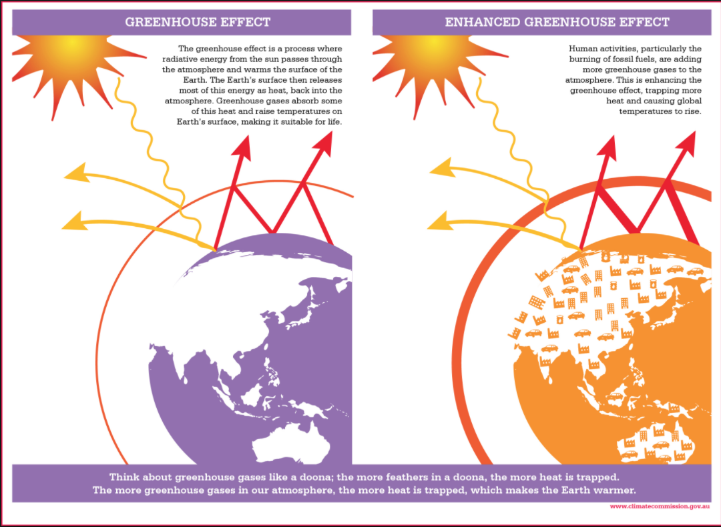

- Identify the main Greenhouse gases and their sources
Greenhouse Gas | Source

- The impact of the GHGs depend on:

- How have human actions enhanced the Greenhouse effect? http://environment.nationalgeographic.com/environment/global-warming/

- What is the ‘Keeling curve´? http://scrippsco2.ucsd.edu/history_legacy/keeling_curve_lessons

- Analyzing Carbon Dioxide emissions
Go to http://cdiac.ornl.gov/trends/co2/sio-baj.html
Make notes on the following
- Station name

- Coordinates:

- Period of record:

- Look at the graphics for overall trends and describe them

- Explain the annual cycles in the data (hint: how does a change in season affect carbon dioxide uptake in plants)

Effect of global warming http://www.epa.gov/climatechange/science/index.html

- How much has our global mean temperature increased in the past 100 years?

- When did the ten warmest years on record occur?

- What year was the warmest year on record?

- What has happened to global sea level over the past century?

- What are the predictions for global temperatures over the next 50 years? 100 years?

7.2.U3 Human activities are increasing levels of greenhouse gases (GHGs, such as carbon dioxide, methane and water vapour) in the atmosphere, which leads to:
– an increase in the mean global temperature
The following table summarizes pages 146-148 in Chapter 7. Make sure you read those pages - they’re probably the most important part of the chapter! I’ve seen those topics in several past IB ESS exams, both as paper 1 and paper 2. You should be able to discuss the effects and the mechanisms/reasons behind each one of these by the time we finish this topic.

Component | Primary Effects | Secondary Effects
oceans and sea levels | - rise in sea levels from  - land ice melts and flows into the ocean, and  - thermal expansion of warmer water | - inundate coastal/low-lying areas  - warmer water absorbs less CO₂ from atmosphere (positive feedback)  - oceans acidified  - plankton life cycles interrupted, affecting marine foodwebs
polar ice caps | - increased melting, total area reduced | - meltwater flows into oceans + dilutes saltwater, disrupting ocean currents (esp. Gulf Stream in Atlantic Ocean)
glaciers | - increased melting  - decreased formation | - short-term increase in meltwater available to human populations  - long-term decrease in same, since fewer/smaller glaciers to melt seasonally
weather patterns | - more violent storms  - maybe more precipitation | - coastal flooding  - maybe longer growing season
agriculture & food production | - increase in photosynthesis  - increase respiration  - No increase in NPP | - expanded growing seasons (growing zones move farther from equator into areas currently too cold to grow much)  - decrease in productivity in tropical areas  - plankton decrease in warmer oceans --> marine productivity/fishing impacts  - How does this impact TZ?
biodiversity and ecosystems | - tundra: permafrost melts, tundra disappears (replaced by taiga)  - alpine ecosystems: ecosystem shifts to higher altitude, driving local extinctions  - coral reefs: increased bleaching, which decreases biodiversity  - deserts: likely to expand with higher evaporation rates  - increase in forest fires  - pests/parasites increase range to new areas | - plankton life cycles interrupted, affecting marine food webs
water supplies | - increased evaporation  - drying rivers and lakes  - refer to glacier melt above
human health | - heat waves --> death rates  - red tides/algae blooms dangerous to people  - increases in asthma and pulmonary diseases  - disease vectors spread to new areas (i.e. malaria zone widens because mosquitoes can live farther north and south
human migration | - 150m people displaced by 2050 (IPCC estimate)  - environmental refugees | - refugees cause economic strain to governments  - tend to be concentrated in LEDCs  - may lead to conflict
economies | - lower heating bills/energy used  - higher cooling bills/energy used  - increased tourism in some areas, lower in others  - damage to coastal zones/increased erosion  - governments invest billions in infrastructure to protect major cities (flood/sea walls, dikes, etc) | - increased ag productivity in some places will help, while decreases in other places will hurt  - infrastructure projects costly to taxpayers, but may provide jobs and new technology

- Correlation vs causation between temperature and greenhouse gas concentrations

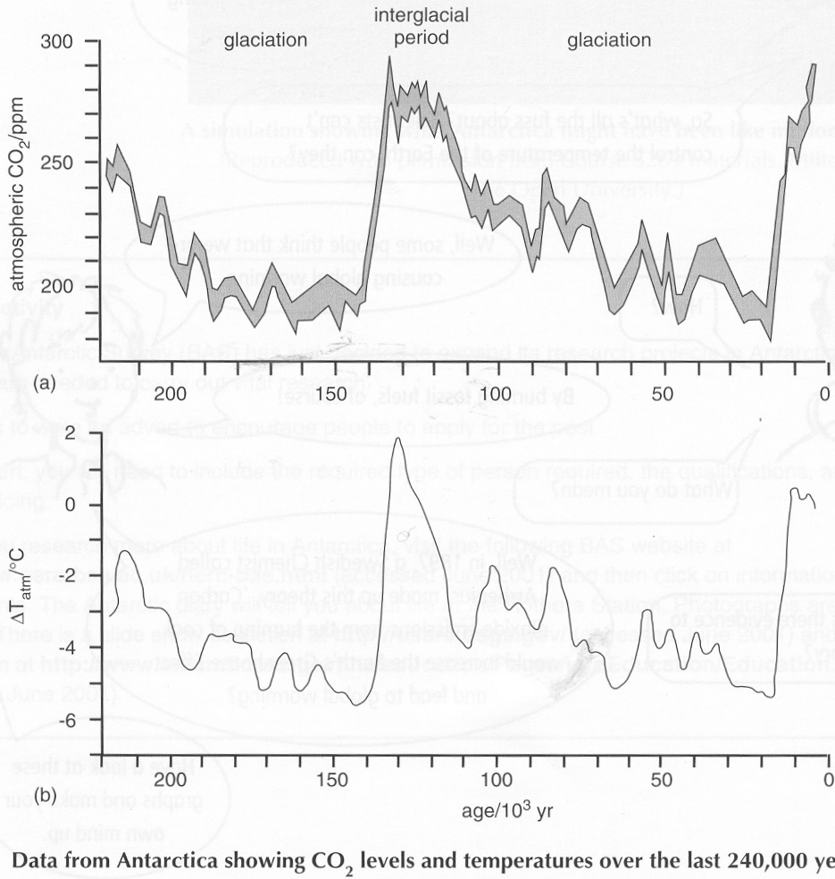
Historically, the main greenhouse gases were water vapor, carbon dioxide, nitrous oxide and methane.

Evidence for the link between the concentration of carbon dioxide in the atmosphere and global mean temperatures over the last quarter of a million years is shown in the graphs. Similar data exists going back hundreds of millions of years.

- How was this data collected?

- What conclusion can you draw from the two graphs?

Recent evidence for global warming
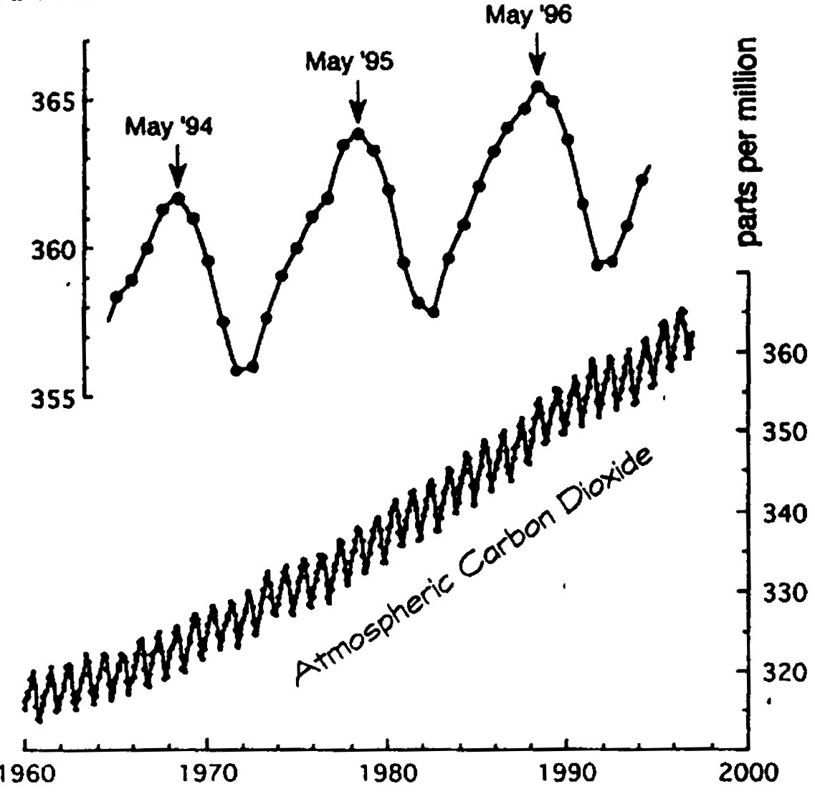
The following graph shows data collected at one of the most unpolluted places on Earth, Mauna Loa, Hawaii in the middle of the Pacific Ocean.

- What is the increase in mean CO2 concentration in the last 40 years?

Look at the more detailed inset.
- Why do CO₂ levels decrease between May and September every year?

- Why do the CO₂ levels climb higher each year from October until May?

Global mean temperatures since the Industrial Revolution

The graph below shows the Central England Temperatures, or CET data, which go back to 1660 when thermometers were first used.

The 20th century has clearly had the warmest in recent history. In the last 100 years the average temperature has increased by 0.6°C, but this warming has speeded up, jumping 0.5°C in the last 25 years. The 10 hottest years since records began have been since 1990. Computer modelling is now used to predict future temperature increases, which currently are between 1.4 – 5.8°C.

What evidence is there that methane, nitrous oxide and CFC-11 may also be contributing to global warming? Look at the graphs on the front cover.

7.2.U3 Human activities are increasing levels of greenhouse gases (GHGs, such as carbon dioxide, methane and water vapour) in the atmosphere, which leads to:
– increased frequency and intensity of extreme weather events

- Give a named example of an extreme weather event and its consequences

7.2.U3 Human activities are increasing levels of greenhouse gases (GHGs, such as carbon dioxide, methane and water vapour) in the atmosphere, which leads to:
– the potential for long-term changes in climate and weather patterns

- Give a named example of a long-term climate or weather pattern change and its consequences

7.2.U3 Human activities are increasing levels of greenhouse gases (GHGs, such as carbon dioxide, methane and water vapour) in the atmosphere, which leads to:
– rise in sea levels

- Give a named example of the consequences of a rise in sea level

7.2.U3 Human activities are increasing levels of greenhouse gases (GHGs, such as carbon dioxide, methane and water vapour) in the atmosphere, which leads to:
- Complete the table below outlining human activities which produce and release greenhouse gases. (Table source: http://www.epa.gov/climatechange/science/indicators/ghg/index.html)
Greenhouse gas | How it is produced | Average lifetime in the atmosphere | 100-year global warming potential
Carbon dioxide

Methane
Nitrous oxide
Fluorinated gases

Also make sure you consult Table 7.1 on p.137 and compare it to the table above.
A note about CFCs, ozone, and global warming: You’ll see CFCs and ozone listed in both of the tables mentioned. Don’t confuse the issues of stratospheric ozone depletion with global warming! Both CFCs and ozone do in fact act as GHGs, but their impact on UV radiation levels is more significant within the context of this ESS course.
- Why is water vapor seldom mentioned as a greenhouse as?

7.2.U4 The potential impacts of climate change may vary from one location to another and may be perceived as either adverse or beneficial. These impacts may include changes in water availability, distribution of biomes and crop growing areas, loss of biodiversity and ecosystem services, coastal inundation, ocean acidification, and damage to human health.
- Use the study guide, the website https://www.epa.gov/climate-impacts and p333-335 of your textbook to summarize the impacts of climate change for each of the factors listed
Activity | Advantages of global warming | Disadvantages of global warming
Oceans and sea levels
Polar ice caps
Glaciers
Weather patterns
Food production
Biodiversity and ecosystems
Water supplies
Human health
Human migration
National economies

Climate change causes widespread and significant impacts on a global scale
- List the 3 broad global warming board categories

The systems diagram below was produced by the UN’s IPCC and does an excellent job of showing the inputs, outputs, and relationships among human activities, climate change processes, climate characteristics, and threats to human populations and ecosystems. I recommend studying it extensively.
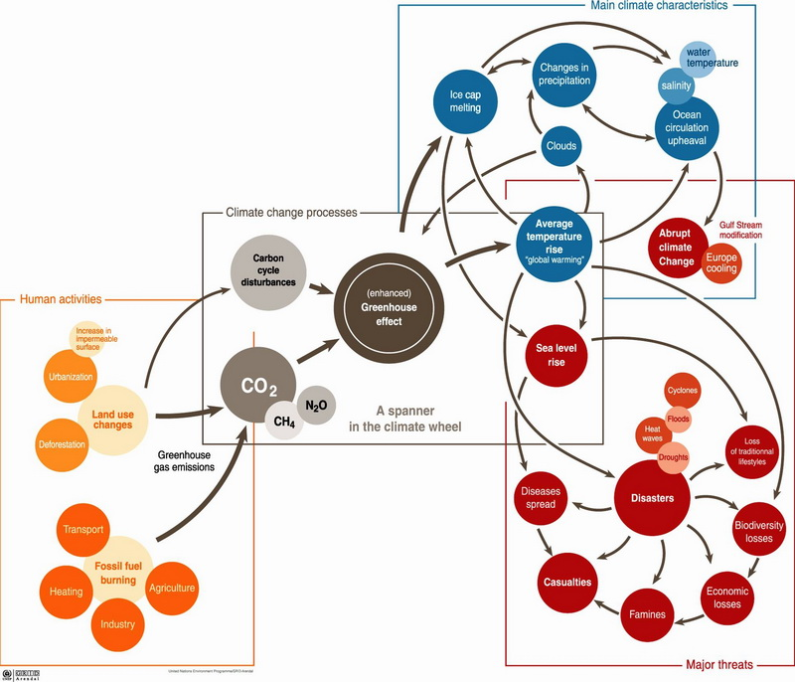 (Image source: http://www.suratclimatechange.org/upload/image/climate_change.jpg)

- Reference the infographic found at https://bifrostonline.org/economic-impacts-of-climate-change-by-country/

What is the Annual GDP loss in
China

United States

South Africa

7.2.U5 Both negative and positive feedback mechanisms are associated with climate change and may involve very long time lags.
7.2.A1 Discuss the feedback mechanisms that would be associated with a change in mean global temperature.
Review of feedback
The changes associated with global warming are long-term and are most easily understood in terms of feedback.
Feedback is the return of part of the output from a system as input, so as to affect succeeding outputs.
There are two kinds of feedback:
- Negative feedback is feedback that tends to reduce or counteract any deviation from an equilibrium, and promotes stability. For example, increased evaporation in tropical latitudes leads to increased snowfall on the polar ice caps, which reduces the mean global temperature.
- Positive feedback is feedback that amplifies or increases change; it leads to exponential deviation away from an equilibrium. For example, increased thawing of permafrost leading to an increase in methane levels, which increases the mean global temperature.

NOTE: Remember that many of the feedback mechanisms are happening simultaneously

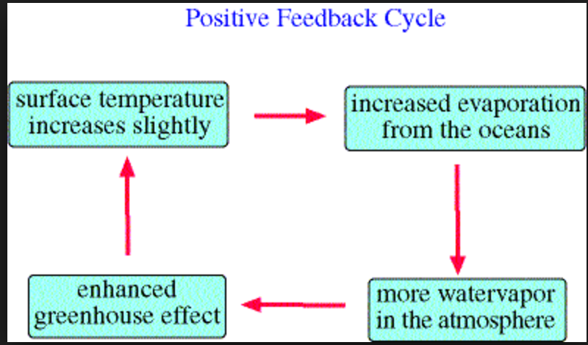
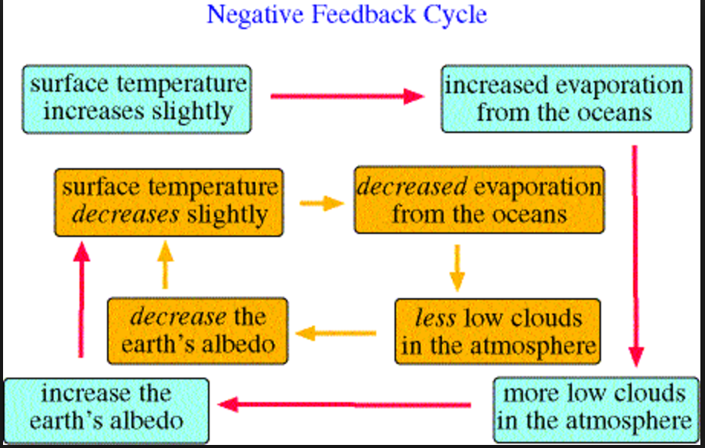

- On the following pages, sketch a feedback cycle for each of the feedback mechanisms stated below in the space provided

Feedback loop | Positive feedback or amplified change | Negative feedback or dampened down change
Oceans | - Oceans are a carbon sink  - Release CO₂ as they warm up  - Stalling of North Atlantic Drift could reduce heat transfer to the north and increase temperatures dramatically | - Oceans absorb more CO₂ in warmer water  - Phytoplankton photosynthesise faster  - Rate of reproduction increases  - More CO₂ absorbed
Clouds | - More evaporation  - More clouds  - More heat trapped | - More evaporation  - More clouds  - More heat reflected
Pollution | - At night cloud formation is increased by aerosols  - Traps heat  - More clouds  - More heat trapped  - Black soot falls on ice  - Albedo effect increased  - Increased heat absorption  - Increased temperature  - melting | - Aerosols (particularly sulphates) form condensation nuclei  - More clouds form  - Heat reflected  - Albedo increases  - Reduced warming during day
Polar ice | - Ice has high albedo  - Heat and light reflected  - Ice melts  - Sea and land have lower albedo  - More heat absorbed  - More ice melts | - Warm air carries more water vapour  - More precipitation (snow)  - More reflection  - Lower temperatures  - More snow
Forests | - Forests cut and burned  - Less carbon absorbed  - More CO₂ in atmosphere  - Higher temperatures  - Forests die or catch fire  - More CO₂ released  - Temperature rises | - CO₂ absorbed as forests act as carbon sink  - CO₂ removed from atmosphere  - Temperature rise decreases
Tundra | - Temperatures rise  - Permafrost melts  - CO₂ released from frozen soil  - Methane also released

Read the following article and highlight instances of positive feedback. Draw a diagram to summarize the links.
Feedbacks that could be paybacks
Particularly alarming are the possibilities of indirect effects of global warming that could further accelerate climatic changes. These are known as ‘positive feedbacks’ and so far, they have not been adequately accounted for in the climate models.
With the warming of the oceans and the surface air above them, evaporation would increase, increasing the amount of water vapor in the air. Water vapor is in fact the most potent natural greenhouse gas, and any increase, caused indirectly by warming due to increases in other greenhouse gas concentrations, would further trap heat. Frank Wentz, a physicist at Remote Sensing Systems of Santa Rosa, California, analyzed data from three NASA satellites to come up with the alarming conclusion that this feedback has already begun. During the 1990s he found the amount of water vapor in the atmosphere had gone up by two per cent.
Once positive feedbacks are triggered, they could go on to trigger others, leading to runaway warming — the models may not predict it but that it is possible cannot be denied. Here is a hypothetical but not entirely improbable doomsday scenario. As greenhouse gases build up in the atmosphere, temperatures rise. Forests begin to dry and die back or burn. Felling continues apace, diminishing forests’ ability to fix atmospheric carbon dioxide. Areas under ice melt to expose the Earth below, which begins to soak up the sun’s heat instead of reflecting it. Long-frozen dead tundra vegetation begins to decompose releasing more carbon dioxide and methane. The seas, swollen by rising temperatures and melting polar ice, swallow densely populated coastal regions. With warming seas also begin to lose their ability to absorb carbon dioxide and could start releasing the gas already dissolved in them — estimated at 50 times the amount contained in the atmosphere... and so on. As vicious circles go this one is hard to beat.
As the 20th century closed, the warming speeded up, with average global temperatures jumping 0.5°C in the last 25 years. This would be the equivalent of 2°C per century. However, the amount of change to which ecosystems can adapt is estimated at a maximum of 1°C over a century. And that is if no further changes are expected. But as Thomas Karl, director of the National Climate Data Centre put it, ‘We are already experiencing the rate of warming predicted right through this coming century. And there could be worse to come, as today’s effects are believed to be mainly the work of carbon dioxide emitted half a century ago. The much higher levels of emissions today are damage we are storing up for the future. Also, to be factored into the equation are the effects of sulfate aerosols, by-products of industrial pollution which have masked the greenhouse effect by their cooling properties. But they have a short atmospheric lifetime and as cleaner production processes become more desirable in our increasingly polluted world, their role could well decline, revealing the true extent of warming.

7.2.U6 There has been significant debate due to conflicting EVSs surrounding the issue of climate change
7.2.A2 Evaluate contrasting viewpoints on the issue of climate change.
33. Summarize the viewpoints of the following EVS models when discussing climate change

Model | Summary
Ecocentric
Technocentric
Anthropocentric

7.2.U7 Global climate models are complex and there is a degree of uncertainty regarding the accuracy of their predictions

- Describe how a global climate change model is used to predict future trends

- List some of the issues with global climate modelling using the sources below:
- http://oceanservice.noaa.gov/education/pd/climate/factsheets/howreliable.pdf
- https://www.theguardian.com/environment/climate-consensus-97-per-cent/2015/jul/31/climate-models-are-even-more-accurate-than-you-thought

ESS can be like learning a new language. So many words are not commonly used in everyday English. This can be challenging. To help you keep up with ESS Terms, you will need to create your own ESS DICTIONARY. You should add to this over the year and keep it in your notebook or on a page file THAT YOU CAN UPDATE AND ADD TO EASILY. Most of the vocabulary words can be found either on your STUDY GUIDE or at mrgscience.com.
You will be responsible for leaning the words and their meaning. Periodic quizzes will be given on the words. So, make your dictionary creative and you will remember the words more easily.
KEY TERMS

carbon trading

thermal expansion

greenhouse effect

gas model

CFC

carbon tax

global dimming

negative feedback

carbon trading

​global warming

solar radiation

coastal inundation

mean global temperature

greenhouse gases

positive feedback

tropospheric heating

general circulation model

carbon offset scheme

​Hadley cells

natural greenhouse effect

enhanced greenhouse effect

time lags

methane

climate

radiant energy

fossil fuel

renewable

CO2 effect

anaerobic activity

coral bleaching

permafrost

carbon dioxide

carbon footprint

water vapor

combustion

correlation

ice albedo

acidification

heatwave

polar ice caps

pollution

methane

nitrous oxide

deforestation

IPCC

Migration

Renewable

​mass transit

