Understandings, Applications and Skills (This is what you may be assessed on)

Significant ideas
- Mitigation attempts to reduce the causes of climate change.
- Adaptation attempts to manage the impacts of climate change.
Big Questions:
- What strengths and weaknesses of the systems approach and the use of models have been revealed through this topic? How does a systems approach help our understanding of climate change?
- To what extent have the solutions emerging from this topic been directed at preventing environmental impacts, limiting the extent of the environmental impacts, or restoring systems in which environmental impacts have already occurred?: Evaluate the success of the Kyoto Protocol in stabilizing global climate change
- What value systems can you identify at play in the causes and approaches to resolving the issues addressed in this topic? Explain why there are still uncertainties regarding global climate change
- How does your own value system compare with others you have encountered in the context of issues raised in this topic? Evaluate measures of mitigation and adaptation.
- How are the issues addressed in this topic of relevance to sustainability or sustainable development? Can sustainable development be achieved without a solution to global climate change?
- In what ways might the solutions explored in this topic alter your predictions for the state of human societies and the biosphere some decades from now? Outline the obstacles to tackling global climate change
- How do models and systems approach help our understanding of climate mitigation and adaptation?
- How far do we already know the answers to climate mitigation and adaptation?
- In what ways do different people/societies consider climate mitigation and adaptation?
- What do you think is the best way forward? Justify your answer
- Which is more sustainable - mitigation or adaptation?
- How might the solutions to climate change evolve in the future?

 | Statement | Guidance
7.3.U1 | Mitigation involves reduction and/or stabilization of GHG emissions and their removal from the atmosphere. | Mitigation is the use of technology and substitution to reduce resource inputs and  emissions per unit of output.
7.3.U2 | Mitigation strategies to reduce GHGs in general may include:  – reduction of energy consumption  – reduction of emissions of oxides of nitrogen and methane from agriculture  – use of alternatives to fossil fuels  – geo-engineering.
7.3.U3 | Mitigation strategies for carbon dioxide removal (CDR techniques) include:  – protecting and enhancing carbon sinks through land management; for example, through the UN collaborative programme on reducing emissions from deforestation and forest degradation in developing countries (UNREDD)  -using biomass as a fuel source  – using carbon capture and storage (CCS)  – enhancing carbon dioxide absorption by the oceans through either fertilizing oceans with compounds of nitrogen, phosphorus and iron to encourage the biological pump, or increasing upwellings to release nutrients to the surface. events  – the potential for long-term changes in climate and weather patterns  – rise in sea level. | CCS is carried out by carbon dioxide being compressed, transported and stored  permanently underground (geological sites used as repositories) or chemically fixed  to form a carbonate.
7.3.U4 | Even if mitigation strategies drastically reduce future emissions of GHGs, past emissions will continue to have an effect for decades to come.
7.3.U5 | Adaptation strategies can be used to reduce adverse affects and maximize any positive effects. Examples of adaptations include flood defences, vaccination programmes, desalinization plants and planting of crops in previously unsuitable climates. | Adaptation is the adjustment of natural or human systems in response to actual or  expected climatic stimuli or their effects, which either moderates harm or exploits  beneficial opportunities.
7.3.U6 | Adaptive capacity varies from place to place and can be dependent on financial and technological resources. MEDCs can provide economic and technological support to LEDCs.
7.3.U7 | There are international efforts and conferences to address mitigation and adaptation strategies for climate change; for example, the Intergovernmental Panel on Climate Change (IPCC), National Adaptation Programmes of Action (NAPAs) and the United Nations Framework Convention on Climate Change (UNFCCC).
7.3.A1 | Discuss mitigation and adaptation strategies to deal with impacts of climate change. | Two mitigation and two adaptation strategies should be considered
7.3.A2 | Evaluate the effectiveness of international climate change talks.

7.3.U1 Mitigation involves reduction and/or stabilization of GHG emissions and their removal from the atmosphere.
- Describe the term mitigation

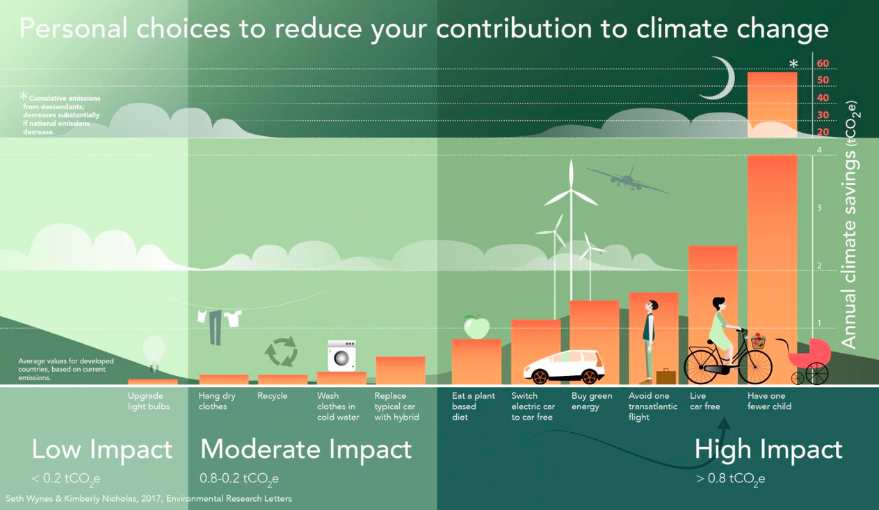
- These strategies show different ways to reduce greenhouse emissions, but how does one remove gasses from the atmosphere?

- Use the app at https://creately.com/app/?tempID=hp2c01jf1&login_type=demo# to draw a Venn diagram that summarizes the similarities and differences between mitigation and adaptation strategies in response to climate change.
Paste your diagram into the space below.

7.3.U2 Mitigation strategies to reduce GHGs in general may include:
  - reduction of energy consumption
  - reduction of emissions of oxides of nitrogen and methane from agriculture
  - use of alternatives to fossil fuels
  - geo-engineering.

- Mitigation strategies often involve attempts to reduce the release of greenhouse gasses into the atmosphere. The table below lists some of the ways that greenhouse gas levels could be reduced. For each one add at least two more suggestions as to how these ideas might be implemented.
  - Reduce energy consumption
  - Reduce agriculture methane emissions
  - Reduce oxides of nitrogen emissions
  - Use alternatives to fossil fuels
  - Geo-engineering

- Look at your examples above and decide which environmental value system is reflected in each one.

- The table below lists some of the ways that greenhouse gas levels could be reduced. For each one add suggestions as to how these ideas might be implemented.
Strategy | Example
Reduce Energy Consumption

Reduce agriculture methane emissions

Reduce oxides of nitrogen emissions

Use alternatives to fossil fuels ( Identify if they are zero-or low CO₂ sources)

Geo-engineering

- Go to the CCAFS website. https://ccafs.cgiar.org/bigfacts/#theme=food-emissions&subtheme=direct-agriculture. Identify three emissions from agricultural soils and three emissions from livestock emissions

- Watch the video on geoengineering. https://www.youtube.com/watch?v=E_6n-ROdL3g. Outline some of the issues involved with geoengineering

7.3.U3 Mitigation strategies for carbon dioxide removal (CDR techniques) include:
– protecting and enhancing carbon sinks through land management; for example, through the UN collaborative programme on reducing emissions from deforestation and forest degradation in developing countries (UNREDD)
-using biomass as a fuel source
– using carbon capture and storage (CCS)
– enhancing carbon dioxide absorption by the oceans through either fertilizing oceans with compounds of nitrogen, phosphorus and iron to encourage the biological pump, or increasing upwellings to release nutrients to the surface.
7.3.U4 Even if mitigation strategies drastically reduce future emissions of GHGs, past emissions will continue to have an effect for decades to come.
- Describe what is meant by the term “mitigation” with regards to climate change.

- Carbon dioxide removal (CDR) is potentially a useful way to mitigate climate change. Summarize the following CDR techniques.
CDR technique | Example
Protecting/enhancing carbon sinks

Bio-fuels

Carbon capture storage

Enhancing ocean absorption

- EvWatch the video clip on UN-REDD https://www.youtube.com/watch?v=9JME_JpwQ-U Identify how UN-REDD is a mitigation strategy.

- Consider these critical elements using biomass as a fuel source as a climate change mitigation strategy
- How quickly can biomass crops be grown?
- What are CO2 emissions from the biomass production cycle (i.e. fertilizer production)?
- How much land is needed to grow biomass fuel crops?
- How does this cycle impact food production systems?

- Describe the advantages of Biochar https://regenerationinternational.org/2018/05/16/what-is-biochar/

- Watch this video on biological pumps or marine carbon cycles.. https://vimeo.com/162911910 Describe how to enhance carbon dioxide absorption by oceans

7.3.U5 Adaptation strategies can be used to reduce adverse affects and maximize any positive effects. Examples of adaptations include flood defences, vaccination programmes, desalinization plants and planting of crops in previously unsuitable climates.
7.3.U6 Adaptive capacity varies from place to place and can be dependent on financial and technological resources. MEDCs can provide economic and technological support to LEDCs.
7.3.A1 Discuss mitigation and adaptation strategies to deal with impacts of climate change.

- Describe what is meant by the term “adaptation” with regards to climate change.

- Explain what is meant by the term “adaptive capacity”

- Even if mitigation strategies drastically reduce future emissions of GHGs, past emissions will continue to have an effect for decades to come. Describe possible strategies of adaptation to climate change
Adaptation | Strategies
Vaccination

Flood defense

Desalinization

New crop locations

New crop types

Weather control

Migrate

Examples of planned adaptations by the economic sector.

https://www.ipcc.ch/site/assets/uploads/2018/02/WGIIAR5-Chap10_FINAL.pdf

https://energy.techno-science.ca/en/climate-101-climate-change-mitigation-and-adaptation.php

https://ec.europa.eu/clima/policies/adaptation_en

Selected a named country. Consider the following factors when you discuss your strategies.
- Cost/benefit analysis at national level
- MEDC vs LEDC practicality
- Degree of personal behavior change required
- Political implications
- Impact on international economic competitiveness
- Remove carbon dioxide from the atmosphere

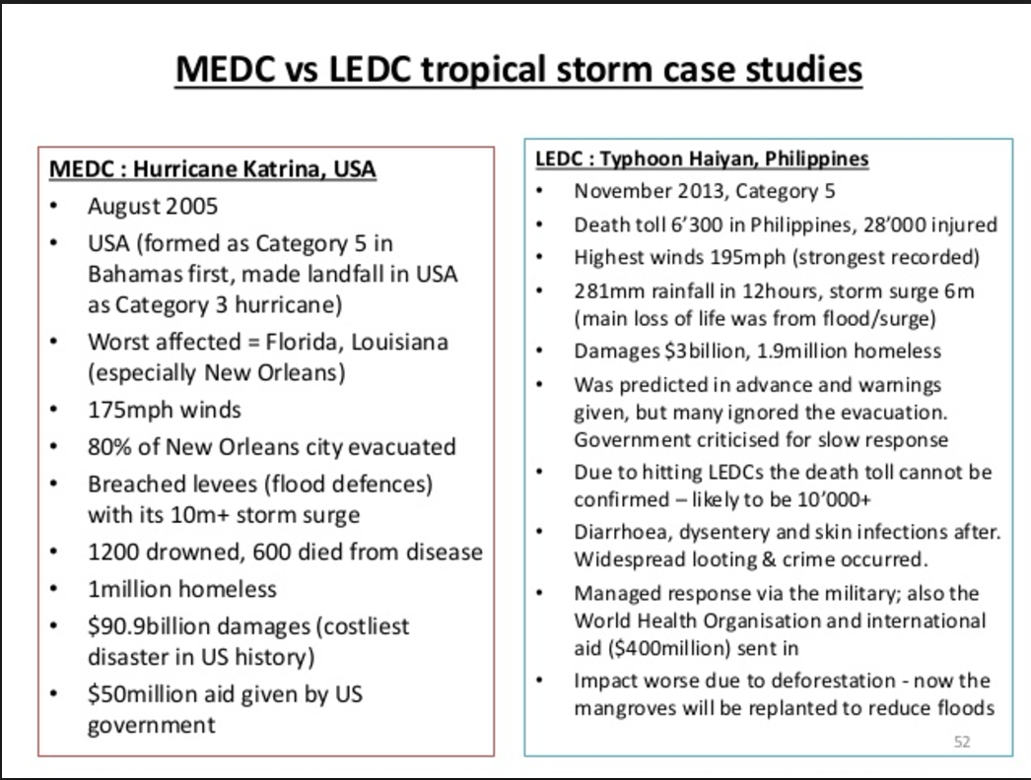

7.3.U7 There are international efforts and conferences to address mitigation and adaptation strategies for climate change; for example, the Intergovernmental Panel on Climate Change (IPCC), National Adaptation Programmes of Action (NAPAs) and the United Nations Framework Convention on Climate Change (UNFCCC).
7.3.A2 Evaluate the effectiveness of international climate change talks.
- Explain why international efforts to tackle climate change are necessary.

- Complete the information below to summarize the details and work of the IPCC. (https://www.ipcc.ch/)

Full title for the IPCC

Established in the year

Established by

Number of climatologists involved

Main activity

Years in which reports were published

- Read up on the 1997 Kyoto Protocol and the Intergovernmental Panel on Climate Change (IPCC). I’ve provided some links below for you to check out on your own.
    - Official IPCC home page - http://www.ipcc.ch/
    - UNEP maps and graphics library - http://www.grida.no/graphicslib/
    - A collection of resources dedicated to climate change and the Kyoto protocol - http://www.kyotoprotocol.com/
    - The UN Framework Convention on Climate Change (UNFCCC) - http://unfccc.int/kyoto_protocol/items/2830.php

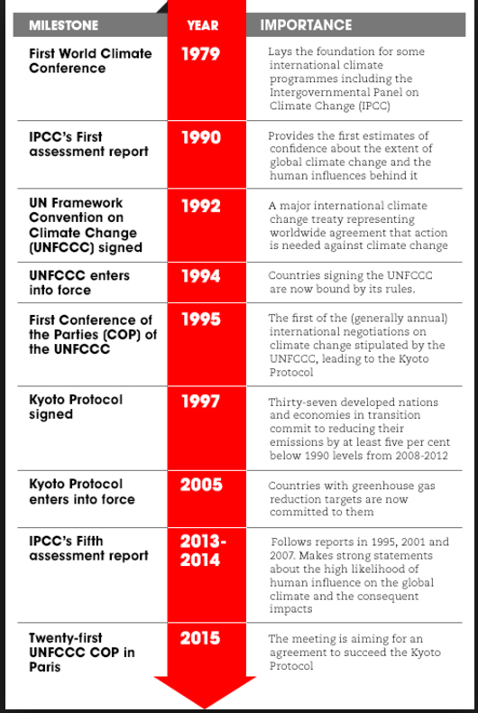
You should evaluate these strategies with regard to their effectiveness and the implications for MEDCs and LEDCs of reducing CO₂ emissions in terms of economic growth and national development
- A full ratified Kyoto Protocol would achieve a reduction of warming around 0.5 degrees
- Concerns about fair target settling between MEDCs and LEDCs continue to cause disagreement
- International agreements affect large numbers of people
- Countries may not sign or agree to international agreements
- Concerns about the economic cost and impacts on development are widespread
- Carbon storage in ecosystems are not well understood and difficult to monitor
- Simulated volcanic eruptions are unpredictable and could damage the ozone layer
- Adaptation methods do not require international cooperation
- Emission mitigation attempts over two decades appear to have failed

  - The United States under President Trump withdrew from the 2015 Paris agreement. It’s just one country. How does that decision impact the overall effectiveness of the agreement?

  - How do other commitments on national or local levels impact climate change, either positively or negatively?

  - What can you do in your own life to affect local greenhouse emissions?

- . In the space below, draw a timeline of major international commitments for tackling climate change.

ESS can be like learning a new language. So many words are not commonly used in everyday English. This can be challenging. To help you keep up with ESS Terms, you will need to create your own ESS DICTIONARY. You should add to this over the year and keep it in your notebook or on a page file THAT YOU CAN UPDATE AND ADD TO EASILY. Most of the vocabulary words can be found either on your STUDY GUIDE or at mrgscience.com.
You will be responsible for learning the words and their meaning. Periodic quizzes will be given on the words. So, make your dictionary creative and you will remember the words more easily.

KEY TERMS

carbon trading

​global dimming

geoengineering

carbon offset scheme

adaptation capacity

​carbon capture

migration

microgeneration

Biochar

community energy

Carbon Dioxide Removal (CDR) techniques

Carbon Capture and Storage (CCS)

