Understandings, Applications and Skills (This is what you may be assessed on)

Significant ideas
- A variety of models and indicators are employed to quantify human population dynamics.
- Human population growth rates are impacted by a complex range of changing factors.
Big Questions:
- What strengths and weaknesses of the systems approach and the use of models have been revealed through this topic?
- To what extent have the solutions emerging from this topic been directed at preventing environmental impacts, limiting the extent of the environmental impacts, or restoring systems in which environmental impacts have already occurred?
- What value systems can you identify at play in the causes and approaches to resolving the issues addressed in this topic?
- How does your own value system compare with others you have encountered in the context of issues raised in this topic?
- How are the issues addressed in this topic of relevance to sustainability or sustainable development?
- In what ways might the solutions explored in this topic alter your predictions for the state of human societies and the biosphere some decades from now?
- How do models help our understanding of human dynamics?
- To what extent have population policies been effective in their aims?
- How do environmental value systems affect population dynamics? Give examples to support your answer.
- What are your views on these?
- Examine the relationship between population dynamics related to sustainable development.

 | Statement | Guidance
8.1.U1 | Demographic tools for quantifying human population include crude birth rate (CBR), crude death rate (CDR), total fertility rate (TFR), doubling time (DT) and natural increase rate (NIR).
8.1.U2 | Global human population has followed a rapid growth curve, but there is uncertainty as to how this may be changing.
8.1.U3 | As the human population grows, increased stress is placed on all of the Earth’s systems.
8.1.U4 | Age–gender pyramids and demographic transition models (DTM) can be useful in the prediction of human population growth. The DTM is a model that shows how a population transitions from a pre-industrial stage with high CBRs and CDRs to an economically advanced stage with low or declining CBRs and low CDRs. | A variety of predictive models could be included, such as computer  simulations, statistical and/or demographic tables for LEDCs and MEDCs,  age–gender pyramids, and graphical extrapolation of population curves.
8.1.U5 | Influences on human population dynamics include cultural, historical, religious, social, political and economic factors.
8.1.U6 | National and international development policies may also have an impact on human population dynamics. | Development policies may increase or decrease population growth.  – CBRs and growth rates are reduced through educating of women for  greater independence (economic and reproductive), stimulation of economic growth to improve economic welfare and give greater economic independence, mechanization of the agricultural sector and subsequent urbanization.  – Growth rates may increase if CDRs fall as a result of improved public health, sanitation, and service infrastructure.
8.1.A1 | Calculate values of CBR, CDR, TFR, DT and NIR
8.1.A2 | Explain the relative values of CBR, CDR, TFR, DT and NIR.
8.1.A3 | Analyse age–gender pyramids and diagrams showing demographic transition models
8.1.A4 | Discuss the use of models in predicting the growth of human populations.
8.1.A5 | Explain the nature and implications of growth in human populations.
8.1.A6 | Analyse the impact that national and international development policies can have on human population dynamics and growth.
8.1.A7 | Discuss the cultural, historical, religious, social, political and economic factors that influence human population dynamics.

8.1.U1 Demographic tools for quantifying human population include crude birth rate (CBR), crude death rate (CDR), total fertility rate (TFR), doubling time (DT) and natural increase rate (NIR).
8.1.A1 Calculate values of CBR, CDR, TFR, DT and NIR
8.1.U2 Global human population has followed a rapid growth curve, but there is uncertainty as to how this may be changing.
8.1.A2 Explain the relative values of CBR, CDR, TFR, DT and NIR.
- Watch the video on Human Populationhttps://www.youtube.com/watch?v=PUwmA3Q0_OE. Suggest factors that influenced human population and growth.

- Standing shoulder to shoulder all 7 billion of us would fill the city of Los Angeles. So, if space isn’t the issue, what is?

- Watch the video The World’s Most Typical Person (National Geographic) https://www.youtube.com/watch?v=4B2xOvKFFz4. Describe the appearance of the world’s most typical person. (handedness – left/right? salary? male/female? age? ethnicity? height? life expectancy?

- Discuss your reaction to the video segment.

Some interesting sites to check out:
- http://www.worldometers.info/watch/world-population/ - see every person in the world
- http://app.thefacesoffacebook.com/ - every Facebook profile picture
- https://ourworldindata.org/world-population-growth/ - lots of data on human growth

- Complete the table below:
 | Definition | Factors influencing
Demographics

Crude Birth Rate (CBR)

Crude Death Rate (CDR)

Natural Increase Rate (NIR)

Total Fertility Rate (TFR)

Doubling Time (DT)

- Identify how gender inequality women will influence birth rates

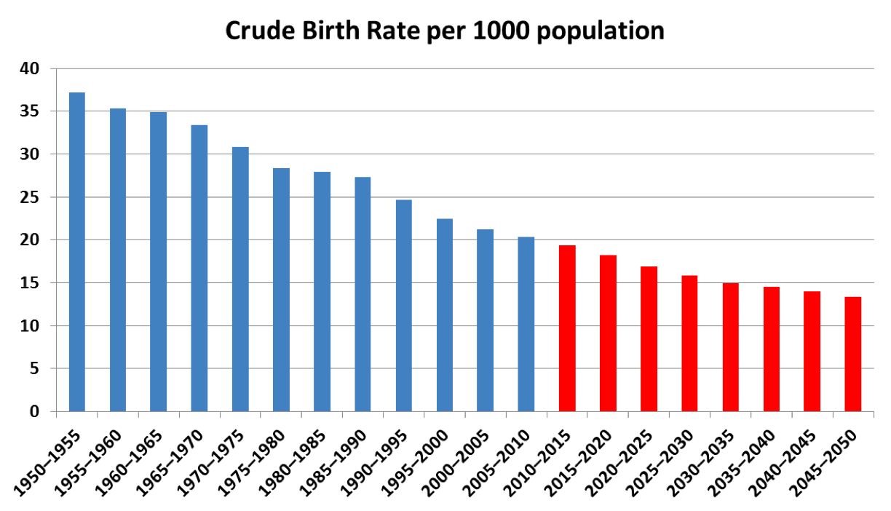
- Describe the CBR trend shown in the graph and suggest two reasons for this pattern

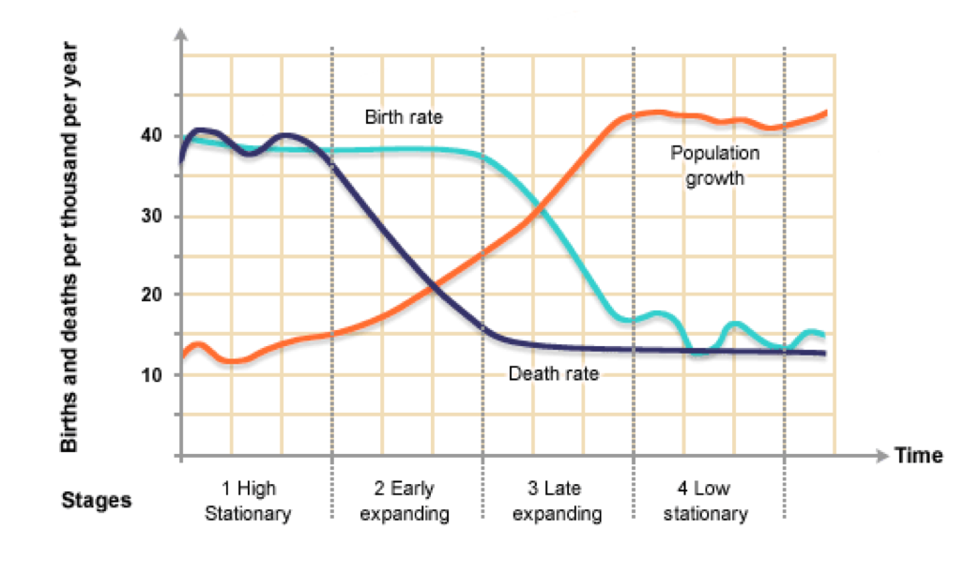
- Explain why there is a time lag between the CDR and CBR in the graph

- Write out the formulas for Crude Birth Rate, Crude Death Rate, Total Fertility Rate, Natural Increase Rate and Doubling Time

- The ICPD was the first international conference to speak out plainly against it, calling on the international community to eliminate the practice, which it stressed, violates basic human rights and constitutes a lifelong risk to women's health. Visit www.unfpa.org for more information.
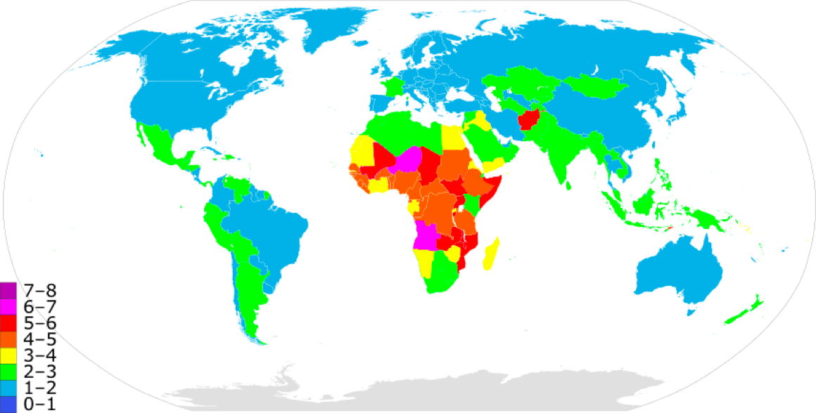
  - List four reasons why educating women will reduce fertility/birth rate.

  - Using named examples, state a pattern or trends which is evident in the map shown

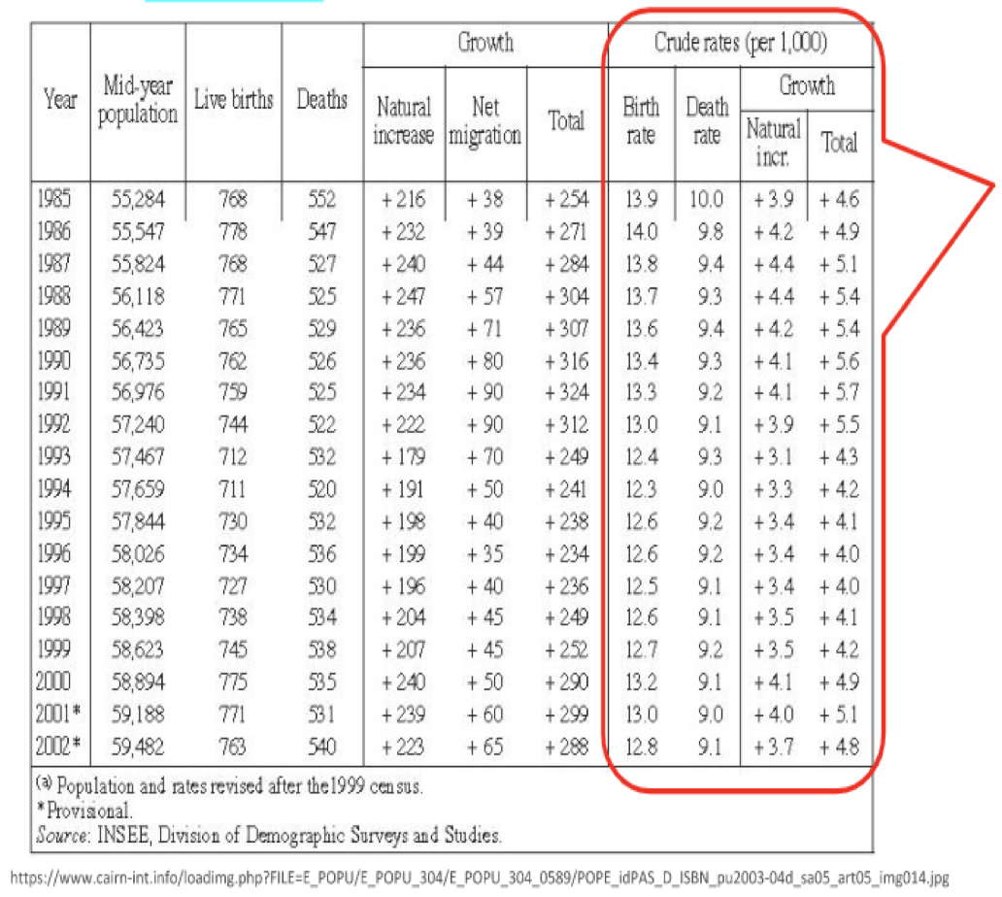
- Can you arrive at these same figures based on the numerical data provided? Apply the formula from your textbook or student handbook to the numbers in the columns at left. You should arrive at values very close to those on the right side of the data table.

Human population growth rates are impacted by a complex range of changing factors

- State the reasons for population explosion

- State the reasons for fluctuation in population growth.

8.1.U5 Influences on human population dynamics include cultural, historical, religious, social, political and economic factors.
8.1.A7 Discuss the cultural, historical, religious, social, political and economic factors that influence human population dynamics.

- Explain how the following factors influence the average family size of a nation:
  - Infant/childhood mortality rates

  - The need for care-giving in old age

  - Children as workers

  - Status of women

  - Availability and cost of contraception

- Explain how the following measures can act to reduce family size:
  - Education

  - Make contraceptives available

  - Improved health care

8.1.U3 As the human population grows, increased stress is placed on all of the Earth’s systems.
8.1.A5 Explain the nature and implications of growth in human populations.

- Complete the table below

System | Effect on System
Food

Soil Nutrients

Water

Timber

Urbanization

- Growing populations need more food. As agricultural technology advances, productivity generally increases. Suggest a reason for the productivity pattern in Africa from 1961 - 2001
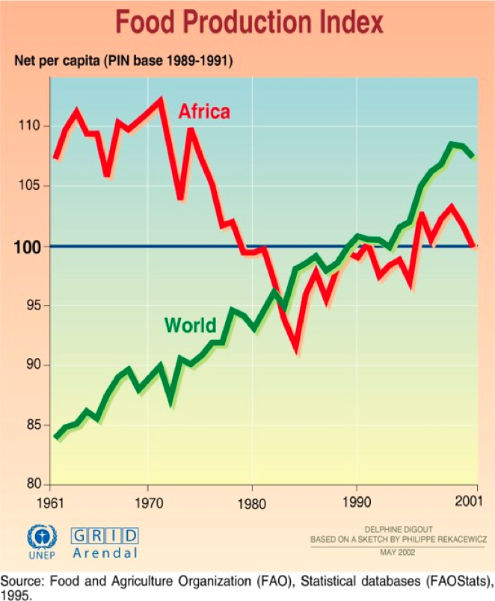

- Increase in demand means increase in prices (basic economics) – law of supply and demand. Describe the relationship between consumer prices for food and Earth’s human population

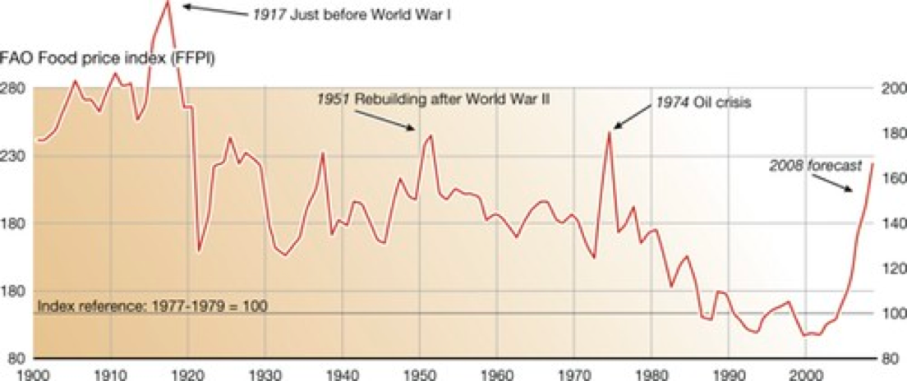

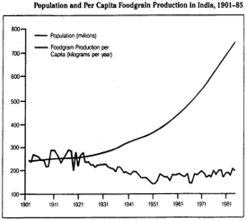
- Study the graph below showing population and food supply in India.

- As the population of India increases, what happens to the per capita food supply? Why?

- Add a third line on the graph to show increase in food production. Label each line.

- Which of the above theories is represented by this data? Explain your reasoning.

- Do you think that the concept of carrying capacity is applicable to the human population? Use evidence from the textbook chapter and your reading in this study guide to justify your response.

Exponential growth and implication for the human population
There are two main theories relating to population growth and food supply, namely Malthus and
Boserup. https://www.youtube.com/watch?v=QAkW_i0bDpQ

Thomas Malthus (1766 – 1834) believed that food production only increased at a linear rate, but human population can increase faster than this. Explain the consequences on the future of the human population if Malthusian theory is accurate.

- Esther Boserup (1910-1999) believed that an increase in population would result in an increase in food production, because we humans would recognize the necessity to provide more, and use new technologies to meet the demand. Explain the consequences on the future of the human population if Boserup’s theory is accurate.

- In your opinion, how will the human population change in the future? Justify your response and try to be specific

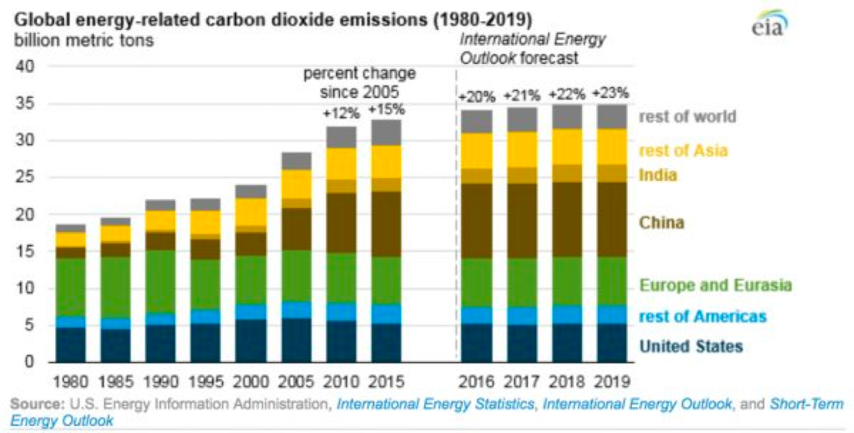
- With reference to the graph, describe the relationship between human populations, economic development, and CO2 emissions per capita. Suggest a reason for this relationship.

A variety of models and indicators are employed to quantify human population dynamics

We often hear about “1st-world” versus “3rd-world” standards of living, but since there is only one world, we should more appropriately refer to “more economically developed countries (MEDCs)” and “less economically developed countries (LEDCs)”. Sometimes these will be abbreviated further as MDCs (more developed countries) and LDCs (less developed countries).
- Characteristics of MEDCs and LEDCs
Characteristics of MEDC & LEDC
MEDC | LEDC

8.1.U4 Age–gender pyramids and demographic transition models (DTM) can be useful in the prediction of human population growth. The DTM is a model that shows how a population transitions from a pre-industrial stage with high CBRs and CDRs to an economically advanced stage with low or declining CBRs and low CDRs.
8.1.A3 Analyse age-gender pyramids and diagrams showing demographic transition models
8.1.A4 Discuss the use of models in predicting the growth of human populations
You should be able to interpret pyramids and describe why populations expand, stabilize or decline as a result of relative CBR and CDR. Also discuss the social, cultural, and economic factors which influence these pyramids
- State the purpose of a Population Pyramid

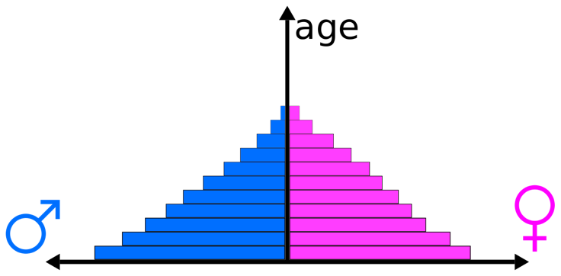
- Identify the structure of the population pyramid

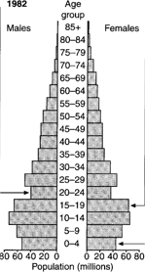
- State the information a population pyramid show

- Look at the bands indicated by the 3 arrows in the pyramid at right. Describe the information / trend indicated by the bars where each of the arrows is located.

he Demographic Transition Model
Demographic transition is the pattern of decline in mortality and fertility (natality) of a country as a result of social and economic development. Demographic transition can be described as a
four-stage population model, which can be linked to the stages of the sigmoid growth curve (S-curve).

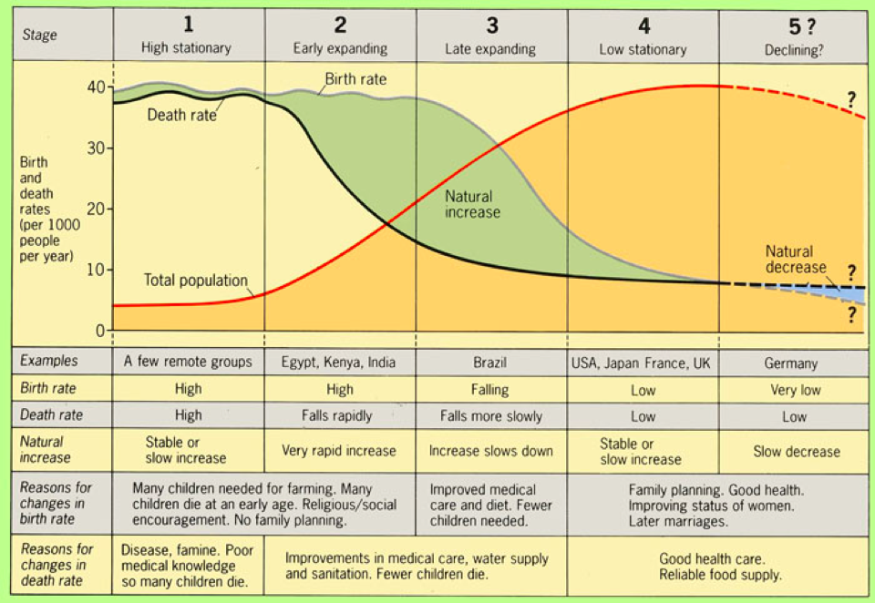
- Outline the function of the DTM

- Compare the CBR and CDR of an early expanding population and a low stationary population in two named countries. Suggest reasons for these differences

- Complete the table below with the characteristics of each pyramid.

Stage | early expansive | late expansive | stationary | contractive
Birth rate
Death rate
Life expectancy
Population growth

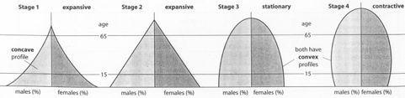

- State the problems and controversies with the DTM

Analyzing population pyramids
Visit the website of the US Bureau of the Census, Centre of International Research, UNDIESA, at www.census.gov and find the International Database. The following population pyramids, from the US Bureau of the Census, show projections into the future for selected countries. http://www.census.gov/ipc/www/idbpyr.html Look at this site as it has dynamic pyramids changing over time.

- For each pyramid below, identify the stage. You might like to look up your own country, if not included, and do the same. Annotate pyramids with comments on the birth rate, fertility, death rate, life expectancy, gender differences and any special events.
Pyramid 1: Afghanistan Pyramid 2: Central African Republic
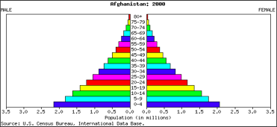
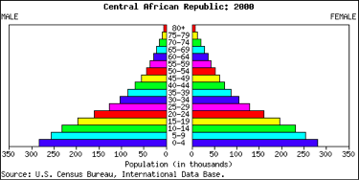

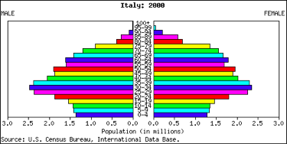
Pyramid 3: Italy Pyramid 4: United Kingdom
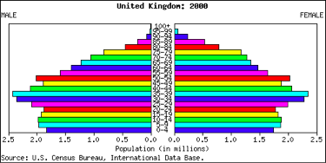

Look up some more countries.
- What is happening in countries with high levels of AIDS?

- What is happening in MEDCs? China? India? Tanzania?

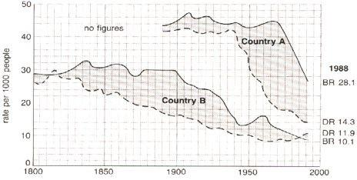
- The following diagram shows two demographic transitions.

- For Country A, draw vertical lines on the graph to indicate the various phases of the transition model.

- For Country B, use a different color pen or pencil to draw vertical lines on the graph to indicate the various phases of the transition model.

- Provide evidence/data from the diagram to justify your placement of the vertical lines showing the different stages of the demographic transition model.

Here are a couple of good websites for learning about the demographic transition model:
      - http://geographyfieldwork.com/DemographicTransition.htm
      - http://www.geography.learnontheinternet.co.uk/topics/popn1.html

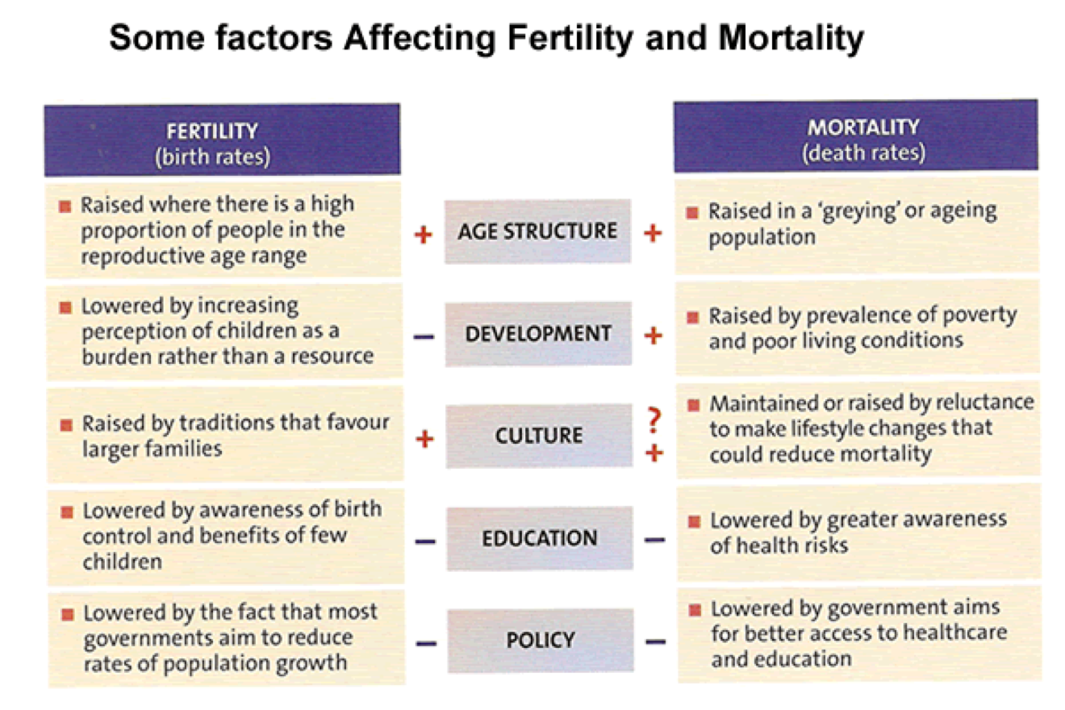
- Do all of these factors shown apply equally to Homo /sapiens and other species? Why or why not?
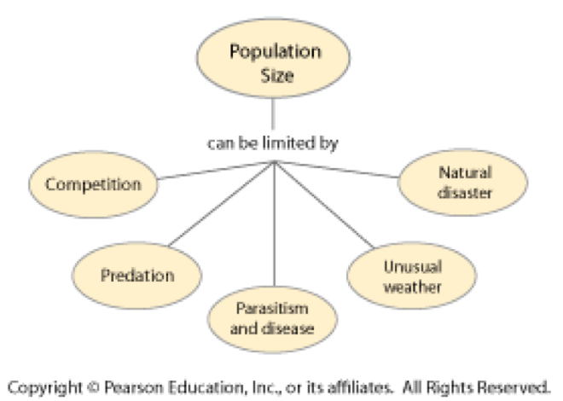

The use of models in predicting the growth of human populations.
computer simulations:
- like climate models, they can be highly accurate if they include all the variables
- is it possible to include all the variables?
- what about unforeseen events (i.e. natural disaster, terrorist strike, warfare)?
- theoretically able to insert events and see the consequences, but do people always behave rationally?
statistical and/or demographic tables
- include actual field measurements
- based on past trends, so tend to reflect reality on the ground
- do past trends always accurately predict future trends?
- how large/representative are the sample populations?
age/sex pyramids (see above)
- like statistical tables, based on actual measurements and past data
- can predict broad trends, but not as precise as computer models
population curves
- mathematical extrapolation from graphs based on real data
- similar to computer models, but less complex

8.1.U6 National and international development policies may also have an impact on human population dynamics.
8.1.A6 Analyse the impact that national and international development policies can have on human population dynamics and growth.
The biggest challenge may not be dealing with global population growth, but with global population ‘greying’ in MEDCs and LEDCs. Currently MEDCs have around 4 workers per retiree, but by 2050 it is expected to be around 2. The solution may lie in expanding the population of workers (increasing retirement age and getting more women into the workplace, increasing productivity, persuading people to save more for their retirement
- Compare and contrast pro-natalistic and anti-natalist

- State the policies that reduce population growth rate

- State the policies that increase population growth rate

- Do you think governments in MEDCs may be unwilling to implement such policies? Explain your answer

ESS can be like learning a new language. So many words are not commonly used in everyday English. This can be challenging. To help you keep up with ESS Terms, you will need to create your own ESS DICTIONARY. You should add to this over the year and keep it in your notebook or on a page file THAT YOU CAN UPDATE AND ADD TO EASILY. Most of the vocabulary words can be found either on your STUDY GUIDE or at mrgscience.com.
You will be responsible for learning the words and their meaning. Periodic quizzes will be given on the words. So, make your dictionary creative and you will remember the words more easily.
KEY TERMS

exponential growth

immigration

TFR

GDP

demographic transition

natural increase rate

​Ester Boserup

life expectancy

​demography

population growth rate

population clock

emigration

infant mortality

pre-reproductive

pre-industrial

​geometric growth

​age-sex pyramid

MGDs

​high stationary

​pro-natalist

limiting factors

doubling time

fertility

reproductive

modernize

​immigration

mortality rate

​child mortality

​early expanding

​Urbanization

LEDC

GNP

age-specific mortality

neonatal death

NIR

​population dynamics

​epidemiological trans

late expanding

population projection

crude death rate

MEDC

carrying capacity

population pyramid

population curve

​Thomas Malthus

prenatal death

​sex ratio

​low stationary

