Topic 2.1 Individuals, Populations, Communities and Ecosystems

Guiding Questions
- How can natural systems be modelled, and can these models be used to predict the effects of human disturbance?​
- How do population dynamics such as birth rates and death rates influence the stability of an ecosystem?

Understandings | Class | Home | Got it
2.1.1 The biosphere is an ecological system composed of individuals, populations, communities, ecosystems.
2.1.2 An individual organism is a member of a species.
2.1.3 Classification of organisms allows for efficient identification and prediction of characteristics.
2.1.4 Taxonomists use a variety of tools to identify an organism.
2.1.5 A population is a group of organisms of the same species living in the same area at the same time, and which are capable of interbreeding.
2.1.6 Factors that determine the distribution of a population can be abiotic or biotic.
2.1.7 Temperature, sunlight, pH, salinity, dissolved oxygen and soil texture are examples of many abiotic factors that affect species distributions in ecosystems.
2.1.8 A niche describes the particular set of abiotic and biotic conditions and resources upon which an organism or a population depends.
2.1.9 Populations interact in ecosystems by herbivory, predation, parasitism, mutualism, disease and competition, with ecological, behavioural and evolutionary consequences.
2.1.10 Carrying capacity is the maximum size of a population determined by competition for limited resources.
2.1.11 Population size is regulated by density-dependent factors and negative feedback mechanisms.
2.1.12 Population growth can either be exponential or limited by carrying capacity.
2.1.13 Limiting factors on the growth of human populations have increasingly been eliminated, resulting in consequences for sustainability of ecosystems.
2.1.14 Carrying capacity cannot be easily assessed for human populations.
2.1.15 Population abundance can be estimated using random sampling, systematic sampling or transect sampling.
2.1.16 Random quadrat sampling can be used to estimate population size for non-mobile organisms.
2.1.17 Capture–mark–release–recapture and the Lincoln index can be used to estimate population size for mobile organisms.
2.1.18 A community is a collection of interacting populations within the ecosystem.
2.1.19 Habitat is the location in which a community, species, population or organism lives.
2.1.20 Ecosystems are open systems in which both energy and matter can enter and exit.
2.1.21 Sustainability is a natural property of ecosystems.
2.1.22 Human activity can lead to tipping points in ecosystem stability.
2.1.23 Keystone species have a role in the sustainability of ecosystems.
2.1.24 The planetary boundaries model indicates that changes to biosphere integrity have passed a critical threshold.
2.1.25 To avoid critical tipping points, loss of biosphere integrity needs to be reversed.
HL Only
2.1.26 There are advantages of using a method of classification that illustrates evolutionary relationships in a clade.
2.1.27 There are difficulties in classifying organisms into the traditional hierarchy of taxa.
2.1.28 The niche of a species can be defined as fundamental or realized.
2.1.29 Life cycles vary between species in reproductive behaviour and lifespan.
2.1.30 Knowledge of species’ classifications, niche requirements and life cycles help us to understand the extent of human impacts upon them.

IB often asks for named examples, be sure to use specific examples and specific names (scientific names are not required).

For example, if you just say tiger this refers to 1 of 10 species versus Bengal tiger is specific to one region and one species!

For a named example of a habitat or ecosystem
Be specific; The Giant Kelp Forest off the coast of Monterrey Bay California is much better than the beach and gives as much detail as possible; The Sundarbans is the largest mangrove forest in Southern Bangladesh and South-eastern India

Ecological Foundations:

- Outline the various systems of the Earth

- Watch the video on Earth’s Biosphers https://youtu.be/0xchPUSBSG0. Answer the following questions
  - State how the different ecosystems within the biosphere interact

  - Outline the role of humans play in the biosphere

  - Identify some of the key threats to the biosphere mentioned in the video

- Define the following terms and give a specific example. (Define: Give the precise meaning of a word, phrase, or physical quantity
Term | Definition | Example
Individual

Species

Abiotic

Biotic

- State the characteristics that determine a species

- Research and record characteristics of one animal species:

Species name | Habitat | Diet | Reproduction | Life span | Unique Characteristics
Example: Gray Wolf | Forests, tundras | Carnivore (meat-based | Mates annually, litter of 4-6 pups | 6-8 years in wild | Social structure, pack behavior

- Outline the problems and limitations associated with the species model

- Suggest the purpose of classification in biology

- Describe the tools used by taxonomists to classify organisms.

  - State how DNA analysis helps in identifying species

- Evaluate the use of the dichotomous key

Advantages | Disadvantages

- Activity - Complete the dichotomous key from salamander species. This will be a separate activity

- Watch the video Biotic and Abiotic Factors, https://youtu.be/qJr1p55rT5M. . Identify the biotic and abiotic components of a ecosystem

- Identify the following as biotic or abiotic

 | Biotic/Abiotic |  | Biotic/Abiotic
River Dolphin |  | Bacteria
Algae |  | Mushroom
Daylight hours |  | Rocks
Precipitation |  | Minerals
Moss |  | Swamp grass
Soil composition |  | Fossil fuels

- Activity: Outline the following abiotic variables and the methods used to measure them. (Outline: Give a brief account or summary)

Abiotic factor (units) | Marine | Freshwater | Terrestrial
Light intensity
(candela or lux)

Temperature
(C)

pH

Soil Particle size
(%)

Slope angle
(degrees)

Soil moisture
(%)

Soil Mineral Content

Flow Velocity
(m/sec)

Salinity
(ppt)

Dissolved Oxygen
(% mg/L or ppm)

Turbidity
(cm)

Population and Community Dynamics:

- Define a population in an ecological context.

- State how environmental factors influence population size and distribution

- Outline the charcteristics of population

- Activity (Fieldwork) - Examine a population of a specific tree species within a local forest or woodland area.

- An ecological niche refers to the ______________________ of conditions and resources under which a species can survive, grow, and reproduce. The fundamental niche includes the broad range of environmental factors such as temperature, ___________________, and available nutrients that a species can tolerate. In any given ecosystem, a species occupies a unique niche that specifies its role in the food web, including what it eats, who its _________________ are, and how it contributes to the recycling of nutrients. The niche concept helps in understanding how species ___________________ with each other and what factors allow multiple species to coexist in the same habitat. Changes in ___________________ factors like light availability or soil pH can affect the dimensions of a species’ niche within an ecosystem.
Answers:
range water predators interact abiotic

- A summary of niche complementarity and overlap in functional groups of pollinators, showing effects of plant species richness, time of day, and flowering height on flower visitation rate of each group.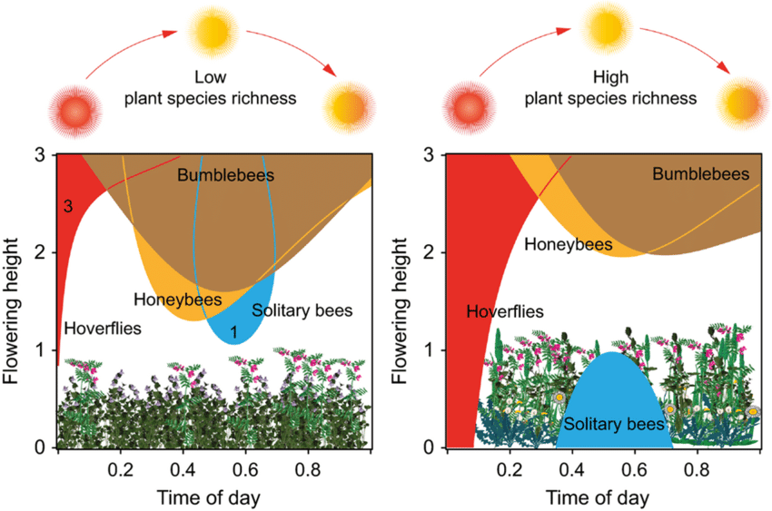
  - How does the diagram illustrate the concept of niche complementarity among pollinators?

  - What does the overlap in the shaded areas of the diagram suggest about the resource use among different pollinator groups?

  - How does increased plant species richness affect the interactions and resource sharing among pollinators according to the diagram?

- Activity: Gather information on a species of your choice:
  - Habitat Requirements: Where does the species live?
  - Diet: What does the species eat, and what role does it play in the food chain?
  - Behavioral Traits: How does the species behave in different seasons or stages of life?
  - Environmental Tolerance: What range of temperatures, altitudes, or moisture conditions can the species tolerate?
  - Interactions with Other Species: Does it compete with other species? Does it have any predators or mutualistic relationships?

- Activity: Identify two named examples in an ecosystem for each specific type of interaction between organisms:
Term | Definition  How do the organisms interact? (How do they influence the population dynamics of each other? | 2 Examples
Interspecific Competition

Intraspecific competition

Predation

Herbivory

Parasitism

Mutualism

Amensalism.

Neutralism.

Disease

- If possible include a sketch/drawing or clipart that shows how the population of one organism affects the population of the other organism.

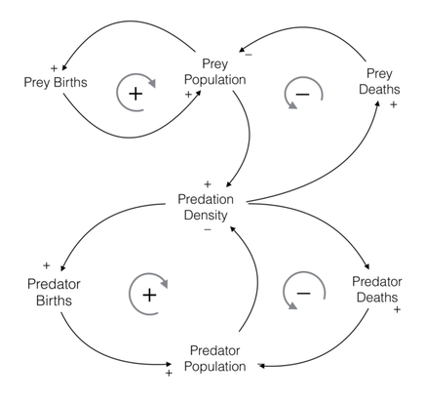
- Activity: You will use the predator/prey simulation lab to demonstrate feeding relationships over time. This will be an in-class activity.

- Watch the video Carrying Capactiy, https://youtu.be/XV2-2Ym3IIc. Answer the following questions
  - Define carrying capacity

  - State how carrying capacity determined in an ecosystem

  - Suggest how changes in abiotic and biotic factors affect the carrying capacity of an ecosystem

  - identify any examples from the video where human activities have altered the carrying capacity of an ecosystem

  - State the consequences of a population exceeding its carrying capacity

  - Suggest how conservation efforts aim to manage or restore the carrying capacity of an ecosystem?

- Identify the limiting factors in:
Plants Animals

- Without limiting factors, there will be exponential growth (there is nothing limiting population size) Is this realistic for most populations? Justify your answer

- State the consequences of exceeding carry capacity

- Activity: In your groups identify a specific ecosystem to study (e.g., tropical rainforest, desert, coral reef, temperate forest).
  - research the key biotic and abiotic factors that affect the carrying capacity of your ecosystem
  - describe the characteristics of your ecosystem.
  - detailed explanations of how each identified biotic and abiotic factor influences the carrying capacity.
  - Real-world examples that illustrate these impacts (e.g., how overfishing has affected the carrying capacity for certain fish species in marine ecosystems)..

- Compare density-dependent and density-independent factors. Identify named example

- Watch the video, Feedback Loops in Nature. https://youtu.be/inVZoI1AkC8, answer the following questions
  - What is a feedback loop and how does it function in natural ecosystems

  - Identify an example of a positive feedback loop in the video and explain its impact on the ecosystem

  - Suggest how a negative feedback loop help maintain stability in an ecosystem

  - State the role do feedback loops play in climate change

  - How can understanding feedback loops help in managing environmental challenges?

- Describe exponential and logistic growth models.

- Suggest the conditions that might cause a population follow exponential growth

- Draw and label the S population curve

- Draw and label the J population curve.

- Activity: Investigate the reindeer population on St. Matthew Island case study. This will be a separate activity

- Watch the video Too Many Humans, https://youtu.be/WGcE3ZWBjfo, and answer the following questions
  - What are the primary concerns raised about the growing human population in the video?

  - How does the video illustrate the impact of human overpopulation on Earth's ecosystems?

  - What solutions or strategies does the video suggest to mitigate the problems associated with overpopulation?

  - According to the video, how does overpopulation affect resource availability and consumption?

  - What ethical questions does the video raise about our responsibility towards future generations in the context of overpopulation?

- Outline how human population growth has impacted ecosystems

- Outline the dynamics of human ecological niche

- Outline how technological impacts carrying capacity

- Calculating the carrying capacity for human populations continues to be a topic of debate. One method employed to address this issue is through the use of the ecological footprint concept. Outline the concept of ecological footprint

Measuring Populations

- Explain methods for estimating population size.

- Outline random sampling

  - Evaluate the random sampling strategy

Advantages | Disadvantages
 | You may not have access to some of the sample points

- Outline systematic sampling

  - Evaluate the systematic sampling strategy

Advantages | Disadvantages
Easier to apply than random sampling as there is no need for a grid

 | Patterns may be missed or areas exaggerated

- Outline stratified sampling

  - Evaluate the stratified sampling strategy

Advantages | Disadvantages
 | You must know the size of the subsets to get an accurate picture
Flexible – can be used in many situations as it combines the random and systematic

- Describe the purpose of a transect

- Compare line transect vs belt transect

- How do you choose the quadrat size?

- For each measurement, explain what the term means, the units of measure, and any applicable formulas. Use the sample quadrates below to help you draw an example of how each measurement could be taken

  - Number of Species

  - Frequency

  - Population Density

  - Evaluate the sampling method of number of species, frequency and population density

Advantages | Disadvantages
Quick easy method to apply

 | May miss some species in layered vegetation
 | Species may look different in different life stages

  - Percent coverage

  - Evaluate the sampling method of percent coverage

Advantages | Disadvantages
Avoids some of the problems of counting individuals

 | May be able to identify species accurately

- Describe the ACFRO Scale

  - Complete the ACFRO Scale table

% Coverage | ACFRO Scale | Score
50
25-50
12-25
6-12 | Occasional
<6 or individual
not present

- Activity: (fieldwork) Use quadrat sampling estimates for abundance, population density, percentage cover and percentage frequency for non-mobile organisms and measures change along a transect.

- Direct methods include actual counts and sampling. Indirect methods include use of capture-mark-recapture with the application of the Lincoln index
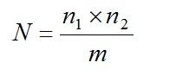
Define each variable in this equation

N =

n₁ =

n₂ =

m =

  - State the assumptions used in the application of the Lincoln index

- Activity: (fieldwork) You will use the Lincoln index to estimate population size. Make sure that you understand the assumptions made when using this method.

Communities and Ecosystems

- Define the following terms and give a specific example
Term | Definition | Example
Community

Habitat

Ecosystems

Sustainability

- Activity: Consider the concept of community in a local ecosystem. Use the Okefenokee Swamp as your example. Identify the following
  - Community Interactions:
  - Ecological Roles and Interactions:
  - Resilience to Disturbance:
  - Resilience to Disturbance:

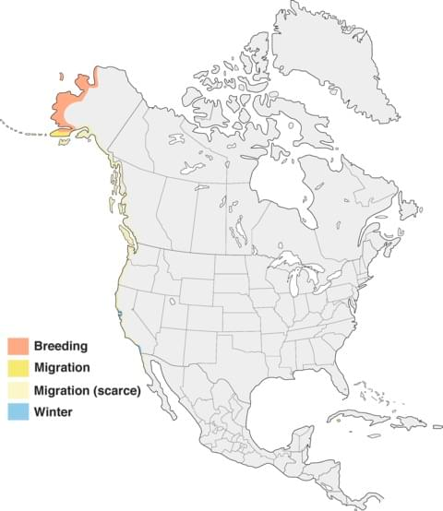
- Explain how the habitat of the Pacific golden plover changes throughout the year.. (Explain: Give a detailed account of causes, reasons or mechanisms) Pacific Golden-Plover Overview, All About Birds, Cornell Lab of Ornithology

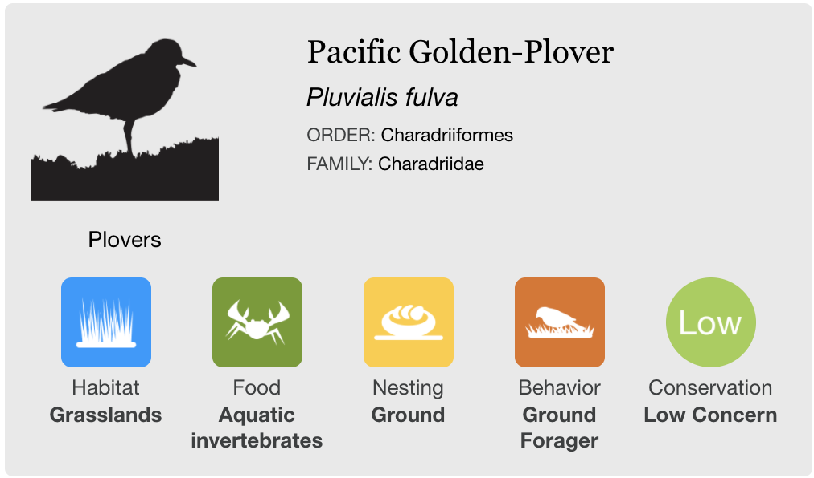

- Activity: Research a local ecosystem. Consider the concept of habitat in a local ecosystem. Identify the following
  - Geographical Location
  - Physical Characteristics:
  - Biotic and Abiotic Factors
  - Climate Conditions
  - Vegetation Species
  - Animal Species

- Activity: Research a local ecosystem Consider the concept of ecosystem in a local ecosystem. Identify the following:
  - Geographical Location
  - Physical Characteristics
  - Inputs
  - Outputs
  - Flows within the ecosystem
  - Processes influencing the ecosystem
  - Interactions and Feedback Mechanisms

- Watch the video on Sustainable https://youtu.be/_5r4loXPyx8 and complete the questions below
  - Which three pillars of sustainability does the video emphasize?

  - What examples does the video provide of sustainable practices?

  - How does the video suggest individual actions can contribute to larger sustainability goals?

  - What challenges or barriers to achieving sustainability does the video highlight?

- Tropical rainforests are among the oldest and most stable ecosystems on Earth. They are incredibly resilient due to their high biodiversity and complex trophic interactions. Outline their inputs, outputs and processes

- Define resilience

  - Outline factors that affect ecosystem resilience

- Draw and label a graph showing how a tipping point happens. (Draw: Represent by means of pencil lines: Label: Add labels to a diagram)

- Explain how the size of storages and the diversity of a system can affect its resilience. (Explain: Give a detailed account of causes, reasons or mechanisms)

- Using the table, state and explain the resilience of the stated systems. (State: Give a specific name, value or other brief answer without explanation or calculation: Explain: Give a detailed account of causes, reasons or mechanisms)
(Help: consider the disturbances that might occur, such as diseases, invasive species, weather changes etc...)
System | Resilience  (high / moderate / low) | Explanation
A very large forest ecosystem with high biodiversity | High | There are many interactions between  organisms if the biodiversity is high. If there is a  change, e.g. a decrease the population of a  particular species through disease, those  organisms that feed on it will have alternative  food sources to turn to. The system will remain  mostly unchanged.
A large field with only corn growing in it, with a small
number of insects feeding on the corn.
An isolated village community in the Gobi desert, with a population of around 1000
people.
The community of Shanghai, China. Population roughly 24,000,000.

- Describe the direct human impacts on Biodiversity

- Describe the indirect human impacts on biodiversity

- How does deforestation in the Amazon rainforest illustrate the concept of an ecological tipping point? Consider the impact of extensive deforestation on the rainforest's ability to generate and recycle moisture, leading to a new equilibrium with potentially drier conditions.

- Activity: Visit the Resilience Alliance database (http://www.resalliance.org/tdb-database ) .
- Browse the list of examples and focus on the "Alternate Regimes" section.
- You need to design a diagram illustrating a positive feedback loop between two states of an ecosystem, showing the "push factors" described in the "mechanism" section of the database.
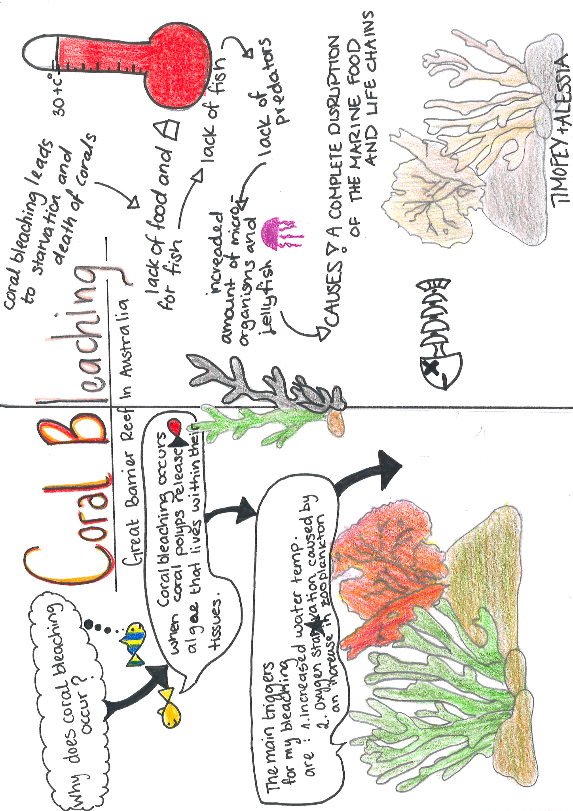
- Here is an example diagram for reference.

- Answer the following questions based on your diagrams:
  - Outline two possible reasons for the tipping point illustrated in their diagram. (Outline: Give a brief account or summary)

  - Identify the mitigation strategies used to reduce the tipping point.

  - Outline how the mitigation strategies contributed to the resilience of the ecosystem represented in their diagram. (Outline: Give a brief account or summary)

- Evaluate the possible consequences of tipping points. (Evaluate: Assess the implications and limitations)
  - Example 1: Cooking fuel and deforestation in India. (DESCRIBE/OUTLINE) https://www.youtube.com/watch?v=UjJHrpx4bUE

  - Example 2: Apo Island (Phillippines) fisheries near-collapse. (DESCRIBE/OUTLINE)
https://www.youtube.com/watch?v=v8oNhckPjFM&feature=youtu.be

- Global climate change is an example of a disturbance on the environment that humans are causing. Most scientists agree that the planet is warming, and that humans are the cause of it. However, the future consequences are still debated. Some people may argue that the Earth environment as a whole is very resilient because it is such a complex system, though others may argue it is not resilient enough to withstand the disturbances we are putting on the system. Using climate change as an example, explain why it is so difficult to predict the tipping point of a complex system. (Explain: Give a detailed account of causes, reasons or mechanisms)

- Discuss resilience in a variety of systems.
  - Example 1: Possums were introduced to both Australia and New Zealand by European settlers in the 18th century. The impact of possums on the New Zealand ecosystem was greater than on the Australian ecosystem. The Australian ecosystem, in this case, proved to be more resilient to the impact of possums compared to the New Zealand ecosystem which became overrun by possums.
Discuss how the size of land mass and presence of natural possum predators could explain what happened in

- Watch the video https://youtu.be/Z7Zd0smPeAg Keystone species
  - Describe why they are classified as a keystone species

  - Outline the consequences of losing Keystone species

- Activity: Research a keystone species that interests you
  - identify its role in the ecosystem
  - describe the specific interactions it has with other species
  - explain the consequences of its removal or decline

Human Interactions with Ecosystems:

- Watch the video What Are the Planetory Boundaries https://youtu.be/Mpv6aPFhr80, answer the following questions
  - What is the planetary boundary model, and who developed it?

  - Can you list some of the key planetary boundaries mentioned in the video?

  - How does the planetary boundary model help scientists understand the limits of Earth's ecosystems?

  - What happens if a planetary boundary is crossed, according to the video?

  - Discuss an example from the video where a specific planetary boundary has been approached or crossed. What are the implications for our environment?

  - How does the video suggest that human activities impact these planetary boundaries?

- Outline biosphere integrity

- Activity: Select a regeneration strategy such as rewilding, afforestation, wetland revival, or soil improvement through composting
- Reintroduction of wolves in Yellowstone National Park, USA
- The Green Great Wall or Three-North Shelter Forest Program
- The restoration of the Mesopotamian Marshes
- The use of biochar and compost in degraded lands in the Amazon Rainforest
- Restoration of mangrove forests in Southeast Asia
- London or New York where natural habitats are restored within urban settings to increase biodiversity and provide green spaces for residents
- Restoring native prairies in the Midwest of the United States,

  - Evaluate whether the strategy has led to a measurable increase in species diversity and genetic diversity within the ecosystem.
  - Assess the extent to which essential ecosystem functions such as nutrient cycling, water filtration, and carbon sequestration have been restored or enhanced.
  - Analyze whether the economic benefits, such as increased tourism, improved water quality, or carbon credits, justify the initial investment.
  - Assess how the strategy affects local populations

HL ONLY

- Describe how cladograms help in understanding the evolutionary relationships among various species by organizing them into clades based on shared derived characteristics

- Outline the differences between cladograms and traditional taxonomic trees which might be based on morphology rather than evolutionary history.

- Activity: Research the evolutionary background of their assigned organisms, focusing on key traits and evolutionary milestones.
- Chimpanzee (Pan troglodytes) - Closest living relative to humans, useful for comparing primate evolution.
- Elephant (Loxodonta africana) - To illustrate the evolution of large mammals and complex social structures.
- Crocodile (Crocodylus niloticus) - Represents reptilian lineage with ancient evolutionary roots.
- Peregrine Falcon (Falco peregrinus) - To show avian adaptations and the evolution of flight.
- Axolotl (Ambystoma mexicanum) - A unique example of neoteny where the juvenile features are retained in adulthood.
- Coelacanth (Latimeria chalumnae) - A "living fossil" to discuss organisms that have changed little over millions of years.
- Giant Sequoia (Sequoiadendron giganteum) - To represent plant evolution and longevity.
- Australian Lungfish (Neoceratodus forsteri) - To explore the evolution of fish and their transition towards terrestrial living.
- Honeybee (Apis mellifera) - To discuss the evolution of insects and social behavior.

  - Draw the most recent common ancestor at the base of the cladogram.
  - Add branches for each organism, positioning according to evolutionary divergence. Remember, organisms that share recent common ancestors should be closer together.
  - Label each branch with the name of the organism

- Distinguish between fundamental niche and realized niche with reference to a named species. Use the video to help you take notes on key points presented. https://youtu.be/8eH6X2rAQEs .(Distinguish: Give the differences between two or more different items)

- Case study: American ecologist Joseph Connell investigated the realized and fundamental niches of two species of barnacles – a common animal on rocky shores in the UK. Connell had observed that one of the species, Semibalanus (Balanus) baladoides, was most abundant in the middle and lower intertidal area and that the other species, Chthamalus stellatus, was most common on the upper intertidal area of the shore. When he removed Chthamalus from the upper area of the shore, he found that no Semibalanus replaced it, his explanation was that Sembalanus could not survive in an area that regularly dried out due to low tides. He concluded that Semibalanus realized niche was the same as its fundamental niche.

In another experiment, he removed Semibalanus from the upper and middle areas. He found that over time Chthamalys replaced it in the middle intertidal zone; his explanation was that Semibalanus was a more successful competitor in the middle intertidal zone and usually excluded Chthamalus. He concluded that the fundamental niche and realized niche of Chthamals were not the same and that its realized niche was smaller due to interspecific competition leading to competitive exclusion
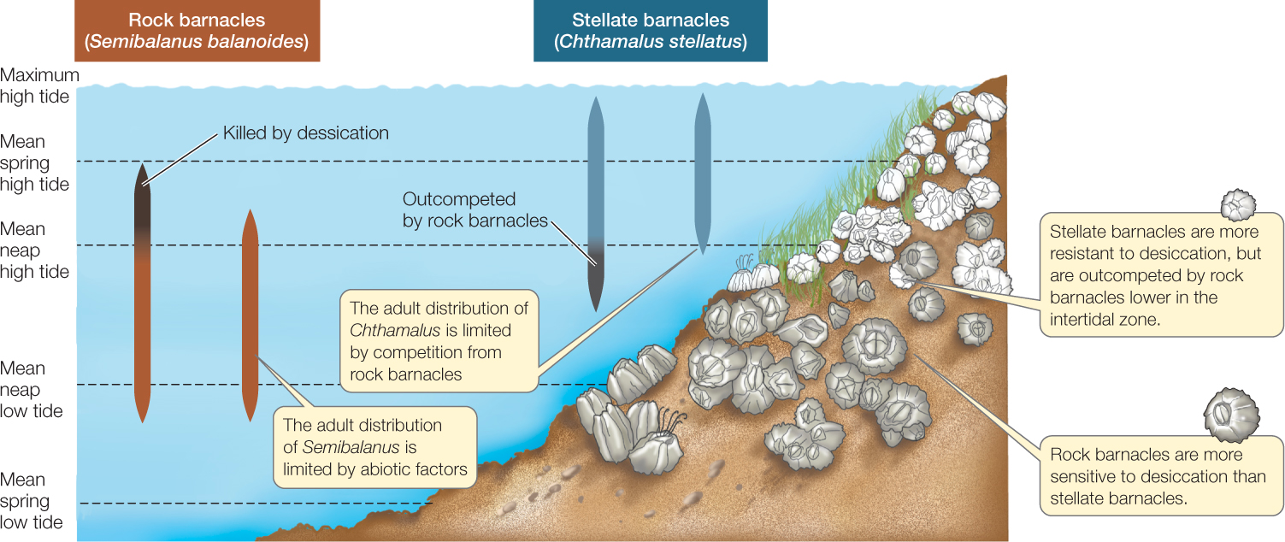

  - What is the habitat of the two species?

  - Why did Connell need to do both experiments to make an accurate conclusion? What information would be missing without the second experiment?

  - Use this example to explain the differences between fundamental niche and realized niche

- Watch the video https://youtu.be/rdZOwyDbyL0 and complete the following questions
  - How does the phylogenetic tree of Anole lizards provide evidence of niche partitioning among different species?

  - What are some specific examples of niche partitioning observed in the Anole lizard species mentioned in the video?

  - How do the different Anole lizard species in the phylogenetic tree occupy distinct microhabitats, and how does this contribute to niche partitioning?

  - How do the dietary preferences of different Anole lizard species demonstrate niche partitioning in their ecosystem?

  - Can you identify any behavioral or morphological adaptations in the Anole lizards that facilitate niche partitioning and reduce competition for resources?

- Read the information below. Underline or highlight key information related to fundamental and realized niches.

Fundamental and realized niche refers to the environmental conditions or positions of different species in an ecosystem. These two niches refer to the conditions needed for the persistence of different species and their ecological roles in the system.

They are two different aspects and differ in many ways. Let us look at some of the differences between a fundamental and a realized niche.

A fundamental niche can be defined as the range of environmental conditions in which each of the species survives. The realized niche can be termed as the range of environmental conditions in which a species is really found.

While a fundamental niche elaborates on the various roles of the species, the realized niche elaborates on what the species actually do. The fundamental niche refers to a range of conditions, roles, and resources under which a species survives, grows, and reproduces. This niche describes the experiences of the species and how it tolerates a particular condition.

The fundamental niche is larger than the realized niche. It can be said that as the realized niche grows, the fundamental niche also grows accordingly. The realized niche can be called a subset of a fundamental niche.

When the species comes across various interactions and pressures from others, they are forced to go for a narrower niche, and thus the realized niche is formed. It is in the realized niche that a species will be well adopted, and so this niche is where the species actually exists.

In order to explore the concept of realized niche and resource partitioning further, you are going to look at some case studies of species.

- Activity: Your task is to produce a graphical summary of an example from one of the resources provided. Remember to use annotations that will aid your understanding

Realized Niche of Cane Toads in Australia (https://www.ncbi.nlm.nih.gov/pmc/articles/PMC4104887/)
Lecture notes from Montana University with several summarized examples (https://www.montana.edu/screel/teaching/bioe-370/documents/Biol%20303%20niches.pdf)
Avoiding a Sticky Situation (https://darwinsbearddotnet.wordpress.com/2014/10/26/avoiding-a-sticky-situation/)
Resource Partitioning and Why It Matters (https://www.nature.com/scitable/knowledge/library/resource-partitioning-and-why-it-matters-17362658/)
Blog post on fundamental and realized niches (https://dynamicecology.wordpress.com/2015/08/19/what-influences-the-realized-niche/)

I
Create Graph Summary Here

- Complete the table below on The Characteristics of Carrying Capacity in K and r strategy Organisms

Characteristic | r-strategy | K-strategy
Life span | short
Number of offspring

Onset of maturity |  | late
Body size

Reproduction | once during lifetime
Parental care

Environment |  | stable

- Activity: Research and describe the complete life cycle of your chosen species, emphasizing each stage from birth to reproduction.
- Monarch Butterfly: explore how habitat destruction, pesticide use, and climate change affect the migratory patterns and reproduction of monarch butterflies.
- Coral Reefs: This would include a focus on species like coral, examining the effects of ocean acidification, warming sea temperatures, and pollution on coral bleaching and reproduction.
- Polar Bears: how melting sea ice due to climate change impacts their hunting habits, reproduction, and overall survival.
- Frogs and Other Amphibians: study how pollution, habitat loss, and the spread of infectious diseases like chytridiomycosis affect their populations and life cycles.
- Bees: Focusing on how pesticide use, habitat destruction, and climate change are influencing bee populations, which are crucial for pollination.
- Atlantic Salmon: Research how overfishing, river dams, and pollution impact their breeding and migration patterns.
- Elephants: examine the impact of poaching and habitat encroachment on their reproduction and social structure.
- Bats: Investigating how white-nose syndrome (a fungal infection), habitat loss, and climate change are threatening various bat species.

  - Identify specific human activities that impact the life cycle stages of the species. This should include both direct impacts (like habitat destruction for urban development affecting nesting sites) and indirect impacts (like climate change altering migration patterns)

Reflection

Reflect on how understanding the different aspects of ecological systems—from individual organisms to ecosystems—can influence human actions towards achieving sustainability. How does this knowledge impact the choices we make regarding the environment and its conservation?

ESS can be like learning a new language. So many words are not commonly used in everyday English. This can be challenging. To help you keep up with ESS Terms, you will need to create your own ESS DICTIONARY. You should add to this over the year and keep it in your notebook or on a page file THAT YOU CAN UPDATE AND ADD TO EASILY. Most of the vocabulary words can be found either on your STUDY GUIDE or at mrgscience.com.
You will be responsible for learning the words and their meaning. Periodic quizzes will be given on the words. So, make your dictionary creative and you will remember the words more easily.

KEY TERMS

planetary boundries

ecological footprint

tipping point

diversity

justice

indicators

sustainability

doughnut economics

circular economy

renewable resources

non-renewable resources

biocapacity

regeneration

