Topic HL.c Environmental Ethics

Guiding questions
- To what extent do humans have a moral responsibility towards the environment?
- How does environmental ethics influence approaches to achieving a sustainable future?
- What role do ethical frameworks such as anthropocentrism, ecocentrism, and biocentrism play in shaping public and corporate policies regarding environmental management?
- How can ethical considerations reconcile conflicts between economic development and environmental preservation?

Understandings | Class | Home | Got it
HL.c.1 Ethics is the branch of philosophy that focuses on moral principles and what behaviours are right and wrong.
HL.c.2 Environmental ethics is a branch of ethical philosophy that addresses environmental issues.
HL.c.3 A variety of ethical frameworks and conflicting ethical values emerge from differing fundamental beliefs concerning the relationship between humans and nature.
HL.c.4 Instrumental value is the usefulness an entity has for humans.
HL.c.5 Intrinsic value is the value one may attach to something simply for what it is.
HL.c.6 The concepts of instrumental and intrinsic value are not exclusive.
HL.c.7 An entity has “moral standing” if it is to be morally considered with regard to how we ought to act towards it.
HL.c.8 There are three major approaches of traditional ethics: virtue ethics, consequentialist (for example, utilitarian) ethics and rights-based (deontological) ethics.
HL.c.9 Virtue ethics focuses on the character of the person doing the action. It assumes that good people will do good actions and bad people will do bad actions.
HL.c.10 Consequentialist ethics is the view that the consequences of an action determine the morality of the action.
HL.c.11 Rights-based ethical systems focus on the actions and whether they conflict with the rights of others. There is debate about what these rights might be.
HL.c.12 Some people hold the view that whatever is natural is correct or good. This position is contentious and is described as the “appeal to nature” fallacy.
HL.c.13 Environmental movements and social justice movements have developed from separate histories but are increasingly seeking common goals of equitable and just societies.

INTRODUCTION TO ENVIRONMENTAL ETHICS

- Provide a comprehensive definition of 'ethics' and 'moral principles,' and discuss how these concepts differ in environmental contexts.

- Watch the video, What Makes Something Right or Wrong https://www.youtube.com/watch?v=pZnDImejvj8, answer the following questions
  - Identify two ethical frameworks discussed in the video and explain how they influence our perception of right and wrong.

  - Provide specific examples from the video where cultural background influenced the moral decisions of individuals or groups.

  - Discuss the implications of prioritizing intentions vs. consequences in moral decision-making as presented in the video. Give one real-life example of where such a prioritization could impact ethical decision-making.

  - Choose one ethical dilemma presented in the video and propose an alternative solution based on a different ethical framework than what was used.

- Discuss the ethical principles across various cultures

- Describe three daily decisions you make that involve ethical considerations and explain the ethical frameworks guiding these decisions.

- Watch this video, Is Rigth or Wrong Alwasys Black and White? https://www.youtube.com/watch?v=fcqhS1ExiBQ&pp=ygUfd2hhdCBpcyByaWdodCBhbmQgd2hhdCBpcyB3cm9uZw%3D%3D answer the following questions
  - Select an ethical dilemma from the video and analyze it using both a consequentialist and a virtue ethics perspective.

  - The video discusses moral ambiguity. Provide a detailed example of a situation that might be morally ambiguous and suggest how one might resolve it ethically.

  - Debate the effectiveness of black-and-white ethical reasoning in addressing global environmental issues, using examples from the video.

  - Discuss how cultural relativism affects ethical decision-making, citing specific examples from the video to support your points.

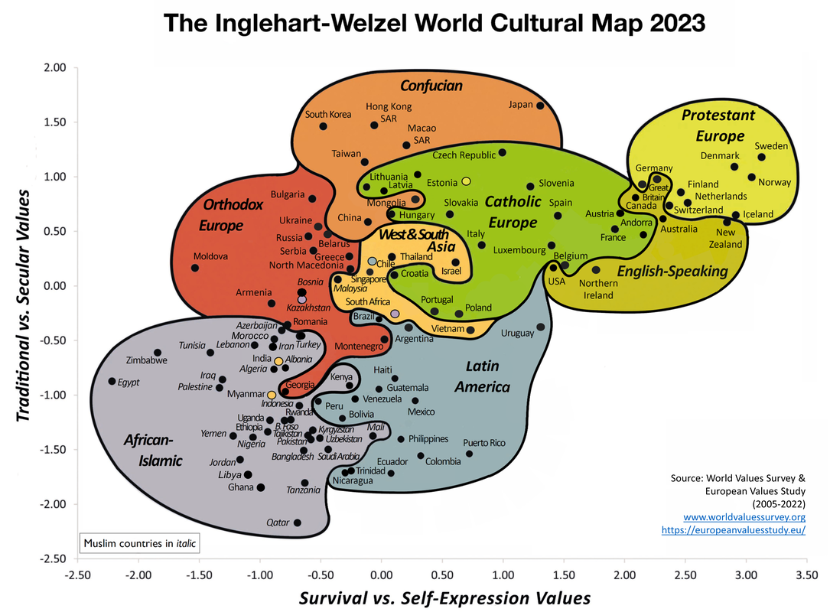

- Reference the Inglehart-Welzel World Cultural Map
  - What are the two primary dimensions used to categorize cultures on the Inglehart–Welzel World Cultural Map, and what do they represent?

  - How do countries in the upper right quadrant of the map differ from those in the lower left quadrant in terms of values and societal norms?

  - Select two countries from different quadrants and describe how their positions on the map reflect their cultural values and societal norms.

  - How might historical, economic, and social factors influence a country's position on the Inglehart–Welzel World Cultural Map? Provide specific examples.

- Activity:You will analyze a complex environmental issue through the lens of different ethical frameworks and understand and the conflicts between economic development, cultural traditions, environmental sustainability, and social justice. Select one of the following case studies:
- Genetic Modification of Crops in Southeast Asia India’s River Rights Movement
- Norway’s Sustainable Whaling Practices E-Waste Management in Ghana
- Community-Based Conservation in Kenya Urban Green Spaces in European Cities
- Amazon Rainforest Conservation in Brazil Water Conservation & Rights in New Zealand
- The North American Great Lakes Water Conservation
- Solar Energy Development in the Moroccan Sahara

Research your case study and complete the table comparing the perspectives of different stakeholders in each ethical dilemma.

Stakeholders | Perspective | Ethical Framework | Proposed Solution

- Stakeholders: Identify the main stakeholders involved in the issue.
- Perspective: Discuss the perspectives presented in the case study.
- Ethical Frameworks: Apply virtue ethics, consequentialist ethics, and rights-based ethics to analyze the issue from different perspectives.
Reflection
- What ethical framework did you find most compelling for your case study and why?
- How did the different ethical perspectives influence your understanding of the issue?
- What are the broader implications of these ethical dilemmas for environmental policy and decision-making?

ENVIRONMENTAL ETHICS AND ITS EVOLUTION

- Define environmental ethics

- Watch the video, Environmental Ethics, https://www.youtube.com/watch?v=AIRdfWFPiOs and complete the following questions
  - State how the three main ethical frameworks (virtue ethics, consequentialist ethics, and rights-based ethics) apply to environmental issues

  - List examples of environmental ethical dilemmas mentioned in the video

  - State the role intrinsic and instrumental value play in environmental ethics

  - Describe how the concept of moral standing relate to environmental ethics

- Watch the video,The Land Ethics and Aldo Leopold, https://www.youtube.com/watch?v=PgoOTtDkhdU . Answer the following questions
  - Who was Aldo Leopold, and what is he best known for in the field of environmental ethics?

  - State the central idea of Leopold's "Land Ethic"?

  - How does Leopold's "Land Ethic" differ from traditional human-centered (anthropocentric) ethics?

  - How can individuals and communities adopt the principles of the Land Ethic in their daily lives?

- Outline the key concepts that define the field of environmental ethics

- Activity: Environmental ethics emerged as a distinct philosophical discipline in the 1960s and 1970s, a period marked by a growing public awareness of ecological issues. This era saw the rise of significant environmental movements, catalyzed by the increasing visibility of pollution, resource depletion, and species extinction. The publication of Rachel Carson’s "Silent Spring" in 1962, which highlighted the dangers of pesticide use, played a pivotal role in sparking widespread environmental concern.

Create a timeline of key events and figures in the evolution of environmental ethics. Here is a starting point. They are not in order "Walden" by Henry David Thoreau, Gro Harlem Brundtland, Aldo Leopold's "A Sand County Almanac", "Silent Spring" by Rachel Carson, Endangered Species Act in the United States, John Muir, Arne Naess, James Lovelock, Wangari Maathai

Timeline Template

Year | Figure/Event | Description | Impact on Environmental Ethics
(add additional rows as needed)

Reflection:
- Which event or figure did you find most impactful in the development of environmental ethics? Why?
- How do historical events in environmental ethics influence current environmental policies?
- What can we learn from the evolution of environmental ethics when addressing modern environmental challenges?

ETHICAL FRAMEWORKS IN ENVIRONMENTAL CONTEXTS

- Anthropocentric ethics emphasize the importance of ___________ benefits, often prioritizing human needs over environmental concerns. In contrast to anthropocentric ethics, ___________ ethics place intrinsic value on all living and non-living elements within an ecosystem. Technocentric ethics rely on ___________ and innovation to solve environmental problems, sometimes overlooking the potential ecological impacts. A major conflict between anthropocentric and ecocentric ethics is the differing views on ___________ value versus ___________ value of nature. Cultural and societal values can significantly shape an individual's ___________ ethics, influencing their decisions and actions towards the environment.
Fill in the blanks:
Human ecocentric technology instrumental
Intrinsic environmental

- Watch the video, Who’s Life is More Valuable,https://www.youtube.com/watch?v=3rQi2uNqwxk&pp=ygUaY29uZmxpY3RpbmcgZXRoaWNhbCB2YWx1ZXM%3D and answer the following questions
  - Identify the main ethical issue presented in the video

  - Outline how the video explore the concept of value of life

  - Identify the ethical frameworks applied or could be applied to the dilemmas presented in the video

  - identify any biases or cultural influences that might affect how life value is perceived as presented in the video?

  - State how the video address the potential consequences of valuing one life over another.

  - Do you agree with any of the positions presented in the video? Why or why not?

- Suggest an example of a conflicting ethical value that arises from differing beliefs about the human-nature relationship

- Suggest how a cultural and societal values might influence an individual's or a community's environmental ethics

- Activity: Research one of the three ethical frameworks (virtue ethics, consequentialist ethics, rights-based ethics) and how it applies to an environmental issue of your choice. Here are some suggested issues
- Deepwater Horizon Oil Spill
- Amazon Deforestation
- The Flint Water Crisis
- Climate Change and Global Warming
- Whale Hunting in Japan
- Plastic Pollution in Oceans
- Fracking and Water Contamination
- Renewable Energy Development and Indigenous Land Rights
- Palm Oil Plantations and Deforestation

INSTRUMENTAL AND INTRINSIC VALUE

- Clearly differentiate between instrumental and intrinsic values, and provide an example of each within the context of environmental ethics.

- Identify two natural entities and discuss the specific goods they provide, linking these goods to their instrumental value.

- Analyze how the recognition of the instrumental value of wetlands in storm protection and biodiversity support influences conservation policies and practices.

- In what ways can natural entities provide opportunities for human development, such as knowledge or creative inspiration

- State two examples of non-living objects that hold intrinsic value,

  - Suggest why they are valued

- State why it is important to recognize the intrinsic value of both living and non-living entities in nature

- Complete the Venn diagram to classify a natural entity of your chose with instrumental and intrinsic values.

- Identify a cultural or spiritual traditions that emphasize the intrinsic value of nature. Explain their significance.

- Activity: Analyze a case study on the protection of humpback whales in the Gulf of Maine, discussing both their intrinsic aesthetic value and their instrumental value as a tourist attraction.
- Intrinsic Value: Identify and discuss the intrinsic values of whales, such as their aesthetic appeal, cultural significance, and ecological role.
- Instrumental Value: Identify and discuss the instrumental values of whales, such as their economic value from tourism and their role in marine ecosystems.
- Ethical Considerations: Analyze the ethical implications of protecting whales based on both intrinsic and instrumental values.

Reflection
- How do intrinsic and instrumental values of whales influence your perspective on their protection?
- Which ethical framework (virtue ethics, consequentialist ethics, rights-based ethics) do you find most compelling in this case study? Why?
- What are the broader implications of these ethical considerations for other environmental issues?

MORAL STANDING AND ETHICAL CONSIDERATIONS

- An entity has “moral standing” if it is to be ___________ considered with regard to how we ought to act towards it. To ask if something has moral standing is to ask if it should be taken into account by others or make a claim on others. ___________ believe that all living things have moral standing because they have ___________ value. Some ecocentrists would extend this argument to non-living things in nature, such as rivers, rocks, and ___________. For example, Aldo Leopold’s land ethic argues that “a thing is right when it tends to preserve the ___________, stability, and beauty of the biotic community. It is wrong when it tends otherwise.” Likewise, one may consider the moral standing of future ___________. For example, do humans alive today have obligations towards humans living in the ___________, irrespective of benefits to humans of today.

Fill in the blanks:

morally ecocentrists intrinsic landscapes
Integrity generations future

- Watch the video, Animal Ethics and Environmental Ethics, https://youtu.be/AzFwOnYPV9U . Answer the questions below
  - Outline the main differences between animal ethics and environmental ethics

  - State how the video define intrinsic value and instrumental value in the context of animal and environmental ethics

  - List several of the ethical arguments for granting moral standing to animals

  - State how ecocentric perspectives view the moral standing of non-living entities such as rivers and landscapes

  - Suggest how individuals and communities integrate both animal ethics and environmental ethics into their daily practices and policies

  - Identify some criticisms or challenges mentioned in the video regarding the implementation of animal and environmental ethics in policy-making

- Do humans alive today have obligations towards humans living in the future, irrespective of benefits to humans of today. Justify your answer

TRADITIONAL ETHICAL APPROACHES

- Watch the video What are the Three Types of Ethics https://youtu.be/2MEKKXGqGVQ , then complete the table

Ethical Approach | Main Principle | Application to Environmental Issues | Strength | Limitations
Virtue Ethics |  | Encourages personal responsibility and moral behavior
Consequentialist | Morality based on outcomes and consequences
Rights-Based |  |  |  | Can conflict with other rights and be inflexible

- Provide examples of environmental issues where each of these ethical approaches might lead to different conclusions

- Complete the table to determine how consequentialist ethics can be applied to balance short-term and long-term environmental goals.

Action | Consequence (Good) | Consequence (Bad) | Overall Evaluation (Good/Bad)
Building a dam |  | Displaces local communities, disrupts ecosystems
Banning plastic bags | Reduces plastic waste, protects marine life
Expanding agriculture |  |  | Bad (if environmental damage is severe)

- Watch the video on Should Animals Have Human Rights https://youtu.be/dkQ0QiEsS80, complete the following questions
  - Outline the main arguments presented in the video for granting human rights to animals

  - Identify the ethical frameworks (e.g., virtue ethics, consequentialist ethics, rights-based ethics) are used in the video to support the argument for animal rights

  - How does the video address the issue of moral standing for animals?

  - How does the cultural and societal context influence the debate over animal rights

  - What are some ethical dilemmas or conflicts that might arise from granting human rights to animals?

  - How might granting human rights to animals impact current practices in industries such as agriculture, entertainment, and research?

- Complete the table to determine how rights-based ethics can be applied to protect the rights of future generations and non-human entities

Right | Definition | Application to Environmental Ethics | Examples
Right to Life |  | Protecting endangered species, preventing habitat destruction
Right to Clean Environment |  |  | Environmental regulations, waste management policies
Right to Health | The right of indigenous and local communities to their ancestral lands

- Activity: - Examine the case study of the Kayapo tribe in Brazil and their fight against deforestation and mining activities. Discuss the following points:
- Virtue Ethics: Consider the character and values of the Kayapo leaders and activists. What virtues are they demonstrating in their fight?
- Consequentialist Ethics: Analyze the consequences of deforestation and mining for the Kayapo tribe, the environment, and the broader global community. What are the short-term and long-term impacts?
- Rights-Based Ethics: Discuss the rights of the Kayapo tribe to their land and the rights of the global community to exploit natural resources. How do these rights conflict and what ethical principles can resolve this conflict?
Answer the following questions
- What virtues are exhibited by the Kayapo in their resistance?
- What are the positive and negative consequences of the deforestation and mining activities?
- What rights are at stake for the Kayapo and for other stakeholders?

Reflection:
- How do the virtues, consequences, and rights discussed in the case study influence your perspective on the Kayapo tribe’s resistance?
- Which ethical framework (virtue ethics, consequentialist ethics, rights-based ethics) do you find most compelling in this case study? Why?
- What are the broader implications of these ethical considerations for other indigenous groups facing similar threats?

ETHICAL FALLACIES AND MISCONCEPTIONS

- Define the “appeal to nature” fallacy

  - Outline why the appeal to nature is considered a fallacy in ethical reasoning

- Some people hold the view that whatever is ___________ is correct or good. This position is contentious and is described as the "___________ to nature" fallacy. It is debatable that all that is "natural" is a reliable ___________ guide. For example, ___________ are natural but not good—is it right to protect ___________ despite their spread of disease?

Fill in the blanks:
natural appeal ethical diseases
mosquitoes

- Watch the video on Logical Fallaciesl https://www.youtube.com/watch?v=9QhP2v38uNQ. Complete the following activity as you watch the video
  - Name of a Fallacy

  - Example from Video

  - Explain the Fallacy

  - Explain why the fallacy is considered a weak argument

  - Think of a recent debate or discussion (e.g., in the media, politics, or personal life) where a logical fallacy was used. Describe the context and identify the fallacy

  - How does recognizing logical fallacies improve your critical thinking and argumentation skills?

  - Why is it important to avoid logical fallacies in discussions and debates?

- State how the appeal to nature fallacy relate to the broader discussion of intrinsic and instrumental value in environmental ethics

- Activity: Research a cultural or historical example where the appeal to nature fallacy has influenced societal norms or practices.

INTERSECTION OF ENVIRONMENTAL AND SOCIAL JUSTICE

- Outline how the environmental movements and social justice movements have evolved over time

- State how environmental degradation and social injustice intersect

- In what ways does the concept of human superiority over nature relate to other forms of exploitation, such as sexism and racism?

- List examples of how environmental degradation disproportionately affects disenfranchised social groups?

- State the role cultural and societal values play in shaping the goals and strategies of environmental and social justice movements

- Suggest how recognizing the parallels between environmental and social justice issues lead to more effective advocacy and policy-making

- Activity: Complete the table illustrating the common goals and unique aspects of environmental movements and social justice movements.

Goals/Issues | Environmental Movements | Social Justice Movements | Common Goals/Issues
Historical Evolution | first Earth Day in 1970 | The Civil Rights Act of 1964 | Addressing systemic inequalities and promoting sustainable development.
Key Events/Influences

Human Superiority and Exploitation

Examples of Disproportionate Effects |  |  | Addressing environmental injustices that disproportionately affect marginalized communities.
Equity with Future Generations

Organizations/Initiatives | Greenpeace | Amnesty International | Protecting natural ecosystems  Promoting sustainable use of resources  Addressing climate change  Advocate for the rights and dignity of marginalized groups
Cultural and Societal Values

- Activity: Analyze the Flint Water Crisis or the Great Bear Rainforest agreement, focusing on the convergence of environmental and social justice issues. Research your case and consider the following
- Environmental Justice: Analyze the environmental health impacts and how they disproportionately affected the community.
- Social Justice: Discuss the role of socioeconomic status and race in the crisis and the response of the government.
- Ethical Frameworks: Apply virtue ethics, consequentialist ethics, and rights-based ethics to analyze the crisis from different ethical perspectives.
Questions
- How did the environmental and social justice issues converge in the case study?
- What ethical principles were violated or upheld in the handling of the crisis?
- How could the crisis have been addressed more ethically?

Reflection
- How did the convergence of environmental and social justice issues impact the community in the case study?
- Which ethical framework do you find most compelling in analyzing the case study? Why?
- What are the broader implications of these ethical considerations for other communities facing similar issues?

Reflection Journal: Write down your thoughts, questions, and reflections on what they have learned.

ESS can be like learning a new language. So many words are not commonly used in everyday English. This can be challenging. To help you keep up with ESS Terms, you will need to create your own ESS DICTIONARY. You should add to this over the year and keep it in your notebook or on a page file THAT YOU CAN UPDATE AND ADD TO EASILY. Most of the vocabulary words can be found either on your STUDY GUIDE or at mrgscience.com.
You will be responsible for learning the words and their meaning. Periodic quizzes will be given on the words. So, make your dictionary creative and you will remember the words more easily.

KEY TERMS

economic growth

environmental economics

market failure

market-based policies

technocentrism

polluter-pays principle

greenwashing

tragedy of the commons

​non-use values

sustainable development

environmental accounting

ecological economics

degrowth

​GDP

​supply and demand

precautionary principle

environmental litigation

​market price

resource depletion

