We use the experimental cycle to help us plan, carry out and write about scientific investigations.

In your notebook, use these sentence starters to begin to plan a lab on . You will later write up your final lab plan for your summative assessment.
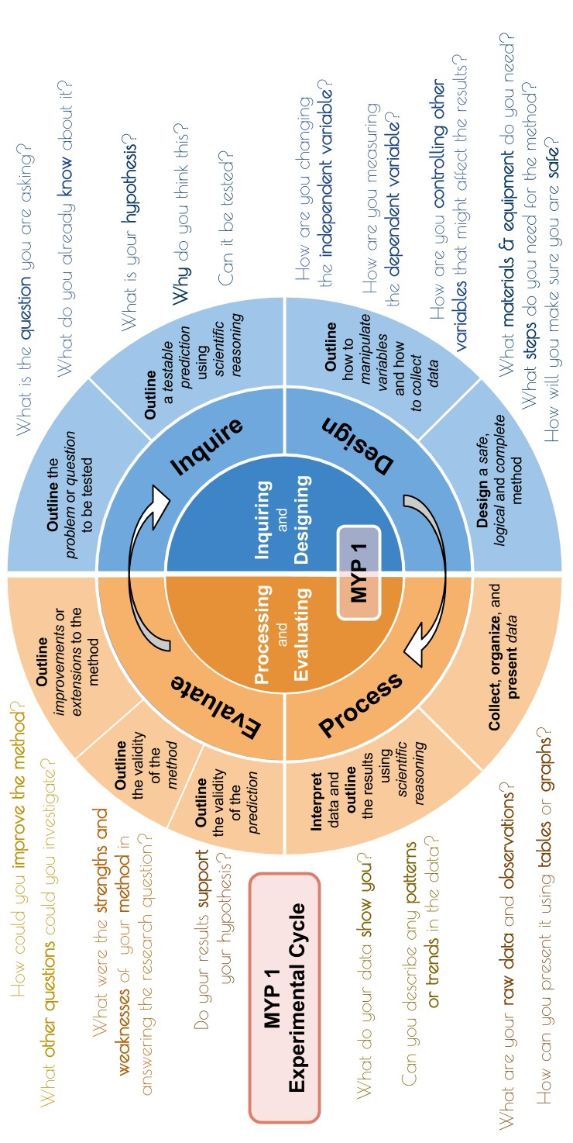

Use these sentence starters to plan your lab. Make sure your lab report has all four major sections.

Research Question: Explain the problem or question to be tested
❏ I want to investigate....
❏ This is because I have observed that…

OR
❏ I will test the effect of ... on ....
❏ This is because I have observed that…

❏ I have included some scientific background information. This should be about two paragraph.
❏ I have referenced my background information with in-text citation and transferred this to my references section at the end

Variables: Explain how to manipulate variables and how to collect data
❏ The independent variable is the variable I am changing.
❏ My independent variable is...
❏ I will change the independent variable by increasing / decreasing from … to …
❏ I will change the independent variable in increments of …
❏ The dependent variable is the variable I will measure.
❏ My dependent variable is...
❏ I will measure the dependent variable by...
❏ I will repeat my measurements ... times to be more reliable.
❏ The controlled variables are variables that I will keep the same to make my test more reliable. Identify at least 3-5.
❏ I will control … by … because …
I have given a detailed account of a problem I want to investigate using scientific facts and sources, and how it is connected to the topic we are studying. I have stated the problem as a research question that includes my variables.

I have given a detailed account of how to manipulate the independent variable, how to measure the dependent variable to collect sufficient relevant data, and how to manipulate all the controlled variables.

Hypothesis: Formulate a testable hypothesis using scientific reasoning
❏ I predict that if I increase / decrease ... then … will …
❏ This is because...
❏ Other information that supports my hypothesis is....
❏ Reference my scientific explanation and transferred this to my references section at the end
❏ My prediction is / is not testable. I know this because ….

Method & Materials: Design a safe, logical and complete method
❏ There are some / no risks in this investigation because...
❏ I will stay safe by ...
❏ I will keep others safe by ...
❏ I need to use these materials and equipment in my investigation...
❏ I need to carry out these steps in my investigation...
❏ I will repeat my method ... times
❏ This is a photo / diagram of my investigation
My hypothesis is testable and I provide details about my variables using words like ‘increase, decrease, no change’, and I have supported it clearly using correct scientific reasoning in my ‘because’ statement.

My procedures are safe, complete, and logical. Someone else would have no problem with my lab because I describe how to work with the variables and collect data.
I have selected every material I will need, including quantities, and I won’t need to ask for anything on the day of the lab.

Commonly-confused words. Make sure you use them correctly.

Facts
are simple truths that we use when we describe the universe. Often we can measure them.

A scientific problem is a question that we are trying to solve by making a hypothesis and testing it with an experiment.

Hypothesis
is a testable prediction that we make, with a logical reason.

Criterion B: Inquiring & Designing
- explain a problem or question to be tested by a scientific investigation
- formulate a testable hypothesis and explain it using scientific reasoning
- explain how to manipulate the variables, and explain how data will be collected
- design scientific investigations

Achievement Level | Level Descriptor | Clarifications
0 | The student does not reach a standard described by any of the descriptors below. | The student does not reach a standard described by any of the descriptors below.
1–2 | The student is able to;  - state a problem or question to be tested by a scientific investigation  - outline a testable hypothesis  - outline the variables  - design a method, with limited success. | - I attempted to state a research question with some variables  - I attempted to state a hhypothesis.  - I attempted to write a method
3–4 | - outline a problem or question to be tested by a scientific investigation  - formulate a testable hypothesis using scientific reasoning  - outline how to manipulate the variables, and outline how relevant data will be collected  - design a safe method in which he or she selects materials and equipment. | - I outlined a problem or question to be tested that contained the IDV and DV  - I formulated a hypothesis that contains the IDV and DV with a simple explanation  - I outlined how to manipulate the IDV; collect the DV; how to control the CV’s  - I have outlined a method which collects multiple sets of data points for the identified variables  - I have designed a method that is safe and contains the equipment used
5–6 | - describe a problem or question to be tested by a scientific investigation  - formulate and explain a testable hypothesis using scientific reasoning  - describe how to manipulate the variables, and describe how sufficient, relevant data will be collected  - design a complete and safe method in which he or she selects appropriate materials and equipment | - I clearly describe a focused problem or research question that contains the IDV and DV  - I have formulated a hypothesis that contains the IDV and DV and explained it scientifically with some errors  - I have described how to manipulate the IDV (4 data points); collect the DV (including units and measuring equipment); how to control the CV’s  - I have described how to collect the multiple sets of the data  - I have designed a detailed method which collects data for at least 4 data points, that is safe, and contains the equipment (amounts and sizes) used.
7-8 | - explain a problem or question to be tested b y a scientific investigation  - formulate and explain a testable hypothesis using correct scientific reasoning  - explain how to manipulate the variables, and explain how sufficient, relevant data will be collected  - design a logical, complete and safe method in which he or she selects appropriate materials and equipment | - I clearly explained a focused problem or research question that contains the IDV and DV and explained why it’s important  - I have formulated a hypothesis that contains a IDV and DV and clearly explained it scientifically  - I have explained how to manipulate the IDV (5 data points); collect the DV (including units and measuring equipment); why and how to control the CV’s  - I have explained how to collect the multiple sets of the data  - I have designed a detailed method which collects data from at least make the best use of available equipment and repeated measurement of at least 5 data points

Self Reflection Rubric
B | i. explain a problem or question to be tested by a scientific  investigation | ii. formulate a testable hypothesis and explain it using  scientific reasoning | iii. explain how to manipulate the variables, and explain how data  will be collected | iv. design scientific investigations
1-2 | I have stated a problem as a research question that connects with our topic. | My hypothesis is testable. | I have given brief details on the  variables. | I have a procedure written down for my lab.
3-4 | I have given brief details on how my problem is connected to the topic we are studying. I have stated the problem as a research question. | My hypothesis is testable, and includes my variables. | I have given brief details on how to manipulate the independent variable, how to measure the dependent variable to collect relevant data, and how to manipulate the controlled variables. | My procedures are safe.  I have selected the materials I will need.
5-6 | I have provided details on a problem I want to investigate, and how it is connected to the topic we are studying. I have stated the problem as a research question that includes my variables. | My hypothesis is testable and I provided details about my variables using words like ‘increase, decrease, no change’, and I have supported it clearly using scientific reasoning in my ‘because’ statement. | I have provided details on how to manipulate the independent variable, how to measure the dependent variable to collect sufficient relevant data, and how to manipulate all the controlled variables. | My procedures are safe and complete. Someone else could probably do my lab because I describe how to collect data.  I have selected the materials I will need, including quantities.
7-8 | I have given a detailed account of a problem I want to investigate using scientific facts and sources, and how it is connected to the topic we are studying. I have stated the problem as a research question that includes my variables. | My hypothesis is testable and I provide details about my variables using words like ‘increase, decrease, no change’, and I have supported it clearly using correct scientific reasoning in my ‘because’ statement. | I have given a detailed account of how to manipulate the independent variable, how to measure the dependent variable to collect sufficient relevant data, and how to manipulate all the controlled variables. | My procedures are safe, complete, and logical. Someone else would have no problem with my lab because I describe how to work with the variables and collect data.  I have selected every material I will need, including quantities, and I won’t need to ask for anything on the day of the lab.

