We use the experimental cycle to help us plan, carry out and write about scientific investigations.

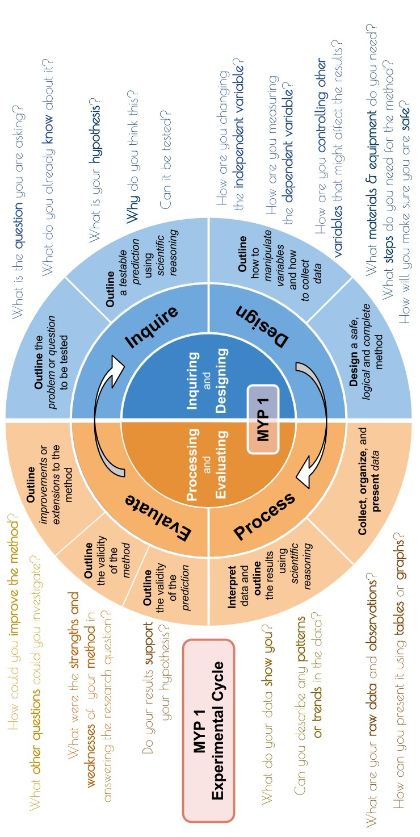

Use these sentence starters to guide the conclusion section of your lab report.

Data: Collect, transform and present data
❏ This table shows my measurements.
❏ This graph shows my final results.
❏ I made these observations while carrying out my experiment...
❏ I think my data were / were not reliable because...

RECORDING RAW DATA:
❏ Large, clear table for your raw (un-processed) results.
❏ Title a descriptive of the data contained in the table.
❏ Table includes the key variables as well as any specific conditions of the experiment
❏ Units and labels identified
❏ Table numbered consecutively throughout the report with a specific identifying title.

Title: Table 1
Independent  Variable  (units) | Dependent  Variables  (units)
 | Trial 1 | Trial 2 | Trial 3 | Trial 4 | Averages

DRAWING YOUR GRAPH

Think about why you are drawing your graph …. It should be a visual representation of the data that allows you to answer the Aim. Therefore it should look like this

Title: Figure 1

Dependent Variable
(units)

Independent Variable
(units)

❏ Large, clear graph of your averaged (processed) results.
❏ Identified data as continuous (line) and discontinuous (bar)
❏ Title a descriptive of the data contained in the table.
❏ Table includes the key variables as well as any specific conditions of the experiment
❏ Units and labels identified
❏ Included a key
❏ Graph numbered consecutively throughout the report with a specific identifying title

I have correctly organized the data I collected in my electromagnet experiment using tables that include units in the proper place. I have processed my data using proper methods and showed examples. My graph is correct, including titles, axis labels, and I have used lines of best fit.

Patterns: Interpret data and explain the results using scientific reasoning
❏ My data show that ....
❏ My data suggest that ...
❏ This might be because ...
❏ Another source that supports this reason is... which says... and transferred this to my references section at the end
❏ I conclude that this experiment has / has not helped me solve my original problem. This is because...

I have correctly used knowledge and understanding of science to recognize patterns and draw conclusions from the data. I have correctly given a detailed account of how and why the variables are related.

Validity of Hypothesis: Discuss the validity of the hypothesis
❏ I predicted that ...
❏ My data support / do not support /partially support my prediction.
❏ I think this because...

Validity of Method: Evaluate the validity of the method
❏ The method I followed did allow / did not allow / partially allowed me to answer the research question.
❏ I think this because…
❏ Some strengths in the method were...
❏ Some weaknesses in the method I was given were...
❏ Something I found difficult in carrying out the method was...
❏ If I wanted to test the same problem again, I would / would not use
the same method. This is because...
I have evaluated my hypothesis by weighing up the strengths and limitations of the data I collected, and have used the data to clearly state if I my hypothesis has been supported or not. I use scientific reasons and sources to help explain my reasons.

I have evaluated my method by weighing up the strengths and limitations of my procedures and lab work. I have specifically discussed the validity and reliability of my methods in the table and addressed its significance.

Improvements: Explain improvements or extensions to the method
❏ I could improve the method by ....
❏ I would make these improvements because...
❏ This investigation has made me think of a new question, which is...
❏ I could test this by...
❏ I would like to find out more about ... because...
I have given a detailed account of how I suggest improvements to specific limitations in my procedures. These suggestions are realistic and based on scientific reasoning and research.

Commonly-confused words. Make sure you use them correctly.
Facts
are simple truths that we use when we describe the universe. Often we can measure them.

Hypothesis
is a testable prediction that we make, with a logical reason.
Good scientists
are not trying to 'prove' themselves 'right'.
Good scientists want to test their ideas in case they are not supported. This gives them more interesting questions to ask next
‘Banned words’
• "Proves"
• "Correct"
• “Right"
• "Wrong"
These are not
scientific.
Instead we talk about how the evidence we collect (our data) do or do not support our hypothesis.

MYP 4/5 Science (Grade 9/10) Lab Conclusion Sentence Starters Name:

(CC) St
Modifie

ephen Taylor (@iBiologySteph d by Brian Neises (@theMYPte

en), Canadian Academy, base acher).

d on MYP Sciences Guide (2

014)
Criterion C: Processing & Evaluating
- present collected and transformed data
- interpret data and explain results using scientific reasoning
- evaluate the validity of a hypothesis based on the outcome of the scientific investigation
- evaluate the validity of the method
- explain improvements or extensions to the method

Achievement Level | Level Descriptor | Clarifications
0 | The student does not reach a standard described by any of the descriptors below. | The student does not reach a standard described by any of the descriptors below.
1–2 | The student is able to;  - collect and present data in numerical and/or visual forms  - interpret data  - state the validity of a hypothesis based on the outcome of a scientific investigation  - state the validity of the method based on the outcome of a scientific investigation  - state improvements or extensions to the method | - I attempted to collect and present DV’s and IDV’s in a table or graph  - I attempted to observe trends in the data  - I stated how the data supports or rejects the hypothesis validity of a hypothesis based on what happened in the experiment  - I stated improvements or extensions to the method
3–4 | - correctly collect and present data in numerical and/or visual forms  - accurately interpret data and explain results  - outline the validity of a hypothesis based on the outcome of a scientific investigation  - outline the validity of the method based on the outcome of a scientific investigation  - outline improvements or extensions to the method that would benefit the scientific investigation. | - I correctly collected and presented the DV/s and IDV/s in a table or graph  - I stated a trend based on the data  - I outlined how the data supports or rejects the hypothesis validity of a hypothesis based on what happened in the experiment.  - I outlined if the method allowed for sufficient collection of data based on the outcome  - I outlined improvements to the method that would benefit the scientific investigation
5–6 | - correctly collect, organize and present data in numerical and/or visual forms  - accurately interpret data and explain results using scientific reasoning  - discuss the validity of a hypothesis based on the outcome of a scientific investigation  - discuss the validity of the method based on the outcome of a scientific investigation  - describe improvements or extensions to the method that would benefit the scientific investigation. | - I collected the DVs, show how the IDV’s were manipulated and organized and presented the data in a suitable table or graph  - I drew a line / curve of best fit (if appropriate)  - I described most relevant trends in the data and made links to correct scientific reasoning  - I discussed how the data supports or rejects the hypothesis validity of a hypothesis based on what happened in the experiment  - I considered multiple problems of my results with regard to the hypothesis and method  - I discussed if the method allowed for sufficient collection of data based on the outcome  - I described clear improvements to the method that would benefit the scientific investigation.
7-8 | - correctly collect, organize, transform and present data in numerical and/or visual forms  - accurately interpret data and explain results using correct scientific reasoning  - evaluate the validity of a hypothesis based on the outcome of a scientific investigation  - evaluate the validity of the method based on the outcome of a scientific investigation  - explain improvements or extensions to the method that would benefit the scientific investigation | - I correctly collected the DV’s, showed how the IDV’s were manipulated and organized, transformed data by including calculations and presented the data in a table or graph with clear headings, labels and units.  - I drew a line / curve of best fit (if appropriate)  - I described all relevant trends in the data and explained them scientifically  - I clearly considered the strengths and limitations of my data and if the data supported or rejected the hypothesis based on what happened in the experiment  - I considered multiple problems of my results with regard to the hypothesis and method  - I clearly considered the strengths and limitations of the method to determine if the method allowed for sufficient collection of data based on the outcome.  - I made clear and realistic improvements and explained why they would benefit the scientific investigation

Self Reflection Rubric
C | i. present collected and transformed data | ii. interpret data and explain results using scientific reasoning | iii. evaluate the validity of a hypothesis based on the  outcome of an investigation | iv. evaluate the validity of the method | v. explain improvements or extensions to the  method
1-2 | I have presented the data I collected in my experiment using tables or graphs. | I have used knowledge and understanding of science to recognize patterns and draw conclusions from the data. | I have evaluated my hypothesis by stating if it has been supported or not, based on my data. | I have evaluated my method by listing errors in my procedures and lab work. | I have stated how I suggest improvement to limitations in my procedures.
3-4 | I have presented the data I collected in my experiment by using the correct type of graph, including titles, axis labels. | I have used knowledge and understanding of science to recognize patterns and draw conclusions from the data. I have given an account of how and why the variables are related. | I have evaluated my hypothesis by briefly mentioning the data to state if I my hypothesis has been supported or not, based on my data. | I have evaluated my method by briefly considering my procedures and lab work. | I have given brief details of how I suggest improvement to limitations in my procedures.
5-6 | I have organized the data I collected in my experiment using tables that include units in the proper place. My graph is the correct type, including titles, axis labels, and I have used lines of best fit. | I have correctly used knowledge and understanding of science to recognize patterns and draw conclusions from the data. I have given a detailed account of how and why the variables are related. | I have evaluated my hypothesis by considering many possibilities. I have used the data to clearly state if I my hypothesis has been supported or not. I use scientific reasons and sources to help explain my reasons. | I have evaluated my method by considering the strengths and limitations of my procedures and lab work. I have discussed the validity and reliability of my methods, and addressed its significance. | I have provided details of how I suggest improvement to limitations in my procedures. These suggestions are realistic and based on scientific reasoning and research.
7-8 | I have correctly organized the data I collected in my experiment using tables that include units in the proper place. I have processed my data using proper methods and showed examples. My graph is correct, including titles, axis labels, and I have used lines of best fit. | I have correctly used knowledge and understanding of science to recognize patterns and draw conclusions from the data. I have correctly given a detailed account of how and why the variables are related. | I have evaluated my hypothesis by weighing up the strengths and limitations of the data I collected, and have used the data to clearly state if I my hypothesis has been supported or not. I use scientific reasons and sources to help explain my reasons. | I have evaluated my method by weighing up the strengths and limitations of my procedures and lab work. I have specifically discussed the validity and reliability of my methods in the table and addressed its significance. | I have given a detailed account of how I suggest improvements to specific limitations in my procedures. These suggestions are realistic and based on scientific reasoning and research.

