Natural Selection Simulation at PHET

Name:__________________________________________

http://phet.colorado.edu/simulations/sims.php?sim=Natural_Selection (biol.co/2wolf2)

Exploration
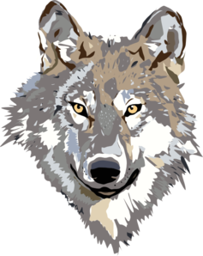
Access the simulation and explore the settings. Answer the following questions.

1. What are some VARIABLES that you have control over in the simulation?

2. What happens to the bunny population if a friend is never added? What happens when you add a friend?

3. What happens when you add food as a selection factor?

4. What is the difference between the arctic and equator environment?

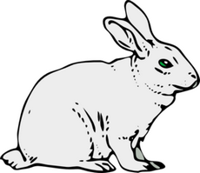
5. What is a genetic mutation? What are the three mutations you can add to your bunny population?

Experiment A - Does brown fur provide an advantage?

a. Add a friend and a brown fur mutation to the bunny population, let the experiment continue to its conclusion.

b. Start over and add brown fur mutation (with friend) but add a selection factor of wolves when your bunnies start to get overpopulated. Let the experiment run until you have a clear idea of what is happening with the rabbit and wolf populations.

c. Change the settings so that you still have brown fur mutations but this time remove the wolves and make the selection factor be food. Let the experiment run until you have a clear idea of what is happening within the population.

d. Reset and change the settings so that you have brown fur mutation in an arctic environment, use wolves as your selection factor.

6. Based on the four simulations you ran, describe what happened to your population and answer the experimental question "Does brown fur provide an advantage?". Provide evidence from the simulation to support your conclusions.

Experiment B - Does long teeth provide an advantage?

7. Following the guidelines from the Experiment A, determine when long teeth provides an advantage to the bunny population. Based on your tests showing long teeth in a variety of situations, determine when long teeth provide a selective advantage. Provide evidence from the simulation to support your conclusion.

Experiment Challenge

8. Using the simulation, determine the conditions when a long tail would be an adaptation. If you cannot discover this from the simulation, propose any possible situation where a long tail would provide a selective advantage for bunnies and explain WHY it would be an advantage.

Post-Lab Analysis

9. Define variation. What genetic variations are presented during this simulation?

10. Define adaptation. Give examples when an adaptation is beneficial to the bunnies.

11. What are 3 other (natural) section factors which effect animal populations in the real world?

12. How has this simulation added to your knowledge of evolution (the study of life’s history)?

