Predator Prey Case Study
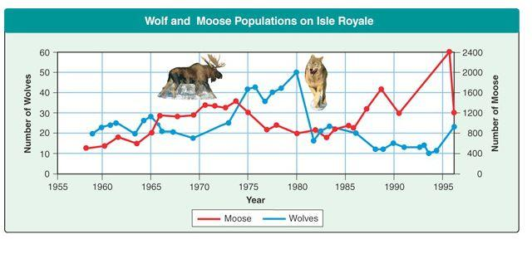
In a stable ecosystem, the number of predators and the number of prey fluctuate, but remain relatively constant. Three factors can affect the cycling of predator and prey numbers:
- The reproductive rate of the prey (birth rate)
- The number of prey eaten by each predator
- The reproductive rate of the predator

Before you begin this simulation, watch “The Wolves and Moose of Isle Royale” video. This case study is the background information for the simulation.
In this simulation, you will manipulate several variables to determine how they affect the overall predator and prey populations.
- Read through the tutorial.
- Keep the following sliders constant (your CV): predator effectiveness, habitat variability and carrying capacity.
The simulation is located below.
https://sites.google.com/site/biologydarkow/ecology/predator-prey-simulation-of-the-lotka-volterra-model
Step 1: Develop your hypothesis
Consider the variables and develop a hypothesis to predict how changing variables affects predator and prey populations. An if-then statement is appropriate in this case, for example: "If the reproductive rate of the prey is increased then [ what must happen ] in order for the ecosystem to remain in balance.
Step 2 : Collect data
Use the simulator to view how populations are affected by changing the variables. In many cases, changing the variables will result in a crash of both species. Finding the appropriate balance will require trial and error. Make sure that you select the “Show the scatter plot of the predator-prey relationship (then run)”. You want the circle to be as round as possible. Keep notes (or screen shots) of your data and outcomes as you manipulate your variables. You will need this later for your lab report.
[When your ecosystem is in balance, you will need to take a "snapshot" of your graph on the screen. To do this, find the "print screen" button on the keyboard or COMMAND+SHIFT+F4. This will create a screen shot.
Be sure the label each image with an appropriapriate “Figure” title
Step 3: Conclusions and Report
Use Google Doc and write your report. It should include your hypothesis, your data (graphs) and a written conclusion of your findings. This lab report does not need to be very long, a single page should be sufficient.
* Accept or reject your hypothesis (prediction)
* EXPLAIN what happened in the experiment as you adjusted the variables (prey and predator reproductive rates, and the number of prey eaten
Write a concluding statement about how the simulation applies to real-life populations and predator prey cycles. Emphasis should be on energy, equilibrium, and feedback loops. In addition, evaluate the simulation as a model for determining feedback loops
Format for Report
- Title and Name
- Hypothesis: Write your if-then statement from Step 1.
- Results (Data): Print a snapshot of your balanced ecosystem from Step 2.
- Conclusions:
RESULTS, ANALYSIS AND CONCLUSION

Achievement level | Descriptor
0 | The student does not reach the standard of any of the descriptors given below
1 -2 | constructs some diagrams, charts or graphs of quantitative and/or qualitative data, but there are significant errors or omissions
 | analyses some of the data but there are significant errors and/or omissions
 | states a conclusion that is not supported by the data
 | states one potential application and/or solution to a real life population
3 -4 | constructs diagrams, charts or graphs of quantitative and/or qualitative data that are appropriate but there are some omissions
 | analyses the data correctly but the analysis is incomplete
 | interprets some trends, patterns or relationships in the data so that a conclusion with some validity is deduced.
 | describes one potential application and/or solution to a real life population
5 - 6 | constructs diagrams, charts or graphs of all relevant quantitative and/or qualitative data appropriately
 | analyses the data correctly and completely so that all relevant patterns are displayed
 | interprets trends, patterns or relationships in the data, so that a valid conclusion to the research question is deduced
 | justifies one potential application and/or solution to a real life population

Checklist

Hypothesis
· Does your hypothesis contain researched scientific reasoning (not simply prior knowledge)
· Does your hypothesis clearly state what you expect to happen to your dependent variable when the independent is changed? What do you expect your graph to look like (if possible)
Is your hypothesis testable? Meaning can you actually determine if it is true
Data
· Snapshop has a clear title e.g. Graph 1 showing….. (I should know what it is about without reading the paper)
· Does your graph show the relationship between independent and dependent variables
Analysis and conclusion
· Discuss any patterns and trends in your graph
· Make sure you constantly support anything you write with numbers from your graph
· The conclusion should discuss how well you can answer your hypothesis with your data
· Did you discuss your research question and hypothesis using data ( tables, graphs, and figures in your data section) from your investigation?
· Does it discuss trends, patterns, or relationships between independent and dependent variables? (using both qualitative and quantitative data?)
Did you emphasize energy, equilibrium, and feedbacks with emphasis on negative feedback.
· Did you link your conclusion to a real life population? Did you give valid reasons or evidence to support an answer or conclusion.
· Did you evaluate the simulation

