Name:__________________________________ Pd: ______ Date:________________

Salinization Lab

Abstract
This lab activity has students work in teams to determine the effect salt has on plant germination. They will use their lab data to create a report on how the increasing salt concentrations affect the germination of the seeds.

Introduction
Salt buildup is a potential problem on almost all of the irrigated farmland in the United States. Much of the world's unused land is in arid or semiarid regions where irrigation would be necessary to grow crops. A small amount of salt in the soil will not affect the germination and growth of crops. Eventually, however, if salt concentrations increase, negative impacts occur. Eventually salt concentrations will affect the germination of seeds. Farmers need to know the relationship between the salt concentration and the percent of seeds that will germinate.

Salt kills germinating seedlings by removing the water from their cells. There are several salts that are responsible but this lab will involve only one, sodium chloride (NaCl). From your results you can assume that other salt concentrations would also affect germination rates.

Procedure
Seeds were placed in petri dishes and exposed to various concentrations of salt solutions.

1) After reading the Introduction determine your hypothesis:
Hypothesis = ___________________________________________________________________
_______________________________________________________________________________
_______________________________________________________________________________

2) Identify the independent and dependent variables:
Independent variable = ___________________________________________________________
Dependent variable = ____________________________________________________________

3) What will be measured? ________________________________ How? ________________________

4) What will be used as the control? ______________________________________________________ What are the constants? ________________________________________________________________

Graph
From the data table (on the next page) you should be able to construct a line graph on which you compare the days on the x - axis with the number of seeds that germinated on the y-axis.

Be sure and give your graph a title, label the axes, and include a key.

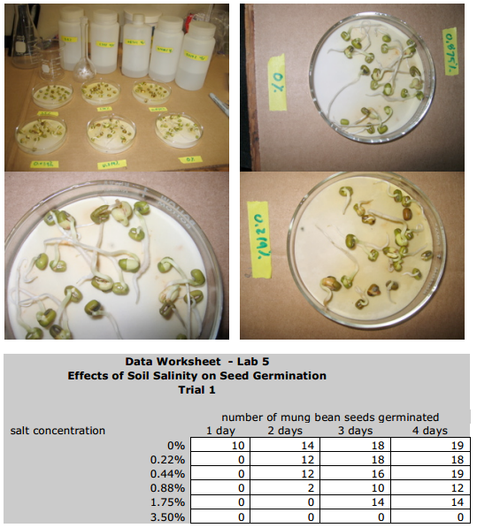

Analysis Questions
1) What is the relationship between the number of seeds that germination and the salt concentration of the water?

2) What is the effect of salinized agricultural land on developing crops? (real life connection)

3) Why was it necessary in the experimental design to have some seeds germinating in pure distilled water (0%)?

4) Did the experimental data support your hypothesis? Explain.

5) What are possible sources of error in this experiment?

6) In addition to determining the number of germinations, what other data could have been collected to determine the effect of soil salinity on plant growth?

7) Apply this investigation to one potential application and/or solution to the an environmental issue

