Tipping Point Assignment

You may do this assignment in pen/pencil or electronically (but electronically is easier).

1. Read the 2 pages on tipping points and resilience ​
​
2. Go to http://www.ecotippingpoints.org/education/feedback-diagrams-for-teachers/index.html ​

3. Scroll down and read the "background​" (see example below)

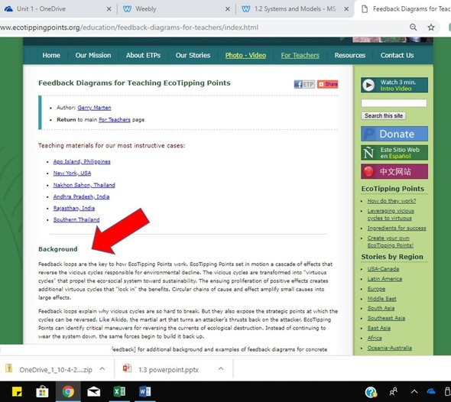

​​​​4. Select ONE of the links for "Teaching materials for the most instructive cases" listed (see example below)
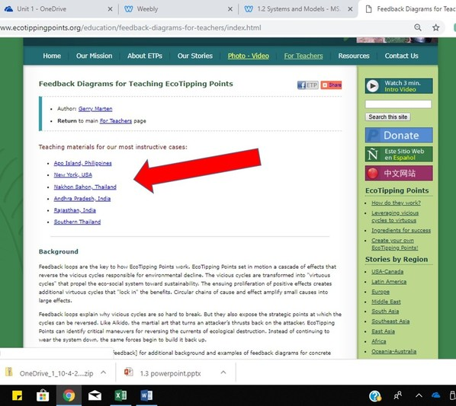

​5. Click on ‘View full Story’ and read the article (see example below)
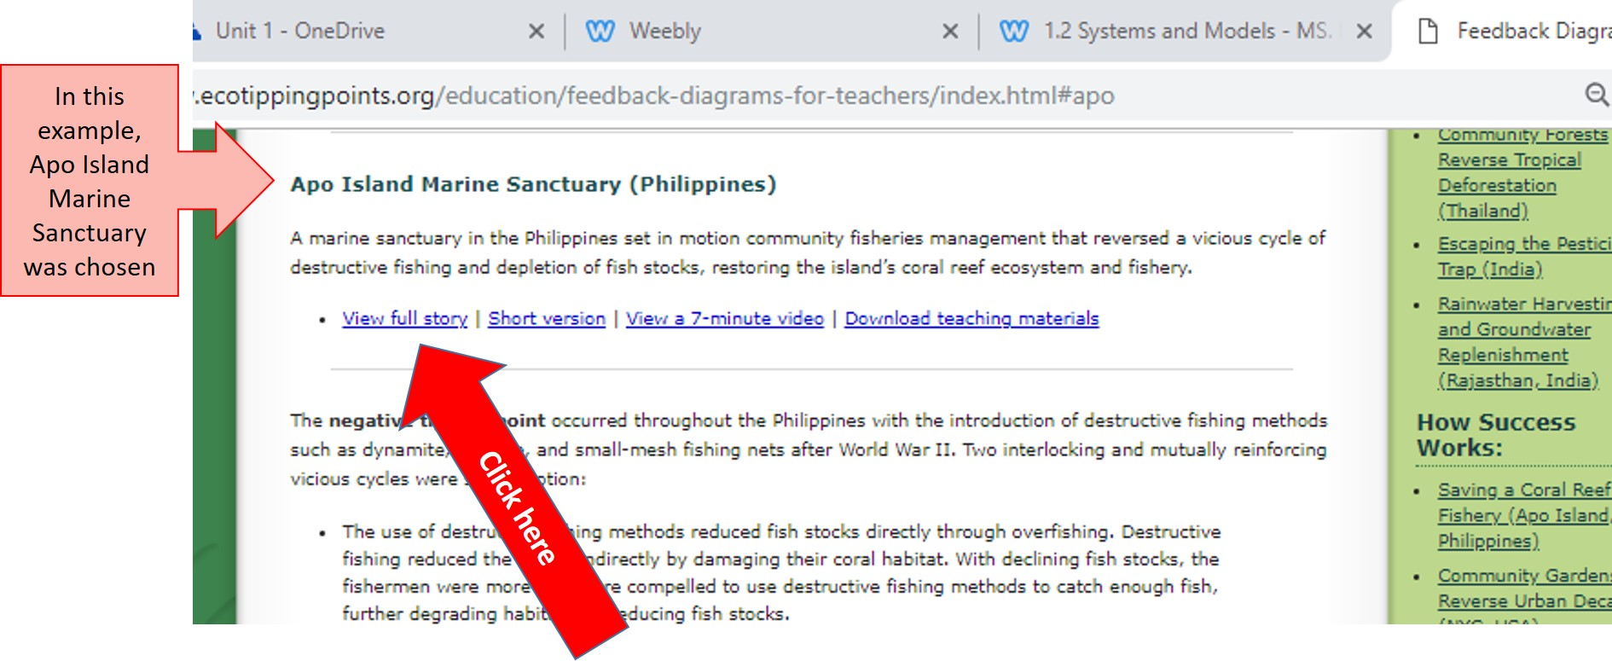

​6. Use the information in the article to complete the graphic organizer below to help you organize the main ideas in the article (use bullet points – no more than 3-4 per box)

NOTE: there may be A LOT of text - just skim to find the important info!!

Who was involved:
What happened
When did it happen
Where id it happen
Why did it happen
How did it happen
How was the problem solved
What does the future hold

​7. Download the teaching materials for that case
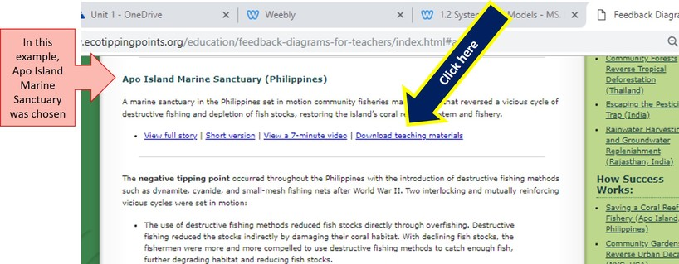
​8. Summarize the negative and positive tipping points for your case into the table in your document
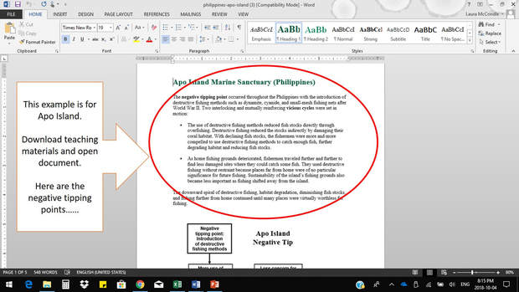

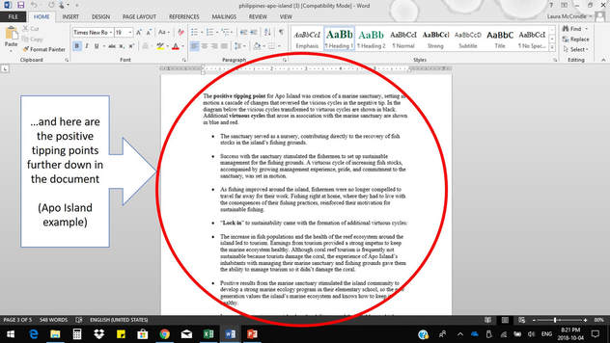
9. ​Copy, paste and complete (<--ignore this) the feedback loop diagram to show how the ‘vicious’ circle was transformed into a ‘virtuous’ circle for your case study

Just ignore the feedback loop that you complete and copy and paste the completed one.

Here's an example for Apo Island:
