Topic 1.1 Perspectives

Guiding questions
- How do different perspectives develop?
- How do perspectives affect the decisions we make concerning environmental issues?

Understandings | Class | Home | Got it
"1.1.1 A perspective is how a particular situation is viewed and understood by an
individual. It is based on a mix of personal and collective assumptions, values and beliefs."
"1.1.2. Perspectives are informed and justified by sociocultural norms, scientific
understandings, laws, religion, economic conditions, local and global events, and lived experience, among other factors.
"1.1.3 Values are qualities or principles that people feel have worth and importance in life."
"1.1.4 The values that underpin our perspectives can be seen in our communication and actions with the wider community. The values held by organizations can be seen through advertisements, media, policies and actions.
"1.1.5 Values surveys can be used to investigate the perspectives shown by a particular social group towards environmental issues"
"1.1.6 Worldviews are the lenses shared by groups of people through which they perceive, make sense of and act within their environment. They shape people’s values and perspectives through culture, philosophy, ideology, religion and politics"
"1.1.7 An environmental value system is a model that shows the inputs affecting our perspectives and the outputs resulting from our perspectives."
"1.1.8 Environmental perspectives (worldviews) can be classified into the broad categories of technocentric, anthropocentric and ecocentric"
"1.1.9 Perspectives and the beliefs that underpin them change over time in all societies. They can be influenced by government or non-governmental organization (NGO) campaigns or through social and demographic change.
"1.1.10 The development of the environmental movement has been influenced by
individuals, literature, the media, major environmental disasters, international agreements, new technologies and scientific discoveries."

Perspectives

- Define environmental perspectives. Suggest why are they important?

- Suggest how personal and collective assumptions influence these perspectives?

- Watch the TEDx video on "Changing Perspectives: The Promise and Challenge of Renewable Energy," Answer the following that probe into the complexities of renewable energy from various perspectives.

  - What are the main promises of renewable energy mentioned in the video?

  - What challenges and obstacles are associated with the adoption of renewable energy, according to the speaker?

  - How does the speaker suggest overcoming these challenges?

  - Can you identify any underlying perspectives (technocentric, anthropocentric, ecocentric) in the speaker's viewpoint on renewable energy? How do these perspectives influence their argument?

  - Reflect on your own perspective regarding renewable energy before and after watching this video. Has your viewpoint changed or expanded in any way? Explain your answer.

- Complete the diagram of the perceptive hierarchy

Perspective

- "The global textile industry plays a significant role in our economy and environment; reflecting on this, what is your perspective on the global textile industry?"

- With reference to the slide 7, select the top three factors you believe most influences your own perspectives
  - Write a brief reflection on why you chose each of the three factors. How have these shaped your viewpoints.
  - Think of specific examples from your lives or current events that illustrate this influence.

Values

- Outline the three main values

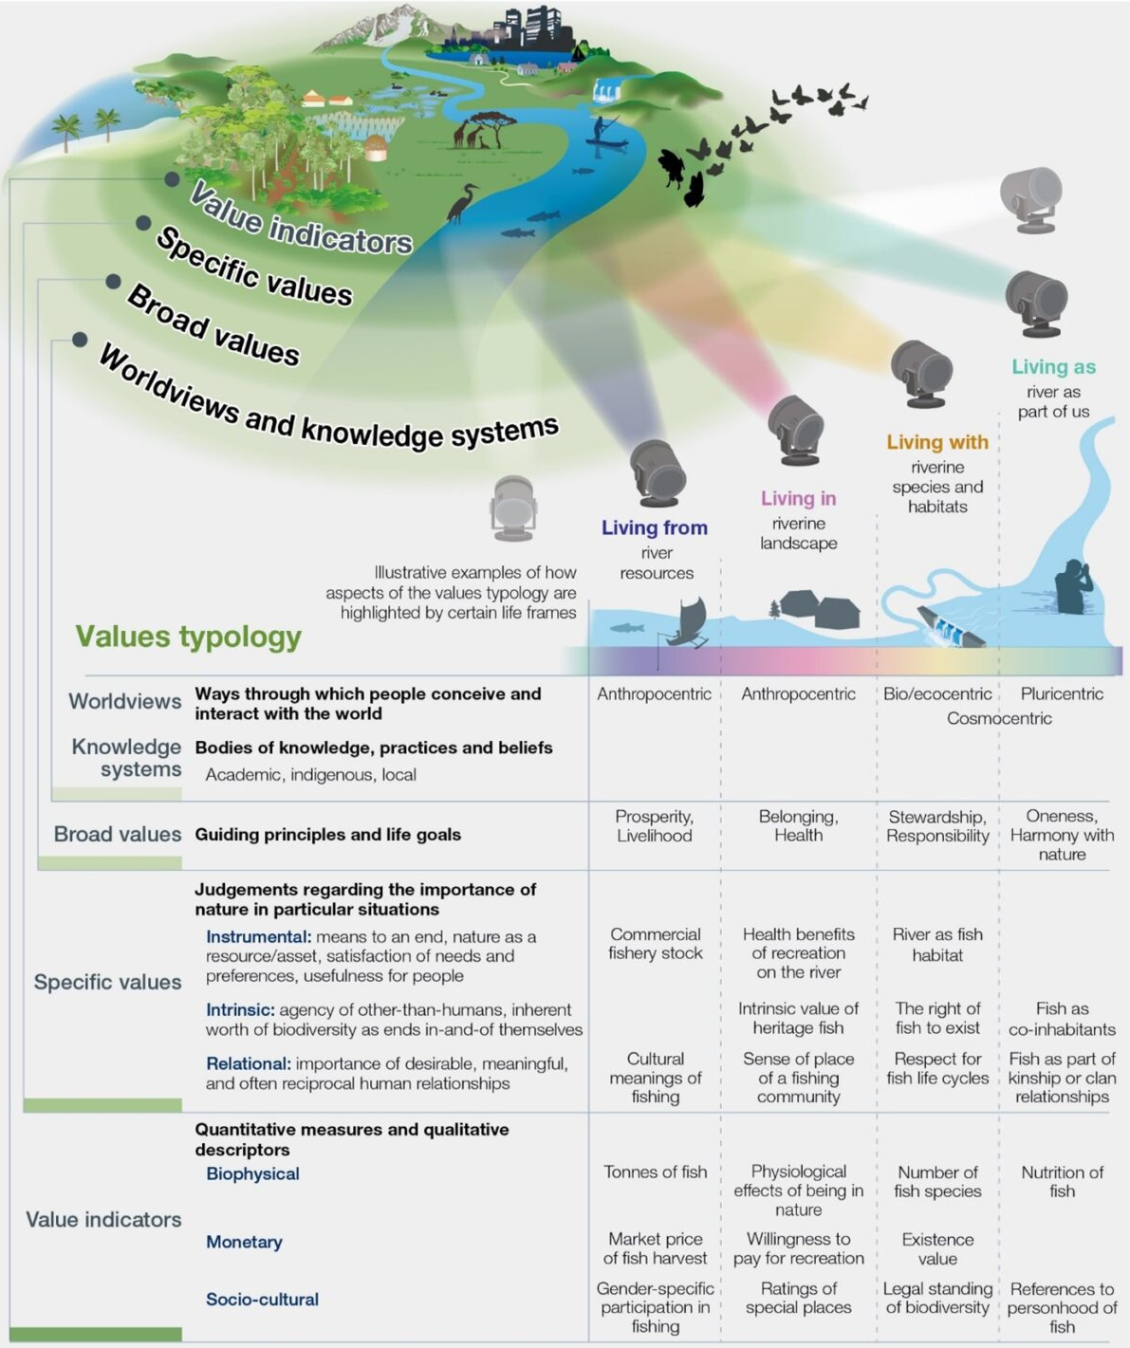
- Reference the infographic illustrating common environmental values and their impacts on decision-making. Discuss how your top values influence your decisions on environmental issues.

- Watch the video on Indigenous knowledge https://youtu.be/eH5zJxQETl4. Answer the following questions
  - Describe the four indigenous land management techniques that Lyla tells us about and explain how they function - what elements of natural systems enhance?

  - Suggest the broad values do you think Lyla June is demonstrating

  - State the type of specific values she demonstrate

  - Justify your placement of Lyla June's life frame and environmental value system (evs).

  - State how your life frame and EVS compare to Lyla June's

- HL ONLY - Watch the video on intrinsic values https://www.youtube.com/watch?v=9i4EexIF_3E and https://www.youtube.com/watch?v=Jrd9bmgOCVI
Give two examples of intrinsic values. Identify an intrinsic value for yourself. Justify your answer. (Identify: Find an answer from a given number of possibilities)

- HL ONLY - Outline instrumental values. Suggest an example

- Different values often lead to tensions between individuals and between organizations. Watch the video on the Keystone Pipeline https://youtu.be/fCPWjg-bXTY . Identify the stakeholders and their individual values

- Construction of large-scale solar farms in the Mojave desert areas are home to the threatened species of desert tortoise and ancient rock art and sacred heritage sites. What values do you think are important?

Worldviews

- Define the term world views

  - How might the world view of a Buddhist be different from yours?

- Complete the table below

World View | Definition | Example
Imperialist worldview:

Stewardship worldview:

Romantic worldview:

Utilitarian worldview:

- Reference the infographic. Outline how the development of the internet and social media can influence a person's perspective by a far greater variety of worldviews than just that of the local community.

Environmental Value Systems

- Complete the systems diagram for an EVS below. Add any additional inputs and outputs
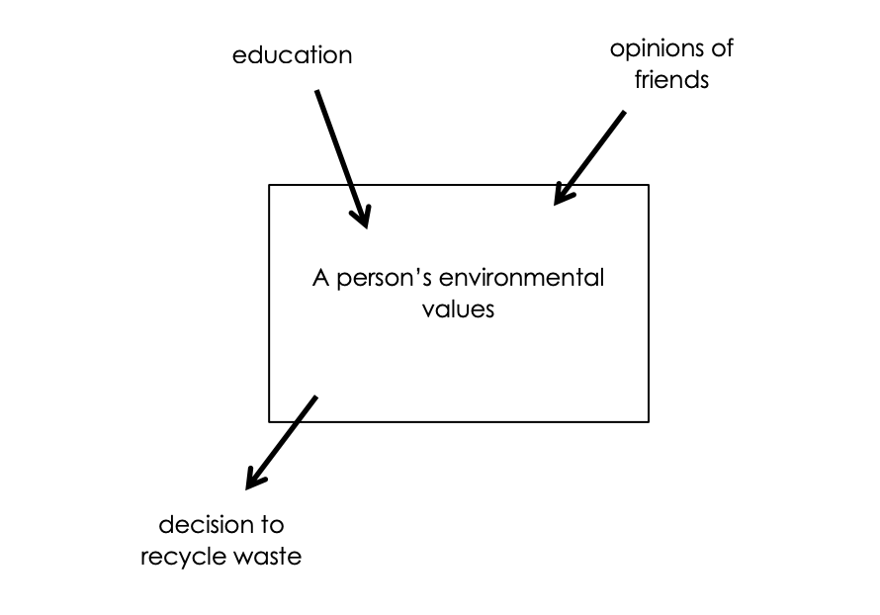

- Define the following value systems:

  - Ecocentric

  - Anthropocentric

  - Technocentric

- The country of Chile is looking to build a large hydroelectric dam in Patagonia in order to support the increased demand of electricity due to its growing population and industry. Outline some possible viewpoints of the following types of people. (Outline: Give a brief account or summary)

Ecocentric

Anthropocentric

Technocentric

- Complete the following table

Environmental Issue | Ecocentrist | Anthropocentrist | Technocentrists
International ivory trade and poaching |  | How can farmers co-exist with elephants?
Rainforest destruction | Safe the trees. It’s the animals’ home first
Intrinsic value of an old growth forest

- View 4 of the videos below. Decide where they lies on the environmental philosophies’ continuum.
- Matt Ridley—The Natural Optimist (https://www.youtube.com/watch?v=Wqr2xfppFuQ&feature=related)
- Going Green—Militant bicyclists and more (https://www.youtube.com/watch?v=DBP2LTQxqZ8)
- Rush Limbaugh blasts a Global Warming caller(https://www.youtube.com/watch?v=atE_QvWwtHo&feature=youtu.be
- Bjorn Lomborg talks about Al Gore overselling Climate Change (https://www.youtube.com/watch?v=-Z_IC3xrgJk&feature=youtu.be)
- Cloud seeding and other Geo-engineering solutions to environmental issues (https://www.youtube.com/watch?v=SvrEAj5JhG8&feature=youtu.be)
- Life in a Russian Eco-village (https://www.youtube.com/watch?v=EjdRxCmPJsk&feature=related)
- Al Gore—Five years after The Inconvenient Truth (https://www.youtube.com/watch?v=aU97aaKZT1g)
- Satish Kumar explains the meaning of Deep Ecology (https://www.youtube.com/watch?v=R2gZ6FRhc3w&feature=youtu.be)

- Write a brief paragraph on your own personal views on environmental systems. Reflect upon where you stand on the continuum of environmental philosophies with regard to specific issues arising throughout the syllabus.
Note: You may have a combination of different viewpoints, this is fine. There is no wrong answer when giving your opinion but you do need to be able to justify it.
  - population control

  - resource exploitation

  - sustainable development

  - any other ideas you feel important
.

Cultural Theory

- The city of Roswell is considering two proposals for a large, undeveloped plot of land in the heart of the city. One proposal aims to develop the land into a green public park (the Green Space Initiative), promoting biodiversity, recreation, and environmental education. The other proposal seeks to build a new commercial and residential complex (the Urban Expansion Project) to stimulate economic growth and provide housing.

Suggest a proposal to approve, considering the city's needs, economic benefits, environmental impact, and public opinion.

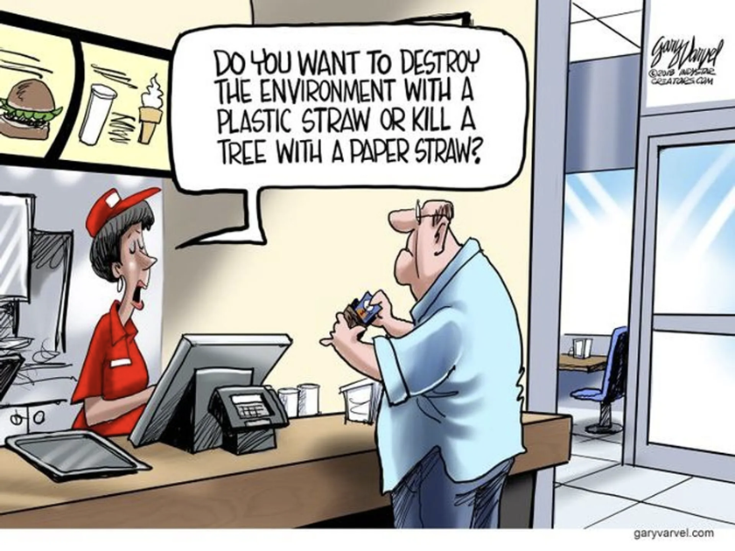
- Look at the image on the right, Suggest how this image reflect your own views on environmental responsibility. Suggest how it might contrast with Aboriginal communities of Australia On the use of plastic and paper products? Evaluate the potential biases in both your perspective and others."

Changes in Perspectives

- Suggest why there is a shift in public opinion regarding nuclear energy and propose reasons for this change.

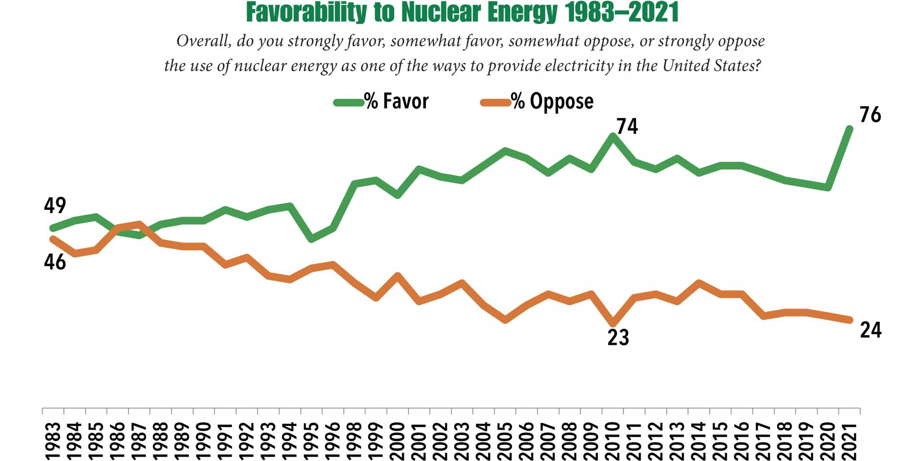

- Research and interpret two behaviour-time graphs (a great source, One World in Data https://ourworldindata.org/) . Examples could include specific changes, such as smoking, littering, eating meat or how traditional lifestyles in indigenous cultures are being replaced by modern ones.

History of Environmentism

- List the seven categories that have influenced the development of the environmental movement

- Make a mind map or write a short in-depth report on ONE example from EACH of the the 7 categories that influenced the environmental movement. Identify, when the event occurred and why it is significant to the modern environmental movement. Feel free to include images. Make sure that you cite and source your resources.
You also have the option to write about events that are culturally or locally interesting to you. These may be from indigenous cultures or local or global events as they arise.
Remember to focus on how these events are developing the environmental movement.

Note. You can use the QR codes to find examples.

Reflection Journal: Write down your thoughts, questions, and reflections on what they have learned.

ESS can be like learning a new language. So many words are not commonly used in everyday English. This can be challenging. To help you keep up with ESS Terms, you will need to create your own ESS DICTIONARY. You should add to this over the year and keep it in your notebook or on a page file THAT YOU CAN UPDATE AND ADD TO EASILY. Most of the vocabulary words can be found either on your STUDY GUIDE or at mrgscience.com.
You will be responsible for learning the words and their meaning. Periodic quizzes will be given on the words. So, make your dictionary creative and you will remember the words more easily.

KEY TERMS

Perspective

Specific values

Broad values

Value indicator

Intrinsic value

World views

Environmental values

Cultural theory

Technocentrism

Anthropocentrism

Rights of nature

ecocentrism
​
​environmentalism

intrinsic value

Values survey
​

​

