Topic 1.2 Systems

Guiding questions
- How can the systems approach be used to model environmental issues at different levels of complexity and scale?

Understandings | Class | Home | Got it
1.2.1 Systems are sets of interacting or interdependent components.
1.2.2 A systems approach is a holistic way of visualizing a complex set of interactions, and it can be applied to ecological or societal situations.
1.2.3 In system diagrams, storages are usually represented as rectangular boxes and flows as arrows, with the direction of each arrow indicating the direction of each flow.
1.2.4 Flows are processes that may be either transfers or transformations.
1.2.5 Systems can be open or closed.
1.2.6 The Earth is a single integrated system encompassing the biosphere, the hydrosphere, the cryosphere, the geosphere, the atmosphere and the anthroposphere.
1.2.7 The concept of a system can be applied at a range of scales.
1.2.8 Negative feedback loops occur when the output of a process inhibits or reverses the operation of the same process in such a way as to reduce change. They are stabilizing as they counteract deviation.
1.2.9 As an open system, an ecosystem will normally exist in a stable equilibrium, either in a steady- state equilibrium or in one developing over time (for example, succession), and will be maintained by stabilizing negative feedback loops.
1.2.10 Positive feedback loops occur when a disturbance leads to an amplification of that disturbance, destabilizing the system and driving it away from its equilibrium.
1.2.11 Positive feedback loops will tend to drive the system towards a tipping point.
1.2.12 Tipping points can exist within a system where a small alteration in one component can produce large overall changes, resulting in a shift in equilibrium.
1.2.13 A model is a simplified representation of reality; it can be used to understand how a system works and to predict how it will respond to change.
1.2.14 Simplification of a model involves approximation and, therefore, loss of accuracy.
1.2.15 Interactions between components in systems can generate emergent properties.
1.2.16 The resilience of a system, ecological or social, refers to its tendency to avoid tipping points and maintain stability.
1.2.17 Diversity and the size of storages within systems can contribute to their resilience and affect their speed of response to change (time lags).
1.2.18 Humans can affect the resilience of systems through reducing these storages and diversity.

Models

There are a number of types of model such as:
- Physical models
- Computer simulations
- Mathematical models (often using computers if they are very complex)
- Diagrams (e.g. systems diagrams)

- Define models (Define: Give the precise meaning of a word, phrase or physical quantity)

- Outline why a systems diagram is considered to be a model (Outline: Give a brief account or summary)

- Identify the strengths and limitations of models. Use the points to guide you. (Identify: Find an answer from a given number of possibilities)
  - Simplifying a complex reality
  - Predicting future changes
  - Identifying patterns
  - Visualising small or large systems

Strengths | Limitations
 | If there are no figures on the models it gives a false impression. Food webs just show the patterns of feeding and no figures.
Can study things that are either too small or too large for us to deal with. E.g. Atoms and our solar system.

- There are FIVE climate model simulations. Look at each one, evaluate each, and JUSTIFY which model you think is the best for understanding climate change. (Evaluate: Assess the implications and limitations)
Climate Model | Strengths | Limitations
Concord Consortium Climate Model (https://learn.concord.org/resources/627/what-is-the-future-of-earth-s-climate)
PHET Greenhouse Gasses Simulation https://phet.colorado.edu/en/simulations/greenhouse-effect/about
STELLA Diagram of Climate Model
https://www.e-education.psu.edu/earth103/node/790
UCAR Climate Model (https://scied.ucar.edu/simple-climate-model)
Java Climate Model https://jcm.chooseclimate.org/
Understanding Global Change - BioInteractive
(https://www.biointeractive.org/classroom-resources/understanding-global-change)

- Suggest which climate model is the BEST for understanding climate change. (Suggest: Propose a hypothesis or other possible answer)

Systems

- Define systems (Define: Give the precise meaning of a word, phrase or physical quantity)

- Compare reductionism with the systems approaches to scientific research. (you will need to look this up) (Comapre: Give an account of similarities and differences between two (or more) items, referring to both (all) of them throughout)

- Complete the table below using THREE examples of systems

Example of a system | Behavior of parts taken separately | Behavior of parts as a whole system
Bicycle | Wheel spin in circles  Pedals move up and down | Bicycle moves forward

- Define emergent properties. (Define: Give the precise meaning of a word, phrase or physical quantity)

- The predator-prey simulation is often used as a classic example of an emergent property in systems science and ecology. Emergence occurs when a system exhibits properties and behaviors that are not evident from the properties of the individual parts of the system. In the context of a predator-prey simulation, several elements contribute to this emergence. What do you think would happen if we added a new kind of predator into the environment of animals eating each other? How might this change the number of animals over time?"

- Imagine a forest where all the wolves are removed. How do you think this would affect the populations of deer and plants in the forest? Explain the chain of effects that might occur. (Explain: Give a detailed account, including reasons or causes.)

- Watch the video on Emergence https://youtu.be/16W7c0mb-rE. Outline the emergent properties of the ants (Outline: Give a brief account or summary)

- Describe the 6 main systems (Describe: Give a detailed account)

- Watch the 2 videos on James Lovelock and Gaia Hypothesis. https://www.youtube.com/watch?v=44yiTg7cOVI, https://youtu.be/sCxIqgZA7ag.
  - Summarize the Gaia hypothesis.
  - In the Daisyworld model, white daisies reflect sunlight and black daisies absorb it. Suggest how the populations of white and black daisies change as the temperature on Daisyworld increases or decreases. Explain why these changes might occur.

- Watch the video, Earth as a System https://youtu.be/BnpF0ndXk-8 . Identify the important aspects of the video (Identify: Provide an answer from a number of possibilities.)

- Outline the various scales associated with an environmental system. Provide a name example for each scale. (Outline: Give a brief account or summary.)

Systems Diagrams

- Systems consists of:
  - Input –
    - these are represented as a _______________

    - they are describe as ____________________

  - Output –
    - these are represented as a _______________

    - they are described as ____________________

  - Storage –
    - these are represented as a _______________

    - they are described as ___________________

  - Flows –
    - these are represented as a _______________

    - they are described as ___________________

  - Boundary –
    - it is represented as a _______________

    - it is described as __________________

- Look at the processes below. Copy each one into the correct column of the following table, depending on whether they are a transfer or a transformation.
Transfers | Transformations

Energy to energy (Light converted to heat by radiating surfaces)
Matter to energy (burning fossil fuels)
The movement of material through living organisms (carnivores eating other animals)
Matter to matter (soluble glucose converted to insoluble starch in plants)
Energy to matter (photosynthesis)
The movement of energy (ocean currents transferring heat)
The movement of material in a non-living process (water being carried by a stream)

- State how energy can be lost in a system. (State: Give a specific name, value or other brief answer without explanation or calculation)

- Draw and label a systems diagram here, showing the inputs, outputs, storages, flows, transfers, and transformations within a single leaf of a Pinus sylvestris. (Pine tree) (Draw: epresent by means of pencil lines: Label: Add labels to a diagram)

Types of Systems

- Systems can be categorized depending on whether or not energy and matter are able to enter/exit the system. Outline what is meant by the following in terms of energy and matter: (Outline: Give a brief account or summary)

  - Open system

  - Closed system

  - Isolated system

- State whether the following are open, closed or isolated systems. (State: Give a specific name, value or other brief answer without explanation or calculation)

Type of system | Description
 | plants fix energy from light entering the system during photosynthesis
 | nitrogen cycle
 | Biosphere 2
 | a fish bowl
 | birds migrating to a remote oceanic island
 | a thermoflask

- Watch the video on Biosphere 2 https://youtu.be/a7B39MLVeIc. Answer the following questions
  - Outline the main goals of the Biosphere 2 project (Outline: Give a brief account or summary.)

  - State the challenges Biosphere 2 faced with oxygen levels during the missions. How were they resolved (State: Give a specific name, value or other brief answer without explanation or calculation)

  - Suggest why biodiversity important in closed ecosystems like Biosphere. (Suggest: Propose a solution, hypothesis or other possible answer.)

  - Suggest how changes in biodiversity affect the sustainability of such systems. (Suggest: Propose a solution, hypothesis or other possible answer.)

Feedback Loops

- Define equilibrium (Define: Give the precise meaning of a word, phrase or physical quantity)

  - State two examples and explanation of each of the above types of equilibrium. Examples are included for each.(State: Give a specific name, value or other brief answer without explanation or calculation)

Type of  Equilibrium | Example | Explanation
Steady  state | A country’s  population | A place will have births and deaths, but will  ultimately remain unchanged (assuming the two  are in balance).
Static | A hat on a hook

- Is a simple ecosystem or a more complex ecosystem more likely to maintain a stable equilibrium when faced with disturbance? Explain your answer, using examples. . (Explain: Give a detailed account of causes, reasons or mechanisms)

- Watch the Ted Video on Feedback Loops https://www.youtube.com/watch?v=inVZoI1AkC8

  - Define the negative feedback loop. (Define: Give the precise meaning of a word, phrase or physical quantity)

- Using the predator-prey relationship, explain how predator-prey relationships can keep populations relatively constant through negative feedback. (Explain: Give a detailed account of causes, reasons or mechanisms)

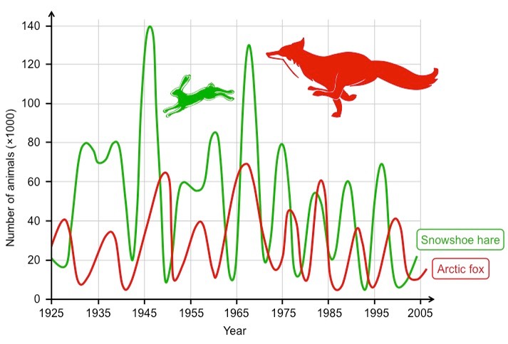

- State how Daisy World is an example of negative feedback (State: Give a specific name, value or other brief answer without explanation or calculation.)

- Watch this video on Global Climate change https://www.youtube.com/watch?v=oTkc4B4D71w

  - Define positive feedback (Define: Give the precise meaning of a word, phrase or physical quantity)

  - Outline global warming as an example of a positive feedback loop. (Outline: Give a brief account or summary)

- Draw and label a diagram to represent a positive feedback mechanism involving the albedo effect (Draw: Represent by means of pencil lines: Label: Add labels to a diagram)

- A causal loop diagram is a "snapshot of all relationships that matter." It is a visual representation of key variables. Draw and label an example below (Draw: Represent by means of pencil lines: Label: Add labels to a diagram)

- An IB student has a lot of work to do and gets stressed. As a result, they might struggle to focus on their work, and delay in completing it. The workload piles up more and more because they aren’t getting through it, making them more stressed. Suggest the type of feedback mechanism being described here? Explain your answer. (Suggest: Propose a hypothesis or other possible answer)

- Here are a number of examples of how both positive and negative feedback mechanisms might operate in the physical environment. No one can be sure which of these effects is likely to be most influential, and consequently we cannot know whether or not the Earth will manage to regulate its temperature, despite human interference with many natural process
  - Label each example as either positive or negative feedback (Label: Add labels to a diagram)

As carbon dioxide levels in the atmosphere rise the temperature of the Earth rises. | As the Earth warms the rate of photosynthesis in plants increases, more carbon dioxide is therefore removed from the atmosphere by plants, reducing the greenhouse effect and reducing global temperatures.
As the Earth warms: | Ice cover melts, exposing soil or water. Albedo decreases (albedo is the fraction of light that is reflected by a body or surface). More energy is absorbed by Earth’s surface. Global Temperature rises. More ice melts.
As the Earth warms, upper layers of permafrost melt, producing waterlogged soil above frozen ground. | Methane gas is released in an anoxic environment. The greenhouse effect is enhanced. Earth warms, melting more permafrost.
As Earth warms, increased evaporation produces more clouds. | Clouds increase albedo, reflecting more light away from Earth. Temperature falls. Rates of evaporation fall.
As Earth warms, organic matter in soil is decomposed faster: | More carbon dioxide is released. Enhanced greenhouse effect occurs. Earth warms further. Rates of decomposition increase.
As Earth warms, evaporation increases: Snowfall at high latitudes increases. | Icecaps enlarge. More energy is reflected by increased albedo of ice cover. Earth cools. Rates of evaporation fall.
As Earth warms, polar icecaps melt releasing large numbers of icebergs into oceans. | Warm ocean currents such as Gulf Stream are disrupted by additional freshwater input into the ocean. Reduced transfer of energy to poles reduces temperature at high latitudes. Ice sheets reform and icebergs retreat. Warm currents are re-established.

Tipping Point

The costs of tipping points, both from environmental and economic perspectives, could be severe, so accurate predictions are critical. Models that predict tipping points are, therefore, essential and have alerted scientists to potential large events. Continued monitoring, research, and modelling is required to improve predictions.

- Define the following terms (Define: Give the precise meaning of a word, phrase or physical quantity)
  - Resilience

  - Stability

  - Tipping point

- Draw and label a graph showing how a tipping point happens. (Draw: Represent by means of pencil lines: Label: Add labels to a diagram)

- Select one of the major Earth System (Arctic sea ice, ice sheets, the El Niño phenomenon, the Amazon rainforest). State how it might affect changes in global climate patterns. (State: Give a specific name, value or other brief answer without explanation or calculation)

- Watch the video, “How Wolves Changed The River” https://youtu.be/ysa5OBhXz-Q then analysle the graph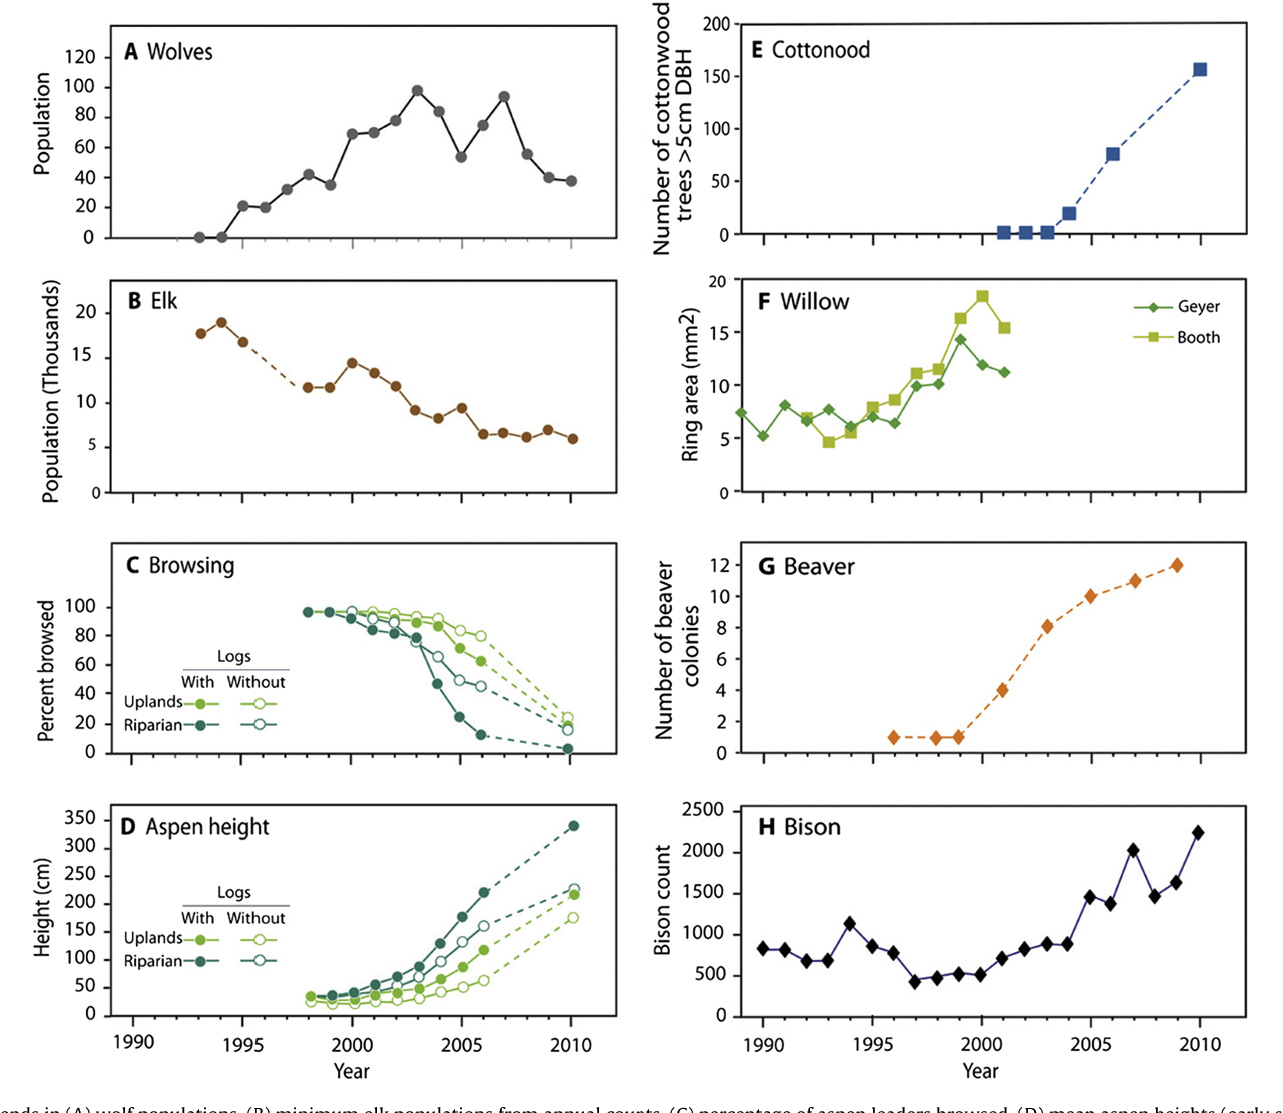

  - With reference to the graph, suggest why the beaver and bison population increase as the wolf populations increased.

  - Outline how the reintroduction of wolves to Yellowstone National Park lead to changes in river geography,

  - State the role trophic cascades play in this ecological transformation

  - List the chain of effects that resulted from the reintroduction of wolves in Yellowstone, highlighting how it impacted both the biological and physical aspects of the ecosystem?"

- Global climate change is an example of a disturbance on the environment that humans are causing. Most scientists agree that the planet is warming, and that humans are the cause of it. However, the future consequences are still debated. Some people may argue that the Earth environment as a whole is very resilient because it is such a complex system, though others may argue it is not resilient enough to withstand the disturbances we are putting on the system. Using climate change as an example, explain why it is so difficult to predict the tipping point of a complex system. (Explain: Give a detailed account of causes, reasons or mechanisms)

Resilience

- Predict which situation(s) resilience is a: (Predict: Give an expected result)
  - BENEFICIAL thing to have

  - DETRIMENTAL thing to have

- List the factors affecting ecosystem resilience. Place a STAR or mark of some sort next to those factors that are affected by humans. (List: Give a sequence of names or other brief answers with no explanation)

- Explain how the size of storages and the diversity of a system can affect its resilience. (Explain: Give a detailed account of causes, reasons or mechanisms)

- Watch this video clip “What Will Earth Look Like When These 6 Tipping Points Hit? https://youtu.be/MBKZWKeKYqE and read the article “Amazon near tipping point of switching from rainforest to savannah” Suggest whether the Earth has passed its tipping point based on the video and article. (Suggest: Propose a solution, hypothesis or other possible answer.)

- Watch the video on Apo Island. https://youtu.be/v8oNhckPjFM.
  - Outline how the community-managed marine protected areas on Apo Island contributed to the resilience and recovery of marine ecosystems (Outline: Give a brief account or summary.)

  - Suggest lessons that can be learned about sustainable resource management from this example? (Suggest: Propose a solution, hypothesis or other possible answer.)

- Using the table, state and explain the resilience of the stated systems. (State: Give a specific name, value or other brief answer without explanation or calculation: Explain: Give a detailed account of causes, reasons or mechanisms)
(Help: consider the disturbances that might occur, such as diseases, invasive species, weather changes etc...)
System | Resilience  (high / moderate / low) | Explanation
A very large forest ecosystem with high biodiversity | High | There are many interactions between  organisms if the biodiversity is high. If there is a  change, e.g. a decrease the population of a  particular species through disease, those  organisms that feed on it will have alternative  food sources to turn to. The system will remain  mostly unchanged.
A large field with only corn growing in it, with a small
number of insects feeding on the corn.
An isolated village community in the Gobi desert, with a population of around 1000
people.
The community of Shanghai, China. Population roughly 24,000,000.

- Visit the Resilience Alliance database (http://www.resalliance.org/tdb-database ) .
- Browse the list of examples and focus on the "Alternate Regimes" section.
- You need to design a diagram illustrating a positive feedback loop between two states of an ecosystem, showing the "push factors" described in the "mechanism" section of the database.
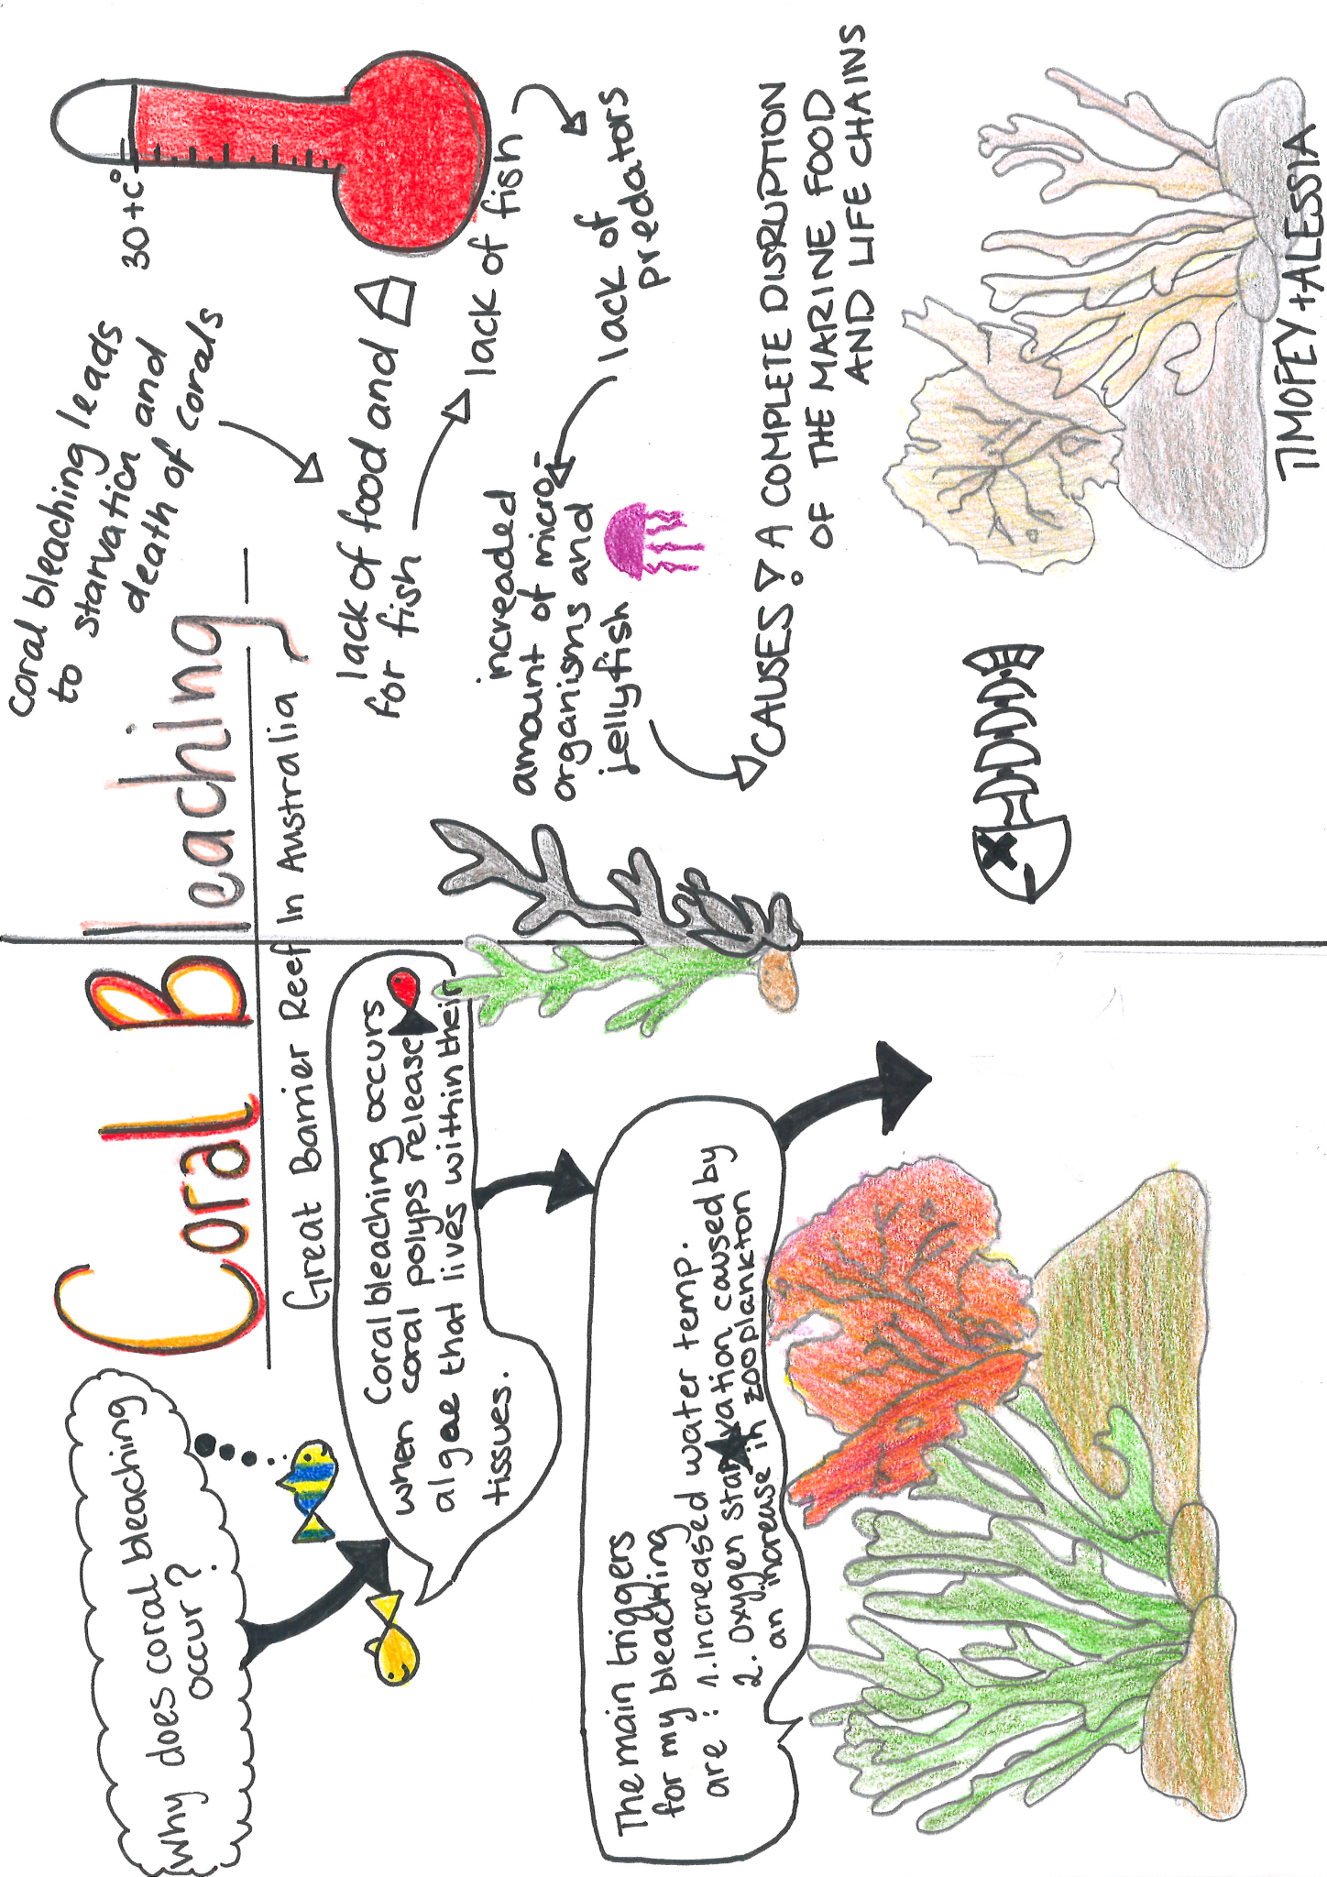
- Here is an example diagram for reference.

- Answer the following questions based on their diagrams:
  - Outline two possible reasons for the tipping point illustrated in their diagram. (Outline: Give a brief account or summary)

  - Identify the mitigation strategies used to reduce the tipping point.

  - Outline how the mitigation strategies contributed to the resilience of the ecosystem represented in their diagram. (Outline: Give a brief account or summary)

- Discuss resilience in a variety of systems.
  - Example 1: Possums were introduced to both Australia and New Zealand by European settlers in the 18th century. The impact of possums on the New Zealand ecosystem was greater than on the Australian ecosystem. The Australian ecosystem, in this case, proved to be more resilient to the impact of possums compared to the New Zealand ecosystem which became overrun by possums.
Discuss how the size of land mass and presence of natural possum predators could explain what happened in

Reflection: How has your understanding of systems and their significance in environmental science evolved?

ESS can be like learning a new language. So many words are not commonly used in everyday English. This can be challenging. To help you keep up with ESS Terms, you will need to create your own ESS DICTIONARY. You should add to this over the year and keep it in your notebook or on a page file THAT YOU CAN UPDATE AND ADD TO EASILY. Most of the vocabulary words can be found either on your STUDY GUIDE or at mrgscience.com.
You will be responsible for learning the words and their meaning. Periodic quizzes will be given on the words. So, make your dictionary creative and you will remember the words more easily.

KEY TERMS

positive feedback

tipping-point

resilient

stability

negative feedback

destabilizing

sustainability

energy transfer

predator/prey

equilibrium

energy

static equilibrium

unstable equilibria

steady-state equilibrium

stable equilibria

Gaia hypothesis

biosphere

system

closed system

emergent properties

models

flows

inputs

outputs

energy transfer

ecosystem

functional

​transfers

storage

processes

matter

transformation

open system

flows

stock

boundaries

​isolated system

